Lab No. 1
Data Preprocessing on Titanic Dataset

Aim: To study and apply various data preprocessing techniques on the given Titanic dataset and prepare the dataset for training a machine learning algorithm.

Objectives:
1. To understand the importance of data preprocessing in machine learning.
2. To inspect and understand the structure and characteristics of the Titanic dataset.
3. To identify and handle missing or null values in the dataset.
4. To remove unnecessary or irrelevant columns from the dataset.
5. To convert categorical data into numerical form using suitable encoding techniques.
6. To prepare a clean and suitable dataset for machine learning model training.

Dataset: Titanic Dataset
Resources/Tools Used:
* Python
* Jupyter Notebook / Google Colab
* Pandas
* NumPy
* Scikit-learn
* Titanic dataset in CSV format
* GitHub for code submission

Date of Performance: 09 August 2026

GitHub URL: https://github.com/MeTa1212/ML-Lab/blob/main/Mehul_ML_Lab_1.ipynb

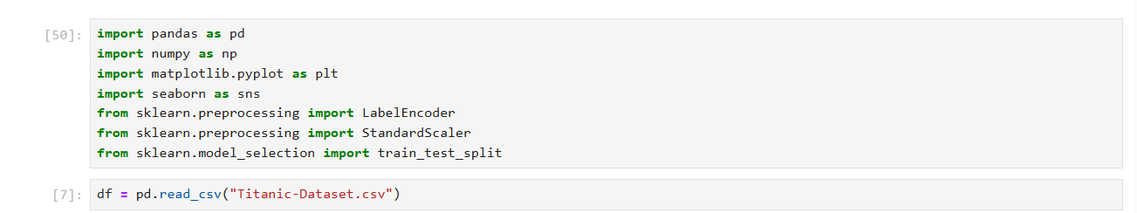
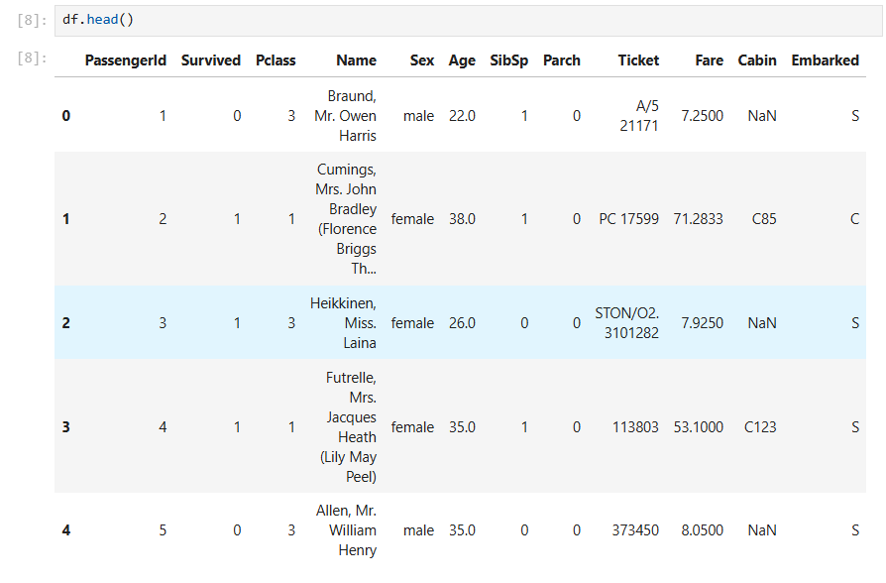
df.head() — First Five Records
The output displays the first five records of the Titanic dataset.
It shows attributes such as PassengerId, Survived, Pclass, Name, Sex, Age, Fare, and Embarked.
This output provides an initial view of the structure and type of data available.
It helps in understanding the different features before performing preprocessing.
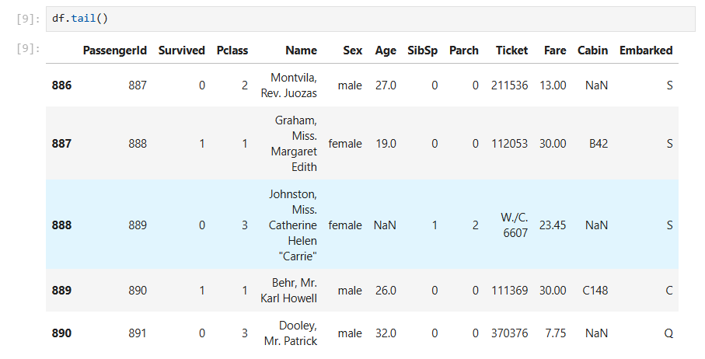
df.tail() — Last Five Records
The output displays the last five records of the dataset.
It confirms that the dataset contains passenger information up to PassengerId 891.
Different values of survival status, passenger class, age, fare, and other attributes can be observed.
This helps verify that the dataset has been loaded completely.

df.shape
The output is (891, 12).
This indicates that the dataset contains 891 rows and 12 columns.
Each row represents a passenger, while each column represents a feature or attribute.
It provides the overall dimensionality of the dataset.
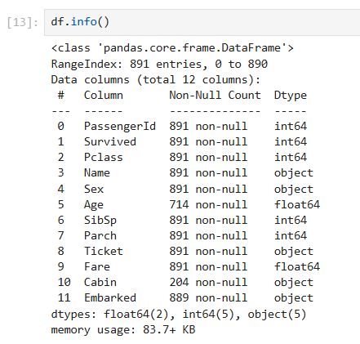

df.info()
The output provides information about the dataset's columns, data types, and non-null values.
The dataset contains 891 entries and 12 columns with integer, floating-point, and object data types.
It also identifies missing values, particularly in Age, Cabin, and Embarked.
This information is useful for deciding the required preprocessing steps.

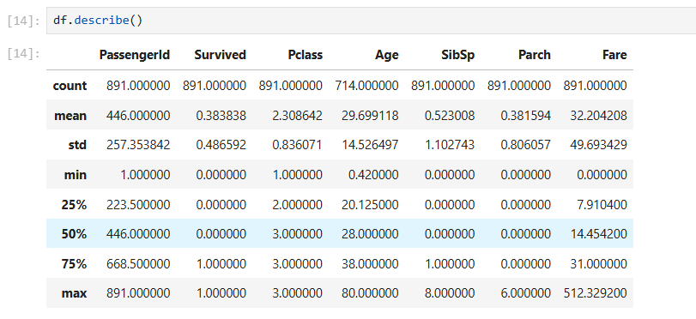

df.describe()
The output provides statistical information for the numerical columns.
It includes values such as count, mean, standard deviation, minimum, quartiles, and maximum.
For example, the average passenger age is approximately 29.7 years and the average fare is about 32.2.
This helps understand the distribution and range of numerical features.
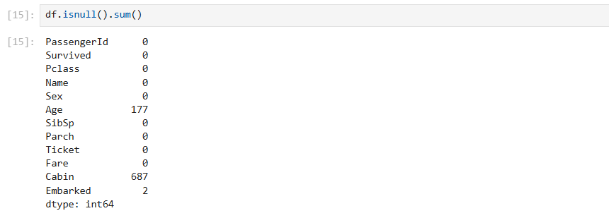

df.isnull().sum()
The output shows the number of missing values in each column.
Age contains 177 missing values, Cabin contains 687, and Embarked contains 2.
The remaining columns do not contain missing values at this stage.
This output helps identify which columns require missing-value treatment.
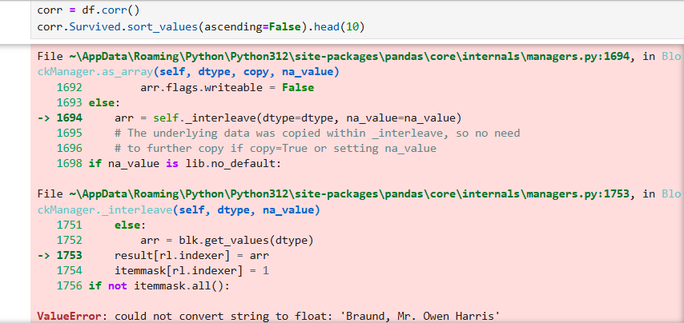

Correlation Output — df.corr()
This cell produces an error because the dataset still contains non-numerical columns such as passenger names.
The correlation function attempts to convert these string values into floating-point numbers.
As a result, a ValueError is generated.
This shows that categorical/string columns need to be excluded or encoded before calculating correlations.

df["Embarked"].unique()
The output shows the unique values present in the Embarked column.
The possible values are S, C, Q, and NaN, representing different embarkation locations and missing values.
This identifies the categorical nature of the feature.
The column is subsequently converted into numerical values for further processing.
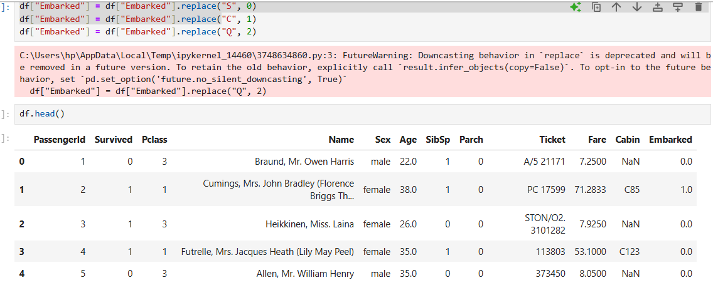

df["Embarked"].unique()
The output shows the unique values present in the Embarked column.
The possible values are S, C, Q, and NaN, representing different embarkation locations and missing values.
This identifies the categorical nature of the feature.
The column is subsequently converted into numerical values for further processing.
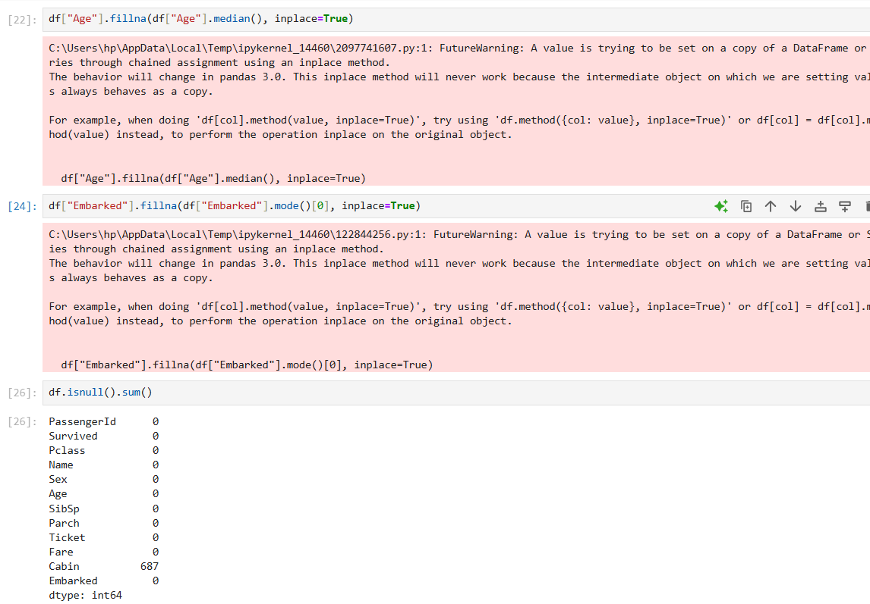

Missing Values After Preprocessing
The output shows that missing values in Age and Embarked have been removed.
Age is filled using its median value, while Embarked is filled using its mode.
The Cabin column still contains 687 missing values at this stage.
The Cabin column is subsequently removed from the dataset.
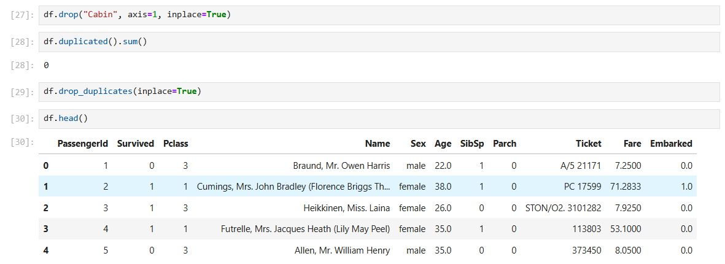

df.duplicated().sum()
The output is 0, indicating that no duplicate rows are present in the dataset.
Therefore, there are no repeated records that need to be removed.
The dataset can proceed to the next preprocessing and analysis stages.
The drop_duplicates() operation is also applied afterward.
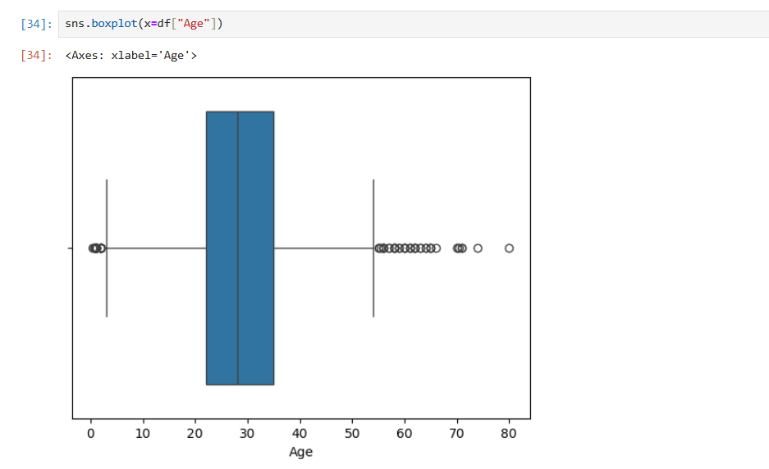

Box Plot — Age
The box plot represents the distribution of passenger ages.
It shows the median, spread, and potential outliers in the Age feature.
The plot is useful for identifying unusually high or low age values.
It also helps understand the variability of passenger ages in the dataset.
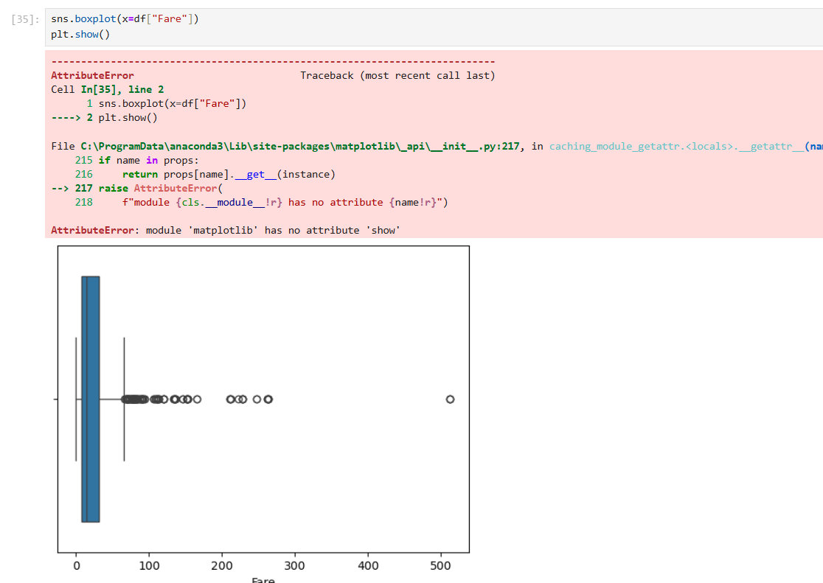

Box Plot — Fare
The box plot represents the distribution of passenger fares.
It shows the central tendency, spread, and extreme fare values.
The distribution contains some considerably higher fare values compared with most passengers.
Such visualization helps identify possible outliers in the Fare feature.
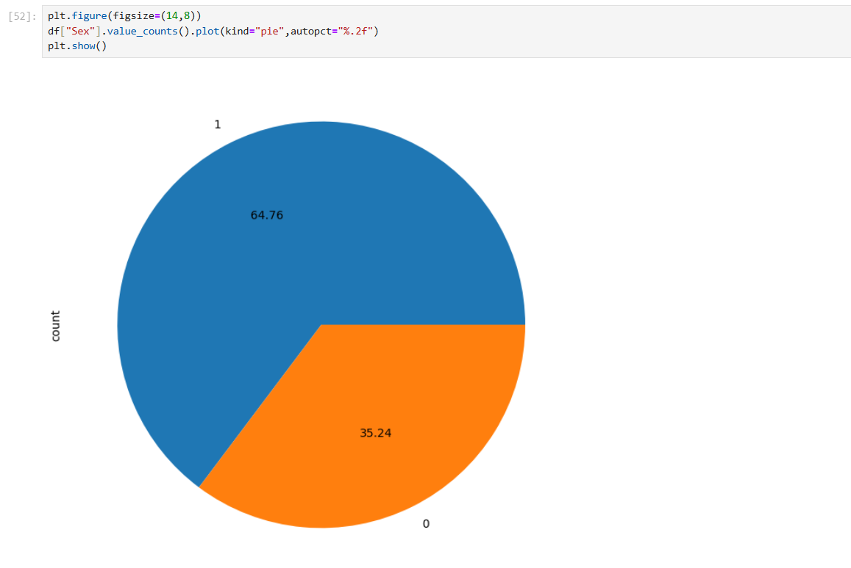

Pie Chart — Sex Distribution
The pie chart represents the proportion of male and female passengers.
It provides a visual comparison of the two gender categories in the dataset.
The percentage values are displayed directly on the chart.
This helps understand the gender composition of the passengers.

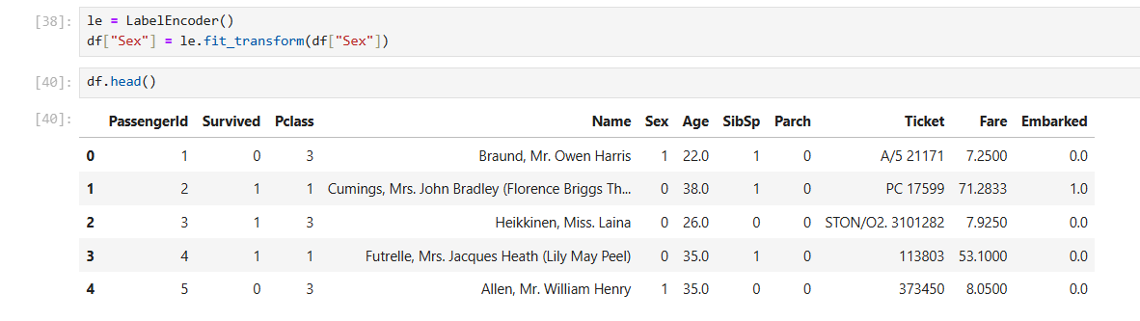
The output shows the Sex column after applying Label Encoding using LabelEncoder.
The categorical values male and female have been converted into numerical labels, making the feature suitable for machine learning algorithms.
The df.head() output confirms that the Sex column now contains values such as 0 and 1 instead of text values.
This converts the categorical data into a numerical format while retaining the original information.

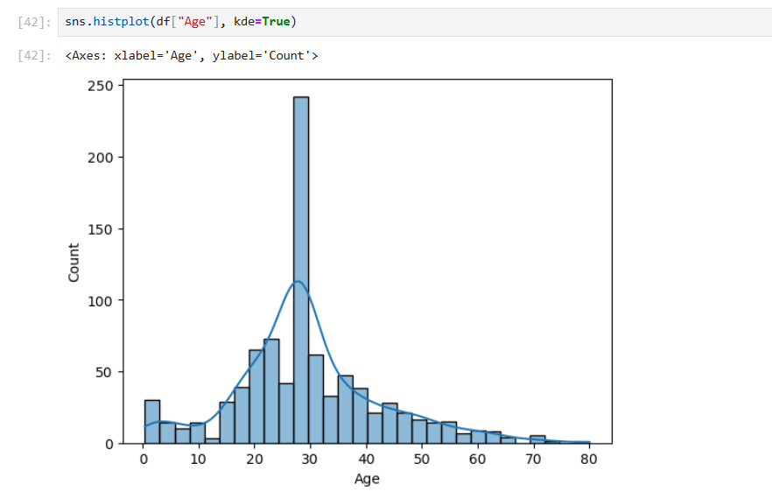

sns.histplot(df["Age"], kde=True) — Age Distribution
The histogram shows the distribution of passenger ages.
The bars represent the frequency of passengers across different age ranges.
The KDE curve provides a smoothed representation of the age distribution.
This visualization helps identify the central concentration and overall shape of the Age feature.

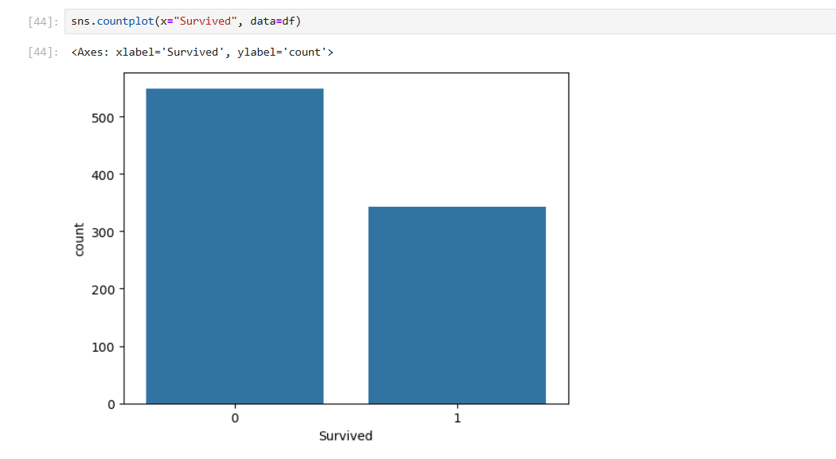

sns.countplot(x="Survived") — Survival Count
The count plot displays the number of passengers who survived and those who did not.
The Survived feature contains two categories: 0 and 1.
Category 0 represents passengers who did not survive, while category 1 represents survivors.
The plot makes the difference between the two groups easy to observe.
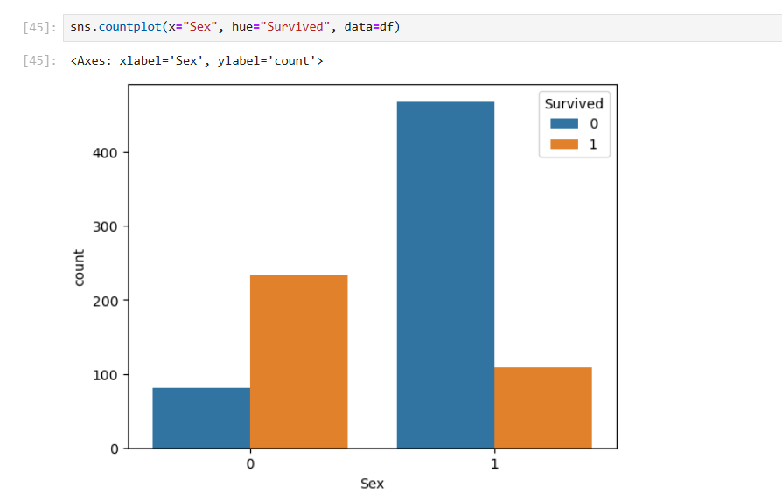

sns.countplot(x="Sex", hue="Survived")
This count plot compares survival outcomes across male and female passengers.
The hue="Survived" parameter separates passengers according to their survival status.
It allows the relationship between gender and survival to be visually examined.
The output provides an important exploratory view of survival patterns.
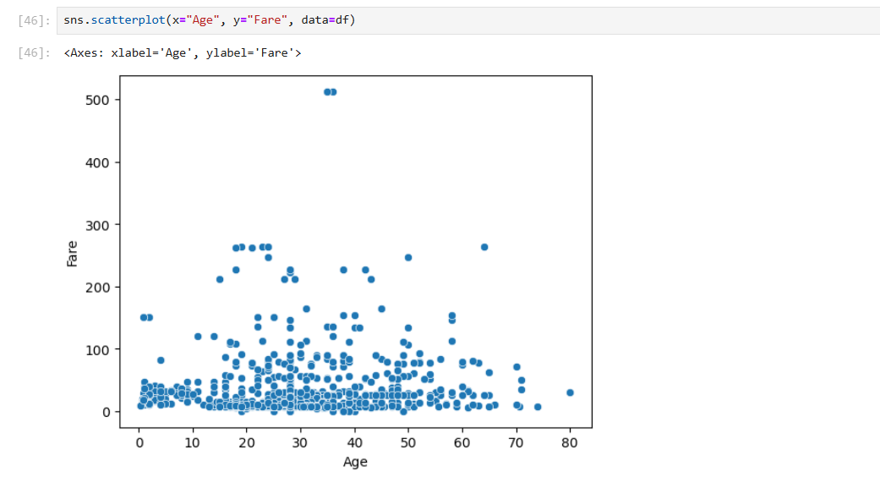

Scatter Plot — Age vs Fare
The scatter plot represents the relationship between passenger Age and Fare.
Each point corresponds to a passenger's age and fare value.
It helps identify possible relationships, clusters, and unusual observations between the two numerical features.
The plot also provides a visual understanding of how fares vary across different ages. 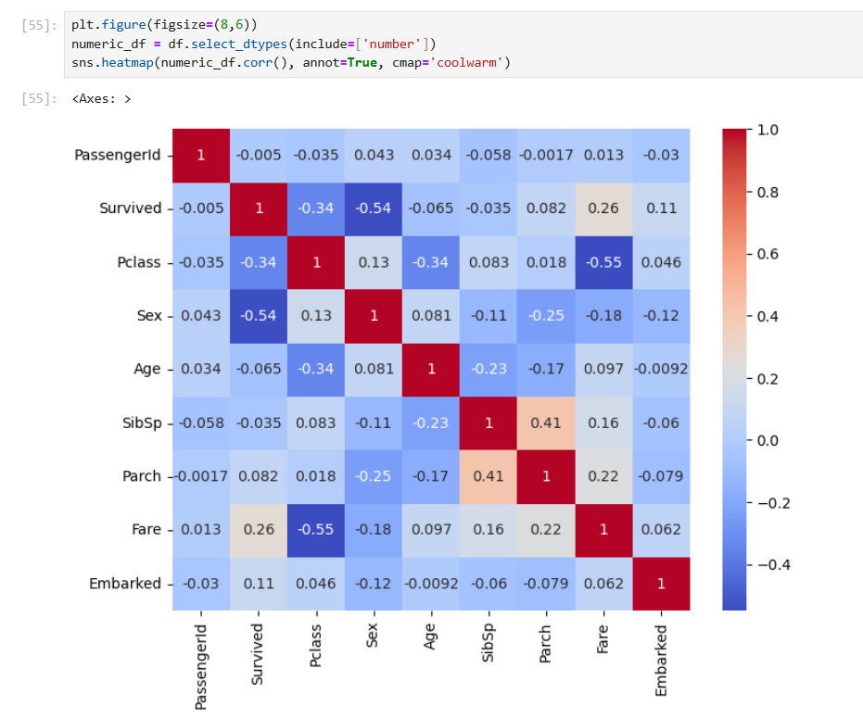

Correlation Heatmap
The heatmap displays correlations between the numerical variables in the dataset.
The correlation values are represented using different shades and annotated numerical values.
It helps identify features that have stronger positive or negative relationships with each other.
This can be useful for understanding feature relationships before model training.

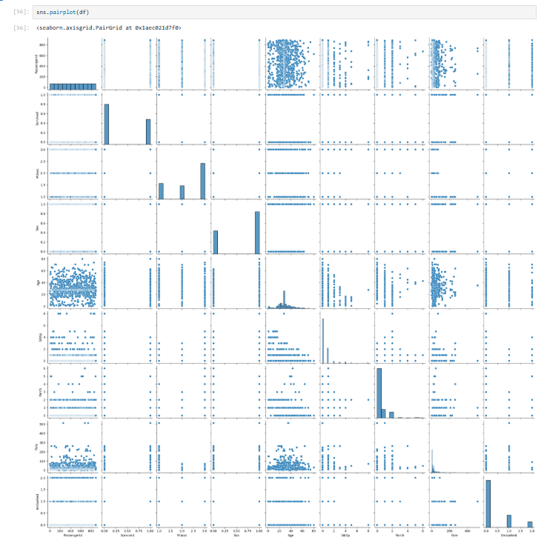

Pair Plot
The pair plot provides pairwise visualizations of the dataset's numerical features.
It combines scatter plots and distributions to show relationships between multiple variables.
This makes it easier to identify patterns, trends, and possible correlations.
It provides an overall visual summary of the numerical data.

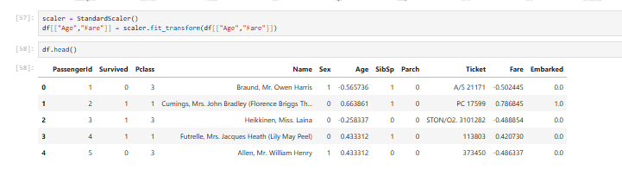
The output shows the Age and Fare features after standardization using StandardScaler.
The values have been transformed so that these features are centered around a mean of approximately 0 with a standard deviation of 1.
For example, the original Age and Fare values are now represented as standardized values such as -0.565736 and -0.502445.
This scaling ensures that Age and Fare are on a comparable scale and prevents features with larger numerical ranges from dominating the model.
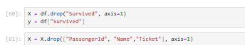
This code prepares the input features (X) and target variable (y) for machine learning.
First, the Survived column is removed from X because it is the target variable we want to predict.
Then, PassengerId, Name, and Ticket are removed because they are identifiers or textual information that are not used as input features here.
Thus, X contains the relevant passenger features, while y contains the survival status used as the prediction target.

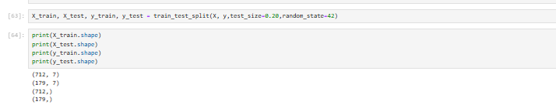

Train-Test Split Output
The output displays the dimensions of the training and testing datasets.
X_train contains 712 samples and 7 features, while X_test contains 179 samples and 7 features.
The target arrays y_train and y_test contain 712 and 179 values respectively.
This confirms that the dataset has been divided into training and testing sets for machine learning.
Viva Questions:
• Why do we use LabelEncoder() on the Sex column?
→ To convert categorical values such as male/female into numerical values like 0 and 1 so that machine-learning algorithms can process them.
• Why is StandardScaler() applied to Age and Fare?
→ Because Age and Fare have different numerical ranges. Standardization brings them to a comparable scale with mean approximately 0 and standard deviation 1.
• Why do we remove PassengerId, Name, and Ticket from X?
→ These columns are mainly identifiers/textual information and are not considered useful input features for predicting the Survived target in this practical.
• What is the difference between X and y?
→ X contains the input/features used by the model, while y contains the target/output that the model needs to predict. Here, y is the Survived column.
• Why do we split the dataset into training and testing data?
→ The training data is used to train the model, while the testing data is used to evaluate how well the trained model performs on unseen data.

