1-Steps for creating EC2 instance

Search EC2 instances on search bar and click on launch instance.

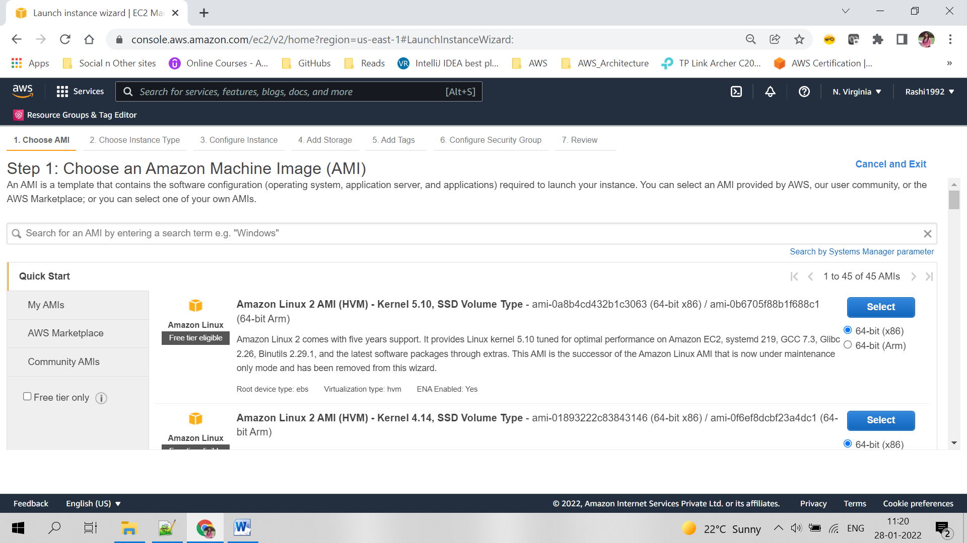

Select the required instance setup, click on Next:Configure Instance Details

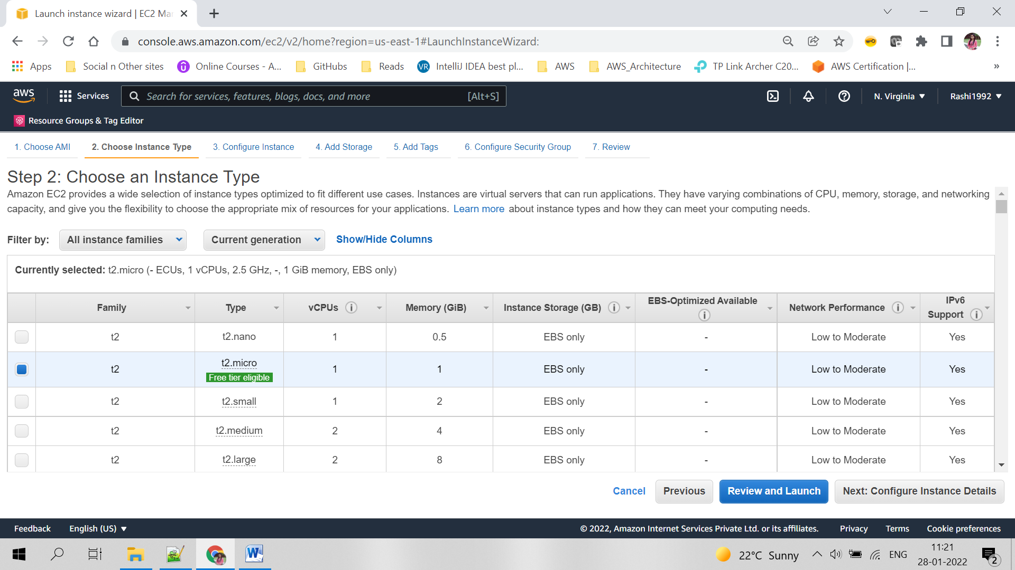

Select all configuration details for instance, click Next: Add Storage

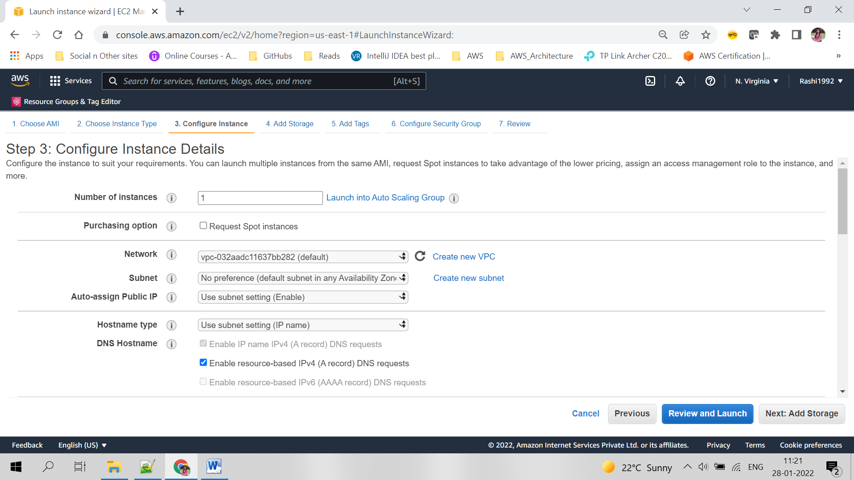

Add extra storage if required otherwise leave default one

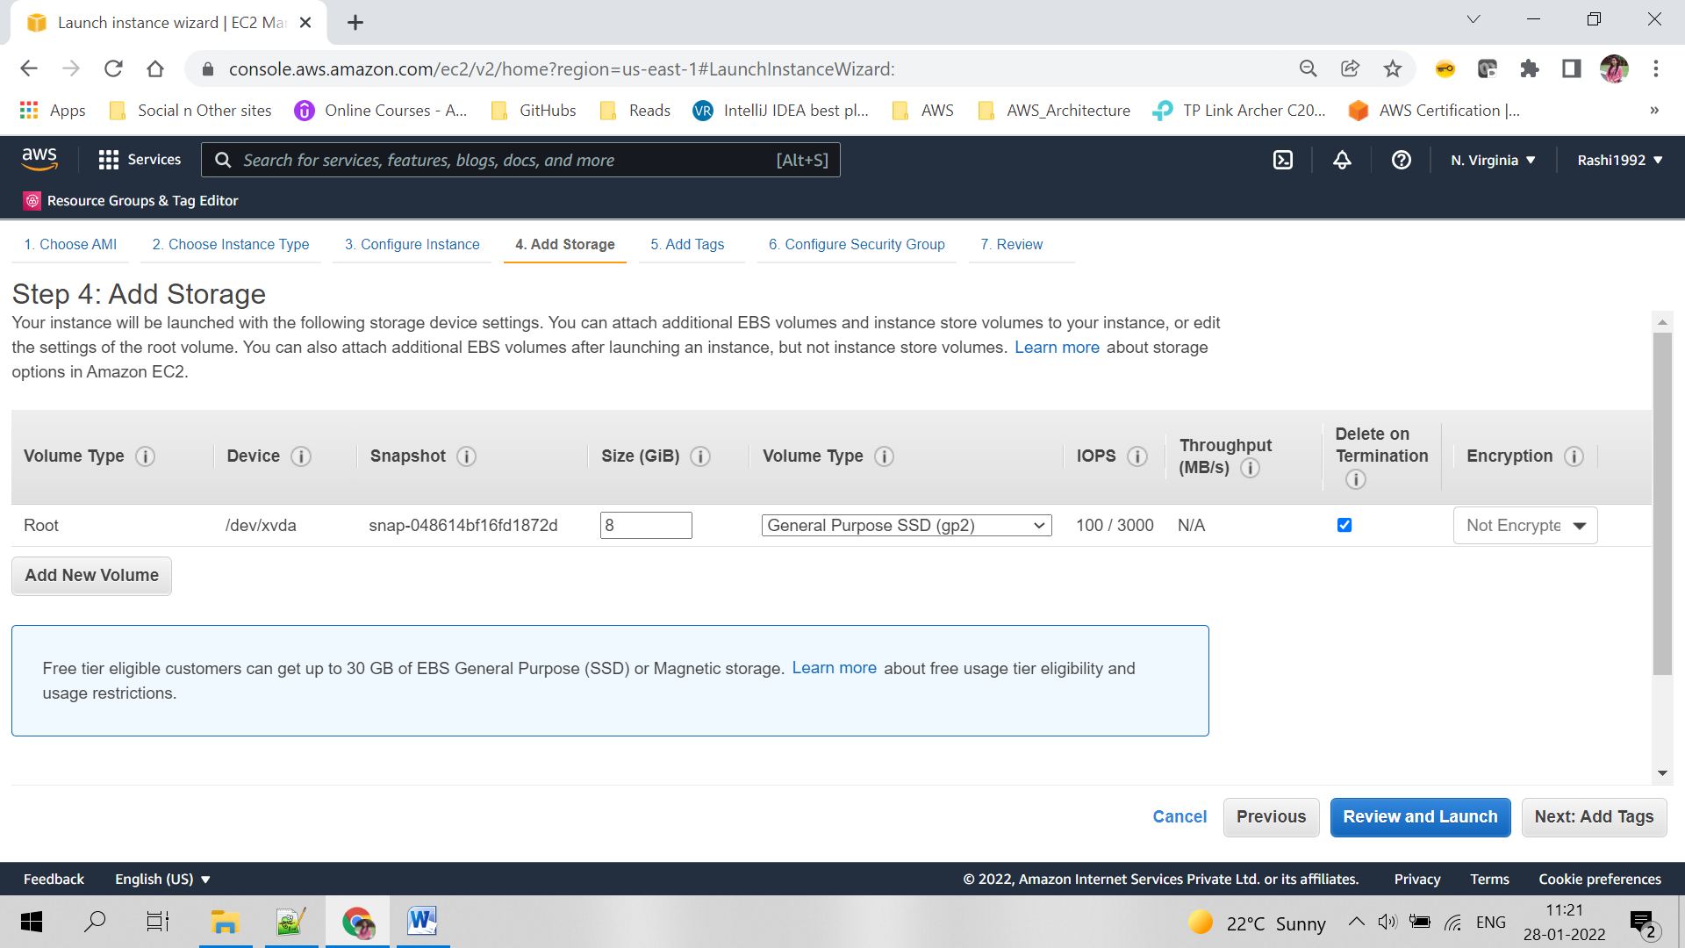

Add tags in key value like

Key-Name

Value- EC2_DeploymentMachine

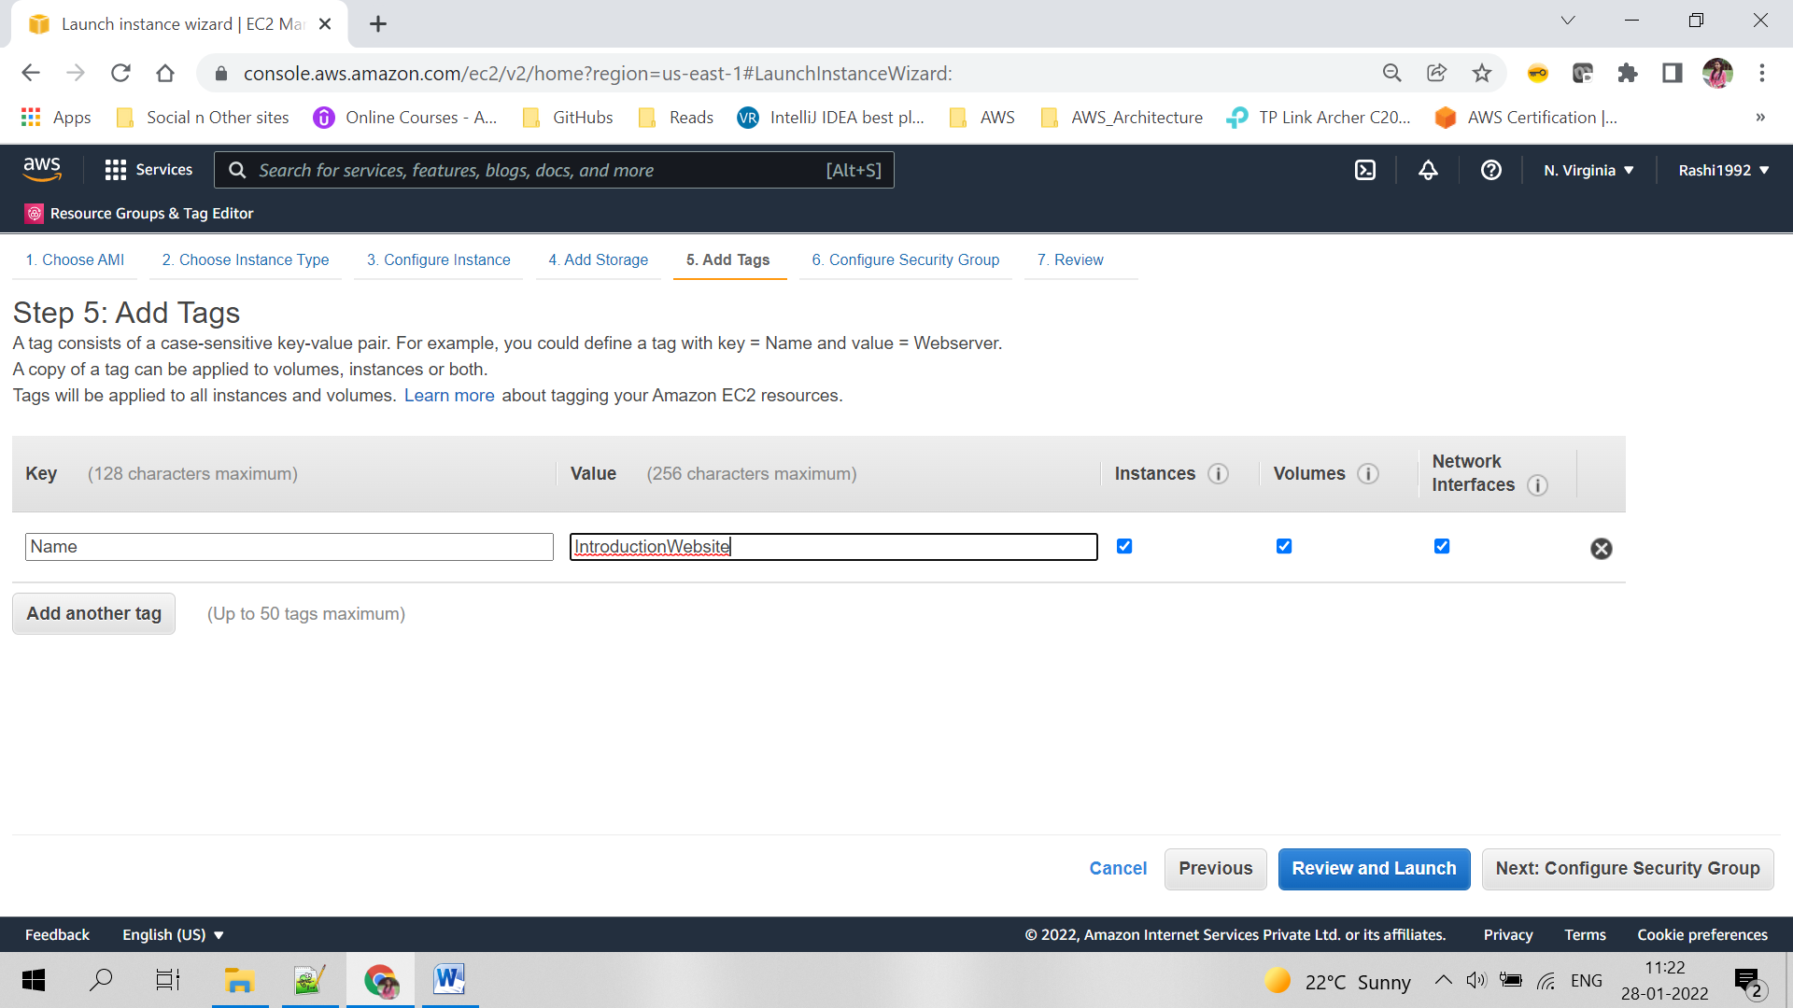

Use existing security group or create a new one. Add http for TCP protocol for opening the port 80

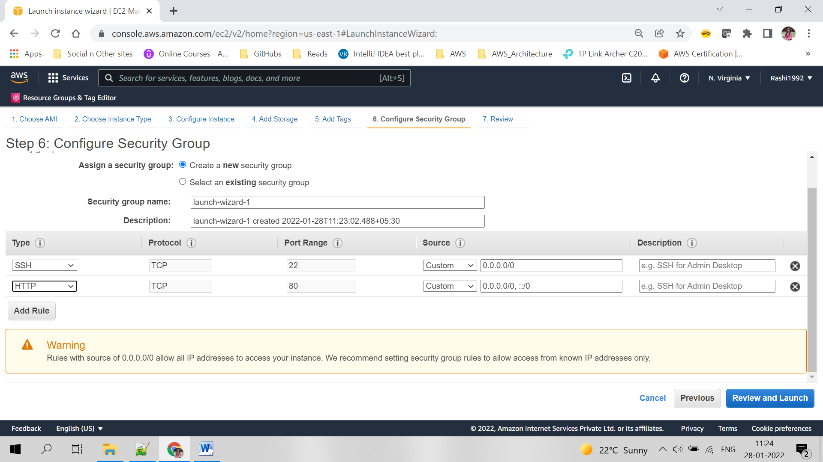

Select an existing key-value pair or add a new one. Download it and keep it safe, will be useful for ssh into the instance.

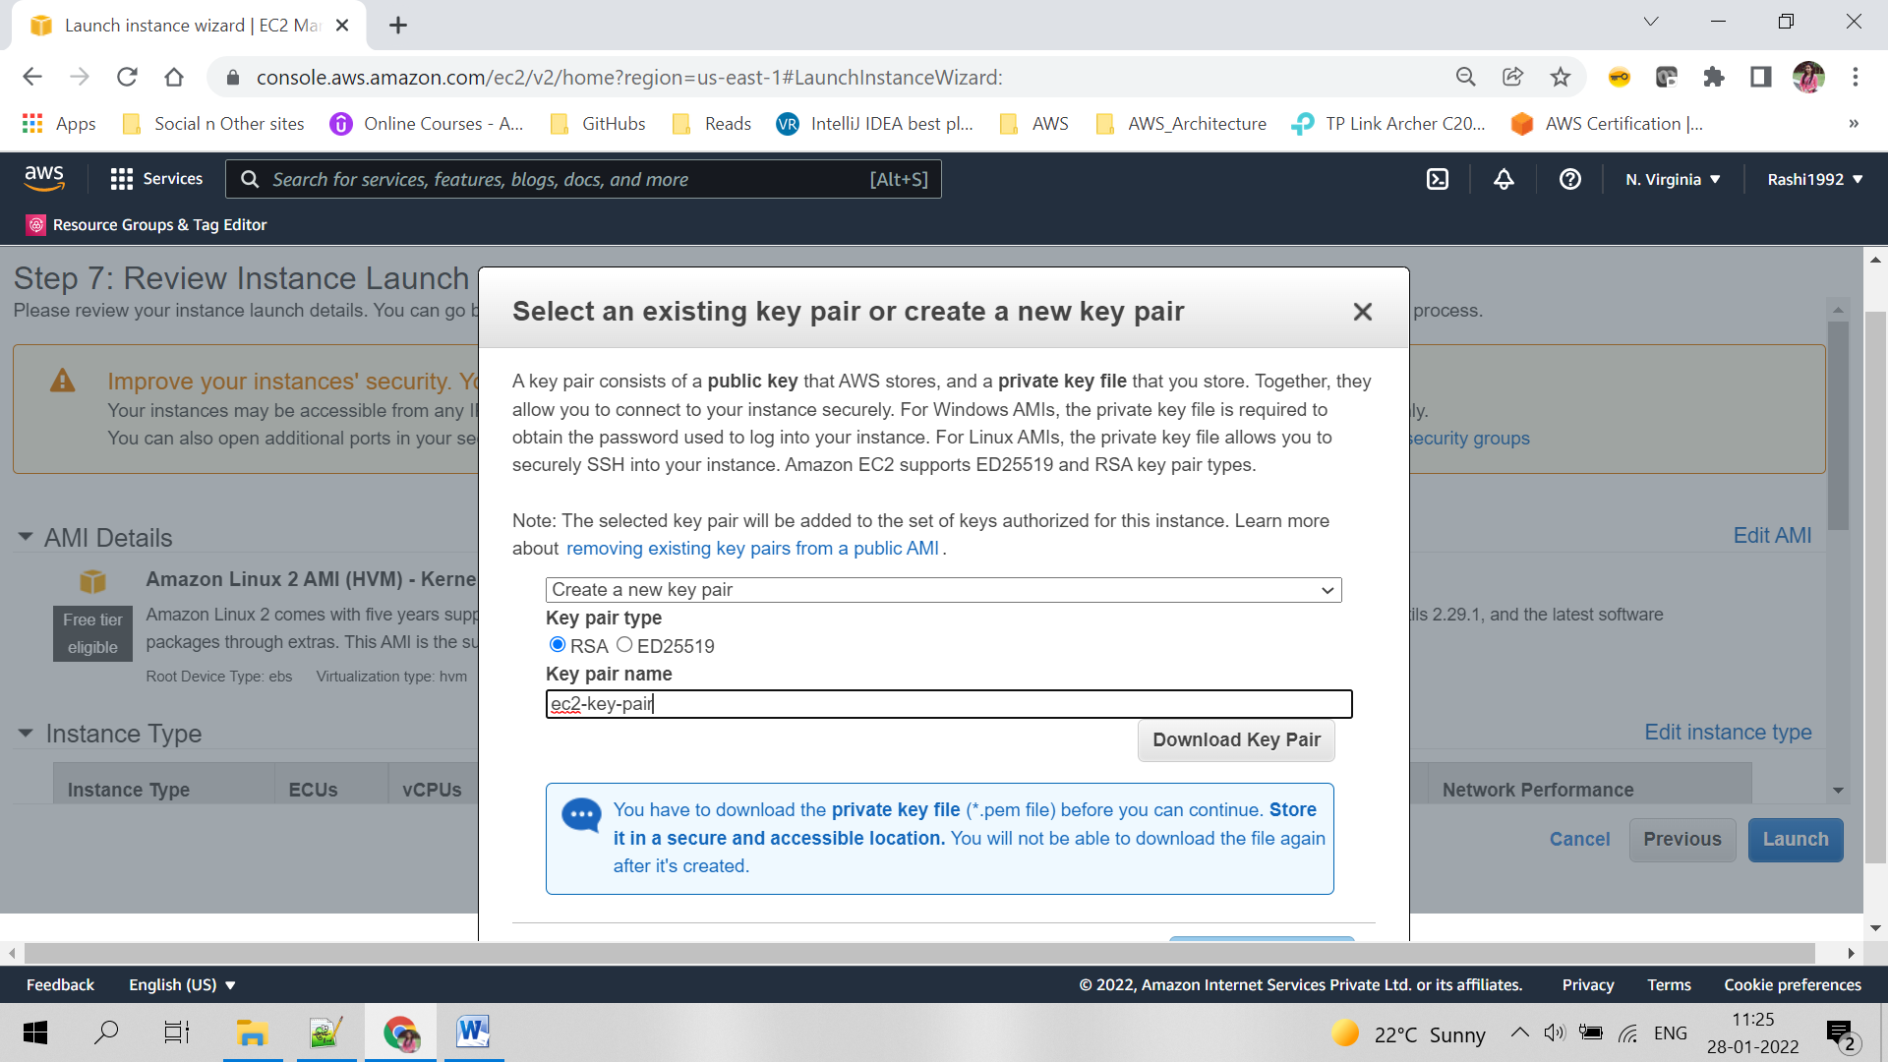

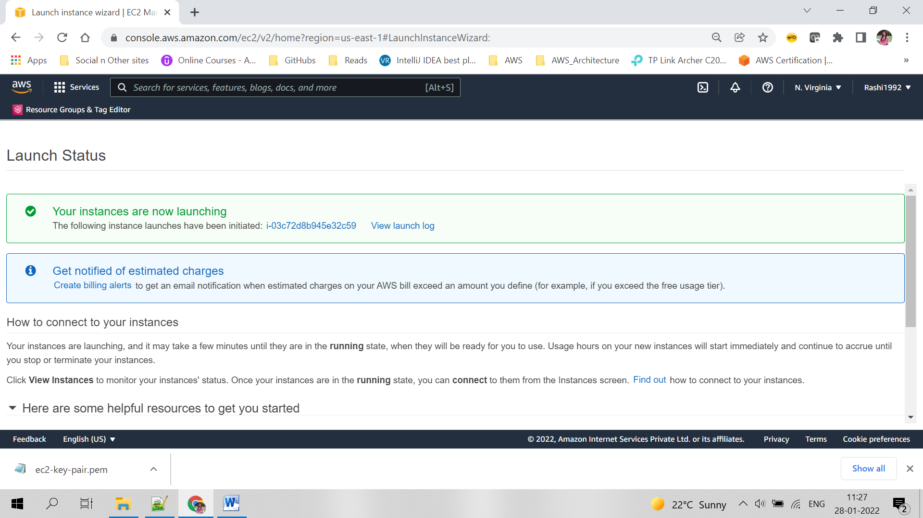

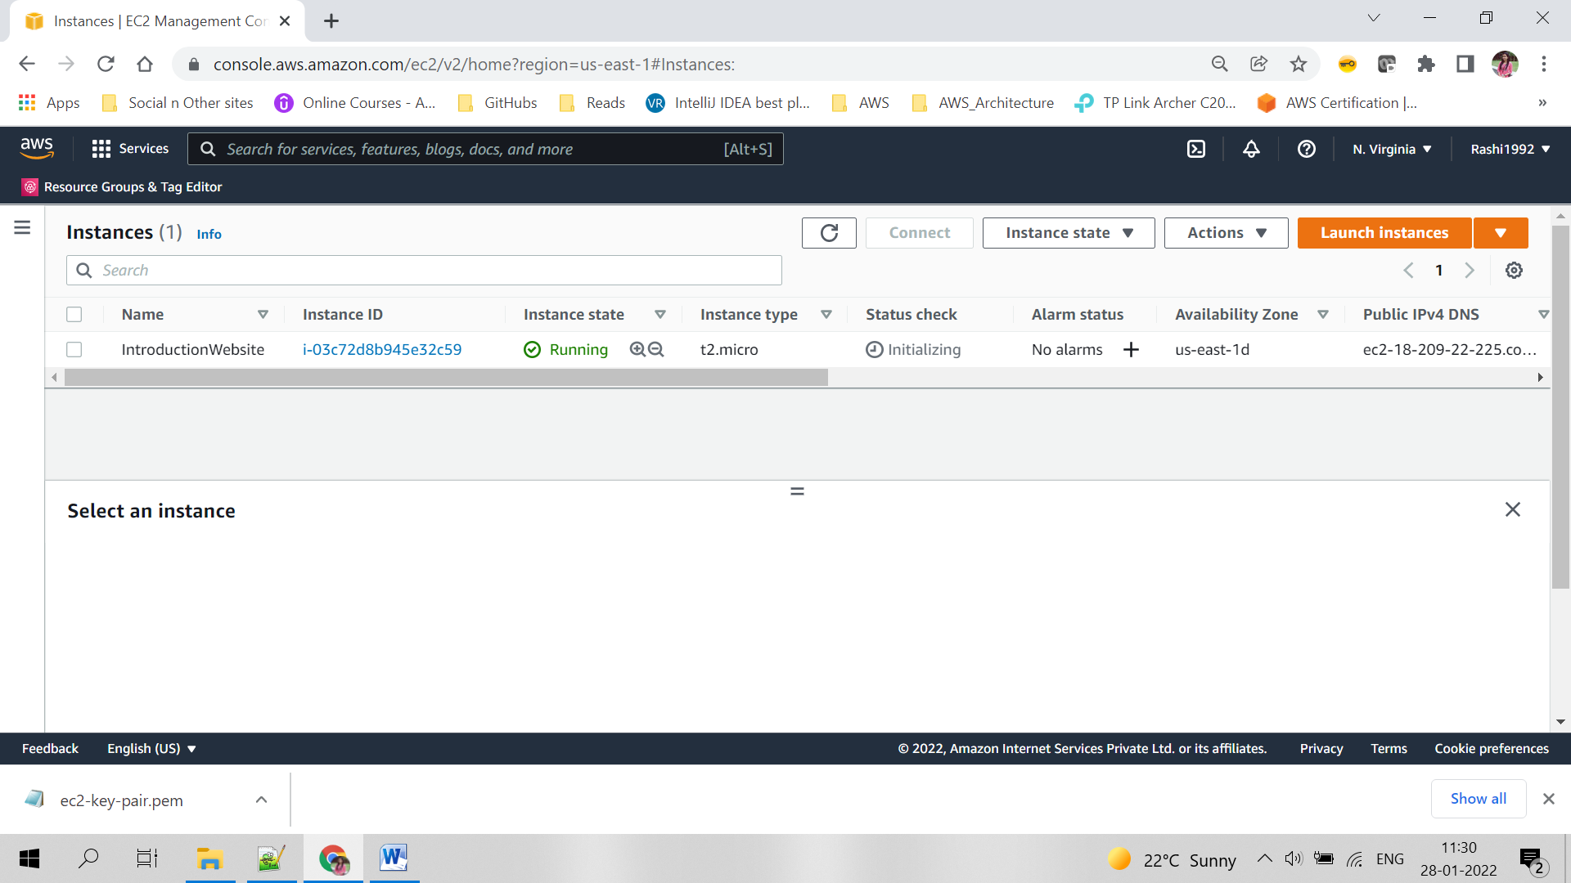

2. Steps for creating S3 bucket

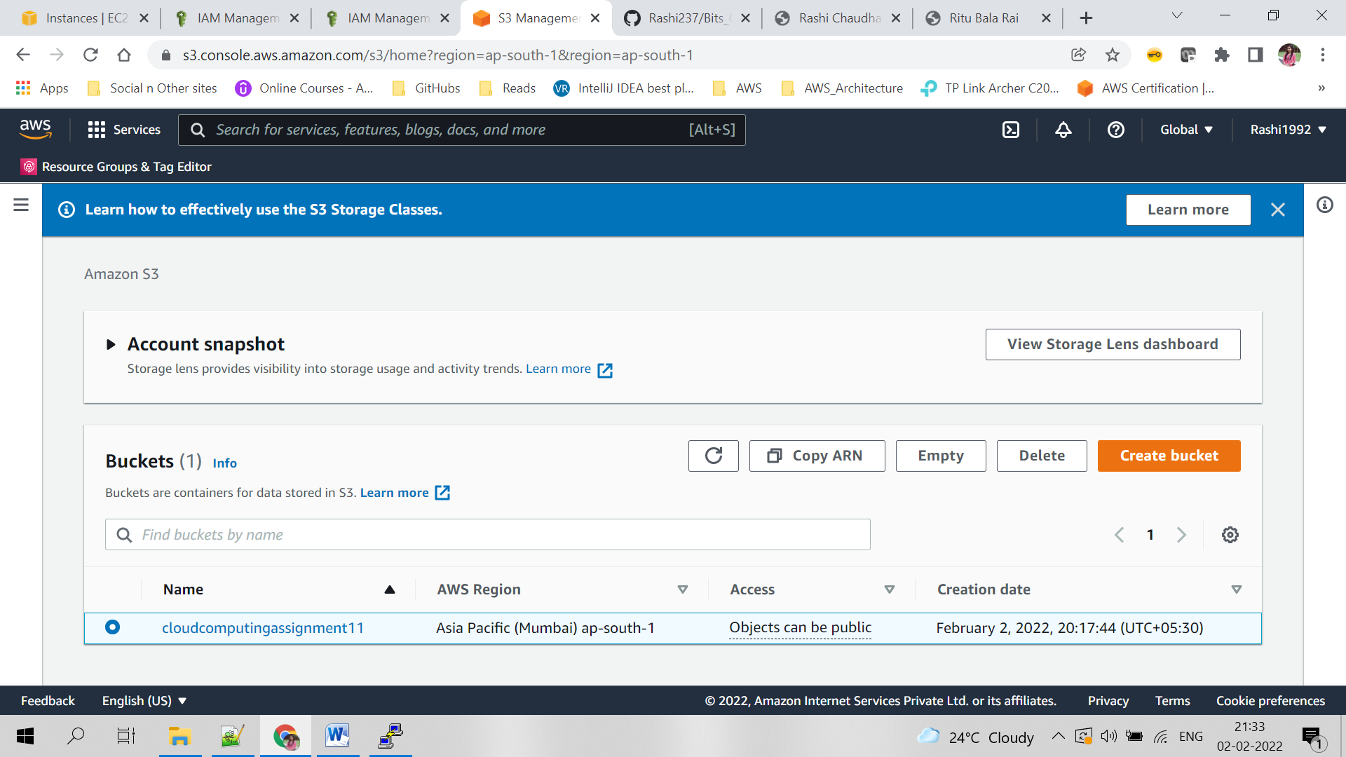

Click on create bucket and give the unique bucket name as shown below leave rest as default

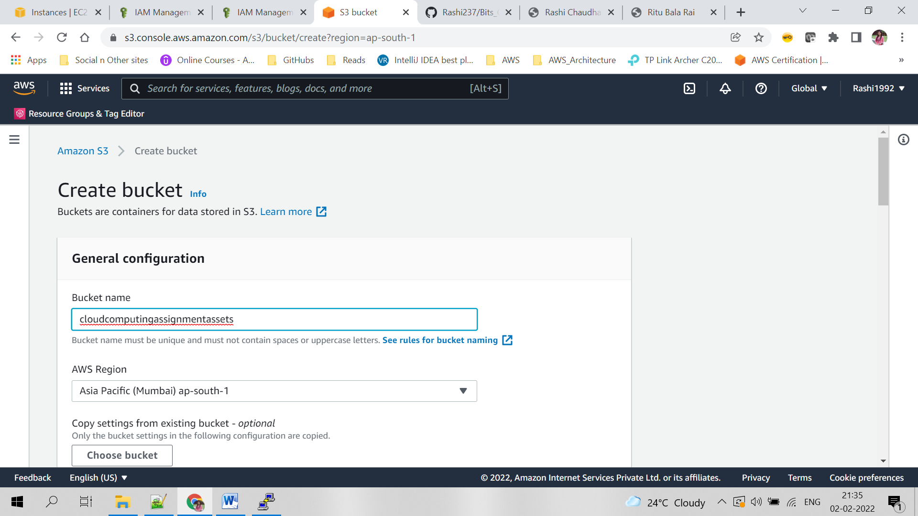

Once bucket is created, upload all the objects in S3.

