
All Cargo - Gati

Deployment Workflow

Prepared by Ashu Rana
On behalf of Rackspace

Table of Contents
1 Infrastructure Workflow 2
2 Application Workflow 4

Infrastructure Workflow

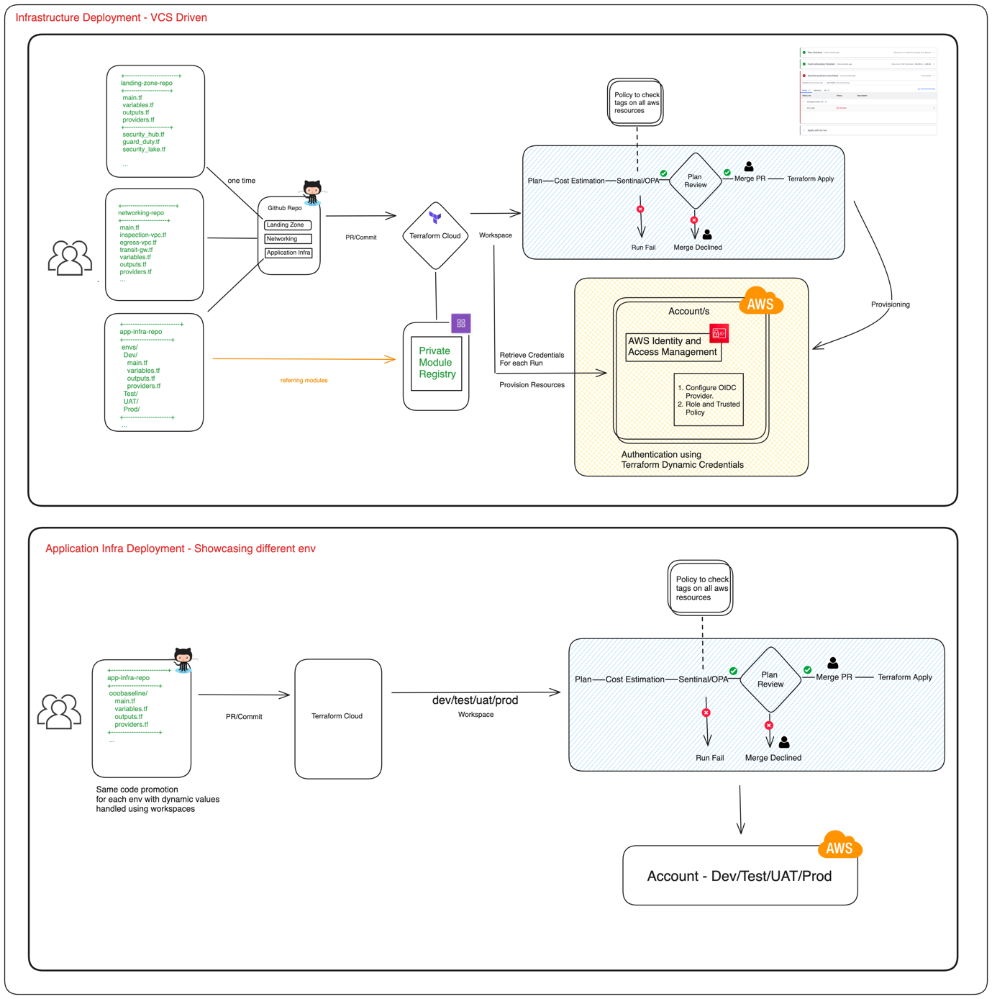

Application Workflow
