Synopsis
PROJECT TITLE - DIABETIES RISK PRIDICTION USING MACHINE LEARNING

PROBLEM ID – 14
STUDENT NAME- AAKHYA GUPTA
UNIVERSITY ROLL NO- 2028373
SECTION- P
STUDENT NAME – RASHI SHARMA
UNIVERSITY ROLL NO- 2028471
SECTION- P

PROBLEM DESCRIPTION:
Diabetes is a chronic health condition that affects millions of people worldwide. Early detection of diabetes is important because it can help prevent complications such as heart disease, kidney failure and nerve damage. Medical professionals collect various clinical measurements such as glucose level, blood pressure, insulin level, body mass index (BMI) and age to determine whether a patient is at risk of diabetes.
The objective of this project is to create a machine learning classification system that predicts whether a patient is diabetic or non‑diabetic based on their health records. The system uses a custom created dataset developed manually for this project. The dataset is preprocessed by handling missing values, removing outliers and normalizing medical measurements. Important features are identified using feature selection techniques.
The dataset contains simulated patient health records designed by considering common medical parameters that are typically associated with diabetes risk.
In addition, three machine learning algorithm Logistic Regression, K‑Nearest Neighbors (KNN) , Support Vector Machine (SVM) are implemented. The algorithms are compared based on the evaluation metrics such as accuracy , precision,recall,F1 score, confusion matrix, ROC curve. The final system predicts diabetes risk where output 0 represents Non‑Diabetic and 1 represents Diabetic.

STEPS OF IMPLEMENTATION:
1. Dataset Creation
A synthetic dataset containing patient health attributes will be manually created
using medically realistic value ranges.

2. Data Preprocessing
Missing values will be handled if necessary and outliers will be checked. Feature
scaling will be applied using normalization or standardization.

3. Feature Selection
Statistical techniques will be used to identify the most important attributes affecting diabetes prediction.

4. Model Training
Three classification algorithms will be implemented:
* Logistic Regression
* K‑Nearest Neighbors (KNN)
* Support Vector Machine (SVM)

5. Model Evaluation
Models will be compared using accuracy and precision.

6. Prediction
The final model will classify patients as:
0 – Non‑Diabetic
1 - Diabetic
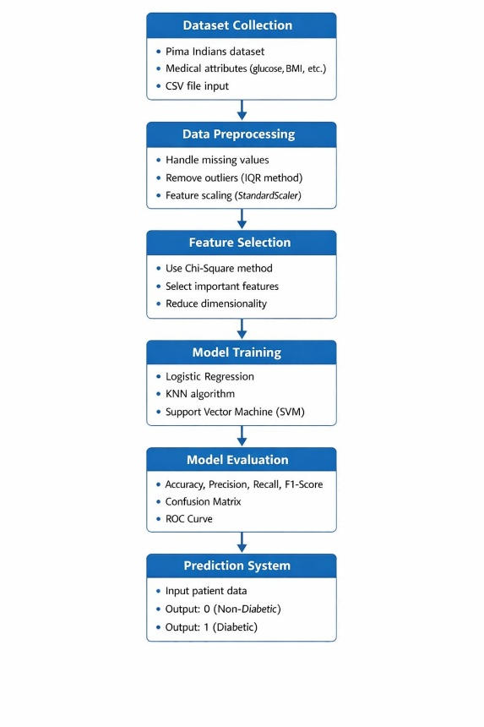

EXPECTED MODULES/ LIBRARIES USED:

NumPy – Used for numerical calculations and array operations.
Pandas – Used to create and manage the manually generated dataset.
Matplotlib – Used to create graphs and plots.
Seaborn – Used for advanced visualizations such as correlation heatmaps
and confusion matrix plots.
Scikit‑learn – Provides machine learning algorithms and tools for
preprocessing, model training, and evaluation

EXPECTED EVALUATION MATRIX AND PLOTS TO BE USED:

Accuracy – Measures the overall percentage of correct predictions.
Precision – Indicates how many predicted diabetic cases are actually diabetic.
Recall– Measures how effectively the model detects diabetic patients.
F1 score– Harmonic mean of precision and recall.
Confusion matrix– Shows the number of true positives, true negatives,
false positives, and false negatives.
ROC curve– Evaluates model performance at different classification thresholds.

REQUIRED TOPICS FOR THE SUBJECTS:

Data Structures – Used to store patient health attributes and labels.
File Handling – Used to read and write the CSV dataset file.
Python Libraries – Libraries such as NumPy, Pandas, and Scikit‑learn are used
to implement the machine learning pipeline.
Data Visualization – Used to represent results through graphs and charts.

PLATFORM REQUIRED:

Python Programming Language
Jupyter Notebook
Google Collab (optional for running the project online)

BOOKS AND LINK SOURCES:

1. Aurélien Géron – Hands‑On Machine Learning with Scikit‑Learn, Keras, and TensorFlow
2. Tom Mitchell – Machine Learning
3. Scikit‑learn Official Documentation – https://scikit-learn.org
4. Python Documentation – https://docs.python

