CURRENT
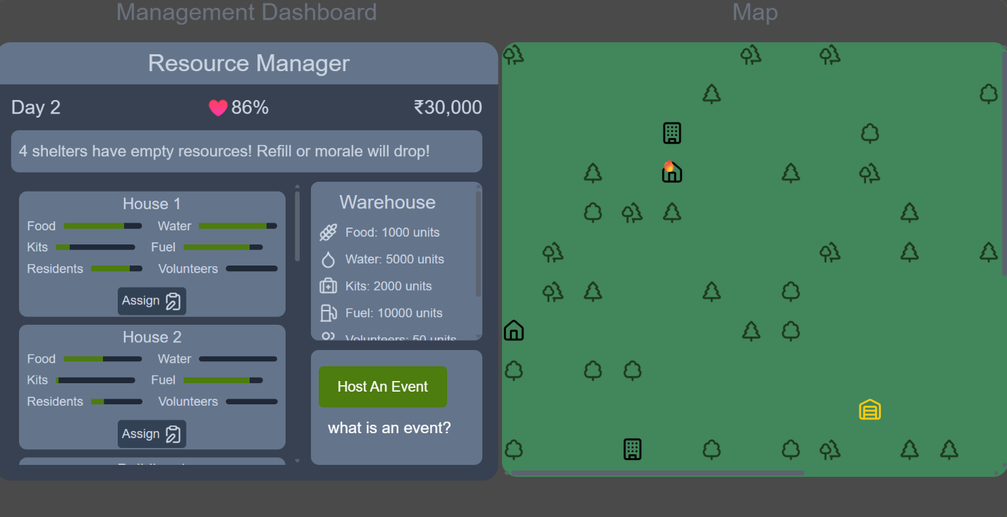

GOAL
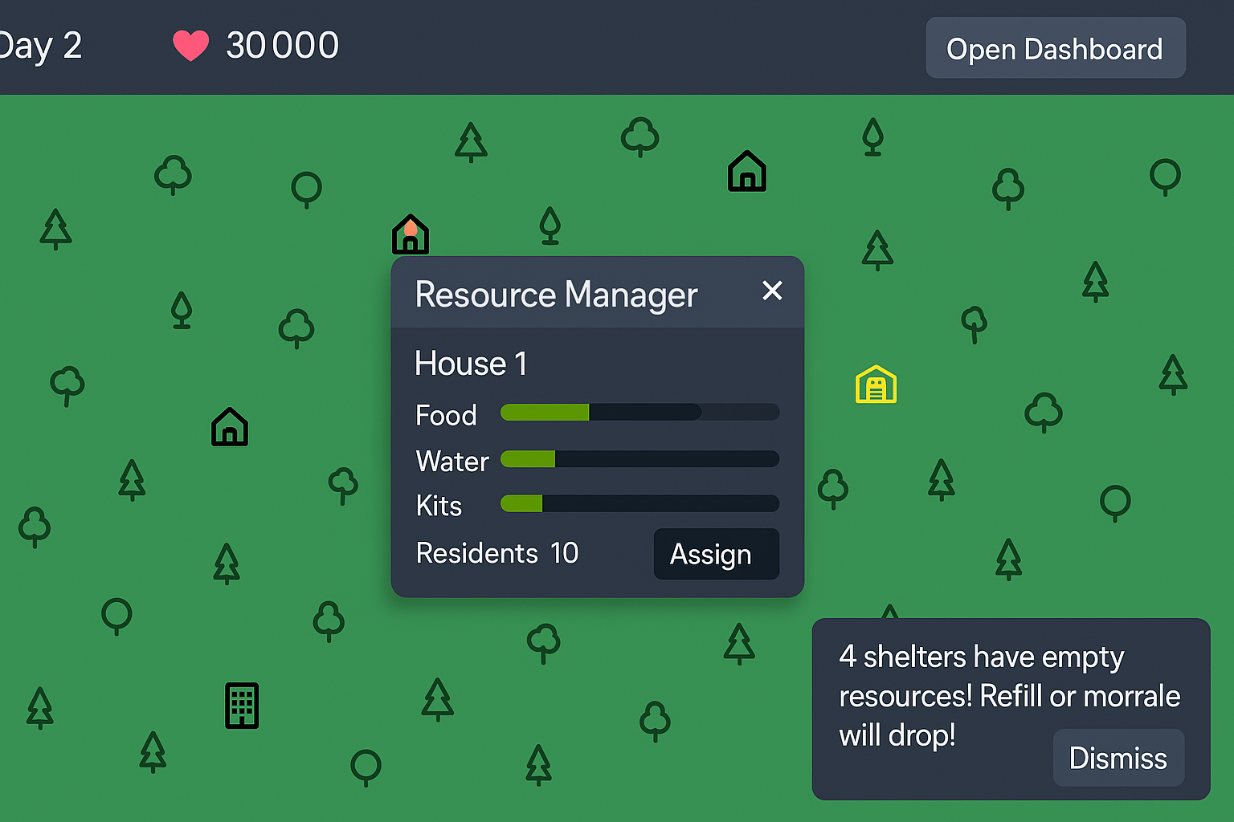
To-Do
- Make a top bar that shows current day, morale, money and open dashboard button DONE
- When open dashboard is clicked, the button changes to close dashboard and a list of all houses and buildings shows up with their current status, scrollable horizontally.
- Notifications pop up at the bottom-right. If there are multiple notifications, they pop up at bottom right, pushing the previous one upward
- Make a central management building that, when clicked, allows us to host events
- When any house is clicked, details specific to that house are shown
- I guess warehouse shows the central resources (make warehouse bigger, maybe 2x2 or bigger to attract attention to it)

Improvements
- The water collection is bugged out. If multiple water sources are collected from at once, the collection gets bugged and even after stopping collection on each one, the water keeps increasing forever
- When you click on assign button for one shelter, and then without clicking ‘close’, you click ‘assign’ on another shelter, the UI gets bugged out
- Add different events a player can host. Give them names so it feels engaging.
- Events have an influence over morale.
- Add weather system
- During rainy season, existing water sources get refilled. Water in shelters drains slower. Food grows faster.
- During summer, water sources dry up a little. Water in shelters drains faster.
- Autumn, morale has a chance to drop. Food grows slower.
- Spring, morale has a chance to increase. Food grows fast, I think.
- Add logic of residents leaving after a certain time
- Add logic of new disaster victims requesting to be allocated shelters
- Add logic of morale dropping if new victims are turned away
- New victims have different messages with which they request shelters
- Residents that leave do so sometimes with a message and sometimes they donate money before leaving
- Add passive income factories sort of which players can buy to earn passive income
- Let players have options to make different factories.
- Some types of factories can generate [FUEL] passively and [REQUIRE] money. Each factory can have different efficiency.
- Farms can be made. They [REQUIRE] money to plant seeds and after certain times, crops grow up and can be harvested. Different types of crops can be added which will differ in terms of how much time it takes to grow them, how much money the seeds require, and how fulfilling it is (i. e. how much it fills the food. More fulfilling crops can do even +2 for each crop and less fulfilling can do +0.5 for each crop). Crops have a chance of giving new seeds.

