**Description:**

* Web application that submits a simple User Registration form to the backend server.
* Two project folders : **Angular5**(create front end using Visual Studio Code) and **Web API**(Backend using .Net framework)
* Angular 5 front end posting to a web api backend
* MVC design pattern used
* Frontend form fields to be 2 simple text fields e.g. first name, last name etc
* Validation on fields are implemented
* Backend to receive posted data as an object and save posted object to simple file in json format.
* GIT Source code available at - <https://github.com/RashiShandilya/WebAPIAngular5Repo>

**User Interface:**

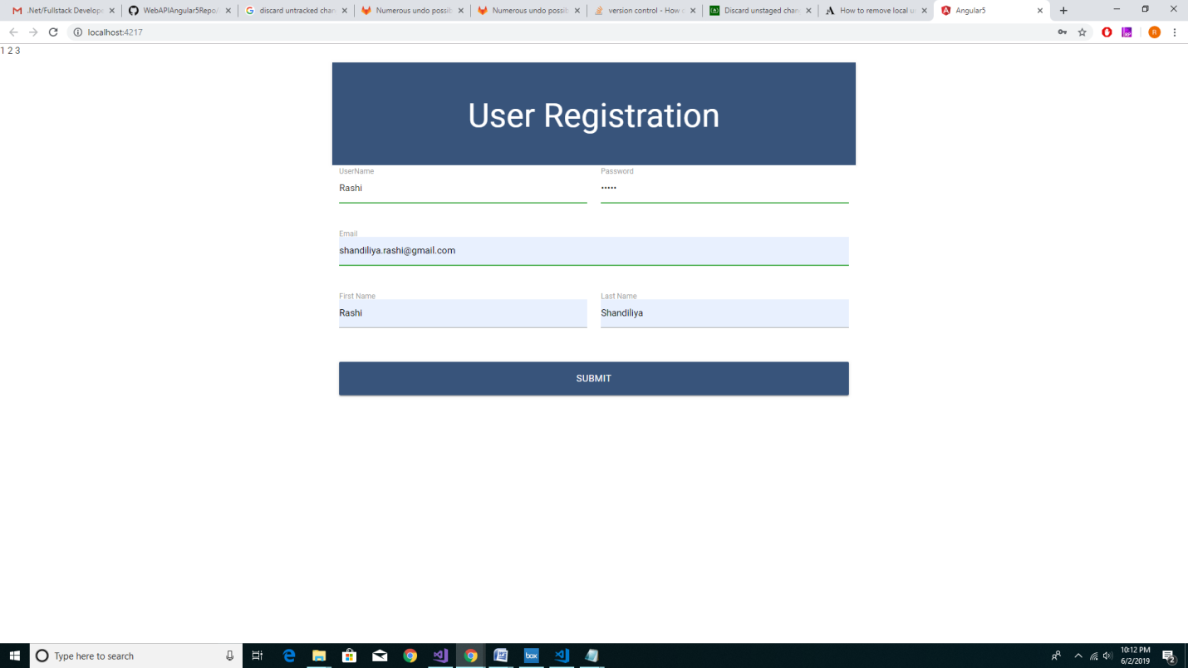

**Form validation:**

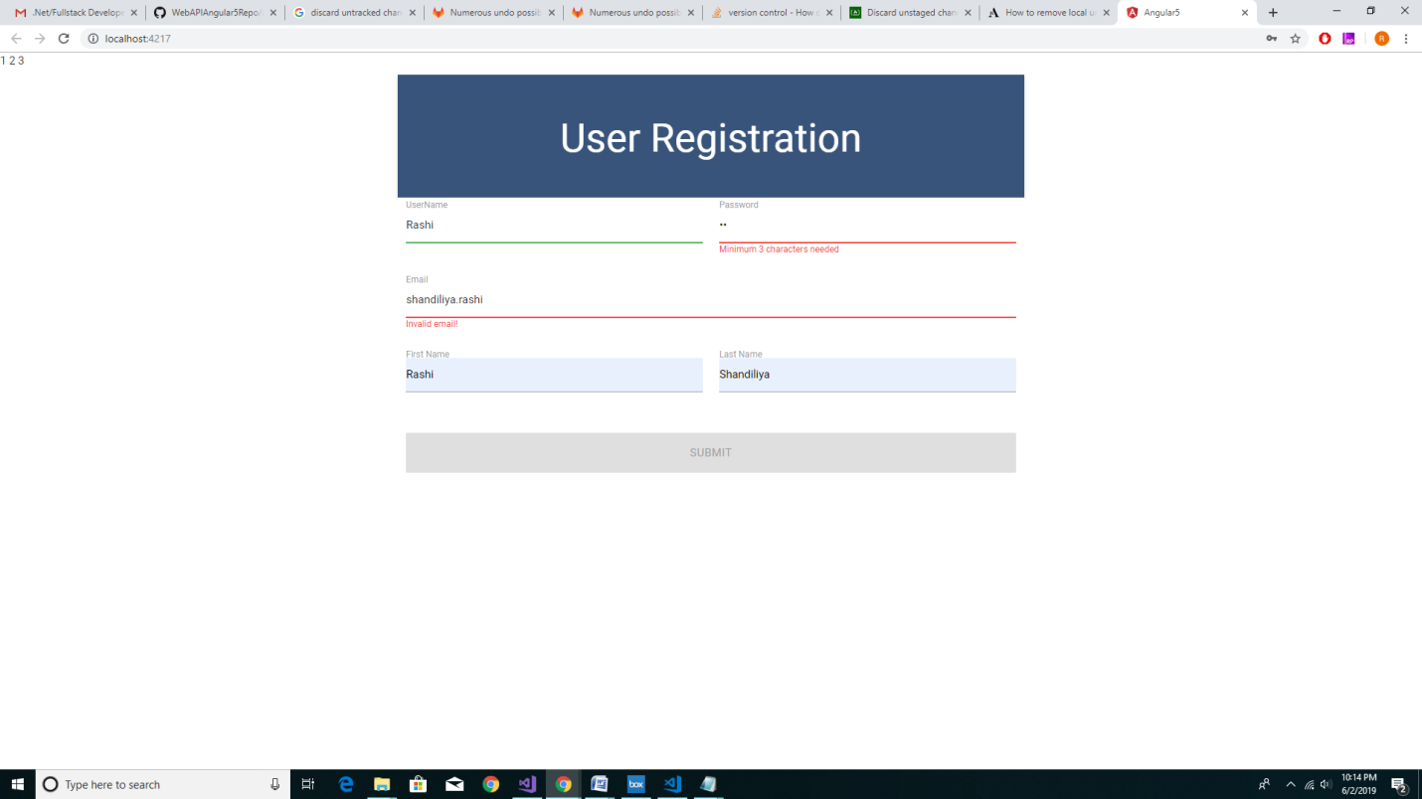

**User Service Class:** Inside registration form submit event, we have to insert a new user using a Web API project. In that project we will have a web api method “/api/User/Register” to add new user

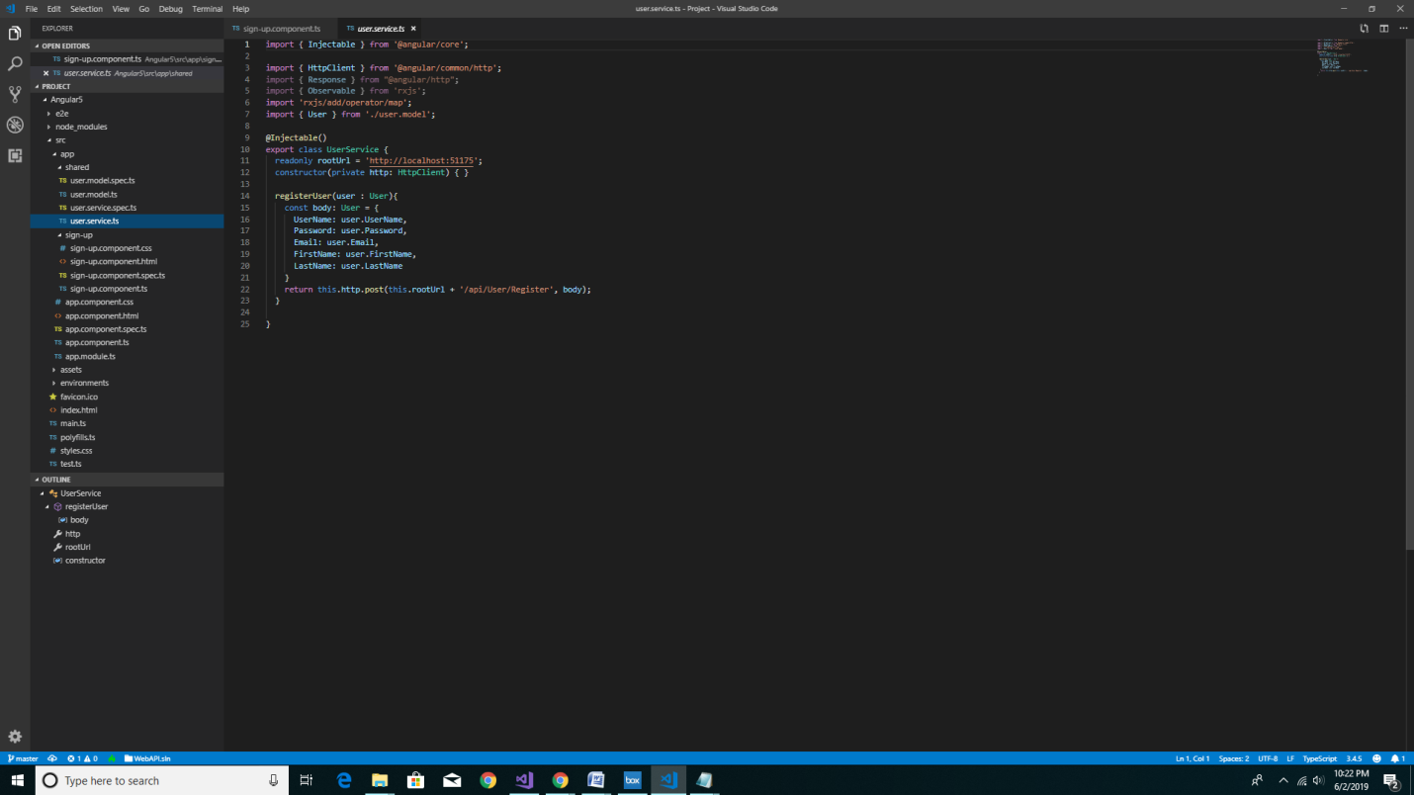

With OnSubmit() function, we called UserService function registerUser() for user registration, submit the form data to Web API method to Insert a new user.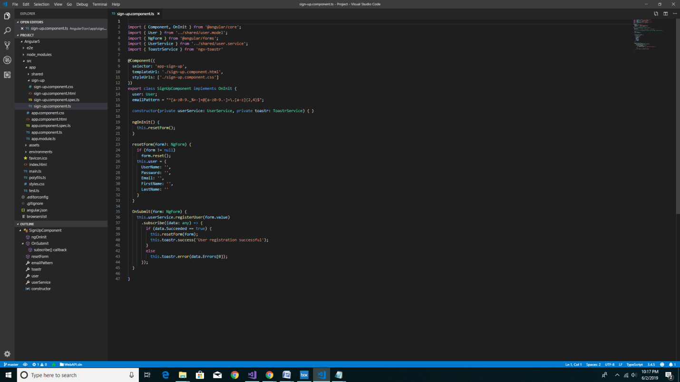

**Web API Project:**

