Risk Analysis
Data Report

Noah Morland, Mehgan Paulino-Alejandro, Rashid Hamid

Department of Civil & Environmental Engineering, University of Nebraska-Lincoln

CIVE 202: Civil Engineering Analysis II

Dr. Kaycie Lane

April 21, 2026

Table of Contents
Introduction and Background 3
Summary 4
Methods 4
Comparing New Risk Definition to National Risk Index (NRI): 6
Conclusion 14
References 16

Introduction and Background
Natural disasters affect housing, transportation systems, utilities, agriculture, businesses, and public facilities. Because mitigation funding and planning resources are limited, agencies rely on quantitative risk models to identify areas with higher relative need. These models influence emergency planning, infrastructure prioritization, and grant allocation decisions.
One of the most widely used national tools is the FEMA’s National Risk Index (FEMA, n.d.-a). The National Risk Index measures relative natural hazard risk across the United States using expected annual loss, social vulnerability, and community resilience. Expected annual loss estimates average yearly damage caused by natural hazards. Social vulnerability measures demographic and economic characteristics associated with greater disaster impacts. Community resilience measures the capacity of a community to prepare for, respond to, and recover from disruptive events.
Risk Averse, LLC requested an independent sensitivity analysis to evaluate whether a different definition of risk produces different rankings. Sensitivity analysis changes model inputs or assumptions and measures the effect on outputs. In this project, the alternative risk definition was based on wildfire and tornado hazards only. The purpose was to compare FEMA’s broader risk framework with a hazard loss framework and determine whether categorical differences appear between the two approaches.
Iowa and Oklahoma were selected because both states experience tornado hazards, while Oklahoma also has substantial wildfire exposure. The code used Iowa census tract data and Oklahoma county data from FEMA’s National Risk Index (FEMA, n.d.-b). Iowa contained 896 records, while the merged Oklahoma dataset contained 1205 records after joining the FEMA county data with the Social Vulnerability Index data. Because the two states were represented at different geographic scales, direct comparison between them must be interpreted carefully. County level records represent larger geographic areas, and larger aggregated values than tract level records.
Summary
This project compared FEMA’s National Risk Index with a custom risk model based on wildfire and tornado hazards. The custom model followed the classical definition of risk as probability multiplied by consequence. Wildfire risk was calculated by multiplying wildfire annual frequency by wildfire expected annual loss. Tornado risk was calculated by multiplying tornado annual frequency by tornado expected annual loss. These two values were then added together to create a combined custom risk score.
The code output shows that Oklahoma had higher values than Iowa under both the FEMA framework and the custom framework. Iowa’s mean FEMA risk value was 941,212.38 and its mean custom risk score was 21,614.46. Oklahoma’s mean FEMA risk value was 75,924,751.96 and its mean custom risk score was 15,799,898.59. These differences reflect both hazard exposure and the fact that the Oklahoma data were joined in a way that repeated county level FEMA values across multiple records in the merged dataset.
Iowa custom scores were driven primarily by tornado risk, while wildfire risk remained very small across most records. Oklahoma custom scores were also driven by tornado risk, although wildfire contributed more than it did in Iowa. The results show that rankings are influenced by model definition, hazard selection, and geographic reporting scale.

Methods
Data for this project were obtained from FEMA’s National Risk Index census tract and county files (FEMA, n.d.-b). the FEMA data dictionary, and Social Vulnerability Index datasets for Iowa and Oklahoma (ATSDR, n.d.). Python was used for data cleaning, statistical analysis, summary tables, figure creation, and map production.
The Iowa NRI file contained 896 census tract records. The Oklahoma NRI file contained 77 county records. The Iowa and Oklahoma Social Vulnerability Index files were merged with the FEMA data using geographic identifiers. For Iowa, the merge was completed using tract level identifiers. For Oklahoma, the merge was completed using county identifiers in the FEMA file and county identifiers in the SVI file. This merge expanded the Oklahoma dataset to 1205 rows because the county level FEMA values were repeated across multiple records from the external dataset. That difference in structure is important because it affects averages and comparisons.
Missing values coded as negative placeholder values were converted to null values. Numeric columns were then filled with zero where missing values appeared in hazard variables used for this analysis. This approach preserved all records for comparison and allowed custom risk calculations to run without errors. The custom risk model used only wildfire and tornado variables from the FEMA data. Social vulnerability and resilience variables were not included in the custom formula.
The methodology is repeatable using the same sequence of steps. First, import the NRI, SVI, and NRI data dictionary files. Second, replace the FEMA missing value code of negative 9999 with null values. Third, create tract level identifiers by removing the leading character from NRI_ID for Iowa and match Oklahoma using county identifiers. Fourth, merge the NRI and SVI datasets using the geographic keys already present in the code. Fifth, preserve the original STATE and COUNTY fields after merging if the merge creates suffixed versions. Sixth, fill missing numeric values with zero. Seventh, convert identifier fields to string so the merge and spatial joins remain consistent. Eighth, calculate wildfire risk by multiplying WFIR_AFREQ by WFIR_EALT. Ninth, calculate tornado risk by multiplying TRND_AFREQ by TRND_EALT. Tenth, add wildfire risk and tornado risk to create custom_risk_score. Eleventh, group the cleaned data by COUNTY and calculate mean values for the FEMA risk score and custom risk score. Twelfth, generate the county level bar charts and the state level comparison chart. Thirteenth, load the census tract shapefile, reset the coordinate reference system to EPSG 3857, project the data to ESRI 102003, filter by state, and merge the custom risk scores back into the spatial data using TRACTFIPS.
County level summary tables were created by grouping the data by county and averaging the available values. Figures were generated to compare wildfire and tornado components, compare FEMA risk values with normalized custom risk values, and compare state level averages. Geographic maps were created with GeoPandas using the NRI census tract shapefile. For Iowa, the custom risk score was joined back to the tract shapefile using tract FIPS values. For Oklahoma, the same method produced a complete spatial match, and the output confirmed that there were zero missing matches in the custom risk map join.
Comparing New Risk Definition to National Risk Index (NRI):
Our teams' custom risk definition was calculated differently compared to the methodology used by the NRI. The NRI uses Expected Annual Loss, Social vulnerability, and Community Resilience to calculate natural hazard risks in communities (FEMA, n.d.-a). This measures how vulnerable a population can be and how a community can respond to a natural disaster.
Results and Discussion
The Iowa data show that the custom risk score was driven primarily by tornado exposure. Wildfire risk values were much smaller than tornado risk values across the highest ranked records. The top Iowa counties by mean custom risk scores were Guthrie, Davis, Lyon, Shelby, and Franklin.
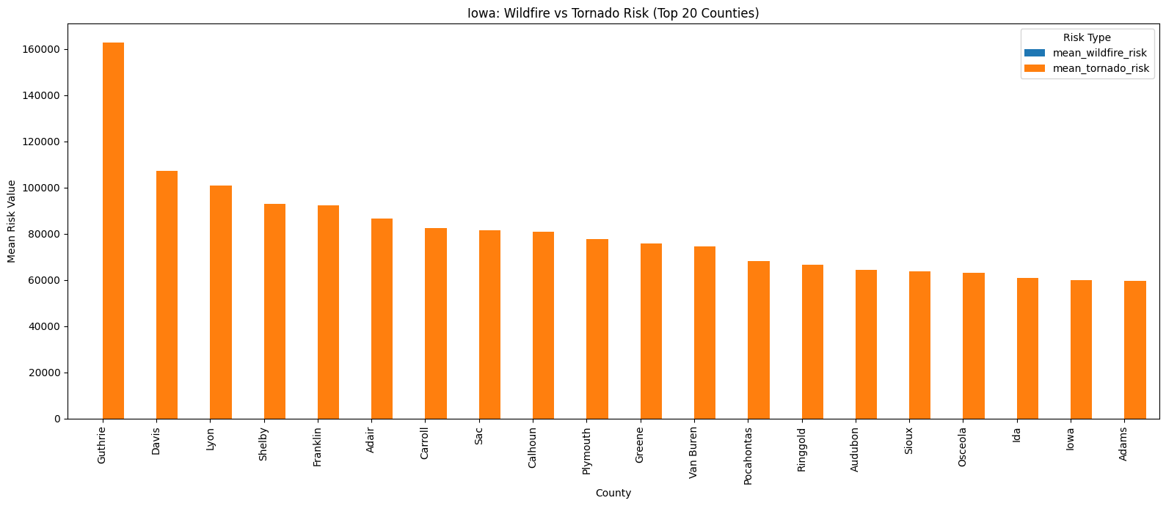
Figure 1 - Iowa Wildfire Risk Compared with Tornado Risk
Figure 1 compares wildfire risk and tornado risk for the top 20 Iowa counties. The tornado component is substantially larger than the wildfire component in all the highest ranked counties. This indicates that tornado hazard losses dominated the custom risk model in Iowa.

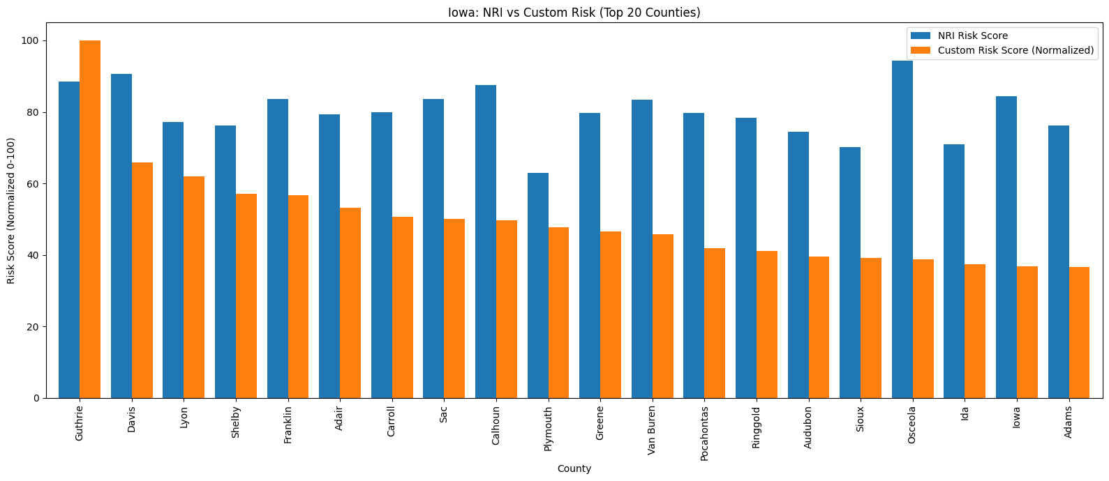
Figure 2 - Iowa FEMA Risk Compared with Normalized Custom Risk
Figure 2 compares FEMA risk values with normalized custom risk values for the top 20 Iowa counties. The figure shows that county rankings differ between FEMA’s methodology and the custom methodology. This difference occurs because FEMA includes social vulnerability and community resilience, while the custom model includes only wildfire and tornado hazard loss.
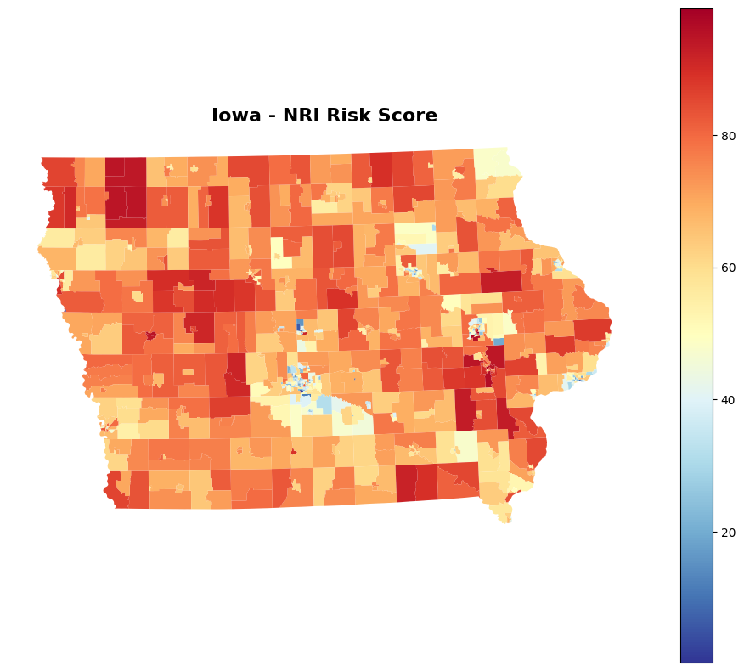
Figure 3 - Iowa FEMA NRI Risk Score by Census Tract
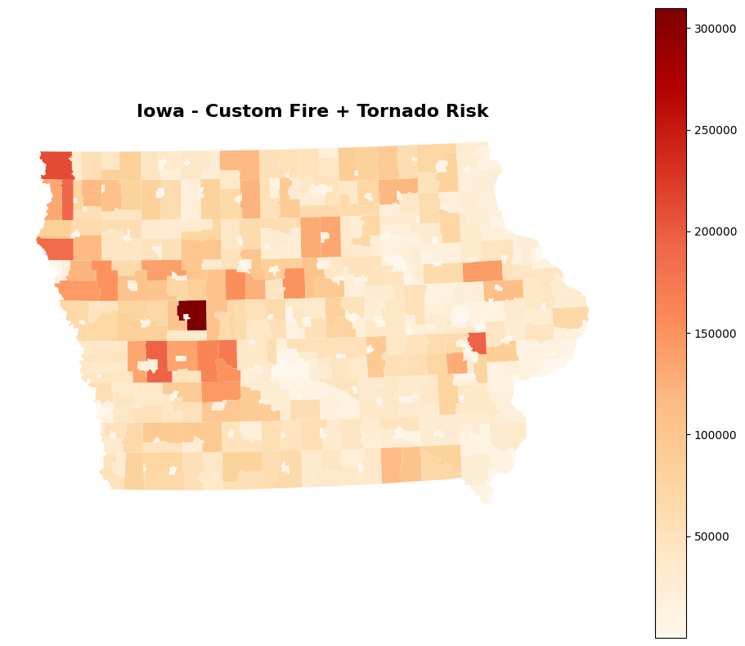
Figure 4 - Iowa Custom Wildfire and Tornado Risk by Census Tract
The Iowa NRI risk map and custom map are shown in figures 3 and 4. They show different spatial patterns because they measure different components of risk. Risk scores include vulnerability and resilience indicators, while the custom map reflects only wildfire and tornado losses.
The Oklahoma data produced much larger raw values than Iowa under both frameworks. The top Oklahoma counties by mean custom risk score were Oklahoma, Tulsa, Canadian, Comanche, and Osage. In the Oklahoma output, tornado risk again dominated the custom score, while wildfire risk remained smaller but still measurable.

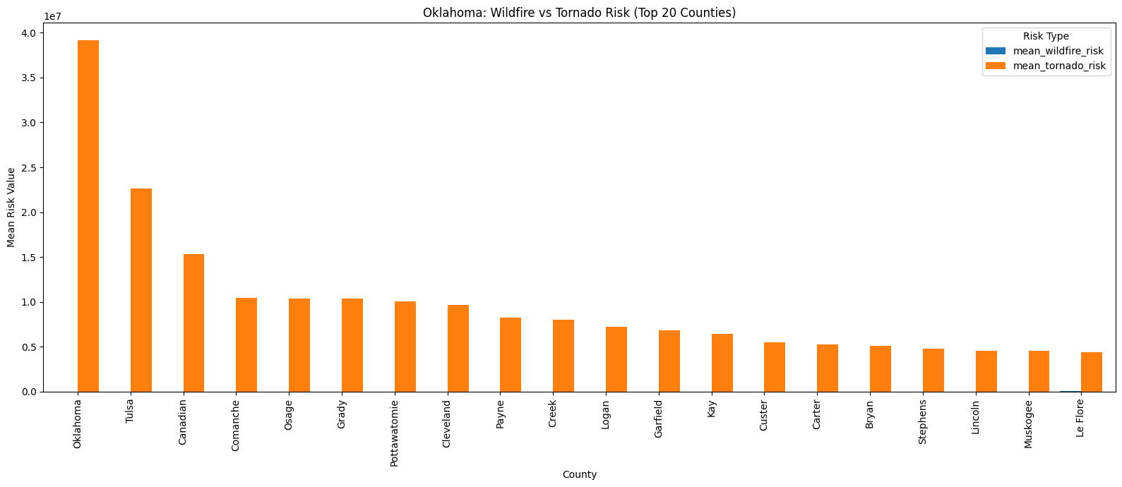
Figure 5 - Oklahoma Wildfire Risk Compared with Tornado Risk
Figure 5 compares wildfire risk and tornado risk for the top 20 Oklahoma counties. Tornado risk is the largest component in the leading counties, and wildfire risk is secondary.
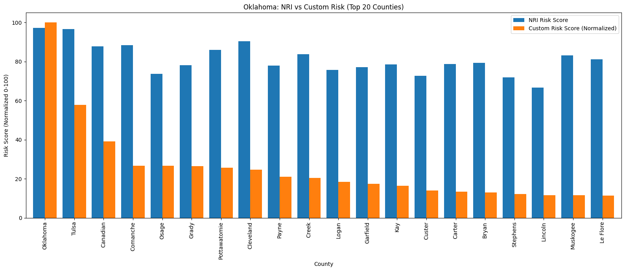
Figure 6 - Oklahoma FEMA Risk Compared with Normalized Custom Risk
Figure 6 compares FEMA risk values with normalized custom risk values for the top 20 Oklahoma counties. Several counties rank highly under both systems, but the order changes because the FEMA model includes social vulnerability and community resilience while the custom model does not.

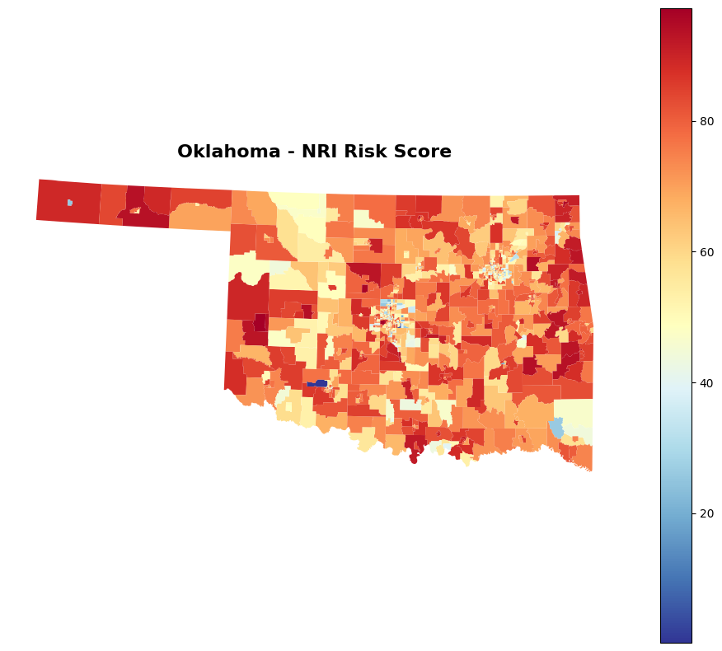
Figure 7 - Oklahoma FEMA NRI Risk Score by Census Tract

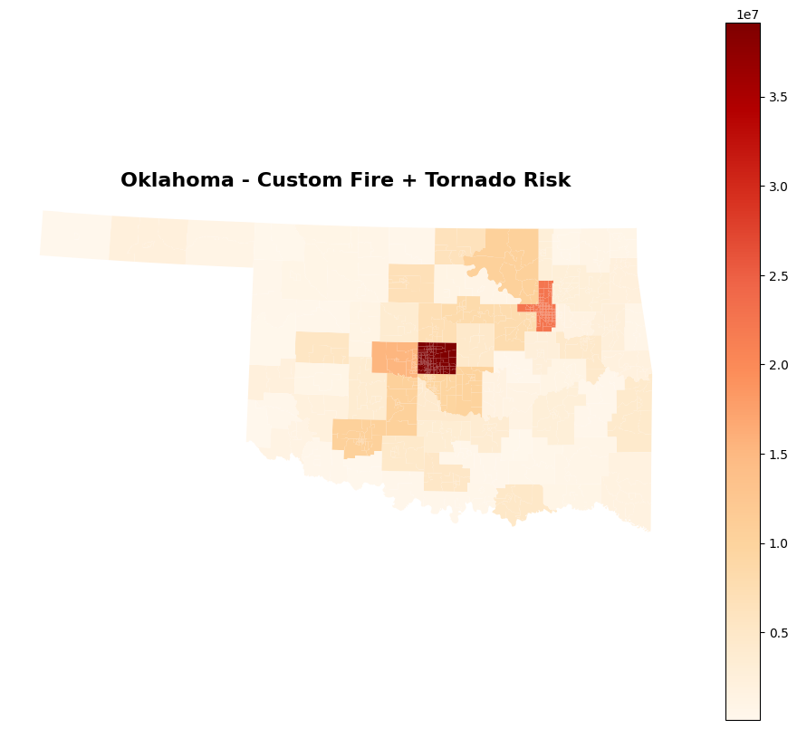
Figure 8 - Oklahoma Custom Wildfire and Tornado Risk by Census Tract

Figures 7 and 8 show both the NRI’s and the custom risk scores respectively. The Oklahoma maps identify spatial concentrations of higher risk values in major population centers and counties with stronger tornadoes and wildfire exposure.
At the state level, Oklahoma scored higher than Iowa under both systems. The code output normalized the state means so the two frameworks could be plotted on the same axis. Oklahoma was the reference state at one hundred for both normalized comparisons, while Iowa was 1.24 for the normalized FEMA risk comparison and 0.14 for the normalized custom risk comparison.

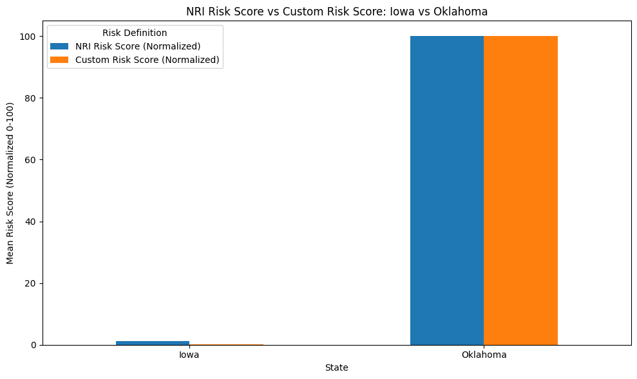
Figure 9 - Iowa Versus Oklahoma State Comparison
Figure 9 shows the comparison of the 2 states for both the custom risk score and the NRI risk score. This must be interpreted carefully because the two states were not represented at the same geographic scale. Iowa data was at the tract level, while Oklahoma data was at the county level and were repeated across multiple merged records. That structural difference can influence averages independently of hazard conditions. Some of the observed differences between the states reflect data aggregation rather than only underlying disaster risk.
The comparison between FEMA’s framework and the custom framework also has ethical implications. FEMA’s method accounts for social vulnerability and resilience, which means communities with fewer resources may receive higher risk values even if hazard exposure is similar. The custom method removes those social factors and focuses only on hazard frequency and expected annual loss. This creates a different distribution of risk values and may change which communities appear most in need of funding.
This difference matters for future funding decisions because risk rankings can shape mitigation priorities. A community ranked high under FEMA may be prioritized for support because of vulnerability and limited recovery capacity. The same community may rank lower under the custom method if hazard losses are smaller. Communities and state agencies may interpret the results differently depending on whether the goal is hazard reduction, social protection, or recovery support.
The results also show that geographic scales can create a form of categorical bias in risk assessment. Differences in geographic scale and model structure introduce potential systematic bias in risk classification, which may lead to unequal allocation of mitigation funding across similarly exposed communities. County level records and tract level records are not directly equivalent, even when the same variables are used. Larger geographic units can produce larger totals and can shift the apparent severity of risk. For future comparative studies, the most reliable approach is to standardize both states to the same geographic unit before calculating rankings.

Conclusion
This report compared FEMA’s National Risk Index with a custom risk model based on wildfire and tornado hazard loss across Iowa and Oklahoma. The analysis showed that the two frameworks produce different risk distributions because they are built from different components. FEMA’s model incorporates expected annual loss, social vulnerability, and community resilience, while the custom model is based only on hazard frequency and expected annual loss for wildfire and tornado events. As a result, the FEMA outputs reflect both physical hazard exposure and socioeconomic conditions, while the custom outputs reflect hazard-driven impacts alone.
Across both states, tornado risk was the dominant contributor to the custom risk score, while wildfire risk contributed less overall, particularly in Iowa. The comparison between Figures 1 and 5 shows this pattern consistently for both states. Differences between FEMA and custom rankings are shown in Figures 2 and 6, where the inclusion of social vulnerability and resilience in the FEMA framework changes the relative ordering of counties compared to the hazard-only approach. The spatial distributions shown in Figures 3, 4, 7, and 8 further illustrate that the two models identify different patterns of high-risk areas, even when based on the same underlying hazard data.
The state-level comparison in Figure 9 indicates higher aggregated risk values for Oklahoma under both frameworks. However, the analysis also shows that differences in geographic scale between Iowa (census tract level) and Oklahoma (county level) affect aggregated results and limit direct comparability between the two states. This demonstrates that both model definition and spatial resolution influence risk outcomes.
Overall, the results show that risk rankings are sensitive to both the structure of the risk model and the geographic scale of the input data. The FEMA framework and the custom hazard-based framework produce systematically different results, and the inclusion or exclusion of social and resilience variables changes both magnitude and spatial distribution of risk values.

References
Federal Emergency Management Agency. (n.d.-a). National Risk Index: Understanding scores and ratings. https://hazards.fema.gov/nri/understanding-scores-ratings
Federal Emergency Management Agency. (n.d.-b). National Risk Index data resources. https://hazards.fema.gov/nri/data-resources
Agency for Toxic Substances and Disease Registry. (n.d.). Social vulnerability index (SVI) data documentation and download. Centers for Disease Control and Prevention. https://www.atsdr.cdc.gov/place-health/php/svi/svi-data-documentation-download.html

