Project #5 - North Dakota Pipeline Water Quality Analysis
Prepared by: Rashid Hamid, Abbas Bashir, and Abdi Aden
Course: CIVE 202 - Civil Engineering Analysis II
Project: Project #5 - North Dakota Pipeline Water Quality Analysis

1. Introduction
This report provides the findings of the water quality analysis for the North Dakota Pipeline project, referred to as Project #5. The client is considering whether water sourced from Lake Sakakawea and the McClusky Canal system will have an effect on the water quality of the receiving waters in the Sheyenne River and Lake Ashtabula regions. The analysis uses Python to clean the data, calculate summary statistics, create visualizations, and run a dynamic TDS mixing model.

2. Client Request Alignment
Table 1. Client Request Checklist
Client Request | How This Report Addresses It
Evaluate whether water quality degrades | Compared key parameters across Lake Sakakawea, Sheyenne River - Lisbon, and Lake Ashtabula.
Identify concerning parameters | Reviewed TDS, sulfate, calcium, magnesium, pH, and other ions.
Calculate mean, median, max, and min | Created summary statistics by location and parameter.
Provide boxplots for at least 4 parameters | Generated boxplots for TDS, sulfate, calcium, and magnesium.
Create dynamic TDS calculation | Defined a TDS mixing function and tested three scenarios.
Discuss coding choices and bias | Discussed missing values, location selection, parameter selection, graph choice, and mixing assumptions.

3. Data Preparation and Decision Making
Data cleaning involved formatting the measurements as numbers, fixing the bad values, and removing rows with missing key information. After this, the analysis was performed on relevant client criteria and locations.
- The parameters selected for the analysis were TDS, sulfate, calcium, magnesium, pH, bicarbonate, chloride, sodium, carbonate, hardness, and sodium adsorption ratio.
- The primary locations included in the analysis were Lake Sakakawea, Sheyenne River - Lisbon, and Lake Ashtabula.
- The locations were arranged from source to destination so that the trend graphs would be easier to read and understand.
- Boxplots were used because they help display the spread of the data, the median values, and any outliers.
- A line graph was used for TDS because it provides a clear view of how the average values change from one location to the next.

4. Summary Statistics
The summary statistics table shows the main values for key water quality parameters. TDS, sulfate, calcium, and magnesium generally increase between Lake Sakakawea and the downstream locations, while pH remains in a similar general range.
Table 2. Key Water Quality Summary Statistics
Location | Parameter | Mean | Median | Min | Max | Count
Lake Sakakawea | Calcium | 49.45 | 49.50 | 41.00 | 56.10 | 78
Lake Sakakawea | Magnesium | 19.89 | 19.70 | 17.50 | 25.60 | 78
Lake Sakakawea | Sulfate | 158.64 | 159.00 | 133.00 | 224.00 | 78
Lake Sakakawea | Total dissolved solids | 394.60 | 394.50 | 341.00 | 476.00 | 78
Lake Sakakawea | pH | 8.22 | 8.25 | 7.24 | 9.40 | 3485
Sheyenne River - Lisbon | Calcium | 85.27 | 85.80 | 43.70 | 134.00 | 87
Sheyenne River - Lisbon | Magnesium | 52.61 | 52.50 | 24.60 | 91.00 | 87
Sheyenne River - Lisbon | Sulfate | 300.95 | 295.00 | 114.00 | 686.00 | 87
Sheyenne River - Lisbon | Total dissolved solids | 783.32 | 768.00 | 337.00 | 1540.00 | 87
Sheyenne River - Lisbon | pH | 8.29 | 8.28 | 7.28 | 11.98 | 172
Lake Ashtabula | Calcium | 74.74 | 75.70 | 48.80 | 128.00 | 292
Lake Ashtabula | Magnesium | 60.34 | 58.15 | 29.80 | 92.40 | 292
Lake Ashtabula | Sulfate | 363.98 | 327.00 | 156.00 | 686.00 | 291
Lake Ashtabula | Total dissolved solids | 902.90 | 842.00 | 436.00 | 1540.00 | 283
Lake Ashtabula | pH | 8.51 | 8.56 | 6.81 | 9.28 | 1388

5. Visual Results
Figure 1 presents boxplots for four major water quality parameters. These plots help compare variability and central tendency across the selected locations.
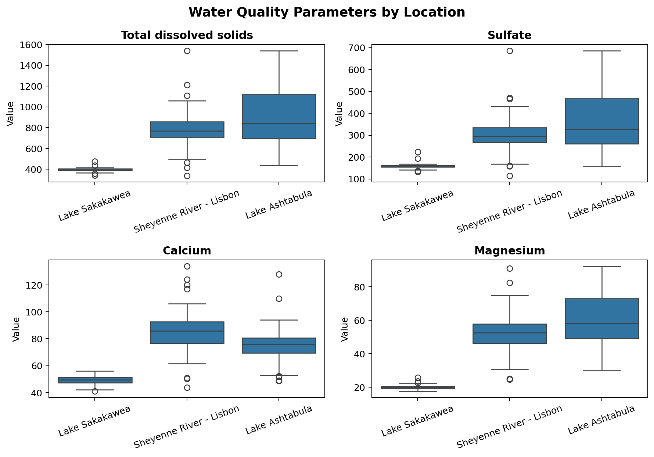
Figure 1: Figure 1. Boxplots of selected water quality parameters by location.

Figure 2 focuses on average TDS. The average TDS values increase from Lake Sakakawea to Sheyenne River - Lisbon and Lake Ashtabula.
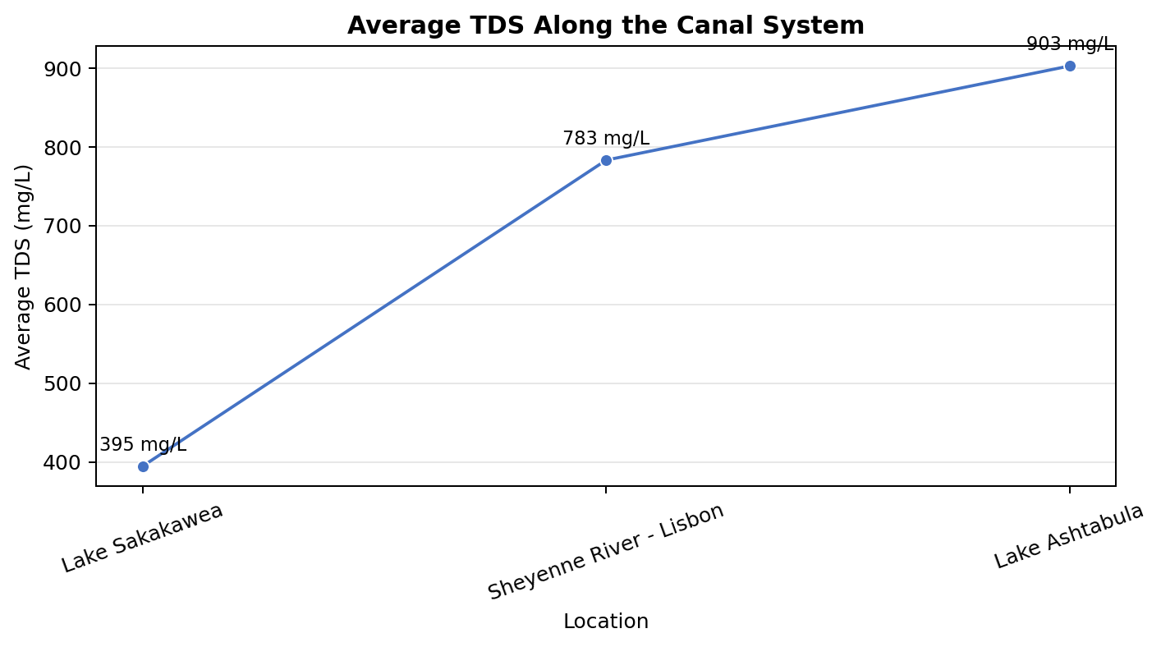
Figure 2: Average total dissolved solids by location.

6. Dynamic TDS Mixing Results
The TDS mixing function estimates a mixed concentration using the flow rate and TDS concentration from the pipe and river. The function allows the client to change inputs and evaluate different scenarios.
Mixed TDS = ((pipe flow x pipe TDS) + (river flow x river TDS)) / (pipe flow + river flow)
Table 3. TDS Mixing Scenario Results
Scenario | Pipe Flow (cfs) | Pipe TDS (mg/L) | River Flow (cfs) | River TDS (mg/L) | Mixed TDS (mg/L)
Low Flow | 6 | 550 | 15 | 680 | 642.86
Base Case | 6 | 600 | 20 | 700 | 676.92
High Flow | 6 | 650 | 25 | 720 | 706.45
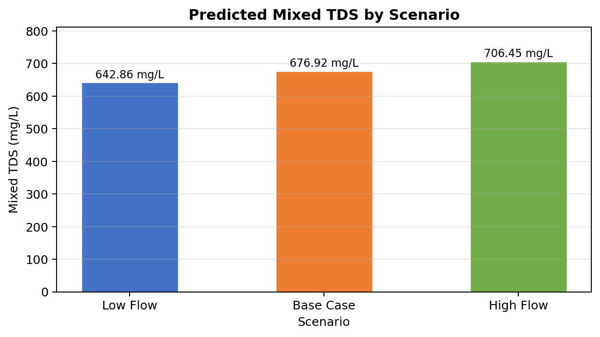
Figure 3: Predicted mixed TDS by scenario.

7. Discussion of Results
The findings indicate an increase in dissolved components from the locations analyzed. Dissolved components like TDS showed a rise from 394.60 mg/L at Lake Sakakawea to 902.90 mg/L at Lake Ashtabula. Similarly, there was a rise in sulfate concentration, which increased from 158.64 mg/L to 363.98 mg/L. It indicates that both TDS and sulfate should be monitored in the future because they were the most significant components found.
Dissolved calcium and magnesium also varied with respect to their concentrations in the different locations and were important for hardness, which could alter taste and scaling. However, pH values were not of much concern since the mean values were closer in all the locations compared to TDS and sulfate.

8. Coding Choices, Bias, and Limitations
- Missing value removal helped prevent calculation errors, but it may result in valuable data being deleted.
- Limiting consideration to just three primary points facilitated the analysis, but it may hide variation from other monitoring points.
- The selected parameters match the client request, but other water quality parameters can affect the overall engineering decision-making process too.
- Graphs were selected for readability; however, the visualization type itself may affect the perceived strength of the trend.
- The mixing model works on the premise of ideal mixing conditions, which is helpful in screening scenarios.
- The scenarios were chosen to illustrate the model functionality and should be validated with measured flow data before final use.

9. Conclusion
The report satisfies the primary client demands with summary statistics, boxplots, TDS trend analysis, TDS mixing function dynamic, and a description of coding choices. Currently, the most serious issues related to water quality according to the analysis conducted are TDS and sulfur, as they demonstrate an obvious increase at the system under consideration. In the further research process, validation of the model inputs using actual flow data should be considered.

