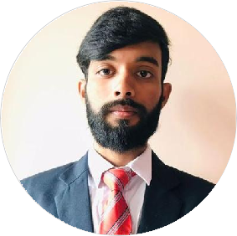



[rashiddss3@gmail.com](mailto:rashiddss3@gmail.com)

Rashid Hussain

Technology Enthusiast

I'm a ﬁnal Year Electronics & Communication student. I have strong ethics while at work.When i have to meet some deadlines at work, I try to complete it within the stipulated time or ahead of that.

8290810250



Mohali, Chandigarh, India



[linkedin.com/in/rashid- hussain-9b737b1b0](https://www.linkedin.com/in/rashid-hussain-9b737b1b0/)



[github.com/RashidHussain78 6](https://github.com/RashidHussain786)

# SKILLS

C++

React Js

Node Js

JavaScript

Engineering

Leadership

**EDUCATION**

## B-Tech(Electronics & Communication Engineering)

### Chandigarh Engineering College/Landran

06/2019 - Present, Chandigarh, India (8.3 CGPA)

## Intermediate

### M.R.P.D College /Chandchaur ,Dalsingsarai

04/2016 - 04/2018, Dalsingsarai , India (65.2%)

## Matriculation

### St.Joseph's Public School/MSV Nagar,Dalsingsarai

04/2015 - 04/2016, Dalsingsarai,India(10 CGPA)

# WORK EXPERIENCE

## .NET Full Stack Engineer Intern

### Cognizant

01/2023 - 07/2023, Gurugram, Haryana, India · On-site

Cognizant is a global IT consulting and services company known for digital transformation solutions and expertise in AI, cloud, and data analytics.

Achievements/Tasks

Successfully implemented a new feature in the .NETFSE web application, resulting in improved user experience and increased customer satisfaction.

Assisted in the development and deployment of a critical module, contributing to the project's timely completion and adherence to quality standards.

Flexibility

Communication

Management

Presentation

# LANGUAGES

English

Full Professional Proﬁciency

Hindi

Full Professional Proﬁciency

# INTERESTS

Listing Music

Painting

Running

Playing Cricket

# PERSONAL PROJECTS

Teamwork

#### Music Community (02/2022 - 03/2022)

submit your song and check whether any person is present who listen same song at the same time. video calling with that person with similar music.

Frontend :- React Js ,Material UI.

Backend :- Node Js , Express , Socket.io ,MySQL.

#### E-Commerce Website (02/2021 - 06/2021)

Login/Signup(SESSION). Add to cart functionality and delete from cart. Pagination.

Admin Control(CRUD Operation).

#### Online Books (01/2022)

Frontend :- React Js ,Material UI Functional Component React Hooks and MakeStyles Responsive

# ACHIEVEMENTS

#### Tecknovate 2K21 (12/2021)

Got ﬁrst position in Deceive The Twist, Organized by Electronics Project Club/Technomm Professional Society

,Landran

Socializing with friends