NPV Practice
Summer 2024
Imagine you and your team are considering a new IoT based project in the field of renewable energy. The initial investment required for the project is $20,000, which will cover the costs of initial installation. You spent $10000 for equipment and installation in the 2nd year. In the 5th year, you had to bear the expenses for the maintenance is around $10000. During the five years project the average HR cost becomes $10000 per year. The projected revenues are as follows: Year 1: $20,000, Year 2: $30,000, Year 3: $50,000, Year 4: $60,000, and Year 5: $70,000. Consider the rate of interest is 12%. Determine whether the project is financially sustainable or not (profit/loss) for your team using the Net Present Value method.
Fall 2024
Imagine you and your team are planning to launch a solar power plant as part of a renewable energy initiative. The project requires an initial investment of $25,000, which will cover the costs of solar panels and basic infrastructure. You had to bear additional costs for maintenance and extra solar panels. The additional costs are: $4000 and $6000 in years 2 and 4 respectively. The projected revenue from selling electricity is $3000, $6000, $11000, $15000, and $20000 in the years 1 through 5. Considering yearly interest rate of 10%, analyze whether this solar power project is financially viable using the Net Present Value (NPV) method.
Spring 2025
Suppose you are considering an investment opportunity for a new mobile app startup. It requires an initial investment of $10,000, followed by additional investments of $4000 and $6000 after 1 and 3 years, respectively. In return, you expect to earn $2000, $3500, $4500, and $9000 after 2, 3, 4, and 5 years, respectively. The annual interest rate for this venture is set at 9%. Find out Profit/Loss through Cash Flow Method.

Example
Suppose you want to launch a new software to the market. Your financial forecasting
team informs you that the business will require an initial investment of $8000, followed
by additional investments of $4000 and $3000 after years 3 and 5 respectively. In
return, they expect to earn $1000, $2600, $3000, and $6000 after 2, 3, 4, and 5 years
respectively.
If the inflation rate is at 20%, How much revenue does the business need in its sixth
year to have a 10% return on investment? Find out the profit/loss status through the
Cash Flow method and NPV method.
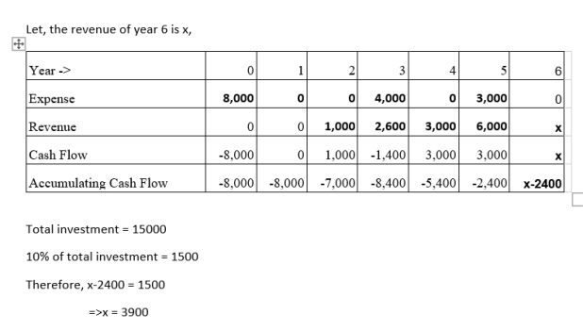

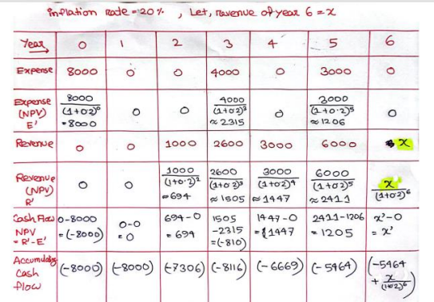
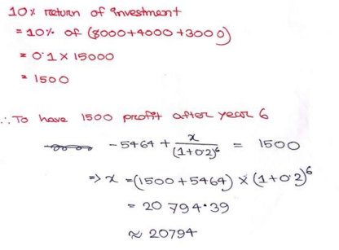
To achieve a 10% real return, the required Year 6 revenue is: $20794

