|  |  |  |
| --- | --- | --- |
| Library Management System  CSE-3110 | Khulna University of Engineering & Technology | |
| Rashik Hasnat  Roll:1107004 | | Department of Computer Science & Engineering |

**Introduction:** This project was done as a part of Database Systems Laboratory (CSE-3110). The main goal of this project was to learn to design a database for a real life problem and implement it. I decided to work with a database system of a small automated library in Oracle DBMS in this project.

**Why Library Management System:** while choosing the project topic I choose Library Management System because now a days small and big libraries are being automated and digitalized. In order to perform the automation of a library we must maintain a database system for it on order to store information about regarding the library.

**About Library Management System Database:** The main objective of this project is to design and implement a database system for a automated library where data of all the members, books and list and details of borrowed books are saved. Here information of all the books in the library, their present condition, details of each member, numbers of books they’ve borrowed, total number of borrowed books, price of books will be available. This database can be used in a small library management system for automation.

**Schema Diagram:**

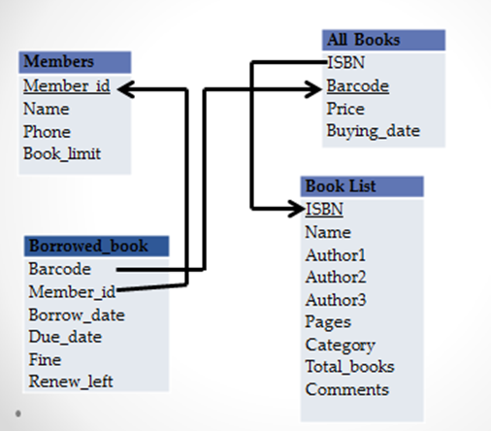

Figure : Schema Diagram

**Schema Analysis**

Here the database design will be analyzed according to relational data model.

**Members Relation:** Here member_id functionally determines all other attributes of the relation.

Member_id→name,phone,book_limit

Here member_id is a super key of the relation. Hence the relation is in BCNF.

**All_Book Relation:** Here Barcode functionally determines all other attributes of the relation.

Barcode→isbn,price,buying_date

Here Barcode is a super key of the relation. Hence the relation is in BCNF.

**Book_list Relation:** Here ISBN functionally determines all other attributes of the relation.

isbn→ Name, Author1, Author2, Author3, Pages, Category, Total_books, Comments

Here ISBN is a super key of the relation. Hence the relation is in BCNF.

**Borrowed_Book Relation:** Here Barcode functionally determines all other attributes of the relation.

Barcode→member_id, borrow_date, due_date, fine, Renew_left

Here Barcode is a super key of the relation. Hence the relation is in BCNF.

**Hence all the relations in this database are in BCNF.**

**Data Definition Language(DDL)**

CREATE TABLE members(

member_id number(20),

name varchar (20),

phone varchar (22),

book_limit number (3),

PRIMARY KEY (member_id)

);

CREATE TABLE Book_list(

ISBN varchar(27),

name varchar(50) NOT NULL,

author1 varchar (30),

author2 varchar (30) DEFAULT NULL,

author3 varchar (30) DEFAULT NULL,

pages number(5),

category varchar(20) NOT NULL,

privilege varchar(10),

total_books number (4),

comments varchar (30),

PRIMARY KEY(ISBN)

);

CREATE TABLE all_book(

ISBN varchar(27),

barcode varchar (20),

price number(20),

buying_date date,

PRIMARY KEY(barcode),

FOREIGN KEY (ISBN) references Book_list(ISBN) on delete cascade

);

DESCRIBE all_book;

CREATE TABLE borrowed_book(

barcode varchar (20),

member_id number(30),

borrow_date date,

due_date date,

fine number(5),

renew_left number(2),

FOREIGN KEY(barcode) references all_book(barcode),

FOREIGN KEY(member_id) references members(member_id)

);

CREATE TABLE borrowed_book(

barcode varchar (20),

member_id number(30),

borrow_date date,

due_date date,

fine number(5),

renew_left number(2),

FOREIGN KEY(barcode) references all_book(barcode),

FOREIGN KEY(member_id) references members(member_id)

);

**Triggers:**

In this project two triggers were used. They are *check_book_limit* and *check_book_availability*.

The trigger *check_book_limit* checks whether a member’s book limit is over or not. If The book limit is over then he/she can’t borrow book from the library so the database will raise an exception.

The trigger *check_book_availability* checks whether a book is available in the library or not. If all the books are borrowed then the database will raise an exception.

**Procedures:**

A parameterized named PL/SQL block was used in the script. It was named *member_details* which accepts the member_id as the parameter and prints the name, borrow date, due date of all the books borrowed by the member.

**Function:**

A parameterized function named *total_borrowed_book* was used in the script which takes the id of the member as input and return total number of book borrowed by the member.

**General SQL Queries:**

Several other general sql queries were used to show other information.

**Conclusion:** In this project I tried to implement all the design issues and SQL scripting techniques that were taught throughout this course. This project can be easily modified and used for a real automated library management system.