**Using OpenGL & GLUT in Code::Blocks**

Download **Code::Blocks 17.12**  
<https://sourceforge.net/projects/codeblocks/files/Binaries/17.12/Windows/>

Download the GLUT bin file (first download link) from:  
[http://www.xmission.com/~nate/glut.html](http://www.xmission.com/%7Enate/glut.html)

After you download and open the GLUT bin zip file, you will need to:

* Copy glut32.dll to **C:\Windows\System32**,
* Copy glut32.lib to **C:\Program Files (x86)\CodeBlocks\MinGW\lib**, and
* Copy glut.h to **C:\Program Files (x86)\CodeBlocks\MinGW\include\GL** .
* These are default locations, your paths may be different. But basically, you place the .lib and .h files in the location of your compiler (in this case mingw). The .dll file goes in the windows system directory.

Now you are ready to start Code::Blocks and make a new project.

Open up Code::Blocks. Start a new Project by going to **File, New, Project.**

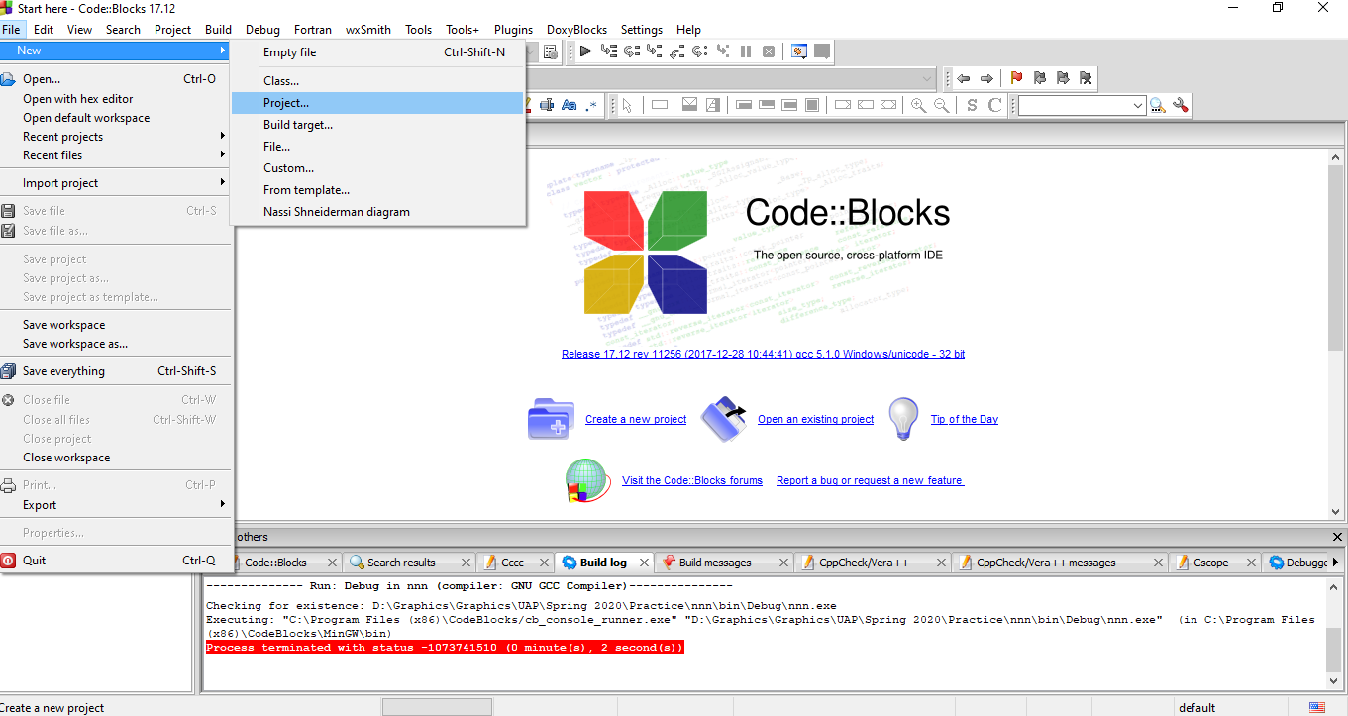

Select to make a new **GLUT project** and press **Go** to continue.

[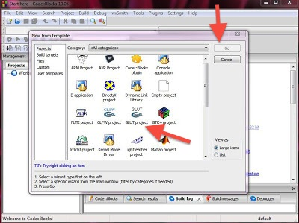](https://www.codewithc.com/wp-content/uploads/2014/08/setupimage2.jpg)

Give a **project title**, and a **location** where to create the project and then press **Next**.

[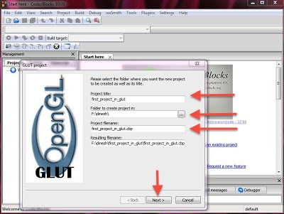](https://www.codewithc.com/wp-content/uploads/2014/08/setupimage3.jpg)

Let Code::Blocks know where you stored your GL files i.e.,

**C:\Program Files(x86)\CodeBlocks\MinGW**, then press **Next**.

[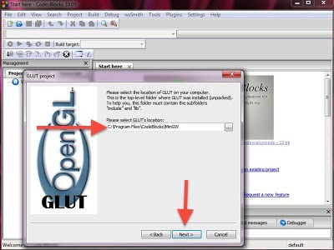](https://www.codewithc.com/wp-content/uploads/2014/08/setupimage4.jpg)

and press **Finish**.

* As of this step, a project is finally created, and you’ll get a default main.cpp file.
* Don’t forget to include the header file –  “*#include<windows.h>*“, otherwise you’ll get error.

[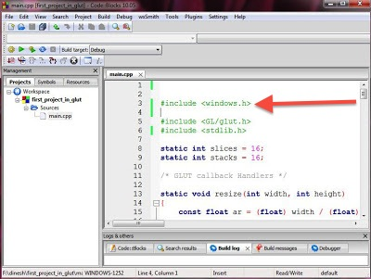](https://www.codewithc.com/wp-content/uploads/2014/08/setupimage7.jpg)

* Build and Run, and you’ll see a window as shown below.

[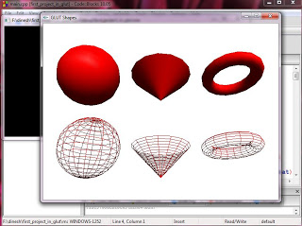](https://www.codewithc.com/wp-content/uploads/2014/08/setupimage8.jpg)

If you see the output of your program as shown above, you’ve properly setup OpenGL (GLUT) in CodeBlocks, and successfully created a project.