Algonquin College Logo

# SCHOOL OF ADVANCED TECHNOLOGY

### ICT - Applications & Programming

### Computer Engineering Technology – Computing Science



A11

Game Interface

Team:

[Rashin Babaee] - Id: [041043836] / [Sewmini Jayasinghe] - Id: [041057012]

Game Proposal - Picross

***This template is suggested (not mandatory) to answer A11 Specification.***

|  |  |
| --- | --- |
| **Part**  **1** | **GUI Definition** |

**EXPLANATION**

*The purpose of this assignment is to define the elements of the GUI application to be used in your game implementation.*

* ***Example (Prof. suggestion)****:*

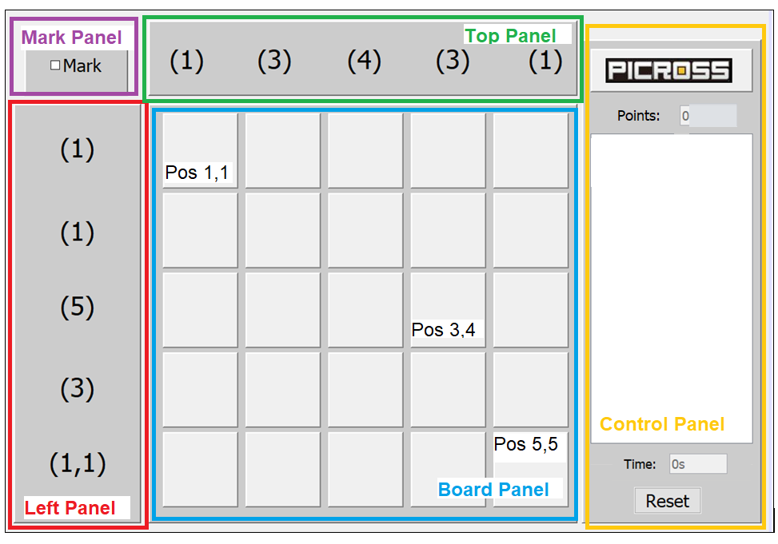

* ***Note****: The professor interface is also a proposal. It means that your own implementation can be different. What does matter is that the game functionality will be respected.*
  1. **Defining the Components**

**List of components**

*Include the list of components that you will use (they can be from Swing or JavaFX).*

We are going to use Java Swing based on the components.

* Panel
* Frame
* Button
* Label

**Functionalities and Behaviors**

*What are the behaviors and functionalities that you will provide? How these elements are related with functionalities.*

* Frame: frame is to create a frame for the Picross Game.
* Button: there is a one button that it has a specific functionality. It is reset to restart the game .
* Labels: labels like time and points show the name of each function.

**Languages**

*Define (at least two) languages to be used – remembering that English is mandatory for one option.*

The first language is English, the second language is Persian, and the third language is Sinhala. Because it is the natural language for members of this group.

**Details**

*Drawn your interface (ex: in an image from Paint / Powerpoint slide, or any sketch tool), describing:*

* *The components;*
* *The properties (ex: size, dimension, color, position, etc)*
* *Additional GUI components (ex: the layout to be used).*

Components:

* Frame: frame is to create a frame for the Picross Game.
* Button: there are two buttons that have a specific functionality. One of them is reset to restart the game and another one is save button to save the game.
* Labels: labels like time and points show the name of each function. Also, there is a language label. When you click on arrow, it shows three languages like English, Persian and Sinhala.
* Panel: there is a control panel in right side that shows every click of the game that user plays.

Properties:

In board panel, when the user clicks for one time, it will be orange and if the user clicks again, it will be white and if the user clicks for the third time it will be blue.

Save and reset buttons are in the right down corner of frame and the color is white.

Language label, points label and time label are in the right up side of the frame. Each one is 3*5 pixels.

Control panel is in the middle of right side of the frame. It is 15* 10 pixels.

Each square is 4*4 pixels.

There is a rectangular in the top of the frame with numbers. It is 6*20 pixels. Moreover, there is another rectangular in the left side of the frame with numbers. It is 20*6 pixels.

There is a square with the name of Picross in the left-up corner with 6*6 pixels.

* 1. **User Manual**

**Basic cycle**

*Create a brief description about how your game can be used.*

***Example****: If you have to design the solution to be saved and played later, how are the stems. Most importantly, how someone can play the* ***Picross****.*

* *Note: your process does not need to be followed exactly when you are going to the implementation. For while, it is only a script about how to play.*

Picross is a puzzle game invented in Japan. There are numbers on the top and side. These numbers represent how many squares need to be filled in. Single numbers represent how many consecutive blocks need to be filled in. The easiest columns and rows to finish are the ones with zeros and the number of columns/rows there are. Zeros define as there are no blocks to fill in. Double numbers represent how many blocks are filled in, according to the first number, at least one space blank, then fill in consecutive squares according to the second number amount.

With reset button, you can restart the game and point button shows the points of your game. If you want to quit the game and leave it to finish later there will be an option to save your game and load it when ever you want to play the game and finish the game.

**FINAL SUGGESTIONS**

*Here some ideas to think about your language....*

* *Try to create a game whose execution can be very intuitive (easy to be played).*
* *Remember that this game will be in fact implemented only in the next assignment.*

**References**

*[1] wikiHow,* [*https://www.wikihow.com/Play-Picross-DS*](https://www.wikihow.com/Play-Picross-DS)*, 23 December 2021.*

* ***NOTE****: Even if you use one specific tool (ex: ChatGPT), report it here.*

Algonquin College

Winter, 2023