**Learners have to come up with a Report to support the answers to the following questions and suggestions**

**Objective Questions:**

1. **What is the distribution of account balances across different regions?**

Insight:- France account balance 31,13,32,499.000 which is almost twice of Spain which is 15,31,23,599.00

Conclusion:- France contribute to maximize the account balance in its region followed by Germany and then Spain.

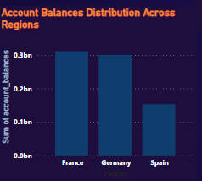 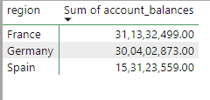

1. **Identify the top 5 customers with the highest Estimated Salary in the last quarter of the year. (SQL)**

Insight:- Dyler has Estimated salary of 19997100 which is 0.16 % more than Mai which is 19963900 in the last quarter of the year and Oluchukwu, Mai, Palerma making 5 top most.

Conclusion:- Dyler rank top with its estimated salary which is 19997100 then followed by Oluchukwu, Mai, Palerma and last Dimauro with 19963900 and make a top 5 person with highest Estimated Salary in last quarter of the year.

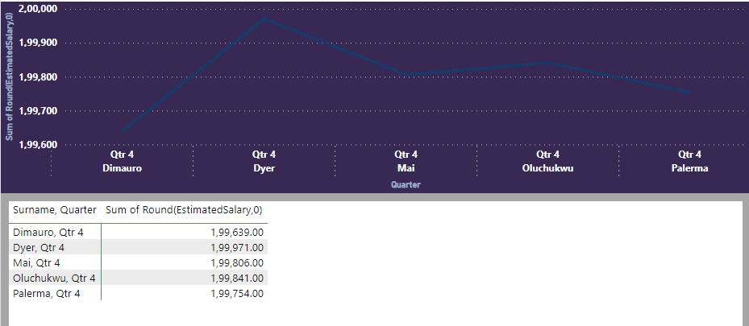

1. **Calculate the average number of products used by customers who have a credit card. (SQL)**

The Average number of product used by customers with credit card is 1.53

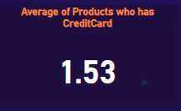

1. **Determine the churn rate by gender for the most recent year in the dataset.**

Insight:- Female Churn rate is 25.05 and Male Churn rate and 15.37 which is 30% more than male

Conclusion:-Female Gender has tent to leave the bank more often than male gender.

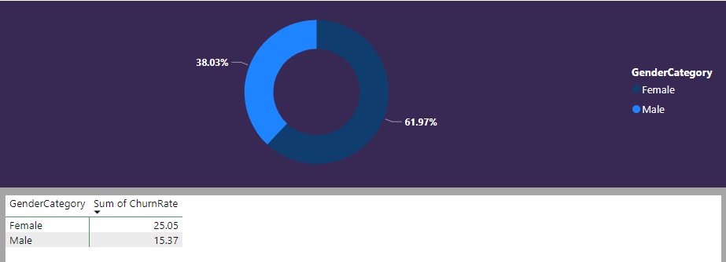

1. **Compare the average credit score of customers who have exited and those who remain.** (SQL)

Insight:- Exited type has average credit score of 645 and not exited has average credit score of 652.

Conclusion:- Exit Tye Exited has less average score than the retained customer credit score.

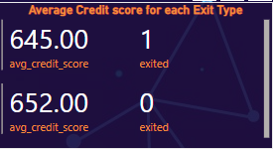

1. **Which gender has a higher average estimated salary, and how does it relate to the number of active accounts?** (SQL)

Insight:- Male Active Account is 5457 as compare to female which is 4543 but the sum of average salary of female is more than male which is 100602.00 where as male is 99,665.00

Conclusion:- Active female are less when compare male which lead to high Average salary.

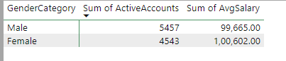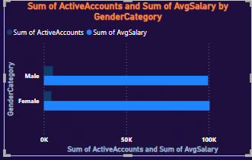

1. **Segment the customers based on their credit score and identify the segment with the highest exit rate.** (SQL)

The Segment of credit score customers with most exit rate is 300-499 which has rate of 0.24.

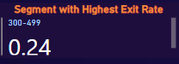

1. **Find out which geographic region has the highest number of active customers with a tenure greater than 5 years. (SQL)**

The France region has most active Customers which is about 1575.

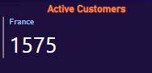

1. **What is the impact of having a credit card on customer churn, based on the available data?**

Insight:- Customer with credit card has Churn rate of 20.18 and which don’t have has churn rate of 20.81.

Conclusion:- Though the churn rate of both the customer who has the credit card and don’t have credit is high but the customer with the credit card is still more is less compare with the customer who don’t.

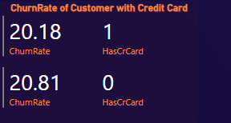

1. **For customers who have exited, what is the most common number of products they have used?**

The customer which has used product 1 has a greater number of churned customers.

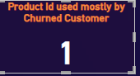

1. **Examine the trend of customers joining over time and identify any seasonal patterns (yearly or monthly). Prepare the data through SQL and then visualize it.**

Insight:- The number of new customer join in year 2019 is more and it is about 3313 than followed by 2018,2017 than 2016 with least 1951.

Conclusion:- The number of customers are increasing every year where 2016 had 1951 new customer and in year we see the number has increased significantly having 3313 new customer in year 2019 there was a linear growth.

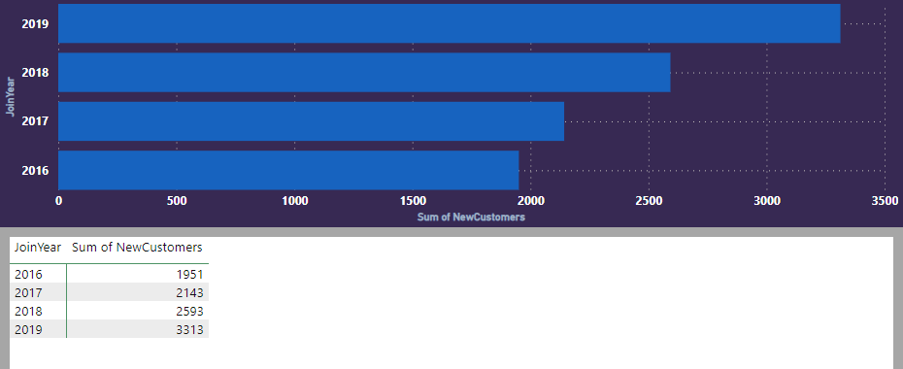

1. **Analyze the relationship between the number of products and the account balance for customers who have exited.**

Insight:- Product id 1 has most account balance which is 12,96,68,67.00 than followed by Product id 2 with 3,14,07,820.00 ,3 with 1,88,87,679.00 and then the least account balance of 56,23,988.00 for product id 4

Conclusion:- Customer with more account balance prefer product with product id 1 and product with id 4 is prefer by customer with least balance.So we can see the product 1 is most loved by the customer than 2 ,3 product are averagely manage product and 4 is least attracted by the customers

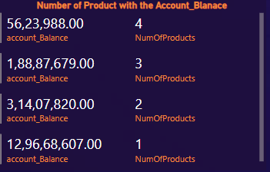

1. **Identify any potential outliers in terms of spend among customers who have remained with the bank.**

There is negative correlation between Z_score and sum of amount spent by each customer.

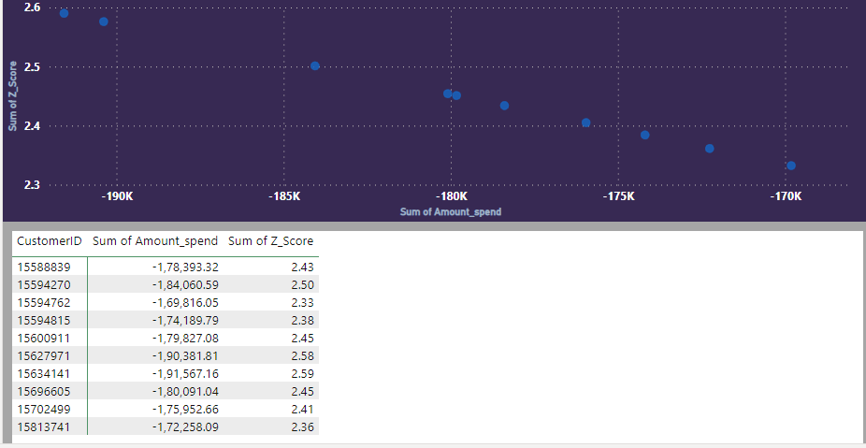

1. **Can you create a dashboard incorporating the visuals mentioned above and additionally derive more KPIs if possible?**

The maximum amount spend is about 199.99K

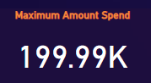

1. **Using SQL, write a query to find out the gender-wise average income of males and females in each geography id. Also, rank the gender according to the average value. (SQL)**

Insight:- The number of female is 99,564.00 and male is 1,00,174.00 for France than for Germany the female average income is 1,02,446.00 whereas male average income is 99,905.00 for average income comparison in region Spain goes as female has about 1,00734.00 and male is 98,426.00.

Conclusion:- The average income in France goes as male proportion is 0.34% more than male in other female take a lead in the other region like Germany and Spain where female average income is more than male

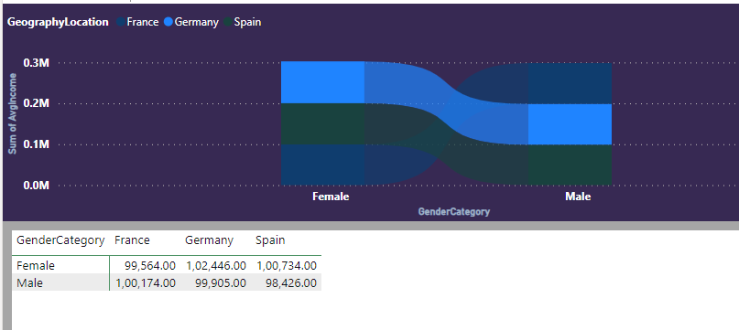

1. **Using SQL, write a query to find out the average tenure of the people who have exited in each age bracket (18-30, 30-50, 50+).**

Insight:- The average tenure is more seen in age group between 31 and 50 which is 4.89 followed by age group above 50 which is 4.83 the least in age group of 18-30 which is about 18-30 which has exited

Conclusion:- The age group of 31-50 are stable with the bank having more average tenure the least is seen in age group of 18-30 which has exited the bank.

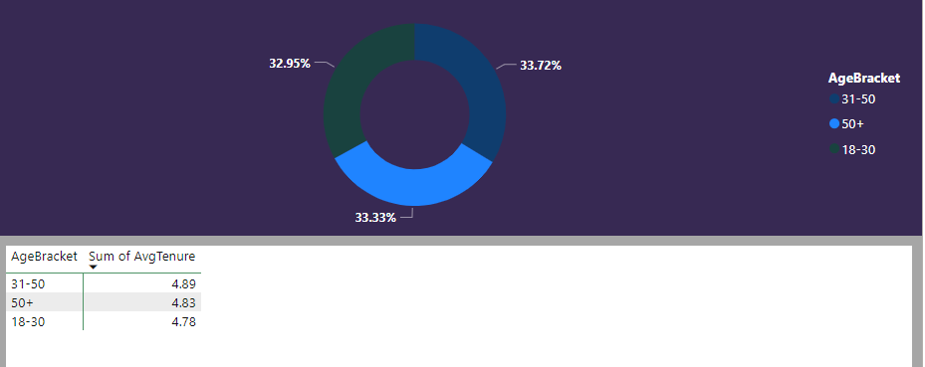

1. **Is there any direct correlation between the salary and the balance of the customers? And is it different for people who have exited or not?**

Insight:- The correlation response for exited customer is 0.73 and non-exited is 0.66.

Conclusion:-The correlation between customer exit type and its customer salary balance is positive but more was seen in the customer who has exited the bank which is 0.73.

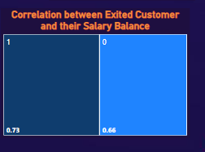

1. **Is there any correlation between the salary and the Credit score of customers?**

Conclusion:- There is no correlation between salary and credit score

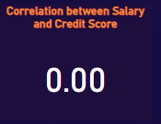

1. **Rank each bucket of credit score as per the number of customers who have churned the bank.**

Insight:- The credit score segment 500-699 has 1256 number of churned customer. Segment 700-799 has about 500 churned customer and rank 2 then 300-499 with 150 churned customer and segment od credit score with least churned customer are from 800-899

Conclusion:- The credit score between 500-699 has more number of churned customer followed by segment of credit score 700-799 and then 300-499 ,800-899.

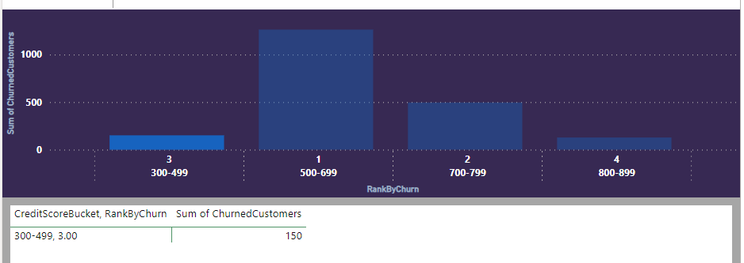

1. **According to the age buckets find the number of customers who have a credit card. Also, retrieve those buckets that have a lesser than average number of credit cards per bucket.**

Conclusion:- The age bucket 18-30 has credit card number which is 1400 lesser than the average credit card number followed by 50+ age group as well with 874 credit card number.

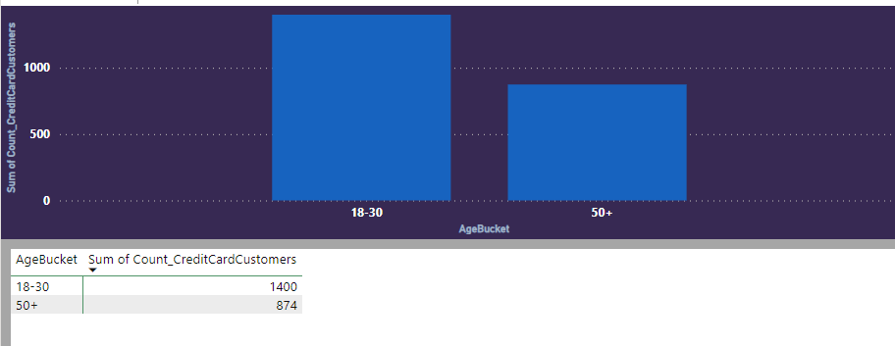

1. **Rank the Locations as per the number of people who have churned the bank and the average balance of the learners.**

Insight:- Germany rank 1 with most sum of average(1,20,361.00) balance and Churned customers(814) than France with sum of average(71,193.00) balance and Churned customers(810) also Spain with sum of average(72,513.00) balance and Churned customers(413)

Conclusion:- The Germany has most churned customer than France with 4 less churned customer than Germany than least in Spain with half the number in Germany same with average balance of all three region the maximum seen in Germany Followed by Spain and then France.

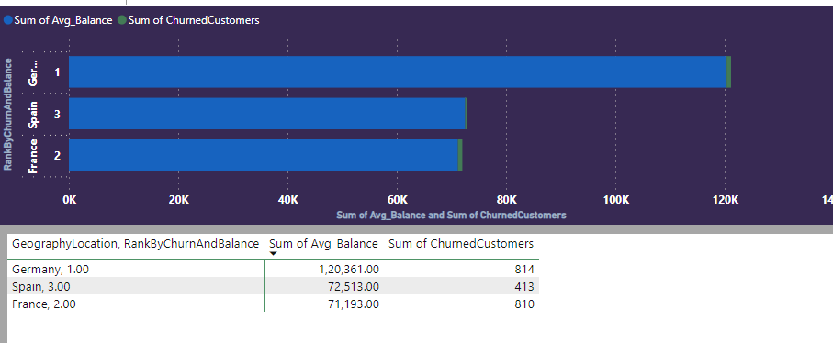

**Subjective Question:**

1. **Customer Behavior Analysis:** What patterns can be observed in the spending habits of long-term customers compared to new customers, and what might these patterns suggest about customer loyalty?

Insights :- ﻿Total Spending was higher for Retain (21,49,46,015.43) than Exit (2,10,97,490.50). ﻿New in ExitCategory Retain made up 61.96% of Spending. ﻿Average Spending was higher for Retain (10,74,73,007.72) than Exit (1,05,48,745.25). ﻿Spending for Retain and Exit diverged the most when the CustomerType was New, when Retain were 12,83,47,086.93 higher than Exit.

Conclusions :- Retained customers consistently demonstrate significantly higher total spending compared to those who exit. New customers within the Exit category contribute notably to the overall spending, indicating a potential for cultivating long-term loyalty even among new clientele. On average, long-term customers exhibit consistently higher spending habits compared to customers who choose to exit. The most significant spending divergence between Retain and Exit is observed in the early stage when customers are labeled as "New." This underscores the critical role of early spending behavior in predicting and influencing long-term customer loyalty. The consistent higher spending by retained customers suggests a strong link between spending behavior and loyalty. The influence of new customers in the Exit category emphasizes the importance of capturing and retaining these customers early on. A clear pattern emerges, demonstrating that higher spending, particularly in the initial stages, can be indicative of long-term customer loyalty.

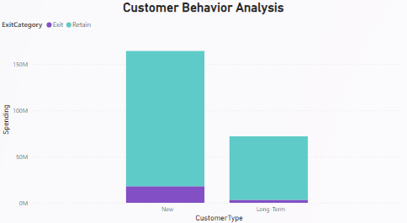 

1. **Product Affinity Study:** Which bank products or services are most commonly used together, and how might this influence cross-selling strategies?

Insight: - ﻿1 had the highest Count of Customer at 5,084, followed by 2, 3, and 4.﻿ 1 accounted for 50.84% of Count of Customer.

Conclusions: - The insights indicate that Bank Product or Service Category 1 has the highest count of customers, comprising 50.84% of the total. This suggests that Bank Product or Service Category 1 is the most commonly used among the analyzed categories. The high usage of this category implies its popularity or relevance among customers. Bank Product or Service Category 1 is the most commonly used, suggesting that it is well-received among customers. Cross-selling strategies could leverage the popularity of Category 1 by promoting complementary products or services within this category. Targeted promotions or marketing campaigns can focus on highlighting products or services that align with the usage patterns of Category 1 customers. Understanding the preferences of this customer segment can guide personalized cross-selling efforts. Bank Product or Service Category 4 has the least popularity with the lowest count of customers, it presents an opportunity for targeted promotion and cross-selling efforts.

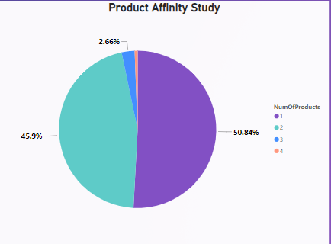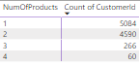

1. **Geographic Market Trends:** How do economic indicators in different geographic regions correlate with the number of active accounts and customer churn rates?

﻿Insights:- ﻿ Total Sum of EstimatedSalary was higher for Active Member (51,22,82,227.32) than Inactive Member (48,86,20,171.49).﻿﻿

﻿﻿Sum of EstimatedSalary and total ChurnRate are negatively correlated with each other.﻿﻿

﻿﻿France in ActiveCategory Active Member made up 25.60% of Sum of EstimatedSalary.﻿﻿﻿Average Sum of EstimatedSalary was higher for Active Member (17,07,60,742.44) than Inactive Member (16,28,73,390.50).

Conclusions:- Based on the provided insight, it appears that the EstimatedSalary column is being used as a proxy for an economic indicator within the context of the dataset. The total sum of EstimatedSalary is higher for Active Members than Inactive Members. This suggests that, in general, active members have a higher combined estimated salary. The negative correlation between the total Sum of EstimatedSalary and total ChurnRate implies that higher estimated salaries are associated with lower churn rates or vice versa. In France, within the ActiveCategory of Active Members, they contribute to 25.60% of the total Sum of EstimatedSalary. This gives an indication of the economic contribution of active members in France.Thus say that negative correlation with churn rates suggests a potential link between economic well-being (reflected in estimated salary) and customer retention.

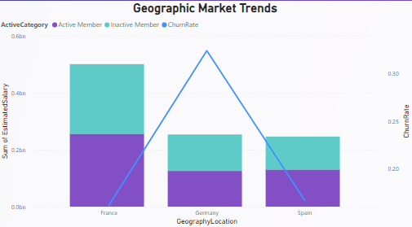



1. **Risk Management Assessment:** Based on customer profiles, which demographic segments appear to pose the highest financial risk to the bank, and why?

Insight:- ﻿At 0.22, 350-599 had the highest ChurnRate and was 11.32% higher than 800-850, which had the lowest ChurnRate at 0.20. ﻿350-599 had the highest ChurnRate at 0.22, followed by 700-799, 600-699, and 800-850.﻿Across all 4 CreditScoreSegment, ChurnRate ranged from 0.20 to 0.22.

Conclusion:- The credit score segment "350-599" appears to pose the highest financial risk to the bank, as it has the highest ChurnRate at 0.22, which is 11.32% higher than the segment with the lowest ChurnRate ("800-850" with ChurnRate at 0.20). Despite ChurnRates ranging from 0.20 to 0.22 across all credit score segments, the higher ChurnRate in the "350-599" segment suggests a potential association between lower credit scores and a higher likelihood of customer exits. This observation indicates that customers with credit scores in the range of 350-599 may be at a higher financial risk, possibly leading to churn. The insight emphasizes the ChurnRate differences across credit score segments, highlighting that "350-599" has the highest ChurnRate. Despite variations, the consistent range of ChurnRates (0.20 to 0.22) across all segments suggests that the "350-599" segment stands out due to its relatively higher ChurnRate indicating a potential financial risk associated with customers having credit scores in that range.

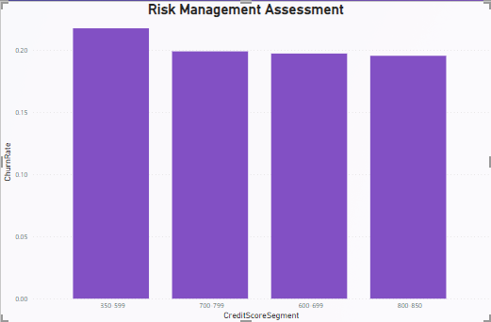

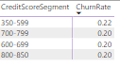

1. **Customer Lifetime Value Forecast:** How would you use the available data to model and predict the lifetime value of different customer segments?

Insight:- 31-50 had the highest total Sum of EstimatedSalary at 67,89,97,437.42, followed by 18-30 at 19,89,45,119.92 and 50+ at 12,29,59,841.47.﻿﻿﻿4 in AgeBucket 31-50 made up 20.05% of Sum of EstimatedSalary.31-50 had the highest average Sum of EstimatedSalary at 13,57,99,487.48, followed by 18-30 at 3,97,89,023.98 and 50+ at 2,45,91,968.29.The Rank for the 31-50 is highest for both exit and retain category.

Conclusion:- Based on the provided insight, customers in the age group 31-50 demonstrate the highest total and average Sum of EstimatedSalary, indicating significant financial contribution. The fact that 4 in the AgeBucket 31-50 make up 20.05% of the total Sum of EstimatedSalary suggests a concentration of economic value within this age group. Additionally, the highest rank in both the exit and retain categories for the 31-50 age group implies a robust financial profile and a balanced distribution between retained and exited customers. This conclusion is reached by considering the comprehensive analysis of total and average EstimatedSalary, concentration within the age group, and the consistent high rank in both exit and retain categories. The age group 31-50 holds the highest rank in both the exit and retain categories, indicating a balanced distribution of customers who stayed and those who exited within this age range. Comparisons with age groups 18-30 and 50+ provide context and emphasize the dominance of the 31-50 age group in terms of financial contributions and customer retention.

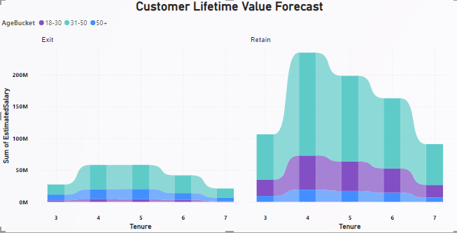

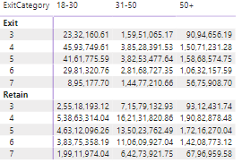

1. **Marketing Campaign Effectiveness:** How could you assess the impact of marketing campaigns on customer retention and acquisition within the dataset?

**Insight:**- Total Count of NumOfProducts was higher for Active Member (5,151) than Inactive Member (4849).﻿﻿ Retain in ActiveCategory Active Member made up 44.16% of Count of NumOfProducts. Average Count of NumOfProducts was higher for Active Member (2,575.50) than Inactive Member (2,424.50). Count of NumOfProducts for Active Member and Inactive Member diverged the most when the ExitCategory was Retain, when Active Member were 869 higher than Inactive Member.

**Conclusion:**- The provided insight reveals that the count of NumOfProducts is higher for active members compared to inactive members. Active members, particularly in the Retain category, contribute significantly to the total count of products. The average count of products is also higher for active members. This suggests that there is a positive correlation between customer activity, as represented by the 'ActiveCategory,' and the count of products, indicating potential engagement and retention. The insight directly addresses the question by illustrating the relationship between customer activity (active or inactive) and the count of products. This relationship is crucial for assessing the impact of customer activity on the acquisition and retention of products, providing insights into marketing campaign effectiveness. A higher count of products among active members, especially in the Retain category, implies that active customers may play a significant role in both customer retention and acquisition. The insight further specifies that within the Retain category, active members (Active Member) make up a significant portion (44.16%) of the total count of NumOfProducts. The insight highlights that the difference in the count of NumOfProducts between active and inactive members is most pronounced when customers are retained (ExitCategory is Retain), with active members being 869 products higher than inactive members.

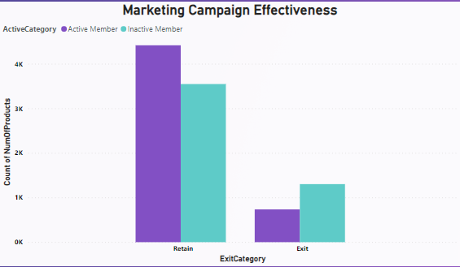

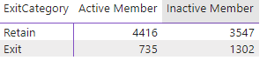

1. **Customer Exit Reasons Exploration:** Can you identify common characteristics or trendsamong customers who have exited that could explain their reasons for leaving?

Insights:- 31-50 had the highest total Count of NumOfProducts at 6,771, followed by 18-30 at 1968 and 50+ at 1261. ﻿Count of NumOfProducts and total Sum of Balance are positively correlated with each other. ﻿Retain in AgeBucket 31-50 made up 54.45% of Count of NumOfProducts. ﻿31-50 had the highest average Count of NumOfProducts at 3,385.50, followed by 18-30 at 984 and 50+ at 630.50. Count of NumOfProducts and total Sum of Balance are positively correlated with each other.

Conclusions:- The insight suggests a positive correlation between the count of NumOfProducts and the total sum of Balance among customers. This implies that as the count of products increases, the total sum of balances also tends to increase. The AgeBucket 31-50 category dominates both the count and average of NumOfProducts, indicating a potential relationship between product diversity and higher balances within this age group. The provided insight directly states a positive correlation between the count of NumOfProducts and the total sum of Balance. The positive correlation implies that customers with a higher count of products tend to have higher total balances. The dominance of AgeBucket 31-50 in both count and average of NumOfProducts reinforces the correlation, suggesting that this age group plays a significant role in contributing to the observed positive correlation. he conclusion is reached by combining the insight, interpreting the correlation, and analyzing the specific age group's impact on the observed relationship.

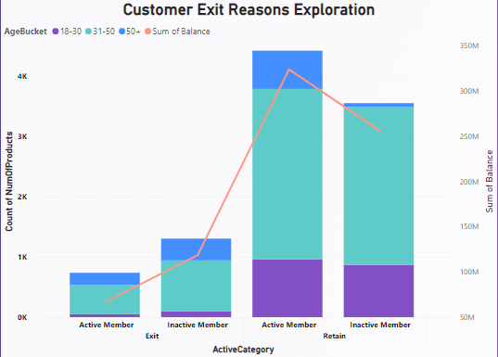

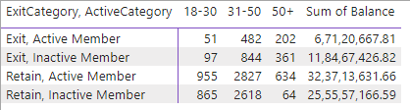

1. **Are 'Tenure', 'NumOfProducts', 'IsActiveMember', and 'EstimatedSalary' important for predicting if a customer will leave the bank?**

Insight:- ﻿﻿﻿Sum of Tenure and total Average of EstimatedSalary are negatively correlated with each other.Active Member accounted for 51.42% of Sum of Tenure.Active Member had 25010 Sum of Tenure, 99,452.97 Average of EstimatedSalary, and 5,151 Count of NumOfProducts. Inactive Member had 23633 Sum of Tenure, 1,00,767.20 Average of EstimatedSalary, and 4,849 Count of NumOfProducts. does this insight answer the question.

Conclusion:- The provided insight suggests that there is a negative correlation between the sum of 'Tenure' and the average of 'EstimatedSalary.' Additionally, it outlines specific metrics for both active and inactive members. The insight mentions a negative correlation between the sum of 'Tenure' and the average of 'EstimatedSalary.' This implies that, on average, as the tenure increases, there is a tendency for the estimated salary to decrease. Active members account for 51.42% of the sum of 'Tenure.'Active members have a sum of 'Tenure' of 25,010.The average 'EstimatedSalary' for active members is 99,452.97.Active members have a count of 5,151 for 'NumOfProducts.'

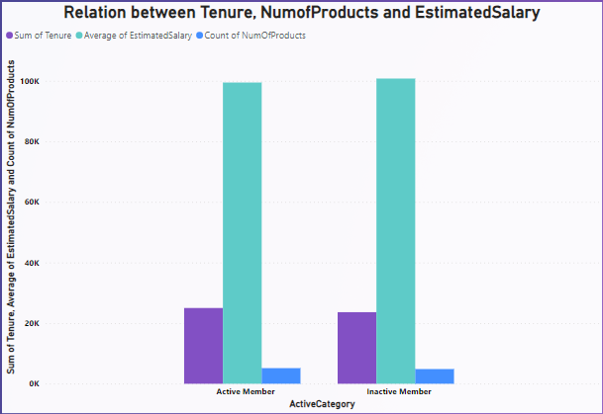

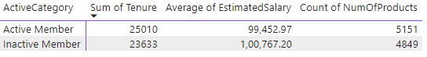

1. **Utilize SQL queries to segment customers based on demographics, account details, and transaction behaviors.**

Insight:- Sum of Tenure and total Average of EstimatedSalary are negatively correlated with each other.﻿﻿Active Member accounted for 51.42% of Sum of Tenure.﻿﻿Active Member had 25010 Sum of Tenure, 99,452.97 Average of EstimatedSalary, and 5,151 Count of NumOfProducts. Inactive Member had 23633 Sum of Tenure, 1,00,767.20 Average of EstimatedSalary, and 4,849 Count of NumOfProducts.﻿﻿

Conclusion:- The provided insight indicates a negative correlation between the sum of 'Tenure' and the average of 'EstimatedSalary.' Active members account for a significant portion of the sum of 'Tenure,' and their characteristics differ from those of inactive members in terms of 'EstimatedSalary' and 'NumOfProducts.'The negative correlation between 'Tenure' and 'EstimatedSalary' suggests that, on average, as the tenure increases, there is a tendency for the estimated salary to decrease. Active members account for 51.42% of the sum of 'Tenure.'Active members have a sum of 'Tenure' equal to 25,010. The average 'EstimatedSalary' for active members is 99,452.97.Active members have a count of 5,151 for 'NumOfProducts.'The negative correlation between 'Tenure' and 'EstimatedSalary' suggests that customers with longer tenure may have lower average estimated salaries. Active members, constituting the majority of the sum of 'Tenure,' exhibit lower average estimated salaries compared to inactive members.The count of 'NumOfProducts' provides insight into the transaction behavior, indicating that active members, on average, have a higher count of products compared to inactive members.

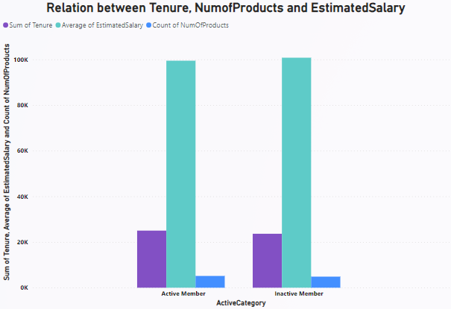

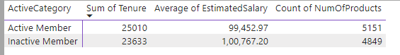

1. **How can we create a conditional formatting setup to visually highlight customers at risk of churn and to evaluate the impact of credit card rewards on customer retention?**

Insight:- At 0.22, 350-599 had the highest ChurnRate and was 11.32% higher than 800-850, which had the lowest ChurnRate at 0.20.350-599 had the highest ChurnRate at 0.22, followed by 700-799, 600-699, and 800-850.﻿Across all 4 CreditScoreSegment, ChurnRate ranged from 0.20 to 0.22.

Conclusion:- The insight reveals variations in ChurnRate across different credit score segments, with the "350-599" segment having the highest ChurnRate at 0.22. This suggests that customers in the "350-599" credit score range are at a higher risk of churn compared to other segments. Utilizing the ChurnRate data, a conditional formatting setup can be applied to visually highlight customers falling within the "350-599" credit score segment. This helps identify and emphasize customers who are at a higher risk of churn. The conditional formatting setup is suggested based on this insight to focus on customers within this segment and, if applicable, to further evaluate the impact of credit card rewards on their retention. The highlighted information is that inactive person are more in exit category than in retained customer.31-50 has most inactive members.

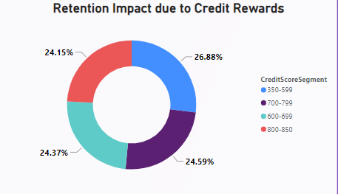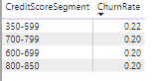

1. **What is the current churn rate per year and overall as well in the bank? Can you suggest some insights to the bank about which kind of customers are more likely to churn and what different strategies can be used to decrease the churn rate?**

Insight:- The overall churnrate and churnrate per year is 0.20.   
﻿ChurnRate trended up, resulting in a 3.06% increase between 2016 and 2019.﻿﻿ ﻿﻿﻿﻿Germany in AgeBucket 50+ made up 26.63% of ChurnRate.﻿﻿ ﻿﻿ ﻿﻿50+ had the highest average ChurnRate at 0.45, followed by 31-50 at 0.21 and 18-30 at 0.09.﻿﻿ ﻿﻿ ﻿﻿[]﻿﻿ ﻿﻿ ﻿﻿ChurnRate for Female (0.25) was higher than Male (0.16).﻿﻿ ﻿

Conclusion:- Targeted Retention Programs: Implement retention programs specifically tailored for customers in AgeBucket 50+, as they demonstrate a higher ChurnRate. Offering personalized incentives and rewards may help retain these customers.Gender-Based Campaigns: Design marketing campaigns focusing on reducing churn among female customers. Analyze the reasons behind the higher ChurnRate for females and address those issues through targeted communication and benefits.Engagement Initiatives for Younger Customers: Develop engagement initiatives for customers in the 18-30 age group, as they have a comparatively lower ChurnRate. Implement strategies that enhance their banking experience, such as exclusive offers, digital features, or educational resources.Customer Feedback and Surveys: Conduct surveys and gather feedback to understand the specific reasons behind customer churn. Use this information to address pain points and enhance overall customer satisfaction.Personalized Communication: Implement personalized communication strategies to connect with customers individually. Addressing their needs, concerns, and preferences can foster a sense of loyalty and reduce the likelihood of churn.Continuous Monitoring: Regularly monitor customer behavior, transaction patterns, and satisfaction metrics. Early detection of signs indicating potential churn allows for proactive interventions.Educational Campaigns: Create campaigns to educate customers about the value of long-term relationships with the bank, emphasizing the benefits of staying loyal and the unique offerings available.By combining these strategies and continuously refining them based on customer feedback and data analysis, the bank can work towards reducing overall churn and improving customer retention rates.