**Problem Statement 2:** Adding and Committing Changes

1. Create a new file and add some content to it.
2. Use git add to stage the changes and git commit to commit them to the repository.

**Learning Outcomes:**

1. Familiarize yourself with creating files and committing changes in Git.
2. Learn to use git add and git commit for version control.

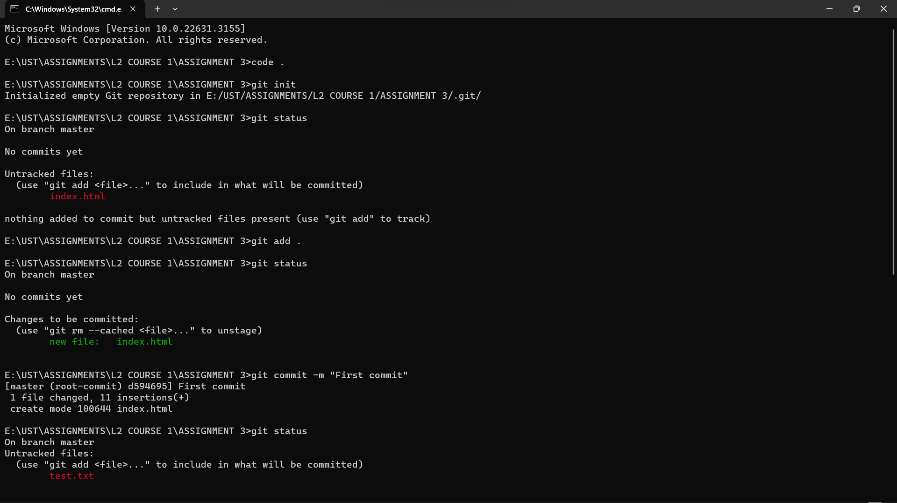**Git code snapshots:**

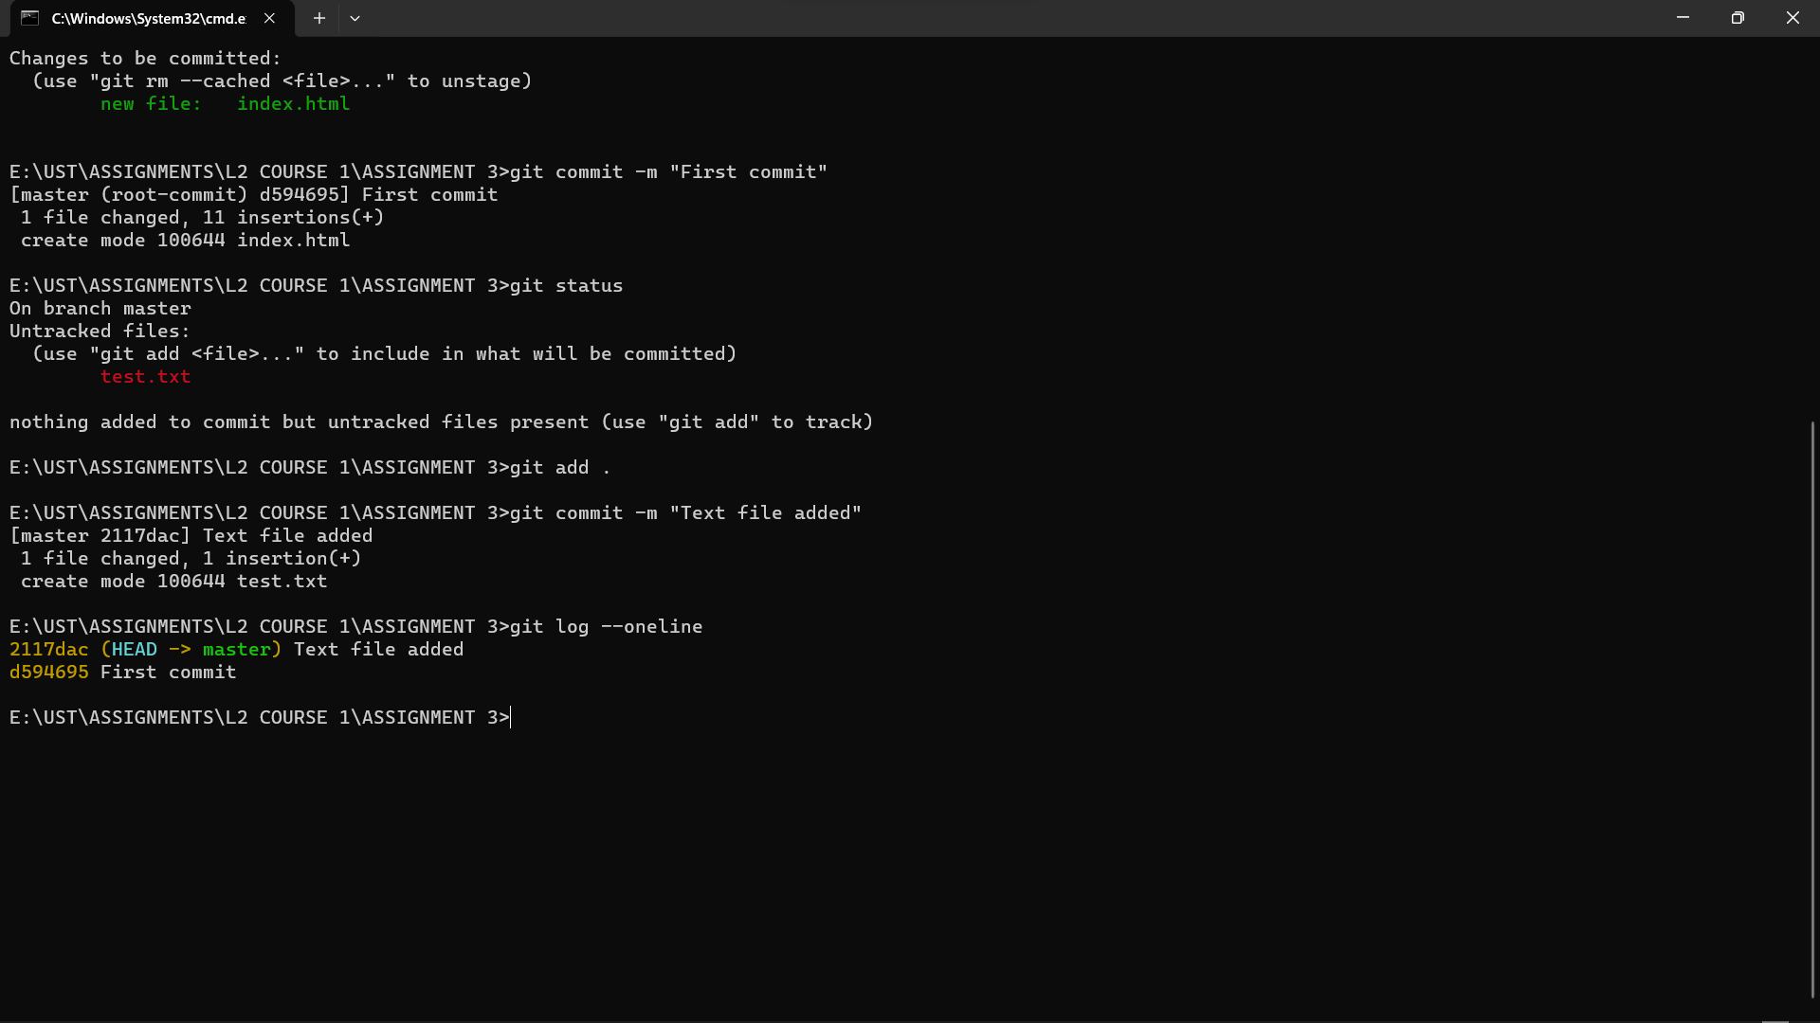

Git link: <https://github.com/Rashmi-kumari5/L2-COURSE-3/tree/master/ASSIGNMENT-02>