**Problem Statement 3:** Checking Repository Status

1. Use git status to check the current status of the repository.
2. Make changes to a file, and observe how the status changes.

**Learning Outcomes:**

1. Learn to use git status for tracking changes.
2. Understand how changes affect the repository status.

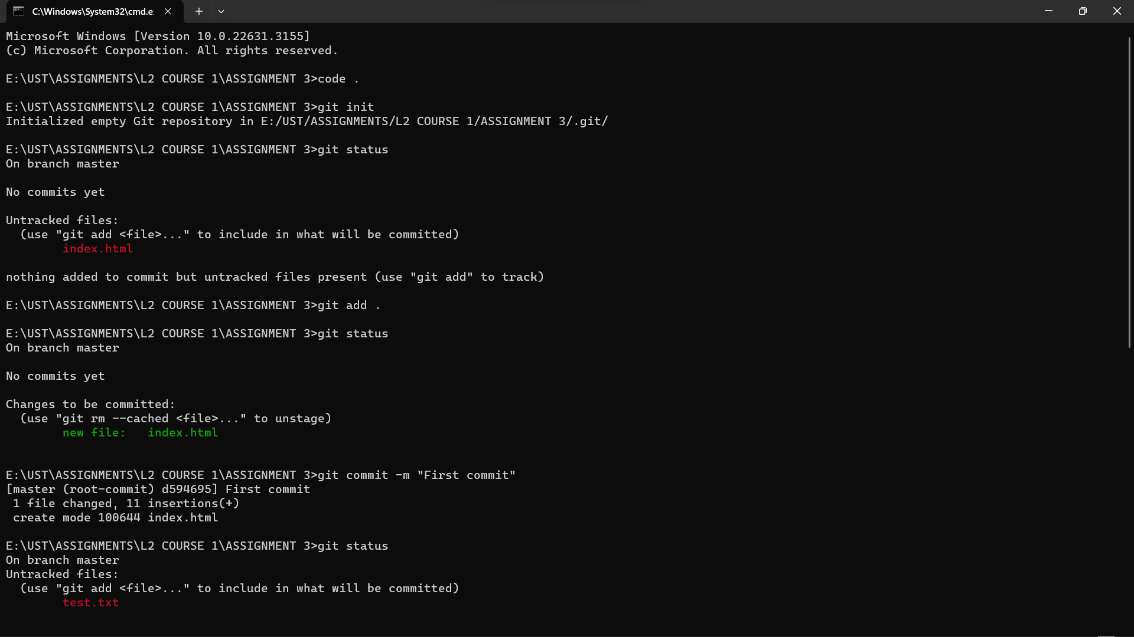**Git code snapshots:**

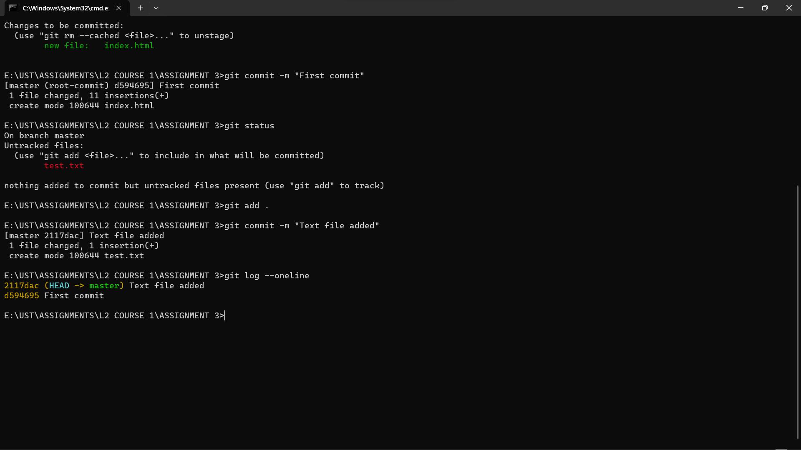

Git link: <https://github.com/Rashmi-kumari5/L2-COURSE-3/tree/master/ASSIGNMENT-03>