1.FIND A STUDENT AVERAGE MARK GIVEN MARK 1 AND MARK 2

ALGORITHM-

-Start

-Declare variable mark1,mark2,avg

-Read values mark1 and mark2

-Add mark1 and mark2 and divided by 2 then assign the result to avg.

-Display avg.

FLOWCHART-

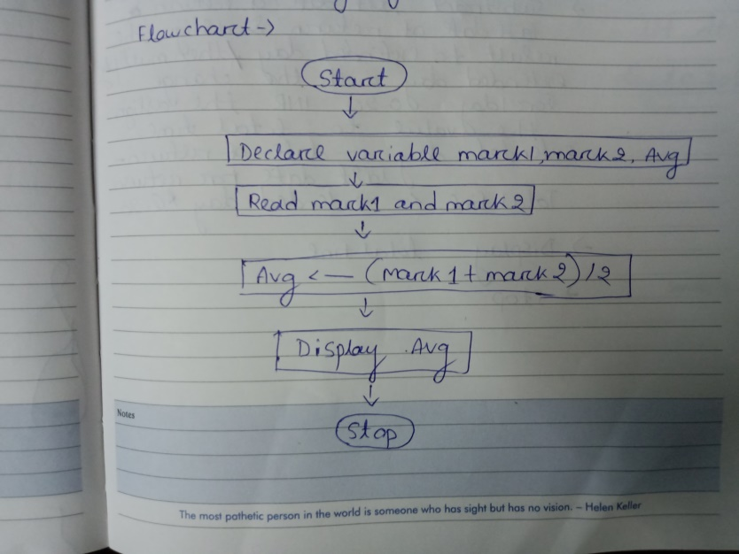

2.CALCULATE THE TOTAL FINE CHARGE BY LIBRARY FOR LATE RETURN BOOK.THE CHARGE IS 0-20 INR FOR 1DAY.

ALGORITHM-

-Start

-Declare variables,date of return,last date of return,total fine extended day

-Read value date of return and last date of return,charge for 1day= 0-20

-Substract last date of return from date of return and assign the result to extended day,

Extended day=date of return-last day for return

-Multiply extended day with the charge for 1day 0-20 INR the assign value to total time.

-Display total fine

-Stop

FLOWCHART-

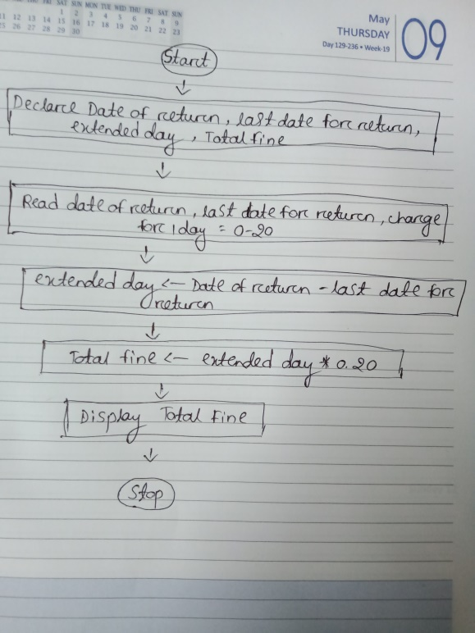

3.YOU HAD BOUGHT A NICE SHIRT WHICH COST RS.29.90WITH 15%DISCOUNT COUNT THE NET PRICE FOR THE SHIRT.

ALGORITHM-

-Start

-Declare variable net price,cost,discount cost.

-Initialize cost=29.90 and discount is 15% that means 0.15

-Multiply cost with discount and assign the result to discount cost,

Discount cost=0.15\*cost

-Substract discount cost from cost and assign the result to net price.

Net price=cost-discounted cost

-Display net price

-stop

FLOWCHART-

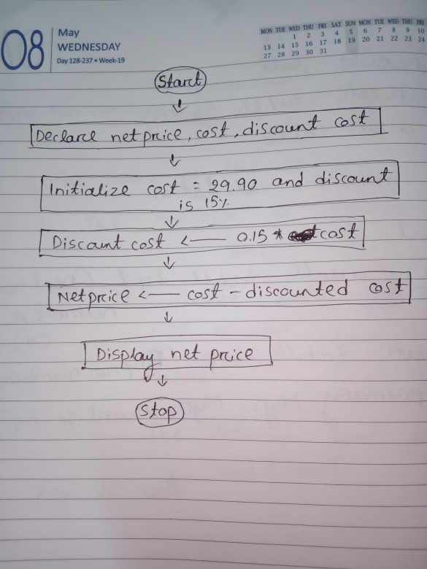

4.Find the smallest no using three different numbers.

ALGORITHM-

-Start

-Declare variable a,b and c.

-Read values a,b and c.

-if a is less than b and c,

Display a is the smallest no. else if b is the smallest no. else display c is the smallest no.

-stop

FLOWCHART-

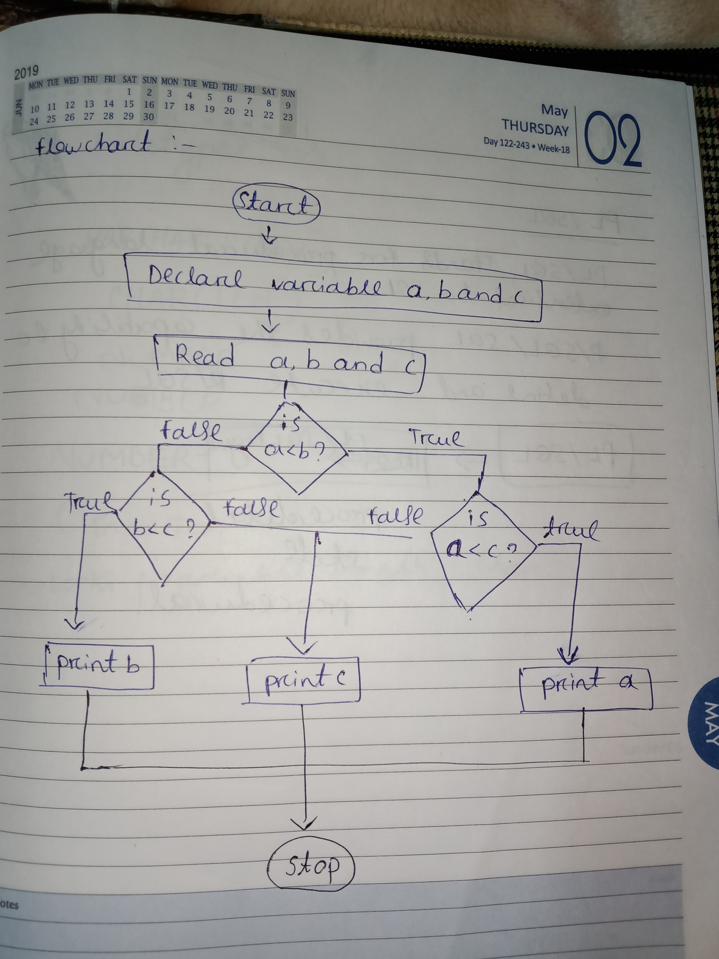

1. Find the roots of a quadratic equation ax2+bx+c=0

ALGORITHM-

-Start

-Declare variables root,D,a,b,c.

-Read values a,b and c.

-Substract product of 4,a and c from sqr of b and assign value to D

D<- b\*b-4ac.

-if D us less than zero

Display roots are imaginary.

Else root is either addition of sqr root of D with -b then divide it with 2a

Or root is substract sqr root of D from -b then divide it with 2a.

root<- -b+sqr root of D/2a

Or root<- -b-sqr root of D/2a

-Diaplay root

-stop

FLOWCHART-

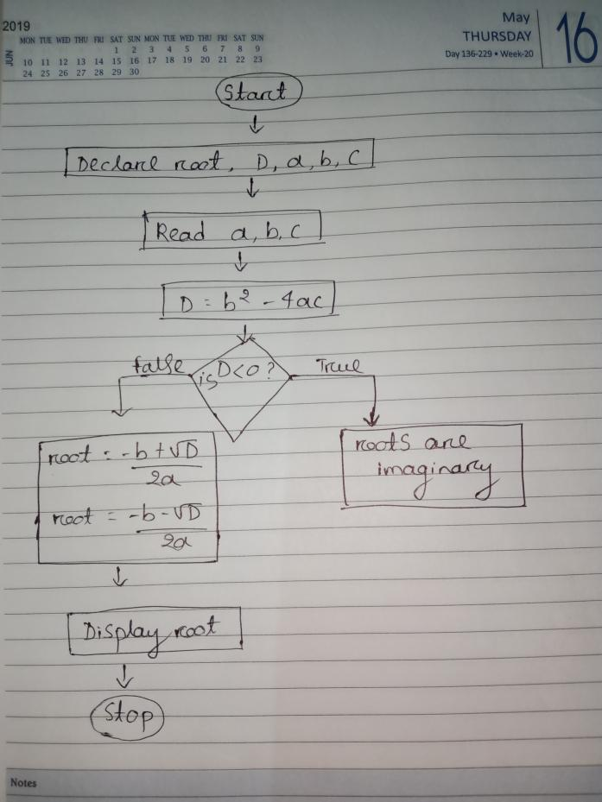

1. Find the factorial of a given number.

ALGORITHM-

-Start

-Declare variable num,fact.

-Read values of num.

-if num is greater than 1 then from value num upto 1 multiply each digit store at fact.

Fact<-num\*(num-1)\*(num-2)…..\*1.

-Display fact.

-Stop.

FLOWCHART-

