Blockchain Mini Project – Report

Name | SRN | Section
Y M Rashmi | PES1UG22CS712 | L
Prapti Arali | PES1UG22CS439 | H
Shrina Anahsour | PES1UG22CS583 | J
Samrudh S M | PES1UG22CS517 | I

Introduction

In today’s digital age, verifying an individual’s skills and work experience remains a cumbersome and inefficient process. Traditional verification methods are often time-consuming, prone to forgery, and lack transparency. Employers and HR departments face challenges in validating the authenticity of resumes and employment histories, leading to potential hiring of unqualified candidates and reputational risks for organizations. There is a pressing need for a secure, tamper-proof, and transparent system that ensures the credibility of candidate profiles and simplifies the verification process for all stakeholders.

Problem statement

Traditional employee certificates are often vulnerable to forgery, loss, and difficult verification processes. This project aims to create a decentralized system where employee certificates are securely stored on the blockchain. By recording certificate details immutably, the system ensures tamper-proof, easily retrievable, and verifiable records. The solution improves transparency, reduces fraud, and allows employers and employees to access trusted certification information without relying on centralized authorities.

Blockchain Implementation Details

1. Smart Contract Overview
- The smart contract is written in Solidity (version 0.8.26).
- It defines a Certificate structure that stores details such as:
  - Employee Name
  - Employee ID (Unique Identifier)
  - Company Name
  - Job Role
  - Skills
  - Performance Feedback
  - Date of Issuance (timestamp)
  - Joining Year
  - Completing Year
  - Calculated Experience (in years)

2. Core Functionalities
- Issuing Certificates:
The issueCertificate() function allows a certificate to be created and stored on the blockchain. It automatically calculates the employee’s experience based on the joining and completing years.
- Retrieving Certificates:
  - getCertificate(uint256 id): Fetches full details of a specific certificate by its ID.
  - getCertificatesOf(string memory employeeId): Returns all certificate IDs linked to a specific employee.
- Tracking Certificates:
A mapping certificatesOfEmployee keeps track of which certificates belong to which employee, based on their unique employee ID.
- Event Emission:
An event CertificateIssued is emitted every time a new certificate is issued, allowing external applications (like dashboards) to listen and react to new issuances.

3. Storage Mechanism
- All certificates are stored in a public array certificates, ensuring immutability and transparency.
- Since the data is on-chain, certificates cannot be modified or deleted once issued.

4. Decentralization and Security
  - Immutable (cannot be changed once created)
  - Tamper-proof (resistant to forgery)
  - Publicly Verifiable (transparent and easily auditable)

5. Tools and Stack Used
- Smart Contract Language: Solidity
- Blockchain Platform: Ethereum
- Wallet for Interaction: Metamask
- Development Environment: Remix IDE

Screenshots of the working application

Remix :
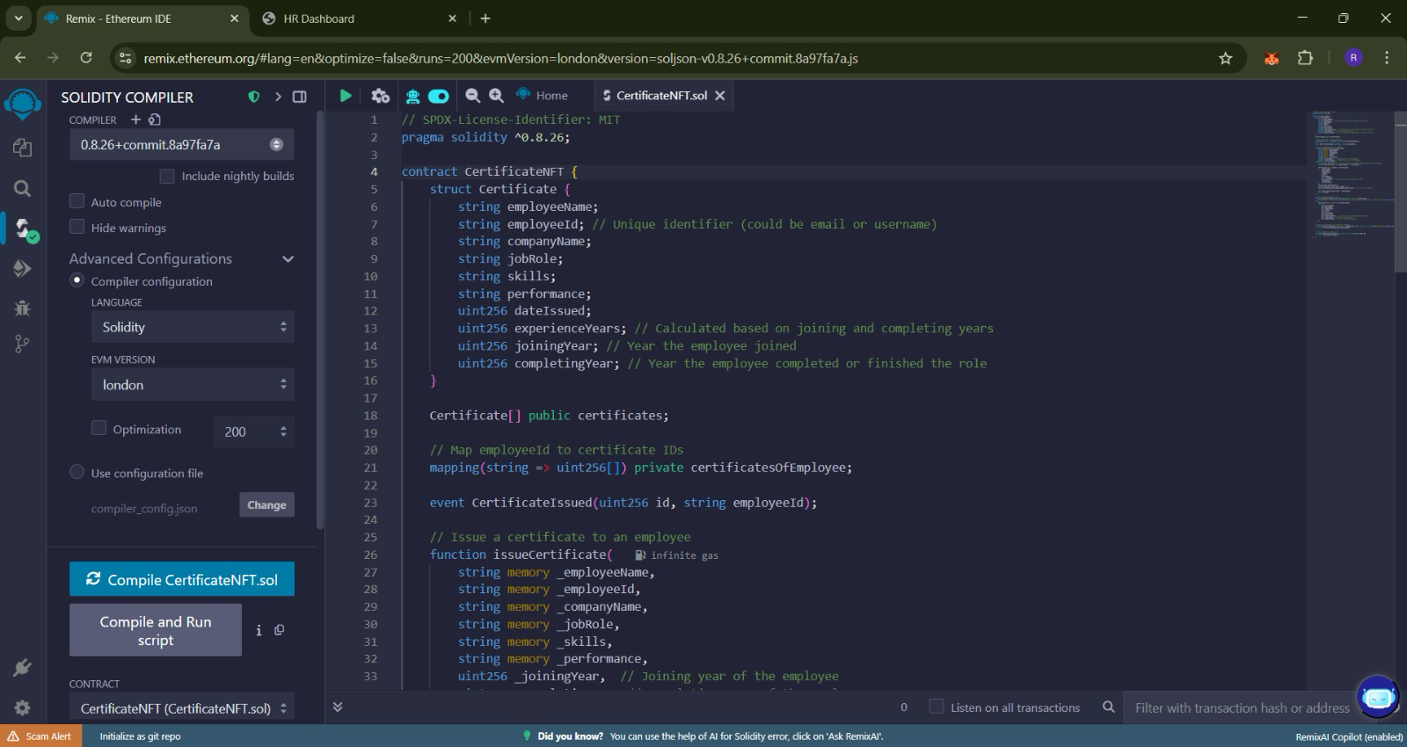
Meta Mask:

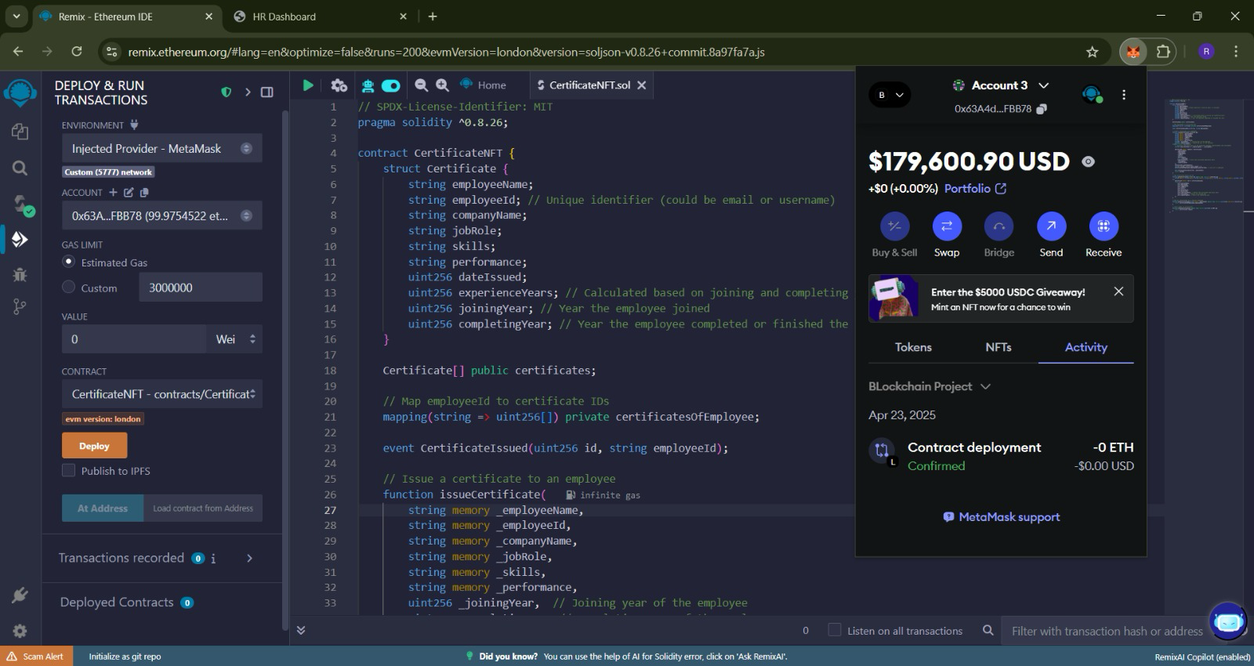

Deployment :
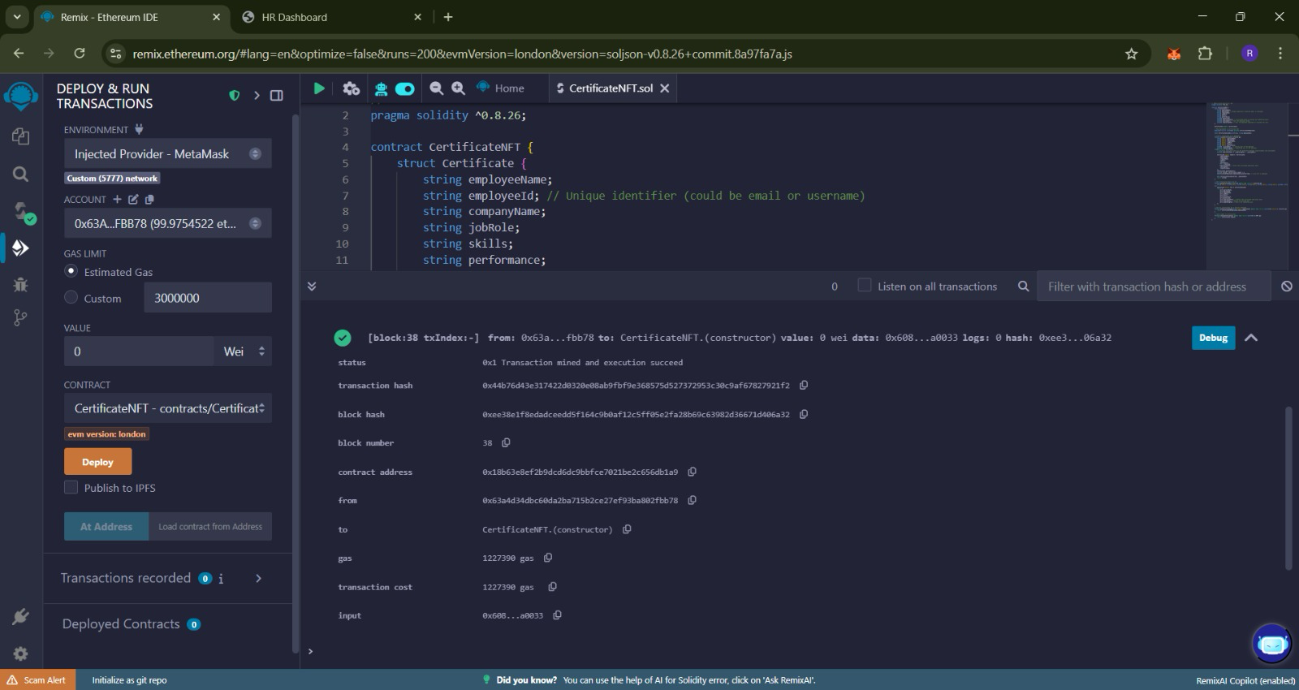

The transaction id:
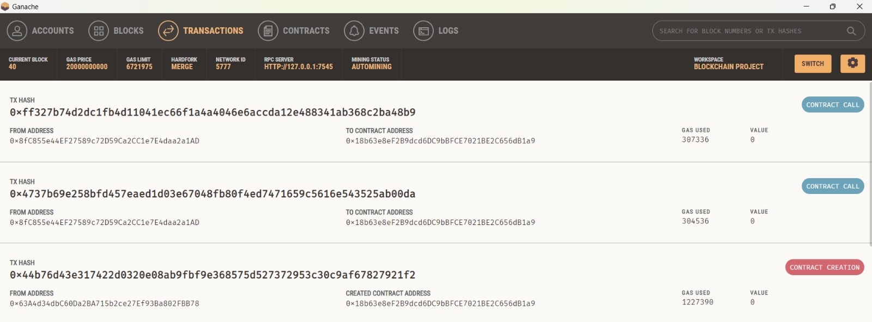

Address: Address in app.py is same as remix contract Address
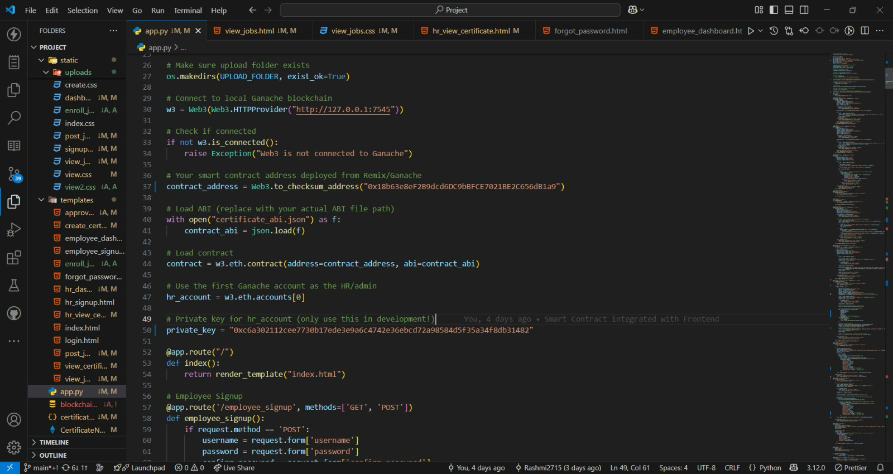

Information is fetched from blockchain through getcertificate() function of contract

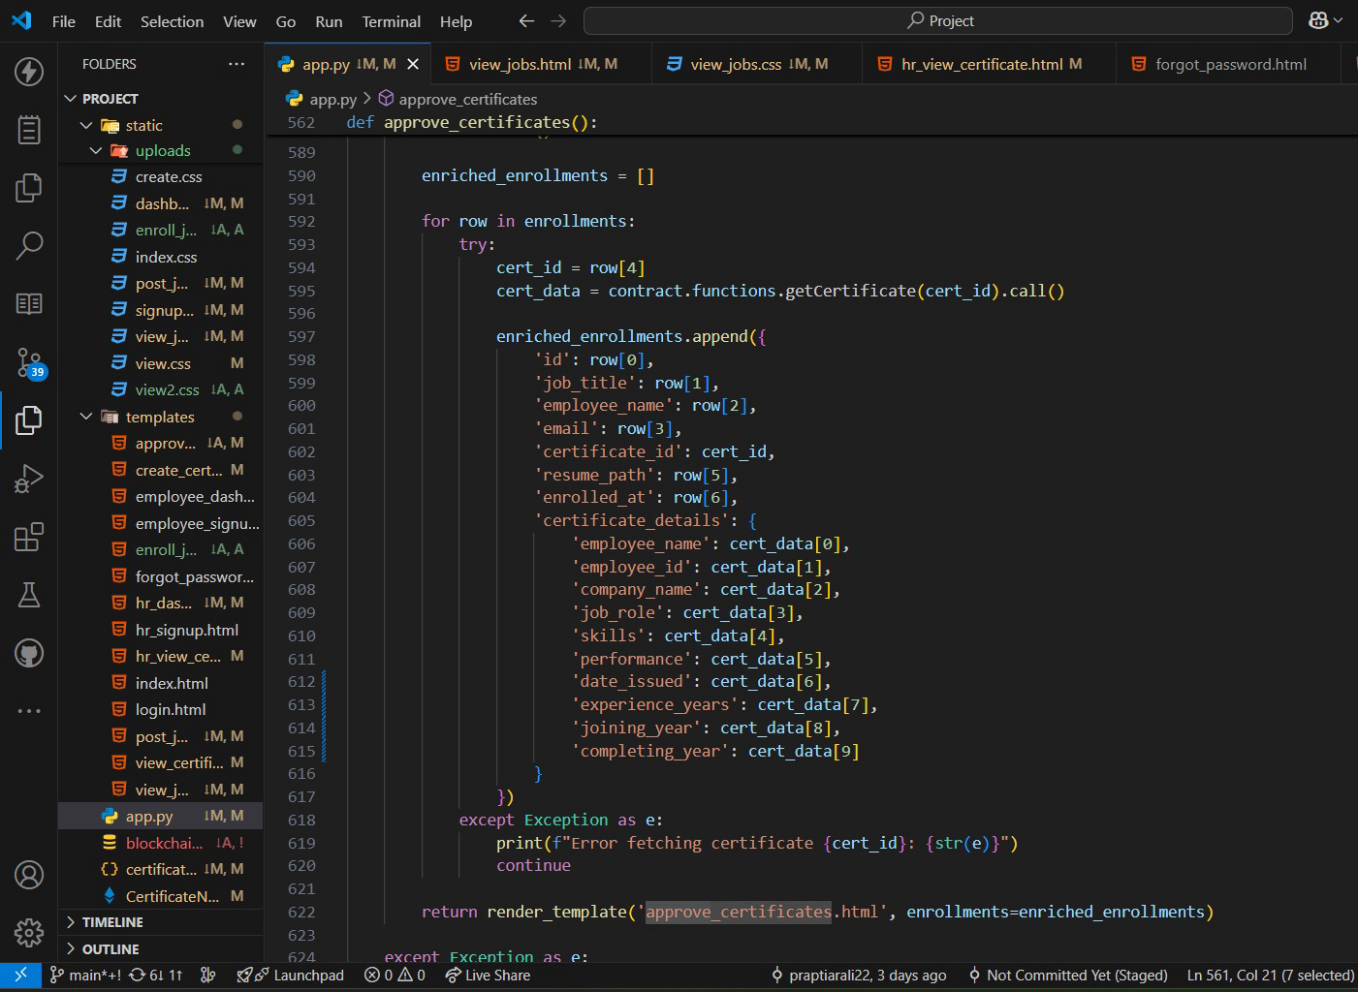

Future Enhancements

• NFT-Based Certificate Minting
Upgrade the system to actually mint each certificate as a Non-Fungible Token (NFT), assigning true digital ownership to employees.
• IPFS Integration for Storage
Store detailed certificate files (PDFs, images) securely on IPFS (InterPlanetary File System), and only keep IPFS hashes on the blockchain to save gas fees.
• Role-Based Access Control
Implement admin and employee roles, ensuring that only authorized companies can issue certificates, and employees can only view their own certificates securely.
• QR Code Verification
Each certificate can have an associated QR code that, when scanned, fetches and verifies certificate details directly from the blockchain.
• Cross-Chain Deployment
Deploy the smart contract on cheaper, faster blockchains like Polygon, Binance Smart Chain, or Optimism to reduce transaction costs.

