Quiz Master Application
1. Aim
To design and develop a full-stack quiz web application using Flask (Python) for the backend and HTML/CSS for the frontend to handle dynamic data processing and user interaction.
2. Prerequisites
- Environment: Python 3.x installed.
- Framework: Flask library (pip install flask).
- Structure: Standard Flask directory hierarchy (templates/ and static/).
3. Implementation Logic (Process)
- Backend (app.py): Utilizes a list of dictionaries to store 5 MCQs. It handles two primary routes: /quiz (GET) to display questions and /submit (POST) to evaluate user input.
- Frontend: Uses Jinja2 templating to loop through questions. A <form> collects user responses via radio buttons.
- Logic: The backend iterates through the QUIZ_DATA, compares the request.form values with correct answers, and calculates a final score.
- Styling: A centralized style.css provides a responsive, card-based UI.

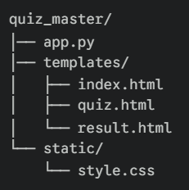
CODE
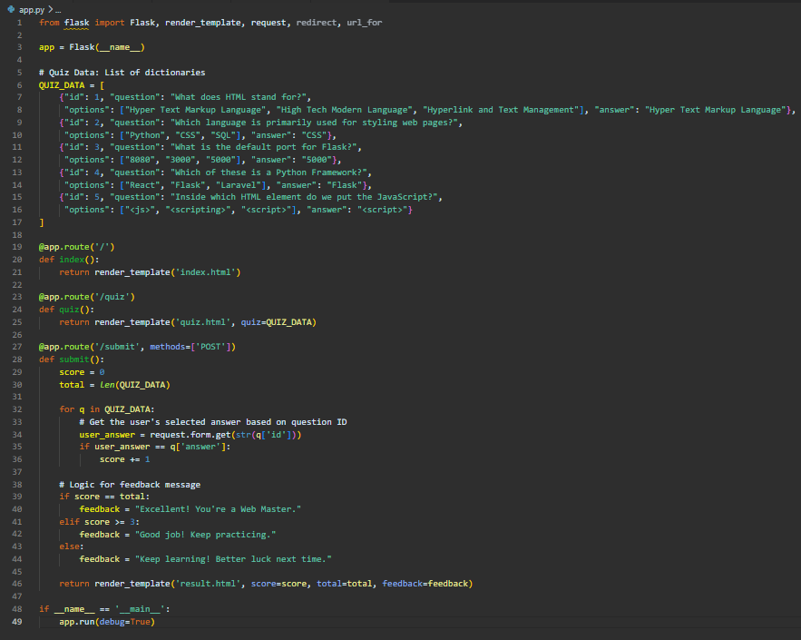
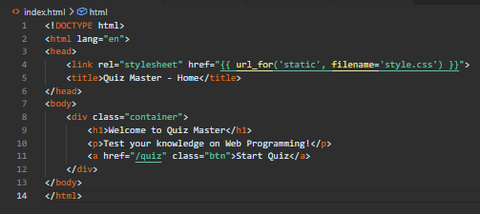
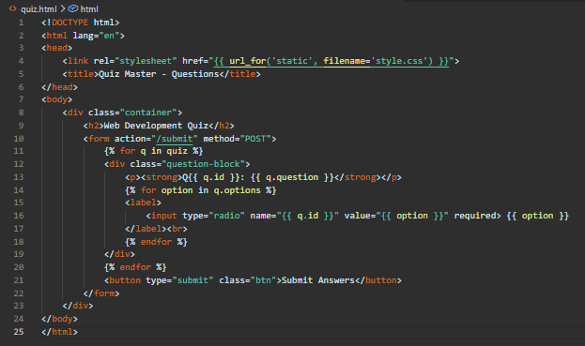
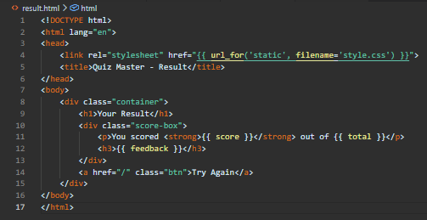
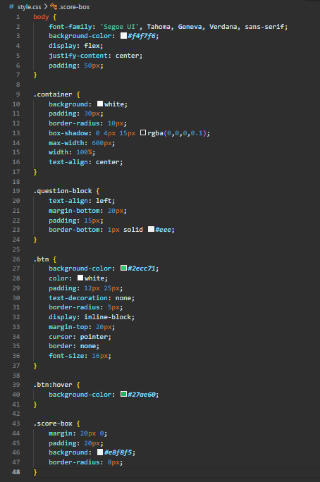

OUTPUT
