Experiment-4: Dynamic To-Do List
Aim
To design and develop an interactive, state-based task management application using HTML, CSS, and JavaScript that enables real-time CRUD (Create, Read, Update, Delete) operations and dynamic task status tracking.
Pre-requisite (Languages Used)
HTML5: Used for building the application container, input interfaces, and the unordered list structure for task display.
CSS3: Used for the modern dashboard layout, responsive design, and status-based styling (such as strikethrough effects for completed tasks).
JavaScript: Used for event handling, DOM manipulation (creating/removing nodes), capturing timestamps, and managing the logic for real-time pending/completed counters.
PROCESS (Implementation)
Task 1: Dynamic DOM Manipulation The application avoids static list items. Instead, it uses JavaScript's document.createElement() to generate task blocks on the fly. Each block is injected with sub-elements: a checkbox for status, a label for the task text, a timestamp, and action buttons for editing and deletion.
Task 2: State Tracking & Real-Time Counters A centralized refreshApp() function scans the list items within the DOM. It calculates the total number of tasks versus those marked with a "finished" class, updating the UI badges instantly to reflect the current workload.
Task 3: Interactive CRUD Functionality
Create: Captures input and current system time to generate a timestamped task.
Update: Uses a toggle logic for completion status and a prompt() window for text modification.
Delete: Targets the specific parent node of the clicked button to remove the task from the view.
CODE
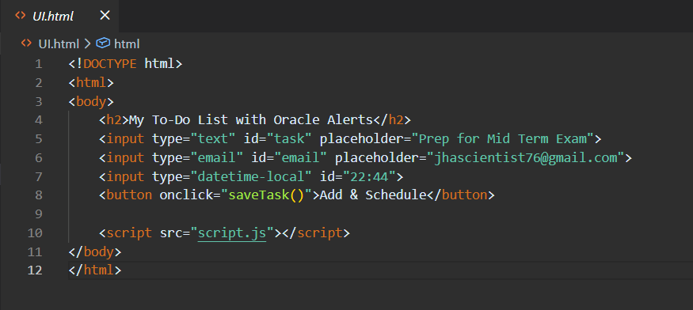
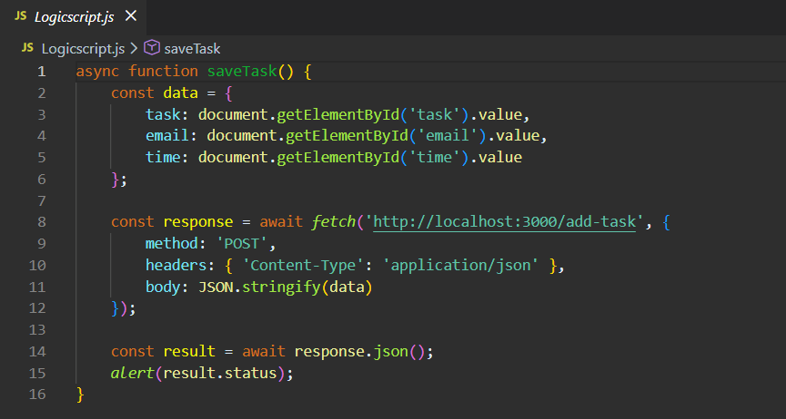
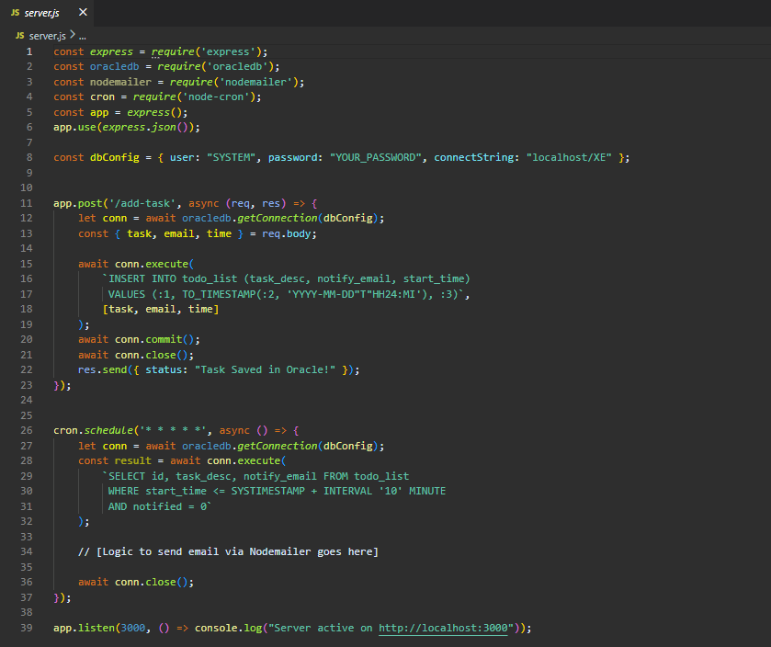
OUTPUT
