Flask-Powered Dynamic To-Do List Application
1. Aim
To design and develop a Flask-Powered Dynamic To-Do List Application that demonstrates full-stack web development using HTML5, CSS3, JavaScript (ES6+), Python 3, and Flask. The application allows users to Add, Edit, Delete, Mark Complete, Filter, and Prioritise tasks — with the Flask backend handling all data persistence through a RESTful API consumed by JavaScript Fetch calls on the front end.

2. Prerequisites
- Environment: Python 3.x installed.
- Framework: Flask library (pip install flask).
- Structure: Standard Flask directory hierarchy (templates/, static/css/, static/js/).
- Frontend: Basic knowledge of HTML5, CSS3, JavaScript ES6+ (fetch, async/await, DOM manipulation).
- Tools: VS Code editor, web browser with DevTools.

3. Implementation Logic (Process)
- Backend (app.py): Stores tasks in an in-memory Python list of dictionaries. Handles six REST routes: GET /api/tasks (with optional status filter), POST /api/tasks, PUT /api/tasks/<id>, PATCH /api/tasks/<id>/toggle, DELETE /api/tasks/<id>, and GET / to render the HTML page.
- Frontend: Uses Jinja2 template inheritance (base.html → index.html). All task cards are injected by JavaScript — no Jinja2 loops used for rendering tasks.
- Logic: JavaScript Fetch API calls the Flask REST endpoints using async/await. Every action (add/edit/delete/toggle/filter) updates the DOM in-place without a full page reload.
- Styling: style.css is divided into 9 named sections with CSS custom properties, priority colour-coded card borders, fadeIn animations, and a responsive <600px layout.

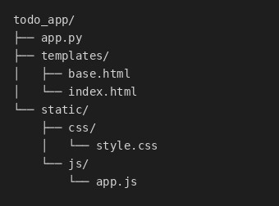

CODE
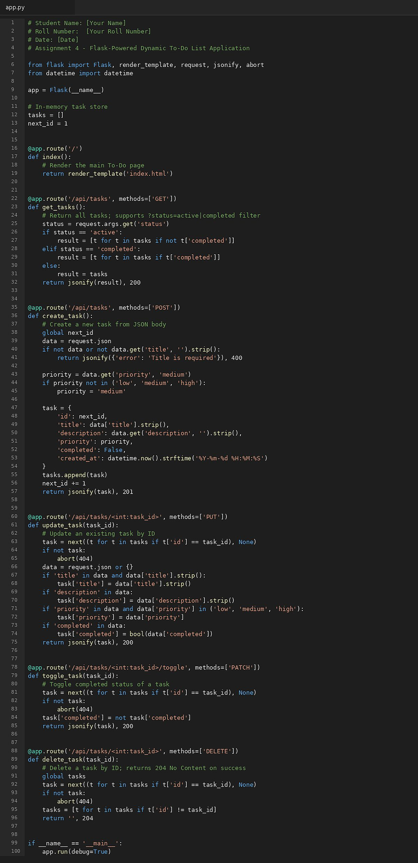

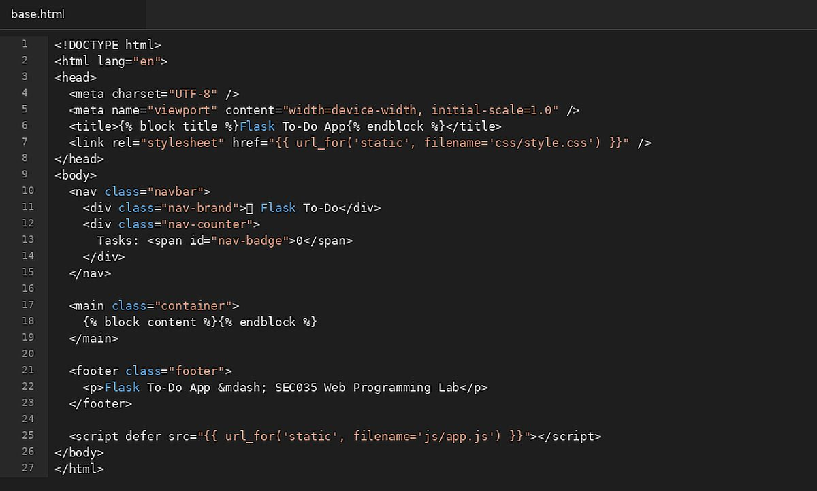

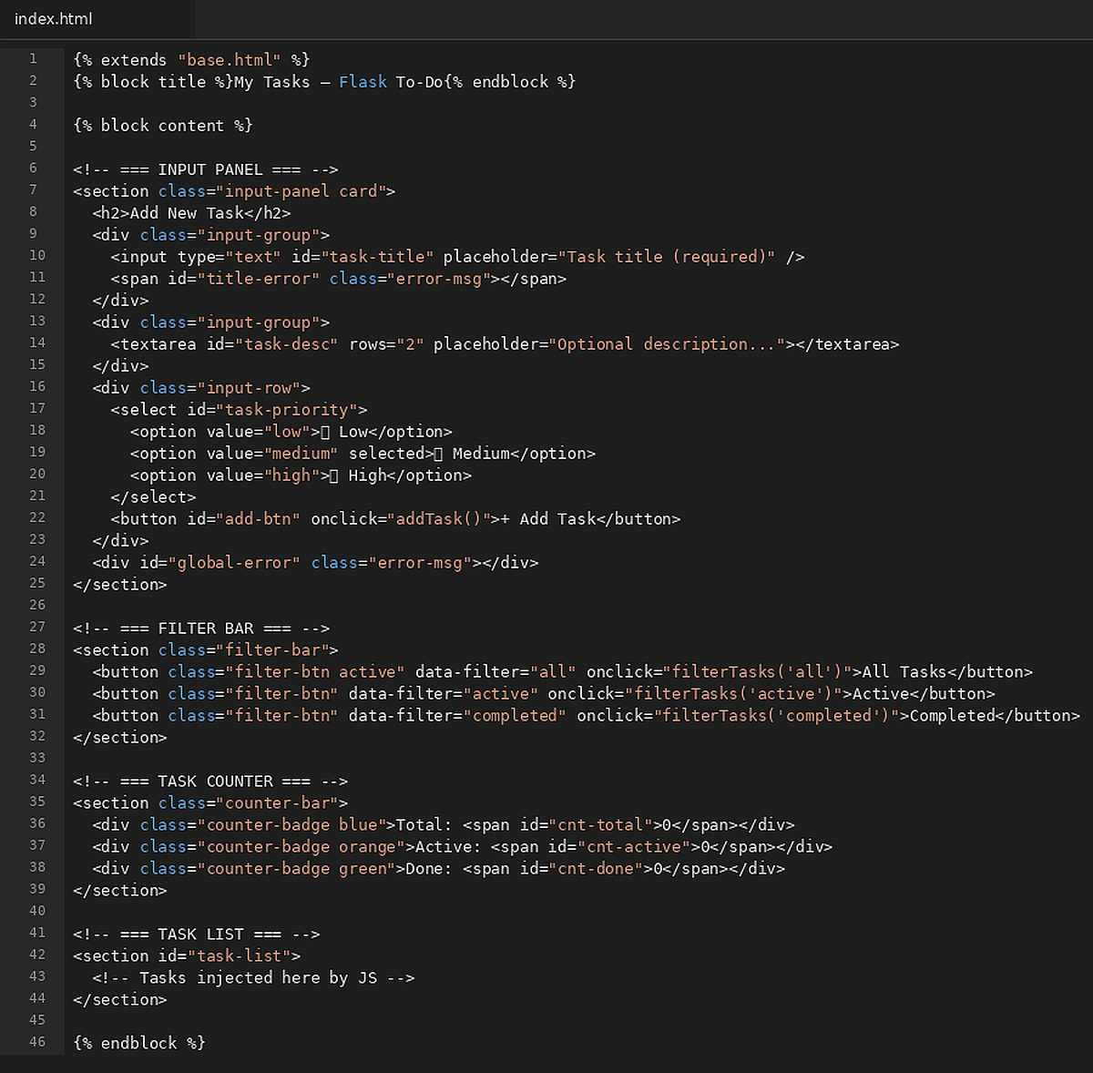

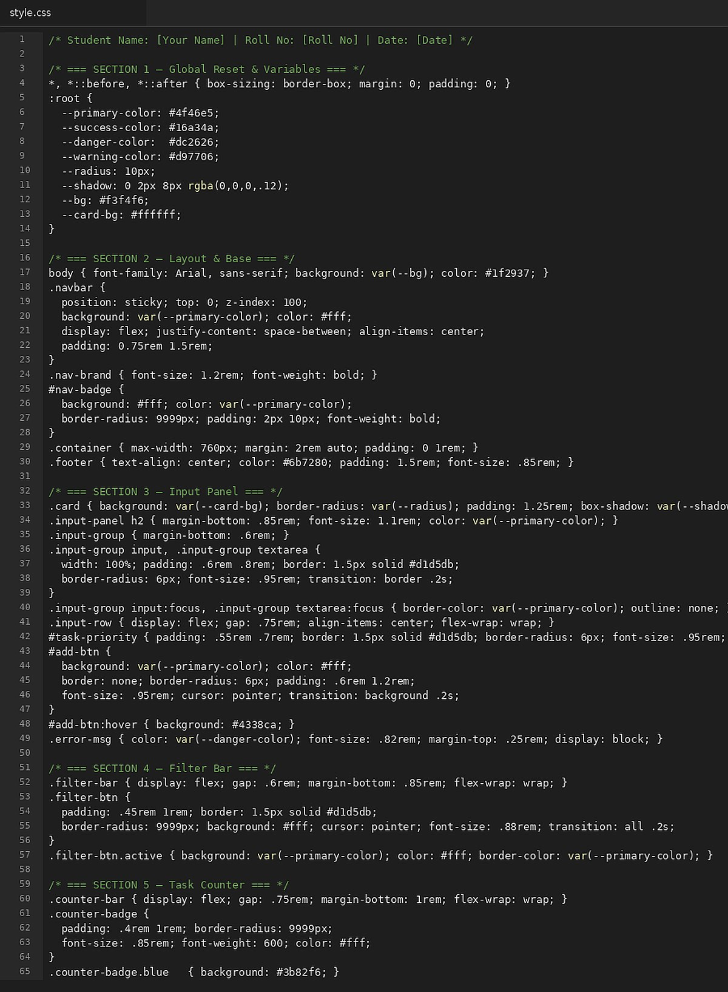

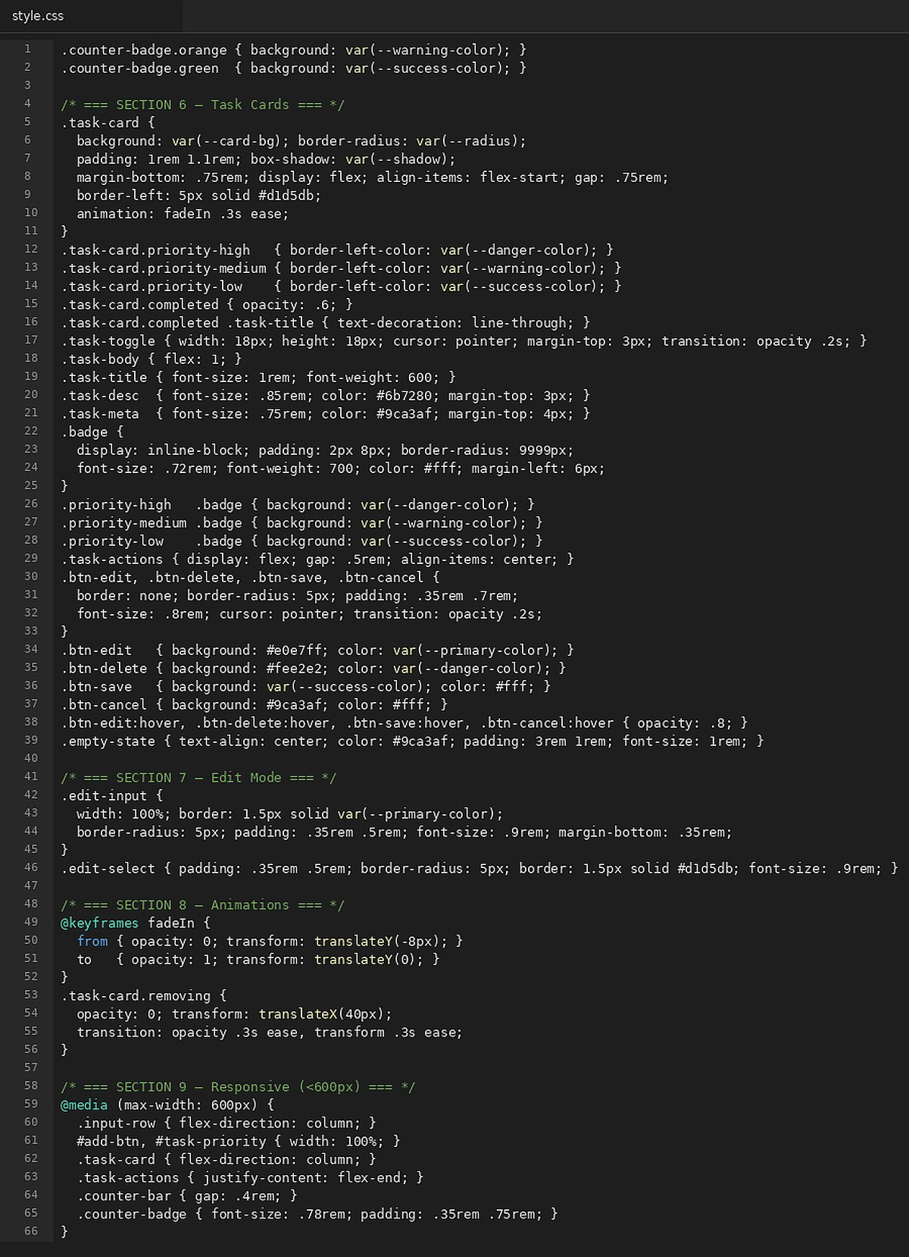

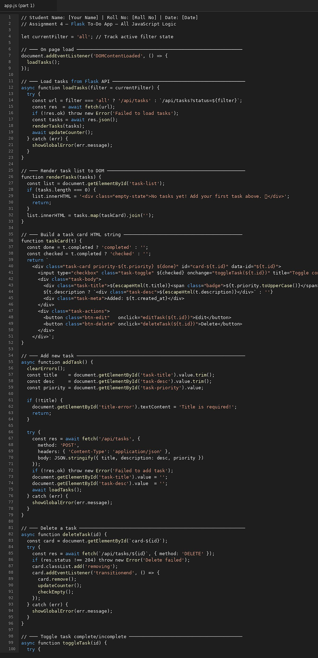
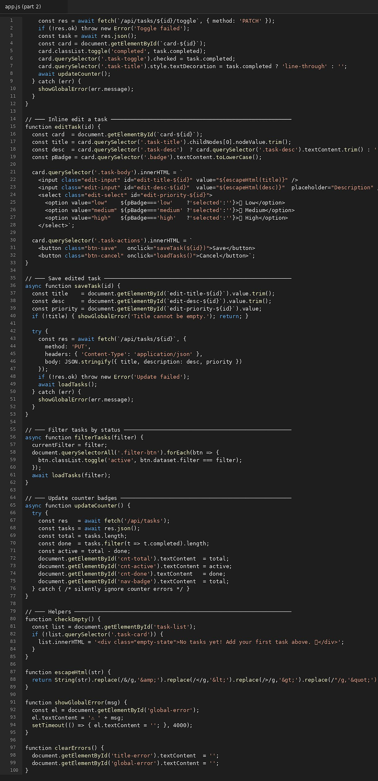

OUTPUT
