**MSDS-7330 File Organization & Database Management**

**Mini Project-2**

**Rashmi Patel**

1) Produce a list of all the students in the student relation, including their ID, name and department name, sorted into ascending order by their name.

**Input:**

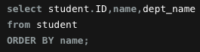

**Output:**

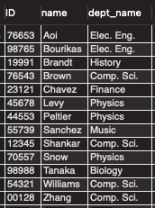

2) Produce a list of the names and salaries of professors in the Comp. Sci. and Elec. Eng. departments ordered by decreasing salary

**Input:**

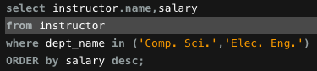

**Output:**

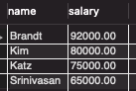

3) Find all courses whose identifier starts with the string ”CS-1”

**Input:**



**Output:**

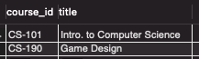

4) Find the maximum and minimum enrollment across all sections, considering only sections

that had some enrollment, don’t worry about those that had no students taking that section

**Input:**



**Output:**

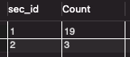

5) Create a view faculty showing only the ID, name, and department of instructors.

**Input:**



**Output:**

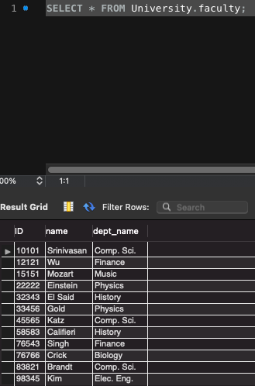

6) Create a view “CSinstructors”, showing all information about instructors from the Comp.

Sci. department.

**Input:**

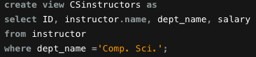

**Output:**

