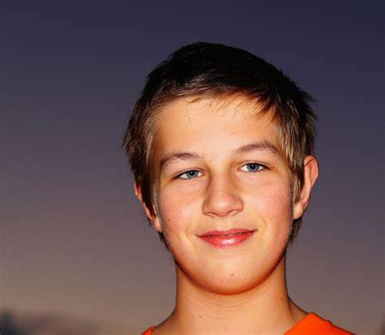

image_path = "/content/drive/MyDrive/Colab Notebooks/images/ronny.jpeg"

target_size = (96, 96)

image = tf.io.read_file(image_path)

image = tf.image.decode_image(image, channels=3)

resized_image = tf.image.resize(image, target_size)

resized_image_numpy = resized_image.numpy().astype(np.uint8)

temp_image_path = "resized_ronny.jpeg"

cv2.imwrite(temp_image_path, cv2.cvtColor(resized_image_numpy, cv2.COLOR_RGB2BGR))

|  |
| --- |
|  |

|  |
| --- |
| It's ronny, welcome home! (0.0, True) |

image_path = "/content/drive/MyDrive/Colab Notebooks/images/ronny_2.jpeg"

target_size = (96, 96)

image = tf.io.read_file(image_path)

image = tf.image.decode_image(image, channels=3)

resized_image = tf.image.resize(image, target_size)

resized_image_numpy = resized_image.numpy().astype(np.uint8)

temp_image_path = "resized_ronny.jpeg"

cv2.imwrite(temp_image_path, cv2.cvtColor(resized_image_numpy, cv2.COLOR_RGB2BGR))

verify(temp_image_path, "ronny", database, FRmodel)

|  |
| --- |
| It's not ronny, please go away (0.86885124, False) |

image_path = "/content/drive/MyDrive/Colab Notebooks/images/ronny.jpeg"

target_size = (96, 96)

image = tf.io.read_file(image_path)

image = tf.image.decode_image(image, channels=3)

resized_image = tf.image.resize(image, target_size)

resized_image_numpy = resized_image.numpy().astype(np.uint8)

temp_image_path = "resized_ronny.jpeg"

cv2.imwrite(temp_image_path, cv2.cvtColor(resized_image_numpy, cv2.COLOR_RGB2BGR))

output = who_is_it(temp_image_path, database, FRmodel)

it's ronny, the distance is 0.0

{'danielle': 1.1203943, 'younes': 0.9498303, 'tian': 1.127015, 'andrew': 0.89993286, 'kian': 0.6634865, 'dan': 0.8696159, 'sebastiano': 0.80749273, 'bertrand': 0.96896297, 'kevin': 0.7329034, 'felix': 0.9931094, 'benoit': 0.7144221, 'arnaud': 0.78297764, 'ronny': 0.0}