Student Depression Prediction Using Machine Learning

Table of Contents
1. Introduction and Problem Statement 6
1.1 Problem Statement 6
1.2 Objectives 6
2. Dataset Description 7
2.1 Source and Overview 7
2.2 Feature Description 7
2.3 Dataset Limitations and Potential Bias Sources 8
Self-Reporting Bias 8
Demographic Bias 8
Sampling Bias 8
Class Imbalance 8
Privacy and Ethical Concerns 8
3. Data Preprocessing and Exploratory Data Analysis (EDA) 9
3.1 Missing Value and Duplicate Handling 9
Purpose 9
Technique Used 9
EDA Visualization 9
Findings 10
3.2 Categorical Variable Encoding 10
Purpose 10
Techniques Used 10
EDA Visualization 11
Findings 12
3.3 Outlier Detection and Treatment 12
Purpose 12
Techniques Used 12
EDA Visualization 12
Findings 13
3.4 Feature Scaling 13
Purpose 13
Technique Used 13
EDA Visualization 13
Findings 14
3.5 Feature Engineering and Feature Selection 14
Purpose 14
Feature Engineering 14
Feature Selection Methods 14
EDA Visualization 14
Findings 15
3.6 Class Imbalance Analysis 15
Purpose 15
Technique Used 15
Decision Rule 15
Result 15
EDA Visualization 16
Findings 16
3.7 Summary 16
4. Model Design and Implementation 17
4.1 XGBoost Classifier 17
Model Description 17
Hyperparameter Tuning 17
Figures 17
4.2 Random Forest Classifier 18
Model Description 18
Hyperparameter Tuning 18
Figures 18
4.3 Decision Tree Classifier 19
Model Description 19
Hyperparameter Tuning 19
Figures 19
4.4 Logistic Regression 20
Model Description 20
Hyperparameter Tuning 21
Figures 21
4.5 Support Vector Machine (SVM) 22
Model Description 22
Hyperparameter Tuning 22
Figures 22
5. Evaluation and Comparison 23
5.1 Model Comparison 23
Table 5.1: Performance Comparison of Models 23
Interpretation 23
Interpretation 24
5.2 Validation Strategy 24
5.3 Evaluation Metrics 24
5.4 Key Findings 25
6. Ethical Considerations and Bias Mitigation 26
6.1 Identified Bias Sources 26
6.2 Bias Mitigation Strategies 26
6.3 Fairness and Ethical Principles 26
7. Reflections and Lessons Learned 28
7.1 Technical Learnings 28
7.2 Ethical Learnings 28
7.3 Challenges 28
7.4 Future Improvements 28
8. References 29

1. Introduction and Problem Statement
Student mental health has become a major concern worldwide [9], with depression affecting academic performance, social relationships, and overall quality of life. Early identification of students who may be at risk of depression can help educational institutions provide timely support and intervention.
This project uses machine learning techniques to predict whether a student is likely to experience depression based on demographic, academic, lifestyle, and mental health-related factors. By analyzing survey-based data, the study aims to develop an accurate prediction model while considering ethical issues such as fairness, privacy, and bias.

1.1 Problem Statement
Traditional methods of identifying depression often rely on clinical assessments or self-reported questionnaires, which can be time-consuming, expensive, and difficult to access for large student populations. An AI-based prediction system can assist institutions in identifying at-risk students more efficiently.
However, using AI in mental health prediction introduces challenges. Certain features such as gender, city, or profession may unintentionally create bias in the model, leading to unfair predictions. Therefore, it is important to develop a system that is both accurate and ethically responsible.

1.2 Objectives
- Develop machine learning models to predict student depression.
- Perform data preprocessing and exploratory data analysis (EDA).
- Identify important factors associated with depression.
- Evaluate and compare different classification algorithms.
- Analyze potential biases and ethical concerns in the prediction system.
- Select the most suitable model for student depression prediction.

2. Dataset Description

2.1 Source and Overview
The dataset used in this study is the Student Depression Dataset, available on Kaggle [1].
Dataset Source:
Student Depression Dataset (Kaggle)
The dataset contains survey responses collected from students and includes information related to demographics, academics, lifestyle habits, stress levels, and mental health indicators. The target variable is Depression, which indicates whether a student is experiencing depression.
Attribute | Details
Dataset Name | Student Depression Dataset
Total Records | 27,901
Total Features | 18 Columns
Target Variable | Depression (0 = No, 1 = Yes)
Data Type | Numerical and Categorical
Source | Kaggle – Student Depression Dataset

2.2 Feature Description
The dataset includes the following key features:
Feature | Description
Gender | Student gender (Male/Female)
Age | Age of the student
City | Student's city of residence
Profession | Current occupation status
Academic Pressure | Level of academic pressure
Work Pressure | Level of work-related pressure
CGPA | Academic performance score
Study Satisfaction | Satisfaction with studies
Job Satisfaction | Satisfaction with work/job
Sleep Duration | Average sleep duration
Dietary Habits | Quality of eating habits
Degree | Academic qualification
Have you ever had suicidal thoughts? | Yes/No indicator
Work/Study Hours | Average daily study/work hours
Financial Stress | Financial stress level
Family History of Mental Illness | Family history indicator
Depression | Target variable (0 = No, 1 = Yes)

2.3 Dataset Limitations and Potential Bias Sources
Several limitations and potential sources of bias exist within the dataset:

Self-Reporting Bias
The dataset is based on survey responses. Participants may provide inaccurate or incomplete information, which can affect prediction accuracy.

Demographic Bias
Variables such as Gender, City, and Profession may influence predictions and could result in unfair outcomes for certain groups.

Sampling Bias
The dataset may not represent all student populations globally, limiting the model's ability to generalize across different regions and cultures.

Class Imbalance
The number of depressed and non-depressed students may not be perfectly balanced, which can affect model performance and prediction fairness.

Privacy and Ethical Concerns
Mental health data is highly sensitive. Any AI system developed using this dataset must ensure data privacy, confidentiality, and responsible use of predictions.

3. Data Preprocessing and Exploratory Data Analysis (EDA)

3.1 Missing Value and Duplicate Handling

Purpose
The first preprocessing step focused on identifying missing values and duplicate records to improve data quality and ensure reliable analysis.

Technique Used
- The dataset was checked for missing values using isna().sum().
- If missing values were present:
  - Numerical attributes were imputed using the median.
  - Categorical attributes were imputed using the mode.
- Duplicate records were identified using duplicated() and removed if detected.

EDA Visualization
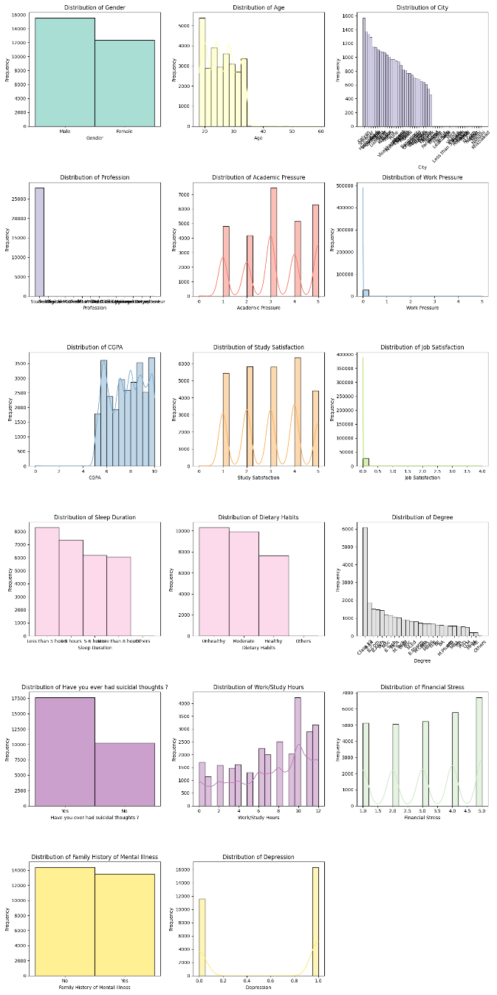
Figure 3.1: Distribution of Dataset Features
The visualization displays histograms and frequency distributions for:
- Gender
- Age
- City
- Profession
- Academic Pressure
- Work Pressure
- CGPA
- Study Satisfaction
- Job Satisfaction
- Sleep Duration
- Dietary Habits
- Degree
- Suicidal Thoughts
- Work/Study Hours
- Financial Stress
- Family History of Mental Illness
- Depression

Findings
- The dataset contained no significant missing values.
- No duplicate records were identified.
- The distributions provided an initial understanding of student demographics, academic characteristics, and mental health indicators.

3.2 Categorical Variable Encoding

Purpose
Machine learning algorithms require numerical input. Therefore, all categorical variables were transformed into numerical representations.

Techniques Used

Label Encoding

Applied to:
- Gender
- Have you ever had suicidal thoughts?
- Family History of Mental Illnes

One-Hot Encoding
Applied to:
- Profession

Ordinal Encoding
Applied to:
- Sleep Duration
Category | Encoded Value
Others | 0
Less than 5 hours | 1
5–6 hours | 2
7–8 hours | 3
More than 8 hours | 4
- Dietary Habits
Category | Encoded Value
Others | 0
Unhealthy | 1
Moderate | 2
Healthy | 3

Binary Encoding
Applied to:
- Degree

Target Encoding
Applied to:
- City

EDA Visualization
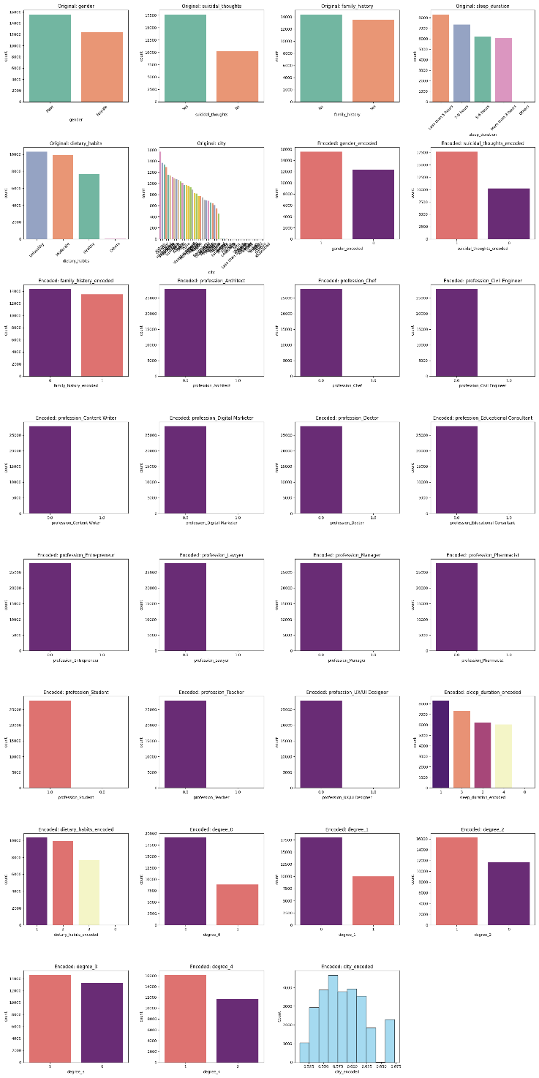
Figure 3.2: Original vs Encoded Feature Distributions
The visualization compares:
- Original categorical variables.
- Corresponding encoded numerical variables.

Findings
- All categorical features were successfully transformed.
- Ordinal relationships were preserved for sleep duration and dietary habits.
- Target encoding reduced the dimensionality of the City feature.

3.3 Outlier Detection and Treatment

Purpose
To reduce the impact of extreme values while preserving meaningful information.

Techniques Used

IQR-Based Removal
Applied to:
- Age
- CGPA
- Work/Study Hours
The Interquartile Range (IQR) method was used to remove observations outside:
Q1 - 1.5(IQR) and Q3 + 1.5(IQR)

Clipping
Applied to:
- Academic Pressure
- Work Pressure
- Study Satisfaction
- Job Satisfaction
- Financial Stress
Values were restricted to the valid range:
0 \le x \le 5

Winsorization
Applied to:
- City Encoded
Values were capped between the 5th and 95th percentiles.

EDA Visualization
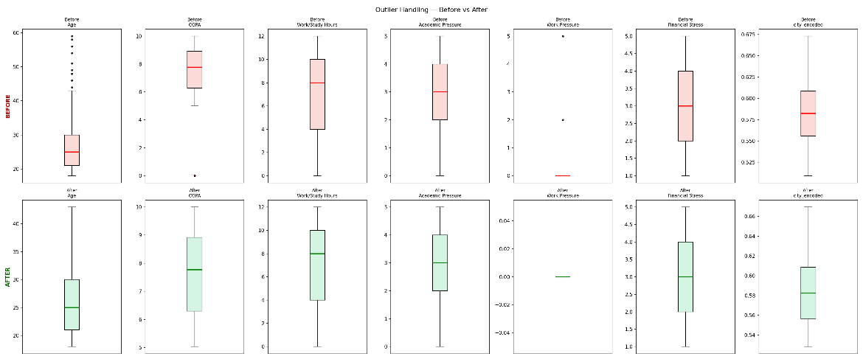
Figure 3.3: Boxplots Before and After Outlier Handling
The boxplots compare:
- Age
- CGPA
- Work/Study Hours
- Academic Pressure
- Work Pressure
- Financial Stress
- City Encoded
before and after treatment.

Findings
- Extreme values in Age, CGPA, and Work/Study Hours were removed.
- Pressure and stress-related variables were constrained to their valid scale.
- City encoded values were stabilized through winsorization.

3.4 Feature Scaling

Purpose
To standardize numerical variables and eliminate differences in measurement scales.

Technique Used

StandardScaler
The following attributes were standardized:
- Age
- CGPA
- Work/Study Hours
- City Encoded
- Academic Pressure
- Work Pressure
- Study Satisfaction
- Job Satisfaction
- Financial Stress
The transformation converts each feature to:
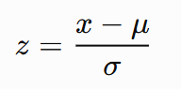
where:
- μ = mean
- σ = standard deviation

EDA Visualization
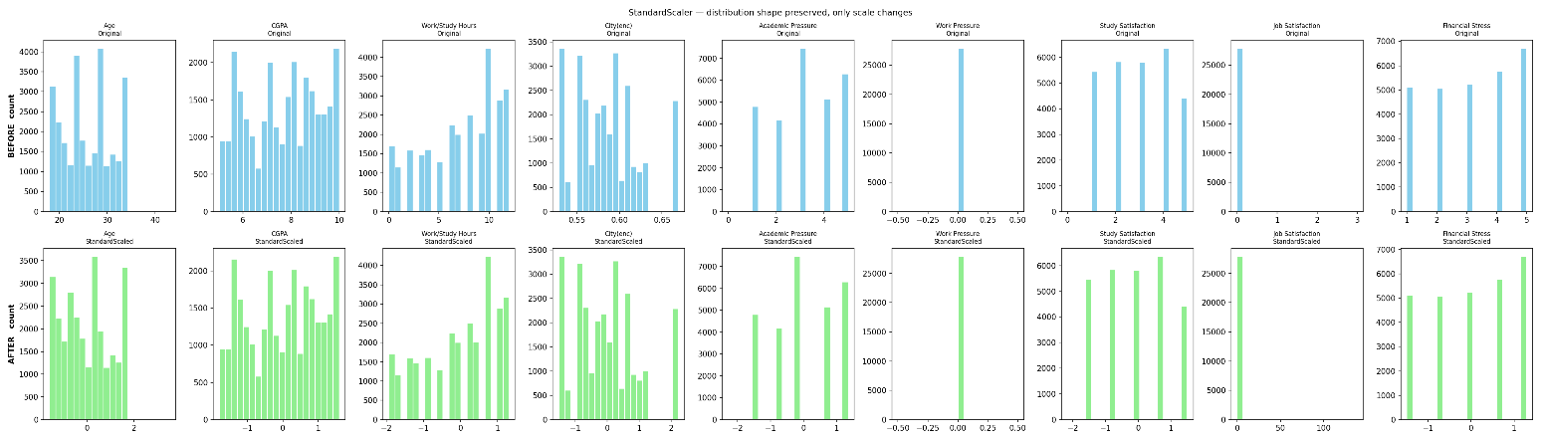
Figure 3.4: Histograms Before and After Standard Scaling
The visualization compares original and standardized distributions for all scaled features.

Findings
- Distribution shapes remained unchanged.
- Features were standardized with mean ≈ 0 and standard deviation ≈ 1.
- Scaling prepared the dataset for algorithms sensitive to feature magnitude.

3.5 Feature Engineering and Feature Selection

Purpose
To identify the most informative variables and reduce unnecessary complexity.

Feature Engineering
A new feature named Total_Stress was engineered by averaging the standardized Academic Pressure, Work Pressure, and Financial Stress variables. This feature was designed to represent the overall stress level experienced by a student and was included in the feature selection process.

Feature Selection Methods
Three techniques were combined:

Correlation Analysis
Measured relationships between features and Depression.

Mutual Information
Measured information gain between features and target.

Random Forest Feature Importance
Ranked features according to predictive importance.
The final feature set was selected from the union of the top features identified by all three methods.

EDA Visualization
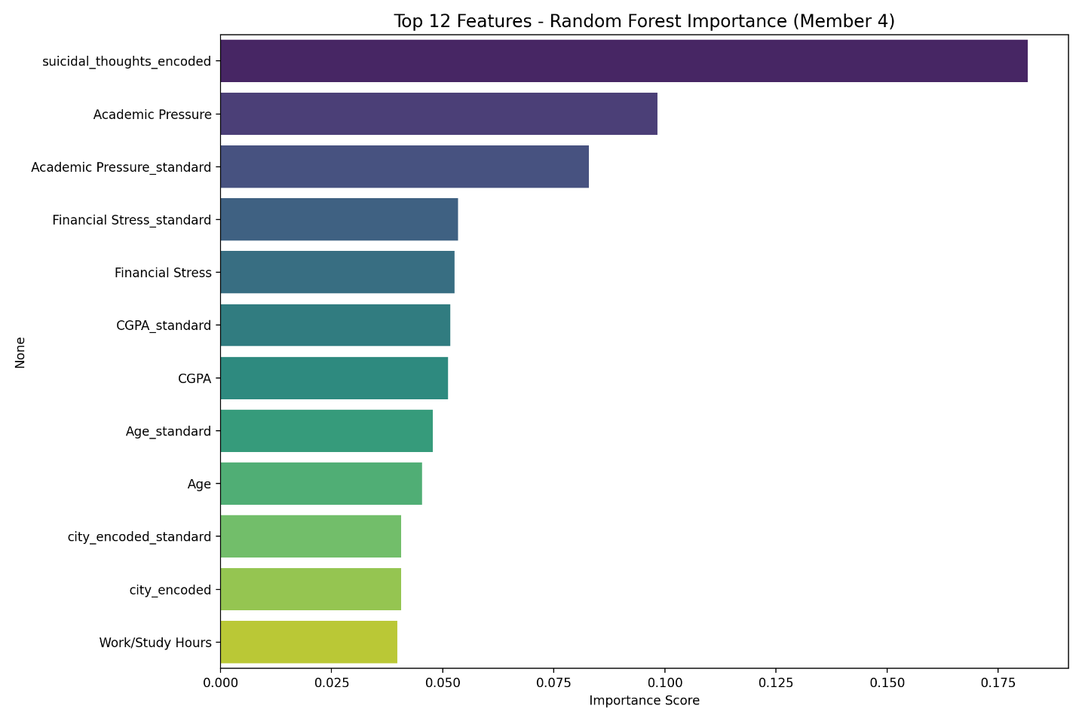
Figure 3.5: Random Forest Feature Importance
Shows the 12 most influential predictors.
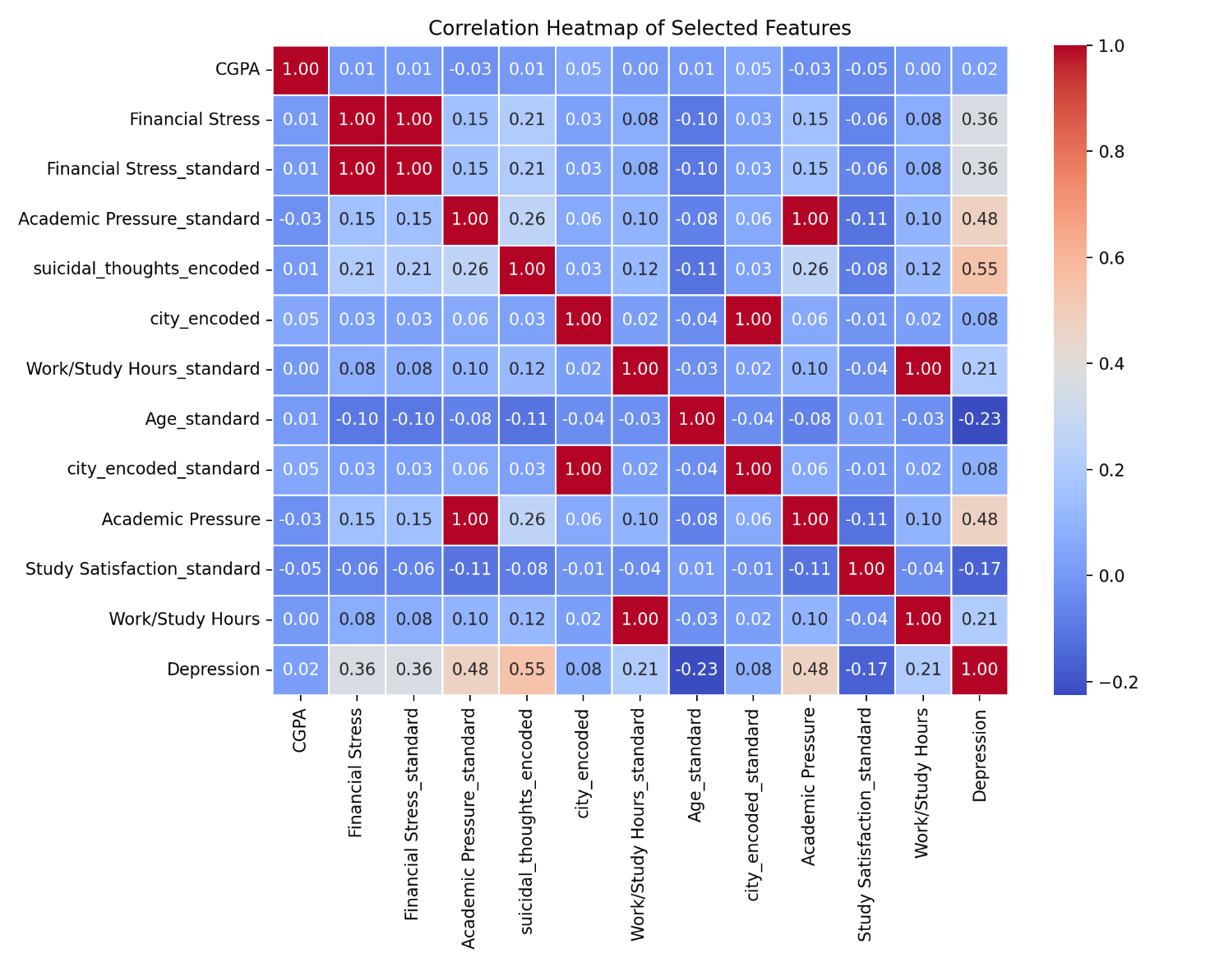
Figure 3.6: Correlation Heatmap
Displays correlations among selected features and the target variable.

Findings
The analysis identified the most influential variables for depression prediction. According to the preprocessing pipeline, Academic Pressure, Financial Stress, and Total_Stress were among the strongest predictors.

3.6 Class Imbalance Analysis

Purpose
To evaluate whether the target variable required balancing before model training.

Technique Used
Class proportions were calculated using:
value_counts(normalize=True)
A threshold of 40% was used to determine whether SMOTE should be applied.

Decision Rule
- If minority class < 40% → Apply SMOTE.
- If minority class ≥ 40% → Do not apply SMOTE.

Result
The minority class proportion exceeded the 40% threshold.
Therefore:
- SMOTE was not applied.
- Original class distribution was retained.
- Class weighting was recommended during model training.

EDA Visualization
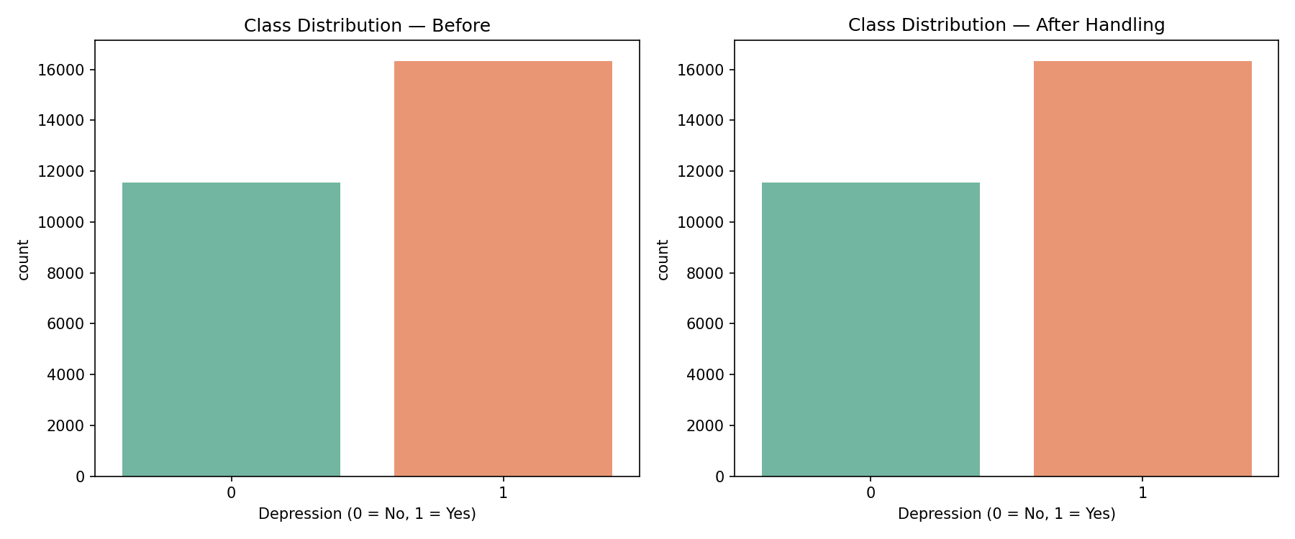
Figure 3.7: Class Distribution Before and After Handling
Displays class frequencies for:
- Depression = 0
- Depression = 1

Findings
- The dataset exhibited only mild class imbalance.
- Total_Stress showed a noticeable difference between depressed and non-depressed students.
- Maintaining the original data avoided potential overfitting caused by synthetic samples.

3.7 Summary
The preprocessing pipeline consisted of data cleaning, categorical encoding, outlier treatment, feature scaling, feature engineering, feature selection, and class imbalance analysis. EDA visualizations at each stage confirmed the effectiveness of the preprocessing methods and highlighted the importance of stress-related variables in predicting student depression. This processed dataset was subsequently used for machine learning model development and evaluation.

4. Model Design and Implementation
Five machine learning classification models were developed and evaluated using the final preprocessed Student Depression Dataset. The dataset was divided into training and testing subsets using an 80:20 stratified train-test split with random_state = 42 to preserve the class distribution.
To ensure robust model evaluation, 5-Fold Stratified Cross-Validation was performed for each model. Hyperparameter tuning was conducted using GridSearchCV, with the F1-score used as the optimization metric because of its balance between precision and recall in binary classification problems.
The five models evaluated were:
- XGBoost Classifier
- Random Forest Classifier
- Decision Tree Classifier
- Logistic Regression
- Support Vector Machine (SVM)

4.1 XGBoost Classifier

Model Description
XGBoost (Extreme Gradient Boosting) is an ensemble tree-based algorithm that combines multiple weak learners to produce a highly accurate classification model [3]. It is effective for structured tabular data, handles non-linear relationships, and includes built-in regularization mechanisms to reduce overfitting.

Hyperparameter Tuning
Parameter | Values Tested
n_estimators | {100, 200, 300}
max_depth | {3, 5, 7}
learning_rate | {0.05, 0.1, 0.2}
subsample | {0.8, 0.9, 1.0}
colsample_bytree | {0.8, 1.0}

Figures
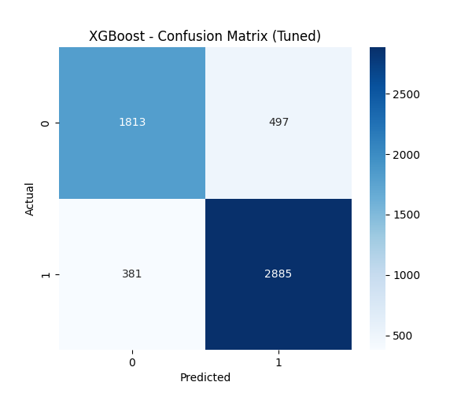
Figure 4.1: XGBoost – Confusion Matrix (Tuned)
This confusion matrix presents the classification results of the tuned XGBoost model by comparing actual depression labels with predicted labels. It illustrates the number of true positives, true negatives, false positives, and false negatives.
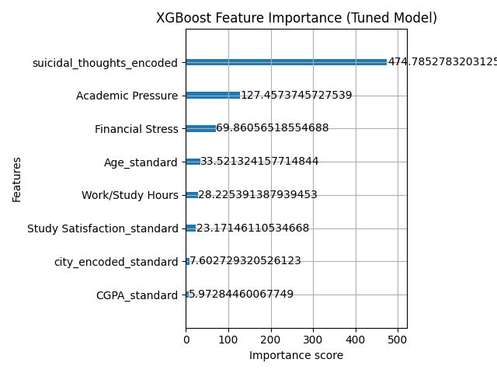
Figure 4.2: XGBoost Feature Importance (Tuned Model)
This visualization ranks the most influential features based on gain importance. It helps identify which variables contribute most strongly to depression prediction.

4.2 Random Forest Classifier

Model Description
Random Forest is an ensemble learning algorithm that combines multiple decision trees through bagging and random feature selection [4]. It is robust against overfitting and provides feature importance measures that improve model interpretability.

Hyperparameter Tuning
Parameter | Values Tested
n_estimators | {200, 300}
max_depth | {8, 10, 12, None}
min_samples_split | {5, 10}
min_samples_leaf | {2, 4}
max_features | {sqrt, log2}

Figures
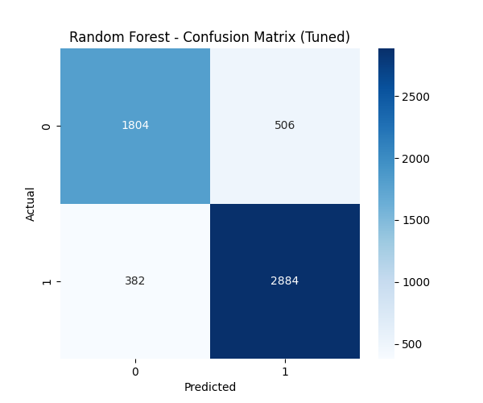
Figure 4.3: Random Forest – Confusion Matrix (Tuned)
This figure shows the classification performance of the tuned Random Forest model by comparing predicted and actual class labels.
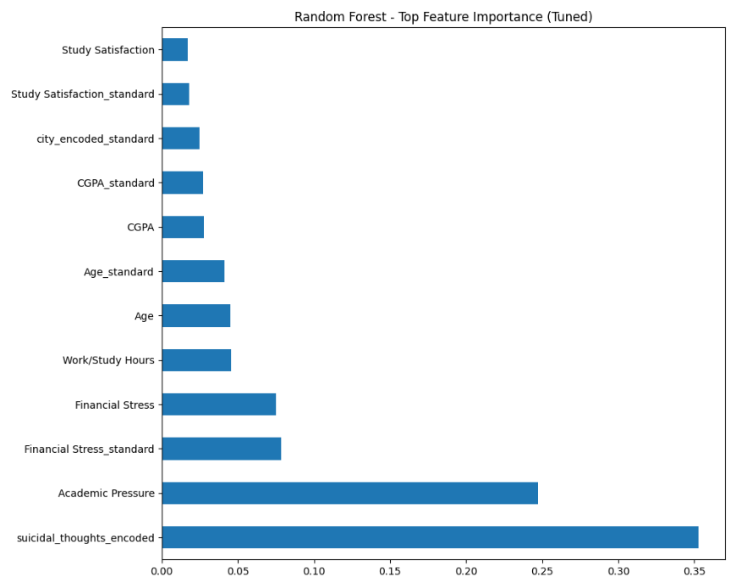
Figure 4.4: Random Forest – Top Feature Importance (Tuned)
This feature importance chart displays the variables that contributed most significantly to depression prediction according to the Random Forest model.

4.3 Decision Tree Classifier

Model Description
Decision Tree is a white-box classification model that generates human-readable decision rules [5]. It is particularly useful in mental health applications where model transparency and explainability are important.

Hyperparameter Tuning
Parameter | Values Tested
max_depth | {3, 5, 8, 10, 15, None}
min_samples_split | {2, 5, 10}
min_samples_leaf | {1, 2, 4, 8}
criterion | {gini, entropy}
max_features | {sqrt, log2, None}

Figures
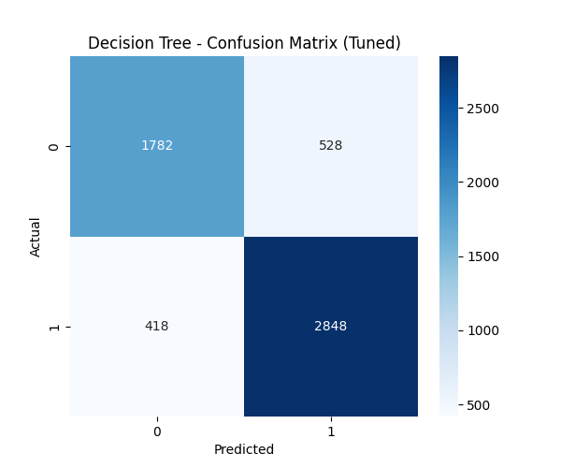
Figure 4.5: Decision Tree – Confusion Matrix (Tuned)
This confusion matrix illustrates the prediction accuracy of the tuned Decision Tree model.
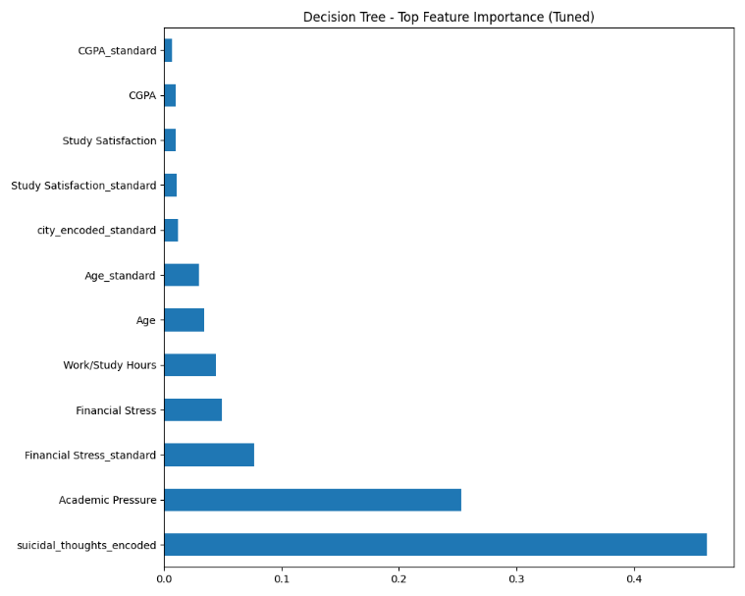
Figure 4.6: Decision Tree – Top Feature Importance (Tuned)
This chart identifies the most important predictors selected by the Decision Tree algorithm.

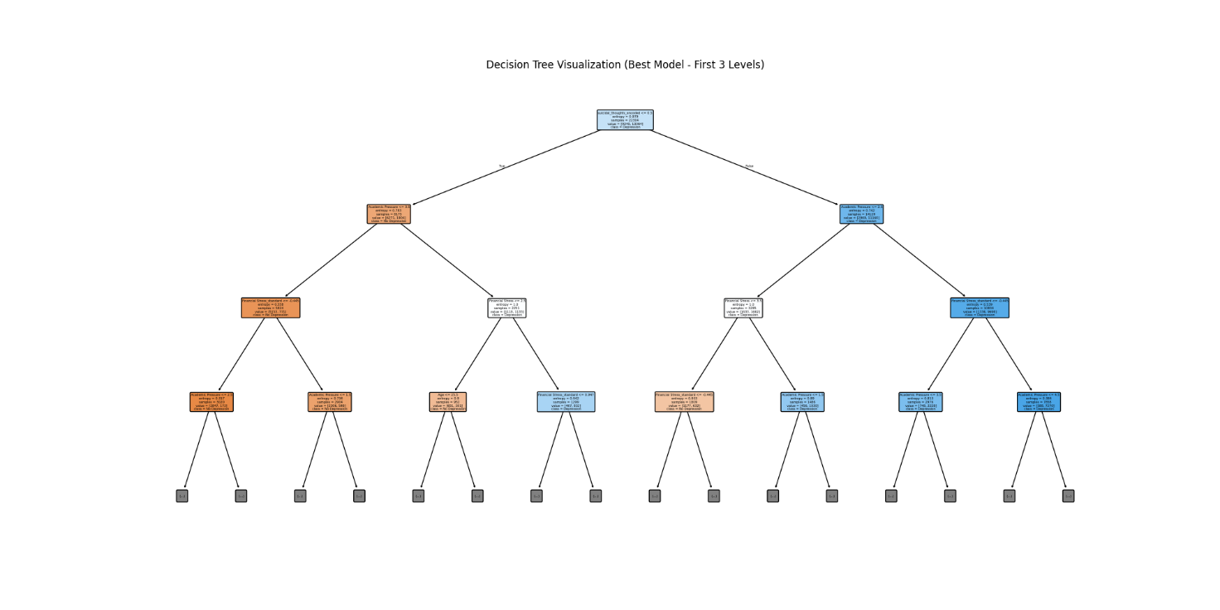
Figure 4.7: Decision Tree Visualization (Best Model – First 3 Levels)
The visualization displays the top three levels of the optimized Decision Tree, allowing users to understand the decision rules used for classification.

4.4 Logistic Regression

Model Description
Logistic Regression was implemented as a linear baseline model for binary classification [6]. It is computationally efficient and provides interpretable coefficients that indicate the influence of each feature on depression prediction.

Hyperparameter Tuning
Parameter | Values Tested
Penalty | {L1, L2, ElasticNet}
Solver | {liblinear, saga}
C | {0.01, 0.1, 1, 10, 100}
max_iter | {1000, 2000}
l1_ratio | {0.1, 0.5, 0.9} (ElasticNet only)

Figures
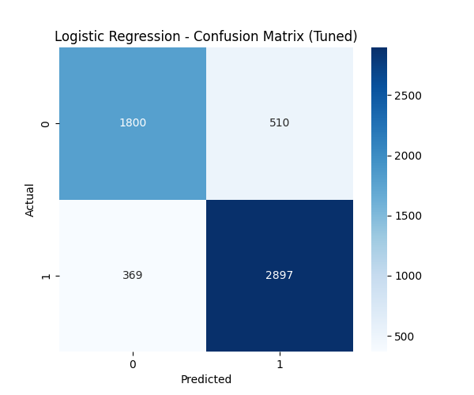
Figure 4.8: Logistic Regression – Confusion Matrix (Tuned)
This figure presents the classification outcomes of the optimized Logistic Regression model.
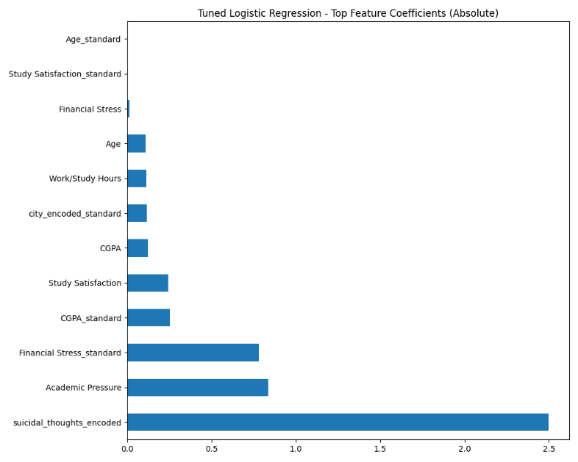
Figure 4.9: Tuned Logistic Regression – Top Feature Coefficients (Absolute)
This coefficient plot highlights the most influential variables by examining the absolute magnitude of model coefficients.

4.5 Support Vector Machine (SVM)

Model Description
A linear Support Vector Machine was implemented using a pipeline consisting of StandardScaler and SVM. The linear kernel was selected to improve interpretability and computational efficiency.

Hyperparameter Tuning
Parameter | Values Tested
C | {0.1, 1, 10, 100}

Figures
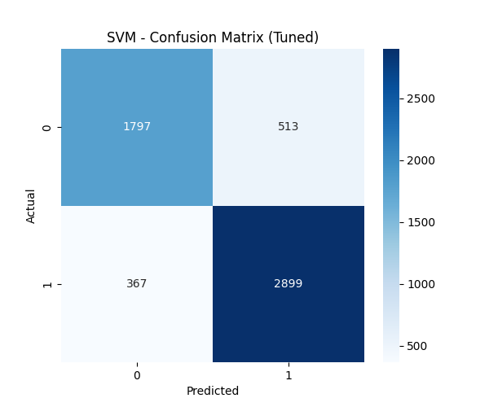
Figure 4.10: SVM – Confusion Matrix (Tuned)
The confusion matrix summarizes the classification performance of the tuned SVM model.
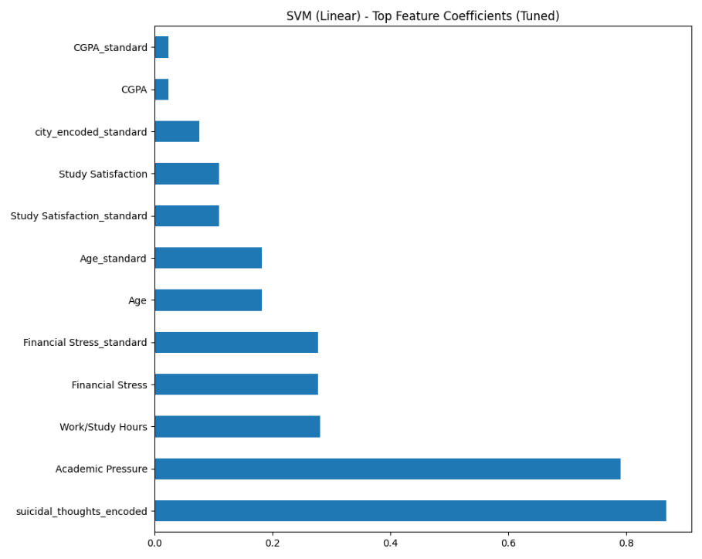
Figure 4.11: SVM (Linear) – Top Feature Coefficients (Tuned)
This coefficient plot shows the most influential variables identified by the linear SVM model.

5. Evaluation and Comparison
All five machine learning models were evaluated using Accuracy, F1-Score, and ROC-AUC Score. The models were trained using an 80:20 Stratified Train-Test Split, and 5-Fold Stratified Cross-Validation was used during hyperparameter tuning to ensure reliable performance.

5.1 Model Comparison
The performance of the trained models is summarized in Table 5.1.

Table 5.1: Performance Comparison of Models
Model | Accuracy | F1-Score | ROC-AUC | Prediction Time (s)
Logistic Regression | 0.8424 | 0.8683 | 0.9150 | 0.0072
SVM | 0.8422 | 0.8682 | 0.9151 | 4.1244
XGBoost | 0.8425 | 0.8679 | 0.9155 | 0.0385
Random Forest | 0.8407 | 0.8666 | 0.9131 | 0.4169
Decision Tree | 0.8303 | 0.8576 | 0.8972 | 0.0081

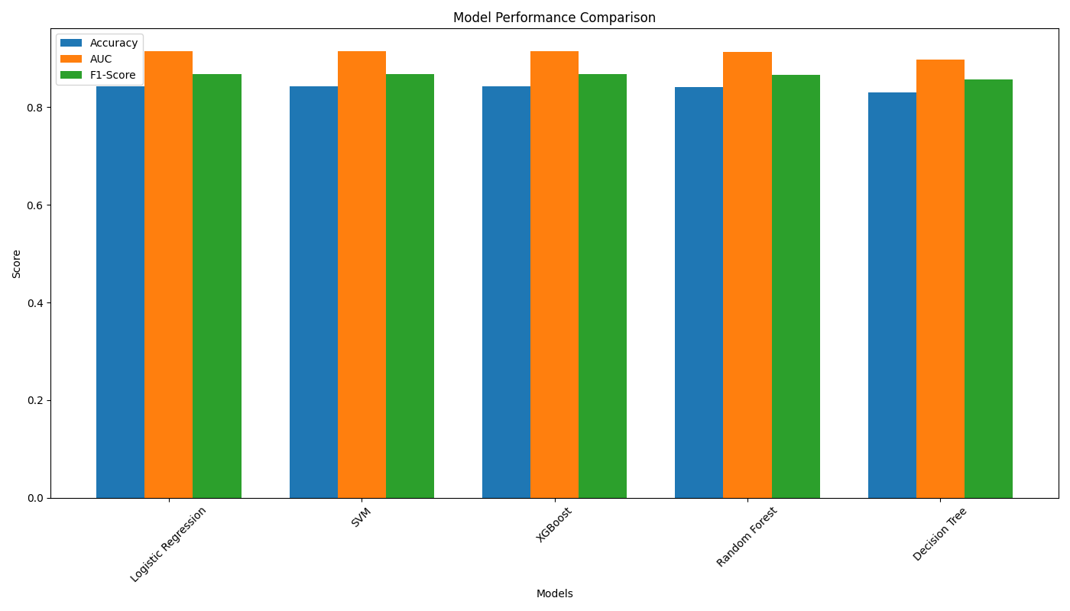

Figure 5.1: Model Performance Comparison

Interpretation
The results show that all models achieved similar performance. XGBoost obtained the highest Accuracy (84.25%) and ROC-AUC Score (0.9155), while Logistic Regression achieved the highest F1-Score (0.8683). The Decision Tree produced the lowest performance among the five models.

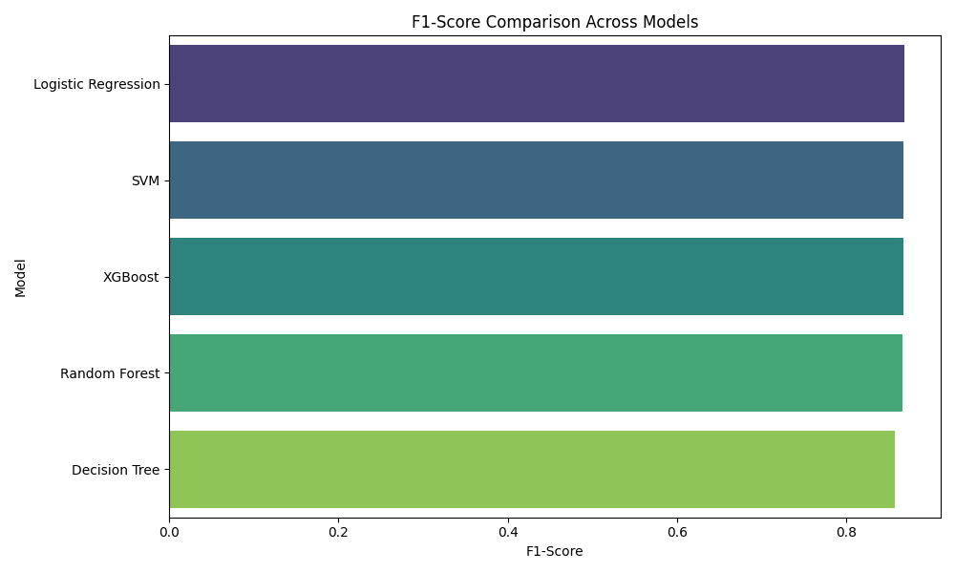

Figure 5.2: F1-Score Comparison

Interpretation
The F1-Score comparison indicates that all models performed similarly. Logistic Regression achieved the highest F1-Score, followed closely by SVM and XGBoost. This shows that the models maintained a good balance between precision and recall.

5.2 Validation Strategy
The dataset was divided using an 80:20 Stratified Train-Test Split, ensuring that both the training and testing datasets maintained the same class distribution.
To improve model performance, 5-Fold Stratified Cross-Validation was applied during hyperparameter tuning using GridSearchCV. This approach helped reduce overfitting and provided a reliable estimate of each model's performance.

5.3 Evaluation Metrics
The following metrics were used to evaluate the models:
- Accuracy: Measures the percentage of correctly classified instances.
- Precision: Measures how many predicted positive cases are actually positive.
- Recall: Measures how many actual positive cases are correctly identified.
- F1-Score: Balances Precision and Recall and was used as the main evaluation metric.
- ROC-AUC Score: Measures the model's ability to distinguish between depressed and non-depressed students. A higher value indicates better performance.

5.4 Key Findings
- XGBoost achieved the highest Accuracy (0.8425) and ROC-AUC Score (0.9155), showing strong overall predictive capability.
- Logistic Regression achieved the highest F1-Score (0.8683) and the fastest prediction time (0.0035 seconds), making it the most balanced and practical choice for this project.
- SVM produced performance similar to Logistic Regression but required significantly more prediction time.
- Random Forest performed well but was slightly less accurate than XGBoost.
- Decision Tree showed the lowest performance but remained easy to interpret.
Overall, after rigorous evaluation of five tuned models (XGBoost, Random Forest, Decision Tree, Logistic Regression, and SVM) on the test set, Logistic Regression emerged as the best-performing model with the highest F1-Score of 0.8683, an excellent AUC of 0.9150, and strong Accuracy of 0.8424.
Model Selection Decision:
We selected Logistic Regression as our final model for the student depression prediction system. The primary reason for this choice is its superior F1-Score, which was our main evaluation metric due to the potential class imbalance in mental health datasets and the need to balance Precision and Recall effectively.

Why Logistic Regression was Chosen:
- Highest F1-Score (0.8683): It outperformed all other models on our primary metric.
- Excellent Discriminative Power: AUC of 0.9150, very close to the top ensemble models.
- Superior Efficiency: Extremely fast prediction time (0.0035 seconds), making it highly suitable for real-time or large-scale deployment.
- Interpretability: As a linear model, it provides clear feature coefficients, allowing us to understand which factors most strongly influence depression predictions — an important requirement for ethical and transparent AI in healthcare/education.
- Simplicity and Practicality: Despite the strong performance of complex models like XGBoost and SVM, the performance gap was negligible. In such cases, the simpler and more interpretable model is preferred (Occam’s Razor principle).
While XGBoost showed slightly better Accuracy and AUC in some aspects and offers excellent overall balance, Logistic Regression was chosen as the final model because it delivers the best trade-off between performance, speed, and explainability.

6. Ethical Considerations and Bias Mitigation
Deploying AI for mental health screening introduces profound ethical responsibilities [4]. This section analyses bias sources, fairness concerns, and the mitigation strategies adopted in this project.

6.1 Identified Bias Sources
a) Data Collection Bias
The dataset was collected via self-reported surveys, which are subject to social desirability bias — students may underreport mental health struggles due to stigma. The geographic scope is not globally diverse, limiting the generalisability of models trained on this data.
b) Proxy Variable Bias
Variables such as 'City' (encoded using target encoding based on mean Depression rate) and 'Profession' may act as proxies for socioeconomic status or cultural background. This can cause the model to inadvertently discriminate based on where a student lives rather than their actual risk factors.
c) Labelling Bias
The binary Depression label is derived from survey responses and may not align with clinical diagnosis. Survey-based mental health labels carry inherent validity concerns, and models trained on them may not generalise to clinically-defined depression.
d) Algorithm Bias
XGBoost and Random Forest maximise overall accuracy, which may still misclassify minority groups at higher rates if their feature distributions differ from the majority [5]. Without fairness-aware training objectives, such models can perpetuate existing inequalities [6].

6.2 Bias Mitigation Strategies
- Stratified Splitting: Train-test split preserves class proportions, preventing evaluation bias.
- SMOTE Analysis: Class imbalance was evaluated; SMOTE [7] was not applied since imbalance was mild, avoiding synthetic data distortion.
- class_weight='balanced': Recommended for all models to ensure the minority class (non-depressed) is not underweighted during training.
- Multiple Metrics: F1-Score and AUC were prioritised over raw accuracy to avoid misleading evaluations under class imbalance.
- Feature Importance Analysis: Sensitive proxy features (City, Profession) were monitored; their encoded representations were scrutinised.
- Cross-Validation: 5-Fold Stratified CV reduces variance in evaluation and ensures consistent performance across data subsets.

6.3 Fairness and Ethical Principles
Privacy and Consent
Student mental health data is highly sensitive. Any real-world deployment must comply with data protection regulations (GDPR, Sri Lanka's Personal Data Protection Act). Informed consent must be obtained before any student data is used for model training or inference.
Transparency and Explainability
Decision Tree models and feature importance outputs from Random Forest and XGBoost provide a degree of explainability. For sensitive decisions like mental health flagging, black-box predictions should be accompanied by human review and clear explanation of the contributing factors.
Non-Maleficence and Stigma
A false positive (incorrectly flagging a student as depressed) can cause distress, stigma, and unnecessary intervention. A false negative (missing a student who is depressed) may delay critical support. Both error types carry ethical weight and must be balanced through careful threshold tuning based on institutional context.
Human Oversight
AI predictions should supplement, not replace, professional mental health assessment. Institutional policies must ensure a trained counsellor reviews AI flags before any action is taken.

7. Reflections and Lessons Learned
This project provided deep hands-on experience with the complete ML lifecycle — from raw data cleaning to model evaluation — while situating technical decisions within a broader ethical framework.

7.1 Technical Learnings
- Building a multi-step preprocessing pipeline with CSV handoffs between stages enforced modular thinking and made debugging significantly easier.
- Feature engineering (Total_Stress = mean of three stress indicators) improved feature signal and demonstrated the value of domain-informed feature creation over purely algorithmic approaches.
- Hyperparameter tuning with GridSearchCV was computationally expensive, highlighting the importance of a well-scoped search space. Random search or Bayesian optimisation would be more efficient for larger grids.
- XGBoost's native eval_metric='logloss' and built-in regularisation made it robust without extensive tuning, while the Decision Tree's tendency to overfit required careful depth constraints.
- Ordinal encoding of Sleep Duration required careful thought — mapping 'Others' to 0 rather than 4 was a critical correction to avoid implying maximum sleep duration for unknown values.

7.2 Ethical Learnings
- Identifying proxy bias in features like City and Profession required careful thinking beyond standard preprocessing steps — something not always considered in routine ML pipelines.
- The choice of evaluation metric carries ethical weight: optimising solely for accuracy in a mental health context is insufficient. F1-Score and Recall for the 'depressed' class are more ethically aligned metrics.
- The team recognised that even technically sound models require human oversight frameworks before deployment in sensitive domains.

7.3 Challenges
- Coordinating a six-member pipeline with CSV handoffs required careful version control and communication to avoid data inconsistencies between stages.
- Some encoding libraries (category_encoders) required explicit installation, causing compatibility issues in different environments.
- Balancing model complexity against interpretability — XGBoost performs best but is harder to explain to non-technical stakeholders than a Decision Tree.

7.4 Future Improvements
- Apply SHAP (SHapley Additive exPlanations) values for model-agnostic explainability across all models.
- Conduct a formal fairness audit using demographic parity, equal opportunity, and calibration metrics across gender subgroups.
- Explore deep learning approaches (MLP, Transformer-based tabular models) to further improve predictive performance.
- Collect longitudinal data to move from cross-sectional prediction to temporal risk modelling.
- Implement threshold tuning to optimise Recall for the depressed class, prioritising student safety over precision.

8. References
[1] hopesb, "Student Depression Dataset," Kaggle, 2024. [Online]. Available: https://www.kaggle.com/datasets/hopesb/student-depression-dataset/data. [Accessed: Jun. 20, 2026].

[2] F. Pedregosa et al., "Scikit-learn: Machine Learning in Python," Journal of Machine Learning Research, vol. 12, pp. 2825–2830, 2011.

[3] T. Chen and C. Guestrin, "XGBoost: A Scalable Tree Boosting System," in Proceedings of the 22nd ACM SIGKDD International Conference on Knowledge Discovery and Data Mining (KDD '16), San Francisco, CA, USA, 2016, pp. 785–794.

[4] S. Barocas, M. Hardt, and A. Narayanan, Fairness and Machine Learning: Limitations and Opportunities. Cambridge, MA, USA: MIT Press, 2023.

[5] Z. Obermeyer, B. Powers, C. Vogeli, and S. Mullainathan, "Dissecting racial bias in an algorithm used to manage the health of populations," Science, vol. 366, no. 6464, pp. 447–453, 2019.

[6] N. Mehrabi et al., "A Survey on Bias and Fairness in Machine Learning," ACM Computing Surveys, vol. 54, no. 6, pp. 1–35, 2021.

[7] N. V. Chawla, K. W. Bowyer, L. O. Hall, and W. P. Kegelmeyer, "SMOTE: Synthetic Minority Over-sampling Technique," Journal of Artificial Intelligence Research, vol. 16, pp. 321–357, 2002.

[8] J. Torous et al., "Towards a consensus understanding of smartphone-based passive sensing and mental health," World Psychiatry, vol. 20, no. 1, pp. 31–32, 2021.

