|  |
| --- |
| Big Data Hadoop & Spark Training |
| Assignment-1 |
|  |
|  |



# Task1-Start Hadoop single node on AcadGild VM.

Started Hadoop single node using the command start-all.sh. Below screenshot provides the output of the command.

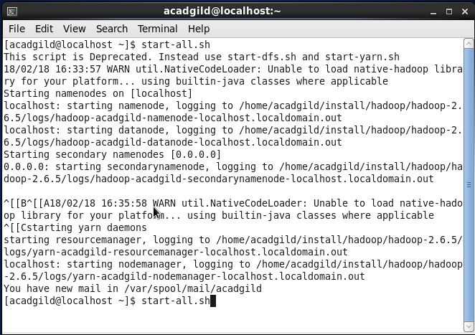

# Task2- Run a JPS command to see if all Hadoop daemons are running.

Jps command is used to check all the Hadoop daemons like NameNode, DataNode, ResourceManager, NodeManager etc. which are running on the machine

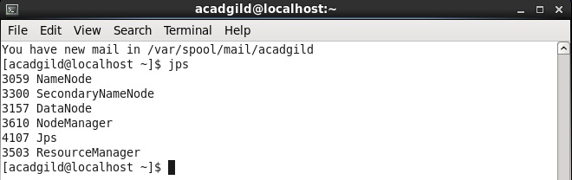

# Task3-Run few Unix commands like pwd, ls -ls, etc.

Used few unix commands which are as follows:-

* pwd-This provides the full path name of the current directory.
* ls- This provides the list of all files in the current directory
* man ls-This provides online manual help about command
* mkdir- This helps to make a new directory
* cd- This helps to change the directory
* cd ..-This helps to move back one directory

Screenshots of outputs of the above commands are as below:-

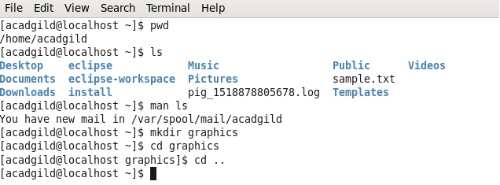

Below screenshot is the output for command” **man ls”,** this provides all details of the commands used in Unix. This is just a screen shot of 1st page.

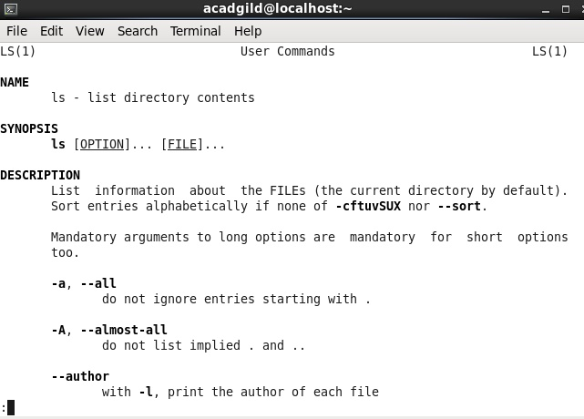

# Task 4-Create a file from the terminal using nano editor (example: nano test.txt), and add some content in it. Cat it to see if the content is saved.

Created a text file “***Sample.txt***” in **nano editor** and added the content ” *Hello all, welcome to Big Data Hadoop and spark training from acadgild!thank you*.”

Read the content of Sample.txt file using the command “*cat*”. Outputs are as shown below.

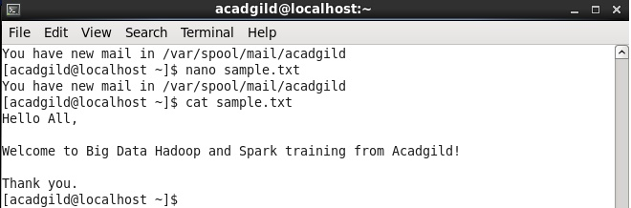

# Task5-Open the hdfs web page by typing localhost:50070 in the browser. Check all the details of the HDFS

Opened hdfs web page- “***localhost:50070***” to check all details of HDFS.

This page provides all details of HDFS like version, started date and time, name node status and so on as shown in the below screen shot.