Ticket Booking System

**Tasks 1: Database Design:**

1. Create the database named "TicketBookingSystem"
2. Write SQL scripts to create the mentioned tables with appropriate data types, constraints, and relationships.

Venue

Event

Customers

Booking

1.

CREATE DATABASE TicketBookingSystem;

USE TicketBookingSystem;

2.

CREATE TABLE Venue(

venue_id int NOT NULL PRIMARY KEY,

venue_name VARCHAR(30),

address VARCHAR(50)

);

CREATE TABLE Event(

event_id int NOT NULL PRIMARY KEY,

event_name VARCHAR(255),

event_date DATE,

event_time TIME,

venue_id int,

total_seats int(10000),

available_seats int(10000),

ticket_price DECIMAL(10,2),

event_type VARCHAR(40) CHECK (event_type IN('Movie','Sports','COncert')),

booking_id int,

FOREIGN KEY (venue_id) REFERENCES Venue(venue_id),

FOREIGN KEY ( booking_id) REFERENCES Booking(booking_id)

);

CREATE TABLE Customer(

customer_id int NOT NULL PRIMARY KEY,

customer_name VARCHAR(20),

email VARCHAR(30),

phone_number INT(10),

booking_id int ,

FOREIGN KEY (booking_id) REFERENCES Booking(booking_id)

);

CREATE TABLE Booking(

booking_id int NOT NULL PRIMARY KEY,

customer_id int,

event_id int,

num_tickets int,

total_cost Decimal(10,2),

booking_date DATE,

FOREIGN KEY (customer_id) REFERENCES Customer(customer_id),

FOREIGN KEY (event_id) REFERENCES Event(event_id)

);

3.Create an ERD (Entity Relationship Diagram) for the database.

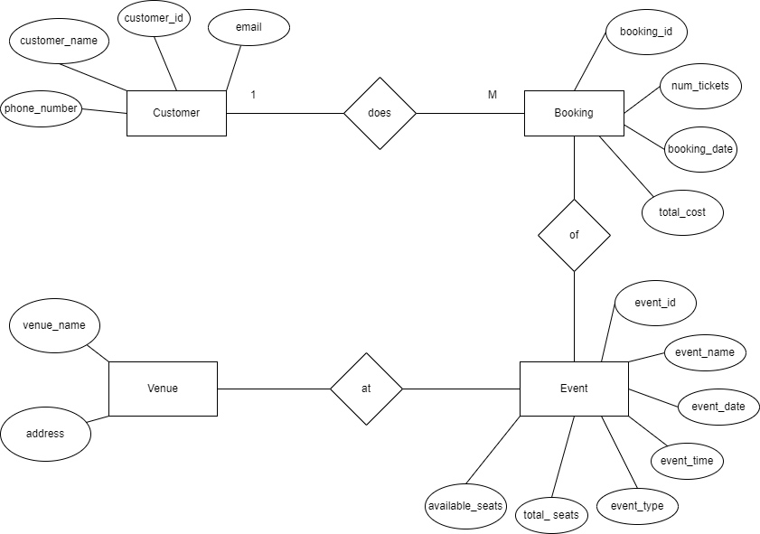

**Tasks 2: Select, Where, Between, AND, LIKE:**

1. Write a SQL query to insert at least 10 sample records into each table.

2. Write a SQL query to list all Events.

3. Write a SQL query to select events with available tickets.

4. Write a SQL query to select events name partial match with ‘cup’.

5. Write a SQL query to select events with ticket price range is between 1000 to 2500.

6. Write a SQL query to retrieve events with dates falling within a specific range.

7. Write a SQL query to retrieve events with available tickets that also have "Concert" in their name.

8. Write a SQL query to retrieve users in batches of 5, starting from the 6th user.

9. Write a SQL query to retrieve bookings details contains booked no of ticket more than 4.

10. Write a SQL query to retrieve customer information whose phone number end with ‘000’

11. Write a SQL query to retrieve the events in order whose seat capacity more than 15000.

12. Write a SQL query to select events name not start with ‘x’, ‘y’, ‘z’

**QUERIES**

1.

INSERT INTO Venu(venue_name,address)

VALUES('PVR Cinemas','The NEXUS Mall, Kormangala Bangalore'),

('Gopalan Cinemas','4th, Gopalan Innovation Mall,Bannerghatta Rd,JP nagar Bangalore'),

('Maheswari Theratre','36th cross road, Near Jal Bhavan, 4th T Block East,Tilak Nagar,

Jayanagar, Bengaluru'),

('M.Chinnaswamy Stadium','Mahatma Gandhi Rd,near cubbon park,Shivaji nagar, Bengaluru'),

('Karnataka State Hockey Stadium','Rhenius St, Langford Town,Langford Gardens,Bengaluru'),

('Shree Kanteerava Indoor Stadium','1st Main Road Sampangi Rama Nagar, Kasturba Rd,

Nunegundlapalli, Raja Ram Mohanroy Extension, Bengaluru'),

('Algorythm','Prestige Shanthinikethan Tower C,Thigalarapalya, Hoodi, Bengaluru'),

('UB City Amphitheatre','24, Vittal Mallaya Rd, KG halli, D'Souza Layout,Sampige Rama Nagar, Bengaluru'),

('Chowdiah Memorial Hall','16th cross Rd, Vyalikaval, Kodandarampura, Malleshwara,

Bengaluru'),

('Palace Ground','JayaMahal, Bengaluru');

INSERT INTO Event(event_id,event_name,event_date,event_time,venue_id,total_seats,available_seats,

ticket_price,event_type,booking_id)

VALUES(1,’Animal’,’2023-12-13’,’14:00:00’,1,120,60,175.80,’Movie’,1),

(2,’Sapta sagar dache’,’2023-12-14’,’10:00:00’,2,120,60,160.50,’Movie’,2),

(3,’Garadi’,’2023-12-13’,’10:00:00’,3,130,0,155.30,’Movie’,3),

(4,’IND Vs AUS WorldCup’,’2023-12-14’,’14:00:00’,4,9999,250,954.80,’Sports’,4),

(5,’India vs Argentina’,’2023-12-15’,’9:00:00’,5,999,90,1544.20,’Sports’,5),

(6,’Bengaluru Bulls Vs Jaipur Pink Panthers’,’2023-12-14’,’19:00:00’,6,999,150,354.50,’Sports’,6),

(7,’Sonu Nigam Nights’,’2023-12-14’,’18:30:00’,7,1000,400,1754.20,’Concert’,7),

(8,’Armaan Malik Nights’,’2023-12-13’,’18:30:00’,8,1000,0,2354.40,’Concert’,8),

(9,’Arjun Janya Musical Nights’,’2023-12-15’,’18:00:00’,9,1000,300,1650.50,’Concert’,9),

(10,’Indu Nagaraj Concert’,’2023-12-16’,’18:30:00’,10,1000,450,2075.70,’Concert’,10);

INSERT INTO Customer(customer_id,customer_name,email,phone_number,booking_id)

VALUES(1,Michel,michel@example.com,8453614702,1),

(2,’Zara’,’zara@example.com’,7589641258,2),

(3,’James’,’james@example.com’,7856912432,3),

(4,’Robert’,’robert@example.com’,8475961235,4),

(5,’Suresh’,’suresh@example.com’,7958463000,5),

(6,’Ramya’,’ramya@example.com’,9854672136,6),

(7,’Divya’,’divya@example.com’,9826547135,7),

(8,’Kelin’,’kelin@example.com’,8754692000,8),

(9,’Kavin’,’kavin@example.com’,9784621356,9),

(10,’Purvi’,’purvi@example.com’,9584216782,10);

INSERT INTO Booking(booking_id,customer_id,event_id,num_tickets,total_cost,booking_date)

VALUES(1,1,1,4,1234,’2023-12-13’),

(2,2,2,3,658,’2023-12-14’),

(3,3,3,5,3268,’2023-12-15’),

(4,4,4,2,788,’2023-12-16’),

(5,5,5,1,175,’2023-12-13’),

(6,6,6,2,1950,’2023-12-14’),

(7,7,7,4,438,’2023-12-15’),

(8,8,8,6,2318,’2023-12-16’),

(9,9,9,4,764,’2023-12-12’),

(10,10,10,8,2368,’2023-12-15’);

2.

SELECT * FROM Event;

3.

SELECT * FROM Event WHERE available_seats > 0;

4.

SELECT * FROM Event WHERE event_name LIKE '%cup';

5.

SELECT * FROM Event WHERE ticket_price BETWEEN 1000 AND 2500;

6.

SELECT * FROM Event WHERE event_date BETWEEN 12/12/2023 AND 14/12/2023;

7.

SELECT * FROM Event WHERE available_seats > 0 AND event_type = 'Concert';

8.

SELECT * FROM Customer ORDER BY customer_id OFFSET 5 ROWS FETCH next 5 ROWS ONLY;

9.

SELECT * FROM Booking WHERE num_tickets > 4;

10.

SELECT * FROM Customer WHERE phone_number LIKE '%000';

11.

SELECT * FROM Event WHERE total_seats > 15000 ORDER BY total_seats;

12.

SELECT * FROM Event WHERE NOT (event_name NOT LIKE '%x' OR event_name LIKE 'y' OR event_name LIKE 'z');

**Tasks 3: Aggregate functions, Having, Order By, GroupBy and Joins:**

1. Write a SQL query to List Events and Their Average Ticket Prices.

2. Write a SQL query to Calculate the Total Revenue Generated by Events.

3. Write a SQL query to find the event with the highest ticket sales.

4. Write a SQL query to Calculate the Total Number of Tickets Sold for Each Event.

5. Write a SQL query to Find Events with No Ticket Sales.

6. Write a SQL query to Find the User Who Has Booked the Most Tickets.

7. Write a SQL query to List Events and the total number of tickets sold for each month.

8. Write a SQL query to calculate the average Ticket Price for Events in Each Venue.

9. Write a SQL query to calculate the total Number of Tickets Sold for Each Event Type.

10. Write a SQL query to calculate the total Revenue Generated by Events in Each Year.

11. Write a SQL query to list users who have booked tickets for multiple events.

12. Write a SQL query to calculate the Total Revenue Generated by Events for Each User.

13. Write a SQL query to calculate the Average Ticket Price for Events in Each Category and Venue.

14. Write a SQL query to list Users and the Total Number of Tickets They've Purchased in the Last 30 Days.

**QUERIES:**

1.

SELECT event_id, event_name, AVG(ticket_price) AS average_ticket_price

FROM Event

GROUP BY event_id,event_name;

2.

SELECT SUM(total_cost) AS total_revenue

FROM Booking;

3.

SELECT event_id, event_name, SUM(num_tickets) AS total_ticket_sales

FROM Booking

GROUP BY event_id, event_name

ORDER BY total_ticket_sales DESC

LIMIT 1;

4.

SELECT event_id, event_name, SUM(num_tickets) AS total_tickets_sold

FROM Booking

GROUP BY event_id, event_name;

5.

SELECT event_id,event_name

FROM Event

WHERE event_id NOT IN (SELECT DISTINCT event_id FROM Booking);

6.

SELECT customer_id, customer_name,SUM(num_tickets) AS total_tickets_booked

FROM Booking

GROUP BY customer_id, customer_name

ORDER BY total_tickets_booked DESC

LIMIT 1;

7.

SELECT EXTRACT(MONTH FROM booking_date) AS month, event_id, event_name,SUM(num_tickets) AS total_tickets_sold

FROM Booking

GROUP BY month, event_id, event_name;

8.

SELECT venue_id, AVG(ticket_price) AS average_ticket_price

FROM Event

GROUP BY venue_id;

9.

SELECT event_type, SUM(num_tickets) AS total_tickets_sold

FROM Event

JOIN Booking ON Event.event_id = Booking.event_id

GROUP BY event_type;

10.

SELECT EXTRACT(YEAR FROM booking_date) AS year, SUM(total_cost) AS total_revenue

FROM Booking

GROUP BY year;

11.

SELECT customer_id, customer_name

FROM Customer

WHERE customer_id IN (SELECT customer_id FROM Booking GROUP BY customer_id HAVING COUNT(DISTINCT event_id) > 1);

12.

SELECT customer_id, customer_name, SUM(total_cost) AS total_revenue

FROM Booking

JOIN Customer ON Booking.customer_id = Customer.customer_id

GROUP BY customer_id, customer_name;

13.

SELECT venue_id, event_type, AVG(ticket_price) AS average_ticket_price

FROM Event

GROUP BY venue_id, event_type;

14.

SELECT customer_id, customer_name, SUM(num_tickets) AS total_tickets_purchased

FROM Booking

JOIN Customer ON Booking.customer_id = Customer.customer_id

WHERE booking_date >=CURRENT_DATE-INTERVAL '30' DAY

GROUP BY customer_id, customer_name;

**Tasks 4: Subquery and its types**

1. Calculate the Average Ticket Price for Events in Each Venue Using a Subquery.

2. Find Events with More Than 50% of Tickets Sold using subquery.

3. Calculate the Total Number of Tickets Sold for Each Event.

4. Find Users Who Have Not Booked Any Tickets Using a NOT EXISTS Subquery.

5. List Events with No Ticket Sales Using a NOT IN Subquery.

6. Calculate the Total Number of Tickets Sold for Each Event Type Using a Subquery in the FROM Clause.

7. Find Events with Ticket Prices Higher Than the Average Ticket Price Using a Subquery in the WHERE Clause.

8. Calculate the Total Revenue Generated by Events for Each User Using a Correlated Subquery.

9. List Users Who Have Booked Tickets for Events in a Given Venue Using a Subquery in the WHERE Clause.

10. Calculate the Total Number of Tickets Sold for Each Event Category Using a Subquery with GROUP BY.

11. Find Users Who Have Booked Tickets for Events in each Month Using a Subquery with DATE_FORMAT.

12. Calculate the Average Ticket Price for Events in Each Venue Using a Subquery

**QUERIES**

1.

SELECT venue_id, venue_name,

(SELECT AVG(ticket_price) FROM Event WHERE Event.venue_id = Venue.venue_id) AS average_ticket_price

FROM Venue;

2.

SELECT event_id, event_name

FROM Event

WHERE (SELECT SUM(num_tickets) FROM Booking WHERE Booking.event_id = Event.event_id) > 0.5 * total_seats;

3.

SELECT event_id, event_name,

(SELECT SUM(num_tickets) FROM Booking WHERE Booking.event_id = Event.event_id) AS total_tickets_sold

FROM Event;

4.

SELECT customer_id, customer_name

FROM Customer

WHERE NOT EXISTS(SELECT 1 FROM Booking WHERE Booking.customer_id = Customer.customer_id);

5.

SELECT event_id, event_name

FROM Event

WHERE event_id NOT IN(SELECT DISTINCT event_id FROM Booking);

6.

SELECT event_type, SUM(num_tickets) AS total_tickets_sold

FROM (SELECT Event.event_type, Booking.num_tickets

FROM Event

JOIN Booking ON Event.event_id = Booking.event_id) AS Subquery

GROUP BY event_type;

7.

SELECT event_id, event_name, ticket_price

FROM Event

WHERE ticket_price > (SELECT AVG(ticket_price) FROM Event);

8.

SELECT customer_id, customer_name,

(SELECT SUM(total_cost) FROM Booking WHERE Booking.customer_id = Customer.customer_id) AS total_revenue

FROM Customer;

9.

SELECT customer_id, customer_name

FROM Customer

WHERE EXISTS (SELECT 1 FROM Booking

JOIN Event ON Booking.event_id = Event.event_id

WHERE Event.venue_id = 'your_venue_id' AND Booking.customer_id = Customer.customer_id);

10.

SELECT event_type,SUM(num_tickets) AS total_tickets_sold

FROM Event

JOIN Booking ON Event.event_id = Booking.event_id

GROUP BY event_type;

11.

SELECT customer_id, customer_name, MONTH(booking_date) AS booking_month

FROM Customer

JOIN Booking ON Customer.customer_id = Booking.customer_id

GROUP BY customer_id, customer_name, booking_month;

12.

SELECT venue_id, venue_name,

(SELECT AVG(ticket_price) FROM Event WHERE Event.venue_id = Venue.venue_id) AS average_ticket_price

FROM Venue