# Problem Statement:

**Travelling Salesman Problem (TSP):** Given a set of cities and distance between every pair of cities, the problem is to find the shortest possible route that visits every city exactly once and returns to the starting point.

Note: Here we need to find a minimum weight Hamiltonian Cycle.  
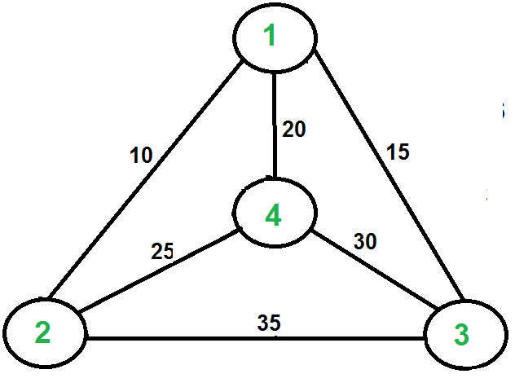

For example:  consider the graph shown in the above figure. A TSP tour in the graph is 1-3-4-2-1. The cost of the tour is 15+30+25+10= 80.

# Solution:

## Algorithm:

1. Consider city 1 as the starting and ending point. Since route is cyclic, we can consider any point as starting point.
2. Generate all (n-1)! permutations of cities.
3. Calculate cost of every permutation and keep track of minimum cost permutation.
4. Return the permutation with minimum cost.