**TaskManagementApp_PM_SimulationProject**

**Retrospective Report**

* **Project Name:** Task Management App (Agile Simulation)
* **Sprint Number:** Sprint 2
* **Sprint Duration:** Sprint 2- September 23-September 24, 2025.
* **Team Members:** Rashmi Swamy, Krishna Sadadekar

**Sprint Goal**

The goal of Sprint 2 was to implement advanced features of the Task Management App: Set Reminder, Dashboard (View All Tasks), Task Priority, Notifications, Search Tasks, and User Profile, to enhance user experience and task management efficiency.

**What Went Well**

* Successfully completed all 6 user stories planned for Sprint 2.
* Smooth workflow using Trello: cards moved from To Do → In Progress → Done.
* Screenshots clearly show progress of tasks for demonstration.
* Able to simulate Agile sprint process and understand sprint execution practically**.**

**What Could Be Improved**

* Time estimation for each user story could be more accurate.
* Daily logs (stand-up updates) could be more consistent for all tasks.
* Some minor delays while switching between tasks; can plan tasks better in future.

**What We Learned**

* Learned how to execute Agile sprints step by step using Trello.
* Learned importance of task prioritization and sprint planning.
* Learned how to track task progress visually using a Kanban board.

**Action Items for Next Sprint**

* Set clear acceptance criteria for each user story.
* Keep daily stand-up logs updated consistently.
* Explore Trello automation (Butler) for automatic status updates.

**Attach Screenshots**

* 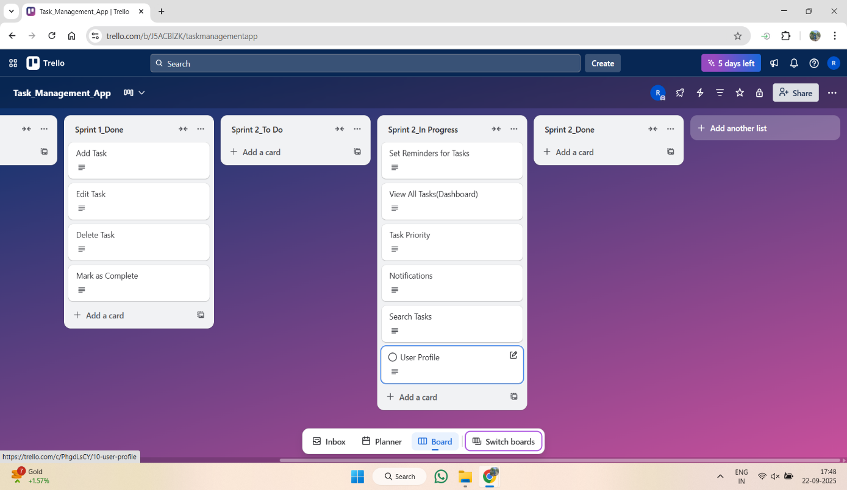Add **Sprint 2 – In Progress screenshot** → 07_Sprint2_InProgress.png
* 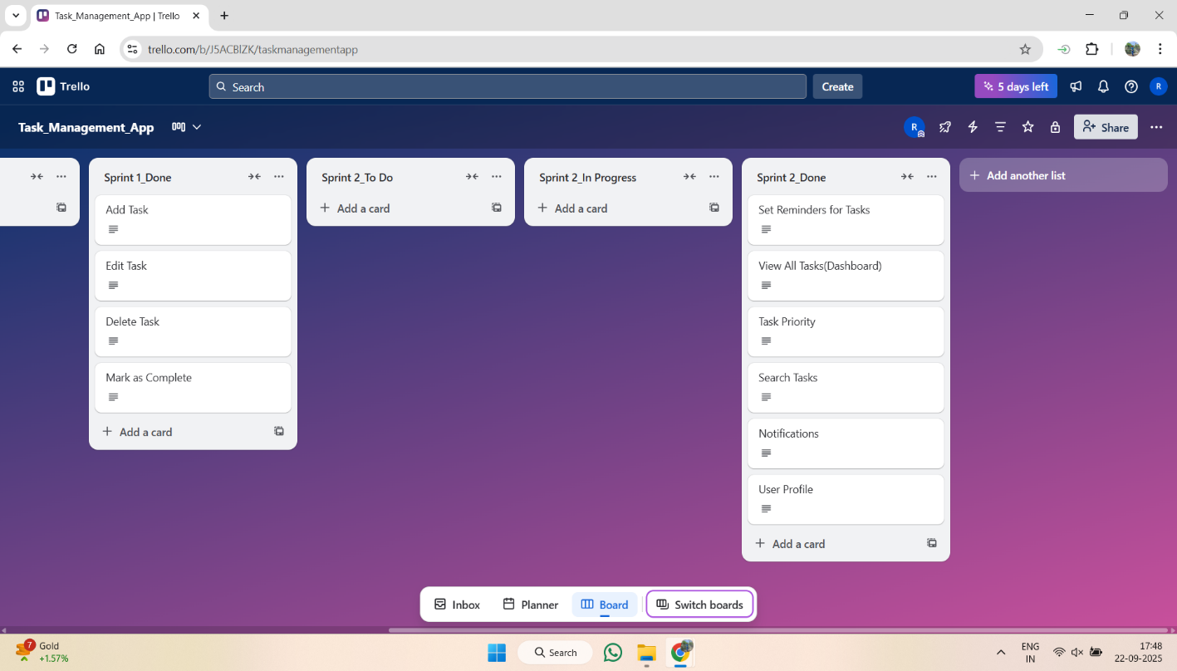Add **Sprint 2 – Done screenshot** → 08_Sprint2_Done.png