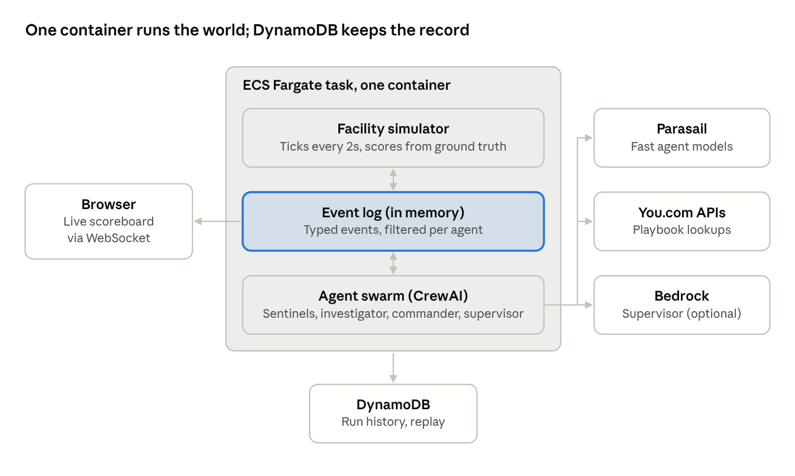

Tool | Job in this build
You.com Search / Research API | Lore researcher finds containment playbooks for each anomaly type
Parasail inference | Fast, cheap calls for sentinels, investigator and evacuation agents
CrewAI | Agent definitions, tools and orchestration of each decision cycle
One (Pica) | Optional shortcut for API auth and connections; check for an event build kit
AWS | Hosting, DynamoDB event log, optional Bedrock model for the supervisor

Event schema
Every message is one typed event in a single envelope, and one correlation_id ties an incident together from first sighting to containment.
{
"event_id": "evt_0142",
"run_id": "swarm-seed42",
"type": "SIGHTING_REPORTED",
"tick": 37,
"source": "sentinel_east",
"zone": "east",
"room": "E4",
"correlation_id": "inc_009",
"confidence": 0.72,
"payload": { "signature": "cold_spot+emf_spike", "suspected": "phantom" }
}
Event type | Published by | Read by
SENSOR_READING | Simulator | Sentinel for that zone
SIGHTING_REPORTED | Sentinels | Investigator
SIGHTING_CONFIRMED / SIGHTING_DISMISSED | Investigator | Researcher, commander, scoreboard
PLAYBOOK_FOUND | Lore researcher | Commander
ACTION_PROPOSED | Commander, evacuation | Supervisor
ACTION_APPROVED / ACTION_REJECTED | Supervisor | Simulator, proposer
ACTION_EXECUTED / ANOMALY_CONTAINED | Simulator | Everyone, scoreboard
CIVILIAN_STATUS | Simulator | Evacuation coordinator
SCORE_UPDATE | Scoreboard | Browser

