Rashmi Vidushani
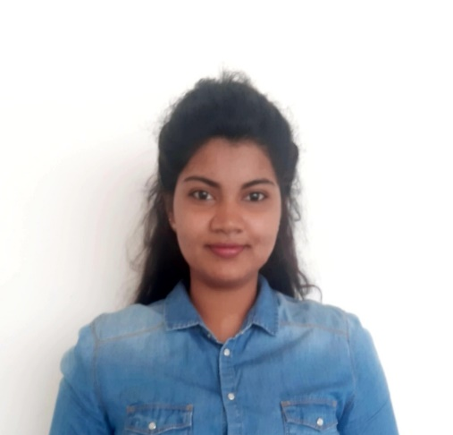

179/A, Rabutanwaththa, Radawana


+94713820425

rashmividushani2020@gmail.com

www.linkedin.com/in/rashmi-vidushani-226815195/

EDUCATION
ABOUT
I, Rashmi Vidushani, is following BSC(HONS) Software engineering at Plymouth university at present. I can describe myself as a Self-motivated, adaptable, conscientious, and enthusiastic with a flexible attitude to work. Strong team-player skills developed through work in retail and group activities. Get on well with people at all level, easily marking good working relationships.
national school of business management - Nsbm
Currently in the third year of BSc (Hons)Software Engineering with Plymouth university at NSBM school of computing.
2019 September- Present

G.C.E Advanced level -holy cross college - gampaha
Followed commerce stream for advanced levels.
- Accounting studies - C
- Business statistics - C
- Economics - C
2016-2019

G.C.E OrDINARY LEVEL- Regent international college - gampaha

2006-2016

SKILLS
Web Design
C language
C#
Java
Professional English
Leadership
Teamwork
ACADEMIC PROJECTS
1st year semester 2:

- Website for a hotel
Created a website using basics of Html, CSS, JS and PHP and databases. Created using visual studio code and xamp.

- Employee management system
Programmed an employee management system using C# and visual studio with the key features of availability of a barcode scanner to scan ID of the employee and mark the attendance.

- Website for keels
Created a website using a template of Html, CSS, and JS. used visual studio, WordPress, xamp and created a site consisted of a front end as well a back end with dashboards, forms, and maps.

- Database for a Library Management system
Created a database for a library management system with tables consisting of diverse types of attributes. Furthermore, contained triggers, functions, views and procedures too.
Consisted of an interface, programmed with C#.

- Smart trash can with a mobile app
(project green)
Project was at success with a smart trash can which was created by connecting hardware such as ultra-sonic sensors, GPS modules, wi-fi modules and an Arduino board. Used firebase as the database holder which would provide data to the mobile app. The mobile app was created using android studio using java.

- Website for a large-scale hospital
Created a website using a template created on Html, CSS and servlets. Consisted of a front end as well a back end with dashboards and maps.

2nd year semester 2:

2nd year semester 1:

- Agriculture related desktop app
Created a desktop application for a agricultural institution. App can act as an intermediate between the administrators, staff and farmers. App consisted of several dashboards, forms, and maps. Interface was made using visual studio and C# as a programming language.
- Software for a canteen
Programmed a desktop application for a canteen which would help in day today sales and orders as well as managing employee details and supplier details. Used visual studios in creating the software. Database was consisted of diverse tables. Programming language used was java.

I do hereby certify that the particulars mentioned above are true and accurate to the best of my knowledge, I assure you that I will perform my duties & responsibilities to the best of my ability and into the best interest of your prestige institution.
Rashmi Vidushani

REFERENCE
Pramudya Thilakaratne
Lecturer
Course Director - Plymouth University Degree Programs
Faculty of Computing
NSBM Green University
pramudya.h@nsbm.ac.lk
0710131643
N.H.K.Asanka
Executive -Bank operations
HSBC data processing Lanka LTD
HSBC Global Service Center
439 Sri Jayawardenepura Mawatha, Rajagiriya
asanka132197@wyb.ac.lk
071 646 0597

