**MINI-PROJECT REPORT**

**Project Title** - Hand- Written Digit Recognition Using Deep Learning

**Tech Stack Used** - Python, TensorFlow, Keras, CNN, Computer Vision

**Dataset** - **MNIST Dataset:** The MNIST dataset is a standard benchmark dataset for handwritten digit recognition. It consists of 28x28 grayscale images of handwritten digits (0 through 9) and their corresponding labels.

**Result / Output** - Accurately predicts the digits being written. Here is the sample result:

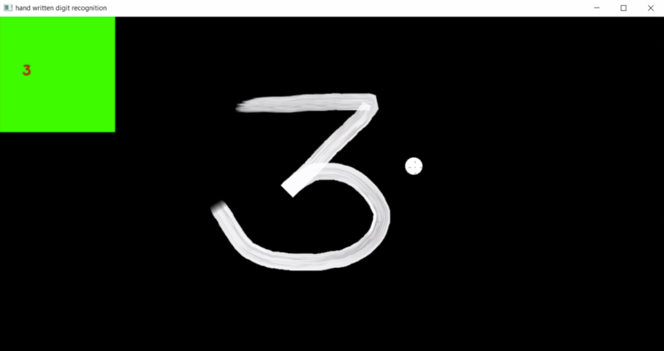

**Link to the project** -

https://github.com/Rashmiar4/Rashmi_Scifor_Technologies/blob/main/Hand-written_Digit_%20Recognition.ipynb