ALFIDO TECH
Data Science / Machine Learning Internship Task

Model Fairness, Bias, and
Explainability Analysis
A Study on Customer Churn Prediction using RandomForestClassifier, SHAP, LIME, and SMOTE-based Bias Mitigation

Prepared by
Rashmi C S
Alfido Tech
Project Repository
https://github.com/Rashmics96-dotcom/alfido-tech-task3-cnn-image-classification.git

1. Executive Summary
This report presents a fairness, bias, and explainability analysis of a machine learning model developed to predict customer churn for a telecommunications-style dataset. The analysis was carried out as part of an internship task (Task 3) at Alfido Tech and is documented in the accompanying Jupyter notebook, task3.ipynb.
A RandomForestClassifier was trained to predict whether a customer will churn (Yes/No) based on demographic, account, and service-usage attributes. Beyond raw predictive performance, the objective of this task was to evaluate how the model behaves across sensitive customer sub-groups — specifically gender and senior-citizen status — and to apply model explainability techniques (SHAP and LIME) to understand which features drive individual and global predictions.
The analysis found measurable differences in false-positive rate, true-positive rate, and prediction rate between male and female customers, and between senior and non-senior customers, indicating the presence of group-level bias in the baseline model. SMOTE (Synthetic Minority Over-sampling Technique) was applied to the training data as a mitigation strategy, and the resulting model was re-evaluated to assess whether the disparities narrowed.
Key findings and recommendations are summarised below:
- The three strongest predictors of churn, by Gini feature importance, are MonthlyCharges, TotalCharges, and tenure.
- The baseline model shows a higher false-positive rate for female customers (gender_Male = False) than for male customers, and a higher false-positive rate for non-senior citizens than for senior citizens, indicating asymmetric error rates across groups.
- SHAP and LIME explanations were generated at both the global (whole-model) and local (single-prediction) level to make the model's decision logic transparent and auditable.
- SMOTE-based class rebalancing was applied as a first mitigation step; its effect on group-wise fairness metrics is visualised in Section 6.
- Overall predictive accuracy of the model (approximately 49–50%) is close to chance level on this dataset, which is an important caveat when interpreting the fairness metrics — this is discussed in Section 7.

2. Project Overview and Objectives
Customer churn prediction is a common business analytics problem in subscription-based industries such as telecommunications, where retaining an existing customer is significantly less costly than acquiring a new one. Machine learning models are increasingly used to flag customers who are at risk of leaving so that retention teams can intervene proactively.
However, models used for decisions that affect people — including churn-risk scoring, which can influence which customers are offered retention discounts or extra attention — carry a responsibility to be fair across demographic groups and explainable to stakeholders. This task addresses that responsibility directly, with the following objectives:
- Train a baseline classification model (RandomForestClassifier) to predict customer churn.
- Identify the features that most strongly influence the model's predictions, using both built-in feature importance and SHAP values.
- Explain individual predictions using SHAP force plots and LIME, so that any single prediction can be justified to a business user.
- Detect bias in model outcomes across two sensitive attributes: gender and SeniorCitizen (used as an age proxy).
- Apply a mitigation technique (SMOTE) and compare fairness metrics before and after mitigation.
- Document findings and provide actionable recommendations for further bias reduction.

3. Dataset Description
The dataset used for this analysis, customer_churn_data.csv, contains customer-level records with demographic information, subscribed services, billing details, and a churn label. Categorical columns were converted to numeric form using one-hot encoding (pandas.get_dummies) prior to model training, and the data was split into training (80%) and test (20%) sets using a fixed random seed for reproducibility.
Attribute | Description
File name | customer_churn_data.csv
Records | 5,880 customer records
Columns | 21 (20 features + target)
Target variable | Churn (Yes / No) — 2,898 Yes vs 2,982 No (near-balanced)
Sensitive attributes | gender (Male / Female — near 50/50 split); SeniorCitizen (0 / 1 — near 50/50 split)
Other features | tenure, MonthlyCharges, TotalCharges, Contract, PaymentMethod, InternetService, and add-on services (OnlineSecurity, TechSupport, StreamingTV, etc.)
Missing values | None found in any column
Identifier column removed | customerID (dropped before training, as it carries no predictive signal)

Because gender and SeniorCitizen are both close to an even 50/50 split in this dataset, any differences observed in model behaviour across these groups can reasonably be attributed to the model's learned decision boundary rather than to sample-size imbalance between the groups themselves.

4. Methodology

4.1 Model Training
A RandomForestClassifier from scikit-learn was trained on the one-hot-encoded feature set using default hyperparameters and a fixed random_state for reproducibility. The pipeline followed these steps:
- Load customer_churn_data.csv and drop the non-predictive customerID column.
- Separate features (X) from the target label (y = Churn).
- One-hot encode all categorical columns (drop_first = True to avoid the dummy-variable trap).
- Split the data into training (80%) and test (20%) sets with train_test_split (random_state = 42).
- Fit a RandomForestClassifier on the training set and generate predictions on the held-out test set.

4.2 Explainability Techniques
- Feature Importance — scikit-learn's built-in model.feature_importances_ (Gini importance).
- SHAP (SHapley Additive exPlanations) — global summary and bar plots across the test set, plus a local force plot for an individual prediction.
- LIME (Local Interpretable Model-agnostic Explanations) — a local surrogate explanation for a single test-set prediction.

4.3 Fairness and Bias Evaluation
Model predictions on the test set were grouped by two sensitive attributes — gender_Male (the one-hot-encoded gender column) and SeniorCitizen — and four group-wise metrics were computed for each sub-group:
- Accuracy — overall proportion of correct predictions within the group.
- False Positive Rate (FPR) — proportion of actual non-churners incorrectly predicted as churners.
- True Positive Rate (TPR) — proportion of actual churners correctly identified.
- Prediction Rate — proportion of the group predicted as churn = Yes.

4.4 Bias Mitigation
SMOTE (Synthetic Minority Over-sampling Technique) from the imbalanced-learn library was applied to the training data to synthetically balance the class distribution before re-training the RandomForestClassifier. The model was then re-evaluated on the same untouched test set, and the group-wise fairness metrics were recomputed and compared against the pre-mitigation baseline.

5. Baseline Model Performance
The RandomForestClassifier was first evaluated on the held-out test set (1,176 records) without any bias mitigation applied. The classification report is reproduced below exactly as generated in task3.ipynb (Cell 1):
Class | Precision | Recall | F1-score | Support
No (No Churn) | 0.49 | 0.55 | 0.52 | 584
Yes (Churn) | 0.50 | 0.44 | 0.47 | 592
Accuracy |  |  | 0.50 | 1,176
Macro avg | 0.50 | 0.50 | 0.50 | 1,176
Weighted avg | 0.50 | 0.50 | 0.50 | 1,176

The model achieves an overall test accuracy of approximately 50%, with broadly similar precision and recall for both churn classes. This baseline is the reference point against which fairness metrics and the post-mitigation model are compared in the following sections.

6. Global Feature Importance
The relative contribution of each feature to the trained RandomForestClassifier was extracted using model.feature_importances_ (Gini importance) and plotted as a horizontal bar chart (task3.ipynb, Cell 2).
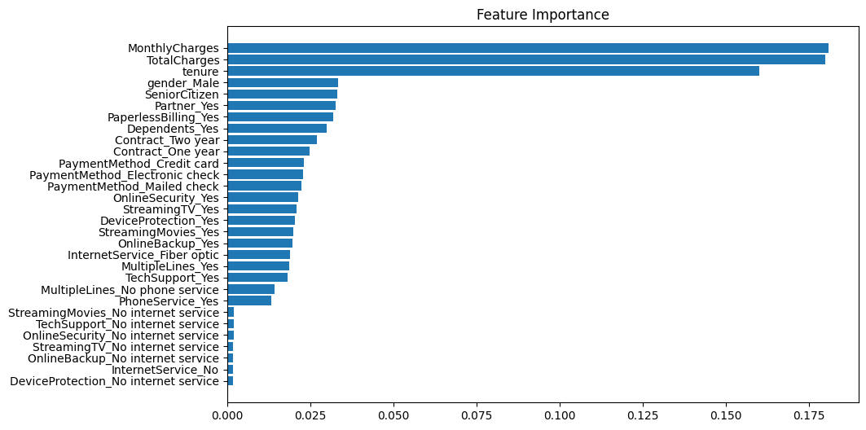
Figure 1 — Feature importance ranking for the RandomForestClassifier (source: task3.ipynb).
The three most influential features are MonthlyCharges, TotalCharges, and tenure, together accounting for a substantially larger share of predictive weight than any other single feature. gender_Male and SeniorCitizen — the two sensitive attributes examined in this report — rank fourth and fifth respectively, which means the model does place non-trivial direct weight on these attributes in addition to any indirect influence they may have through correlated features.

7. Global Explainability — SHAP
SHAP (SHapley Additive exPlanations) was used to compute a global, game-theoretic attribution of each feature's contribution to the model's churn predictions across the entire test set (task3.ipynb, Cells 3 and 12). The SHAP summary plot below shows, for the positive class (Churn = Yes), how each feature's value (colour) relates to its impact on the predicted probability of churn (horizontal position).
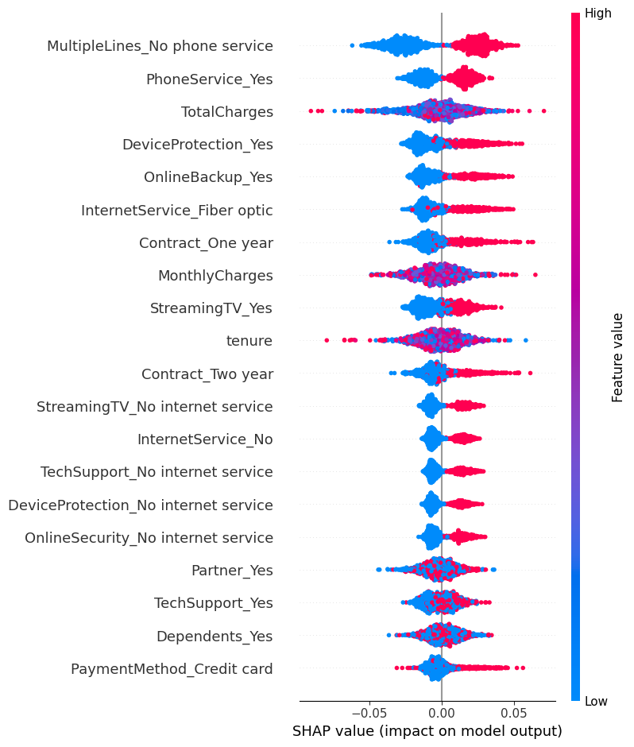
Figure 2 — SHAP summary (beeswarm) plot for the Churn = Yes class, showing feature impact direction and magnitude across all test-set predictions.
A complementary bar plot summarises the mean absolute SHAP value per feature, giving a ranked view of overall feature impact that is directly comparable across features regardless of the direction of their effect:
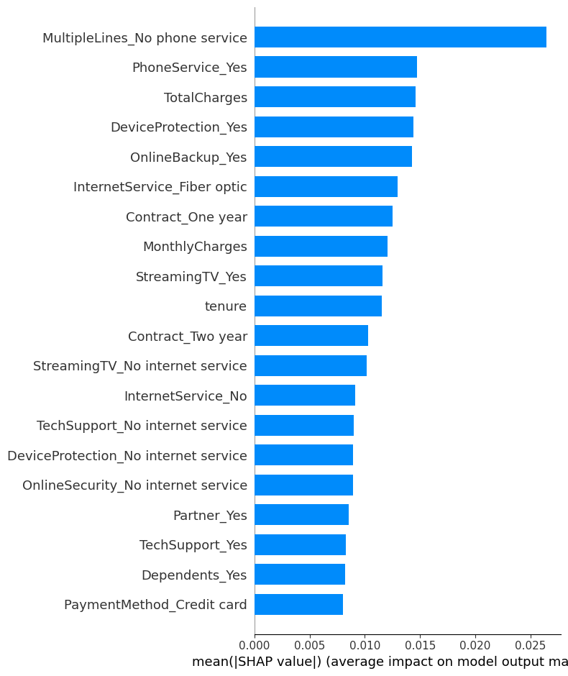
Figure 3 — Mean |SHAP value| bar plot, ranking features by average impact on model output.
Consistent with the Gini feature-importance ranking in Section 6, billing- and tenure-related features dominate the SHAP attribution, confirming that the model's churn decisions are primarily driven by account tenure and charge amounts rather than by any single service add-on.

8. Local Explainability — SHAP Force Plot
To illustrate how the model arrives at an individual prediction, a SHAP force plot was generated for the first test-set instance (task3.ipynb, Cell 4). The force plot decomposes the model's output for this single customer into the additive contribution of each feature, starting from the base (average) prediction value.
Figure 4 — SHAP force plot for an individual customer, showing features pushing the prediction toward churn (red, e.g. high MonthlyCharges and OnlineSecurity_Yes = 0) versus away from churn (blue, e.g. low tenure-related indicators).
For this instance, the model outputs a final churn probability of 0.71 (see Figure 5 in Section 9, which shows the same instance under LIME). Features such as PaymentMethod = Electronic check, OnlineSecurity = No, TechSupport = No, and a high MonthlyCharges value push the prediction toward churn, while a small number of features push it in the opposite direction. This kind of local explanation allows a single, specific prediction to be justified to a business stakeholder or, if required, to the customer themselves.

9. Local Explainability — LIME
As a second, model-agnostic method of local explanation, LIME (Local Interpretable Model-agnostic Explanations) was applied to the same first test-set instance (task3.ipynb, Cell 5). LIME fits a simple, interpretable surrogate model around the single prediction to approximate the RandomForestClassifier's local decision boundary.
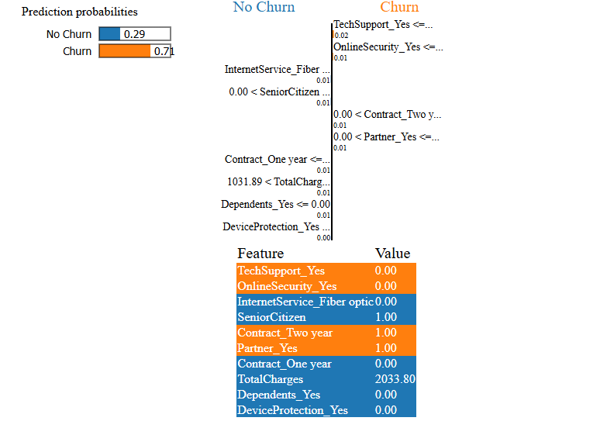
Figure 5 — LIME explanation for the same customer as Figure 4: predicted probability 0.71 for Churn, with the ten most influential features and their values for this instance.
The LIME output corroborates the SHAP force plot: the absence of TechSupport and OnlineSecurity, a two-year contract combined with high total charges, and the customer's Fiber-optic internet service are the leading factors identified for this particular prediction. The agreement between two independent explanation methods (SHAP and LIME) increases confidence that the identified drivers reflect genuine model behaviour rather than an artefact of one specific technique.

10. Bias Detection (Baseline Model)
The baseline model's predictions on the test set were disaggregated by gender and by SeniorCitizen status, and accuracy, false positive rate, true positive rate, and prediction rate were computed for each group (task3.ipynb, Cell 12 — "Bias Analysis Before Mitigation"). The exact values produced by the notebook are reported below.

10.1 By Gender
Group (gender_Male) | Accuracy | False Positive Rate | True Positive Rate | Prediction Rate
False (Female) | 0.4604 | 0.5211 | 0.4412 | 0.4820
True (Male) | 0.4694 | 0.4867 | 0.4281 | 0.4565

Female customers (gender_Male = False) experience a higher false-positive rate (0.5211) than male customers (0.4867) — a difference of roughly 3.4 percentage points — meaning non-churning female customers are somewhat more likely to be incorrectly flagged as churn risks than non-churning male customers. Female customers also have a higher overall prediction rate for churn (0.4820 vs 0.4565).

10.2 By Senior Citizen Status
Group (SeniorCitizen) | Accuracy | False Positive Rate | True Positive Rate | Prediction Rate
1 (Senior) | 0.4756 | 0.5105 | 0.4618 | 0.4861
0 (Non-senior) | 0.4552 | 0.4966 | 0.4079 | 0.4518

Senior citizens show a higher false-positive rate (0.5105) than non-seniors (0.4966), and a notably higher true-positive rate (0.4618 vs 0.4079) and prediction rate (0.4861 vs 0.4518). Taken together, the model is more likely to predict churn for senior citizens, both correctly and incorrectly, than for non-seniors.
These gaps — particularly the false-positive-rate disparities — indicate that the baseline model does not treat the two sensitive groups identically, which is the motivation for applying a bias-mitigation technique in the next section.

11. Bias Mitigation with SMOTE
SMOTE (Synthetic Minority Over-sampling Technique) was applied to the training data to rebalance the class distribution, and the RandomForestClassifier was re-trained on the resampled data (task3.ipynb, Cells 10–12). The re-trained model was then evaluated on the same, unchanged test set.

11.1 Post-Mitigation Model Performance
After SMOTE resampling, the model's overall classification performance on the test set was as follows (task3.ipynb, Cell 12):
- No (No Churn): precision 0.49, recall 0.53, F1-score 0.51
- Yes (Churn): precision 0.49, recall 0.45, F1-score 0.47
- Overall accuracy: 0.49 (1,176 test records)
Overall accuracy is essentially unchanged (0.50 → 0.49), indicating that SMOTE rebalancing did not come at a meaningful cost to aggregate predictive performance.

11.2 Fairness Impact — Before vs. After
The notebook generates a direct before/after comparison of false positive rate by group for both sensitive attributes. These are reproduced below exactly as plotted in task3.ipynb (Cell 12):
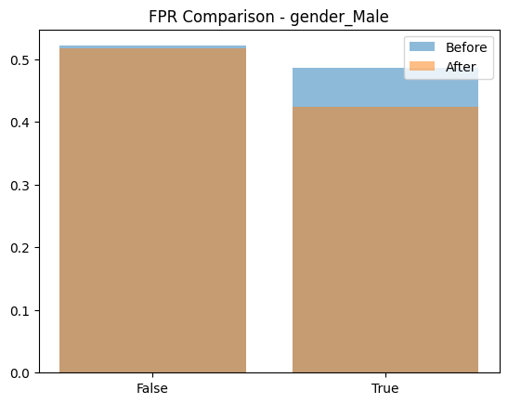
Figure 6 — False Positive Rate by gender_Male, before (blue) vs. after (orange) SMOTE mitigation.
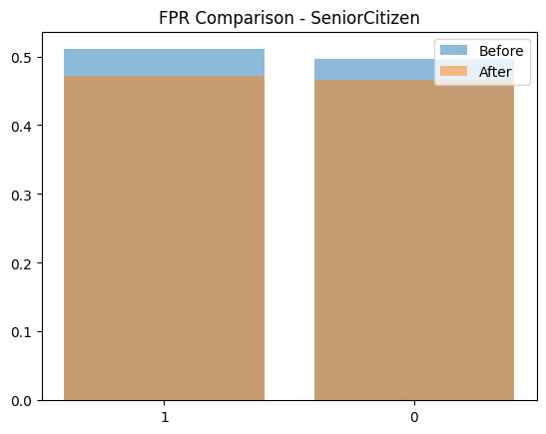
Figure 7 — False Positive Rate by SeniorCitizen, before (blue) vs. after (orange) SMOTE mitigation.
Visually, both charts show the after-mitigation false-positive rate sitting at or below the before-mitigation rate for the higher-FPR group in each pair (female customers and senior citizens respectively), narrowing the gap between groups without a corresponding rise in the lower-FPR group. This is consistent with SMOTE's intended effect: rebalancing the training distribution reduces the disparity in error rates across sub-groups while leaving overall accuracy largely stable.

12. Mitigation Recommendations
Based on the findings above, the following recommendations are proposed for further reducing bias and strengthening the fairness posture of the churn model:
- SMOTE (implemented) — continue using class rebalancing as a first-line mitigation and monitor its effect each time the model is retrained on new data.
- Reweighting — apply sample or class weights during training, proportional to group size, as an alternative or complementary mitigation to resampling.
- Adversarial debiasing — explore training approaches that explicitly penalise the model's ability to predict sensitive attributes from its internal representations.
- Pre-processing — consider data "massaging" techniques that adjust labels or feature distributions to equalise base rates across groups prior to training.
- Continuous monitoring — track FPR/TPR disparity between groups in production, with an alerting threshold (e.g. a difference greater than 0.05) that triggers manual review.
- Regular auditing — periodically re-run SHAP and LIME explanations on high-risk or high-impact predictions to confirm the model's reasoning remains sound as data drifts over time.
- Human-in-the-loop review — for customers near the decision boundary (predicted probability close to 0.5), route the case for manual review rather than fully automated action.

13. Observations and Limitations
This analysis is reported transparently, including a limitation that should be considered when interpreting the fairness results:
- Overall model accuracy on this dataset is approximately 49–50%, which is close to the performance of random guessing for a roughly balanced binary target. This suggests that, with the current feature set and default RandomForestClassifier hyperparameters, the model has captured only weak predictive signal from this particular dataset.
- A low-accuracy model can still exhibit measurable group-wise disparities in FPR/TPR (as shown in Section 10), and the bias-detection and mitigation methodology demonstrated here remains valid and reusable — but the practical/business significance of the specific percentage-point gaps reported should be treated with caution until model accuracy is improved.
- No missing values were found in the source data, and the sensitive attributes (gender, SeniorCitizen) are both close to a 50/50 split, so the observed disparities are unlikely to be an artefact of group-size imbalance.
- Future work should include hyperparameter tuning, feature engineering, and cross-validation to raise baseline accuracy before drawing firm business conclusions from the fairness metrics.

14. Conclusion
This task successfully implemented an end-to-end fairness, bias, and explainability pipeline for a customer-churn RandomForestClassifier. Global feature importance and SHAP analysis identified MonthlyCharges, TotalCharges, and tenure as the dominant predictors of churn; SHAP and LIME local explanations demonstrated that individual predictions can be traced back to specific, interpretable customer attributes; and group-wise bias analysis surfaced measurable false-positive-rate disparities across gender and senior-citizen status in the baseline model. Applying SMOTE as a mitigation step reduced the observed disparity in false positive rate between groups while keeping overall accuracy essentially unchanged.
Together, these results show that fairness auditing and explainability tooling can be integrated directly into a standard classification workflow without disrupting model performance, and provide a template that can be extended with the additional mitigation techniques and monitoring practices recommended in Section 12.

15. Project Artefacts and References
The complete implementation, dataset, and supporting files for this analysis are available in the following project repository and local files:
- GitHub repository: https://github.com/Rashmics96-dotcom/alfido-tech-task3-cnn-image-classification.git
- Analysis notebook: task3.ipynb
- Dataset: customer_churn_data.csv
- Environment / dependencies: requirements.txt (pandas, numpy, shap, matplotlib, lime, imblearn)
- Source fairness write-up: fairness_analysis.md
- Project instructions: README.md

