
Linux System Administration (E1ITA307)
Linux Infrastructure Deployment Project Report
On
LINUX STORAGE MONITORING SYSTEM
Submitted by
RASHMI | (2411021061295)
PANCHAKSHARAYYA | (2411021061321)
APOORVA P KERETOT | (24110210613161)
S DARSHAN SAI | (2411021061289)
In partial fulfillment of the award of the degree of
BACHELOR OF TECHNOLOGY
In
Information Technology
Under the Supervision of
Prof. Ananthanagu U

ALLIANCE SCHOOL OF ADVANCED COMPUTING
ALLIANCE UNIVERSITY
BENGALURU
Oct 2026

Linux System Administration E1ITA307
DEPARTMENT OF INFORMATION TECHNOLOGY
ALLIANCE SCHOOL OF ADVANCED COMPUTING
CERTIFICATE
This is to certify that the Project work entitled "LINUX STORAGE MONITORING SYSTEM" submitted by Rashmi [2411021061295], Panchaksharayya [2411021061321], Apoorva P Keretot [24110210613161] and S Darshan Sai [2411021061289] in partial fulfillment of the requirements for the award of the degree of Bachelor of Technology in Information Technology of Alliance University, is a bonafide work during the academic year 2026-2027.
Prof. Ananthanagu U | Prof. Ananthanagu U | Dr. Shekhar R
Course Handling Faculty | Course Coordinator | Professor & HoD

Linux System Administration E1ITA307
Table of Contents
1. Introduction | 4
1.1 Aim | 4
1.2 Background | 4
1.3 Problem Statement | 4
1.4 Objectives | 4
2. Methodology | 6
2.1 Tools and Technologies Used | 6
2.2 Approach / Development Process | 7
3. Linux System Administration – Design and Implementation | 10
3.1 System Architecture | 10
3.2 Linux Environment Setup | 11
3.3 User and Group Management | 16
3.4 File and Directory Management | 20
3.5 Package and Process Management | 21
3.6 Storage and File System Configuration | 27
3.7 Backup and Automation | 34
3.8 Security and Access Control | 39
4. Results and Testing | 44
4.1 Implementation Results | 44
4.2 Testing and Validation | 49
5. Conclusion and Future Scope | 51
5.1 Conclusion | 51
5.2 Future Scope | 51
References | 52
Appendices | 53
Appendix A: System Architecture Diagram | 53
Appendix B: Linux Commands and Configuration | 54
Appendix C: Shell Scripts | 63
Appendix D: Web Dashboard & API Integration | 68

Linux System Administration E1ITA307
Linux System Administration
E1ITA307
1. Introduction
1.1 Aim
The main aim of this mini project is to design, develop, and implement a Linux Storage
Monitoring System that automatically monitors disk space, inode usage, and storage growth in a
Linux environment.
The system uses Bash shell scripts to collect storage information, identify potential storage issues,
generate alerts based on predefined thresholds, and maintain storage history logs. It also uses cron
scheduling to automate monitoring tasks and generate storage reports at regular intervals.
1.2 Background
Linux is widely used in servers, cloud infrastructure, enterprise systems, networking, and software
development. Proper storage management is an important part of Linux system administration
because insufficient disk space or excessive inode usage can affect system performance and
prevent applications from creating or storing files.
The Linux Storage Monitoring System was developed to simplify these tasks using Bash shell
scripting and standard Linux utilities. It monitors disk space and inode usage, records storage
measurements, checks warning and critical thresholds, and generates reports. Cron is used to
schedule monitoring activities automatically.
1.3 Problem Statement
In Linux systems, storage space can become insufficient due to the accumulation of files, logs,
and application data. High inode usage can also prevent new files from being created, even when
disk space is available. Manual monitoring makes it difficult to identify these issues promptly.
Therefore, this project develops an automated Linux Storage Monitoring System to monitor disk
space and inode usage, maintain storage records, generate threshold-based alerts, produce
periodic reports, and perform basic backup and recovery checks.
1.4 Objectives
The main objectives of the Linux Storage Monitoring System are:

- To monitor disk space and inode usage using Linux commands and Bash scripts.

Linux System Administration E1ITA307
Linux System Administration
E1ITA307

- To maintain storage history and track usage changes.

- To configure warning and critical storage thresholds.

- To generate alerts when storage usage exceeds the defined limits.

- To automate monitoring and report generation using cron scheduling.

- To generate readable storage reports.

- To perform basic backup and recovery checks.

Linux System Administration E1ITA307
Linux System Administration
E1ITA307
2. Methodology
2.1 Tools and Technologies Used
2.1 Software Requirements
The Linux Storage Monitoring System was developed using Ubuntu Linux, Bash shell scripting,
and standard Linux utilities to monitor storage, maintain logs, generate alerts, and produce
reports.

- Ubuntu Linux: Operating system used for development and testing.

- Bash Shell: Used to create disk monitoring, inode monitoring, storage growth, alert, and
report generation scripts.

- Cron: Automates monitoring every five minutes and report generation every fifteen
minutes.

- Linux Utilities: Commands such as df, du, ls, find, ps, free, and systemctl support
storage and system monitoring.

- APT and Tree: Used for package management and displaying the project directory
structure.

- Tar and Gzip: Used to create and inspect compressed backups.

- Text Editor: Used to create and modify scripts and configuration files.

- CSV and Log Files: Used to store storage history, monitoring records, and administrator
alerts.
2.2 Hardware Requirements
The project was implemented on a computer running Ubuntu Linux. The system requires
sufficient resources to execute monitoring scripts, maintain logs, generate reports, and store
backups.
General hardware requirements include:

- A laptop or desktop computer.

Linux System Administration E1ITA307
Linux System Administration
E1ITA307

- A compatible processor capable of running Ubuntu Linux.

- Sufficient RAM to run the operating system and required utilities.

- Adequate storage space for scripts, logs, reports, historical data, and backups.
2.3 Other Tools and Resources

- Linux Terminal: Used to execute commands and run monitoring scripts.

- System Monitoring Commands: Used to inspect disk space, inode usage, processes,
memory, and services.

- Configuration File: config/monitor.conf stores the monitoring path and warning and
critical thresholds.

- Cron Logs: Used to inspect scheduled task execution.

- Architecture Diagram: Illustrates the relationship between monitoring scripts,
scheduling, logs, reports, and backups.

- Backup Verification Commands: Used to inspect the backup archive and compare
selected recovered files with their originals.
2.2 Approach / Development Process
The project was developed in stages, covering problem identification, requirement analysis,
environment setup, implementation, automation, testing, and documentation.
Step 1: Problem Identification
The need for automated Linux storage monitoring was identified. The system was designed to
monitor disk space and inode usage, record measurements, generate threshold-based alerts, and
produce storage reports.
Step 2: Requirement Analysis
The project requirements included Ubuntu Linux, Bash, Cron, standard Linux utilities, the tree
utility, and sufficient hardware and storage resources. Security requirements included appropriate
file permissions, user and group management, and configurable monitoring thresholds.

Linux System Administration E1ITA307
Linux System Administration
E1ITA307
Step 3: Linux Environment Setup
The project was implemented in an Ubuntu Linux environment. A project directory was created to
organize scripts, configuration files, logs, historical data, reports, backups, tests, and
documentation. Terminal commands were used to inspect filesystem usage and system services.
Step 4: System Configuration
The monitor.conf file was configured to define the monitoring path and warning and critical
thresholds. User and group management was practised to demonstrate file ownership, permissions,
and controlled access. System processes and services were also inspected using Linux
administration commands.
Step 5: Implementation
The monitoring system was developed using Bash scripts, each responsible for a specific task:

- disk_monitor.sh – monitors disk space usage.

- inode_monitor.sh – checks inode usage.

- storage_growth.sh – records storage measurements and tracks changes.

- alert_monitor.sh – checks thresholds and records alerts.

- generate_report.sh – generates storage monitoring reports.
The scripts store their outputs in the project’s data, log, and report directories.
Step 6: Automation
Cron was configured to run monitoring tasks every five minutes and report generation every fifteen
minutes. The Cron service and scheduled task activity were inspected to verify the automation
setup.
Step 7: Testing
The system was tested to verify disk and inode monitoring, CSV history recording, threshold-
based alerts, report generation, and Cron configuration. The backup archive was inspected, and

Linux System Administration E1ITA307
Linux System Administration
E1ITA307
selected recovered files were compared with their originals. User and group permissions were
tested using a dedicated test user.
The tests demonstrated that the main monitoring scripts, alert checks, report generation, and
permission demonstrations worked under the tested conditions. Backup verification was limited to
archive inspection and selected file comparisons.
Step 8: Documentation
The final stage involved documenting the project structure, tools, configuration, scripts, testing
procedures, and results. Screenshots were collected as implementation evidence, and a system
architecture diagram was prepared to illustrate the relationships between the scripts, Cron
scheduler, configuration file, storage history, alert logs, reports, and backup archive.

Linux System Administration E1ITA307
Linux System Administration
E1ITA307
3. Linux System Administration – Design and Implementation
3.1 System Architecture
The Linux Storage Monitoring System is designed to monitor disk space, inode usage, and storage
growth on a Linux system. It uses Bash scripts, configuration files, scheduled tasks, log files, and
report generation to automate storage monitoring.
The system runs on Ubuntu Linux. The monitoring scripts collect storage information, compare
usage against configured thresholds, record measurements, generate alerts when required, and
create storage reports. A backup archive is also maintained to support project file recovery.
This figure 3.1 presents the system architecture and component relationships, providing visual
evidence of the configuration or result described above.

Figure 3.1: System Architecture of Linux Storage Monitoring System

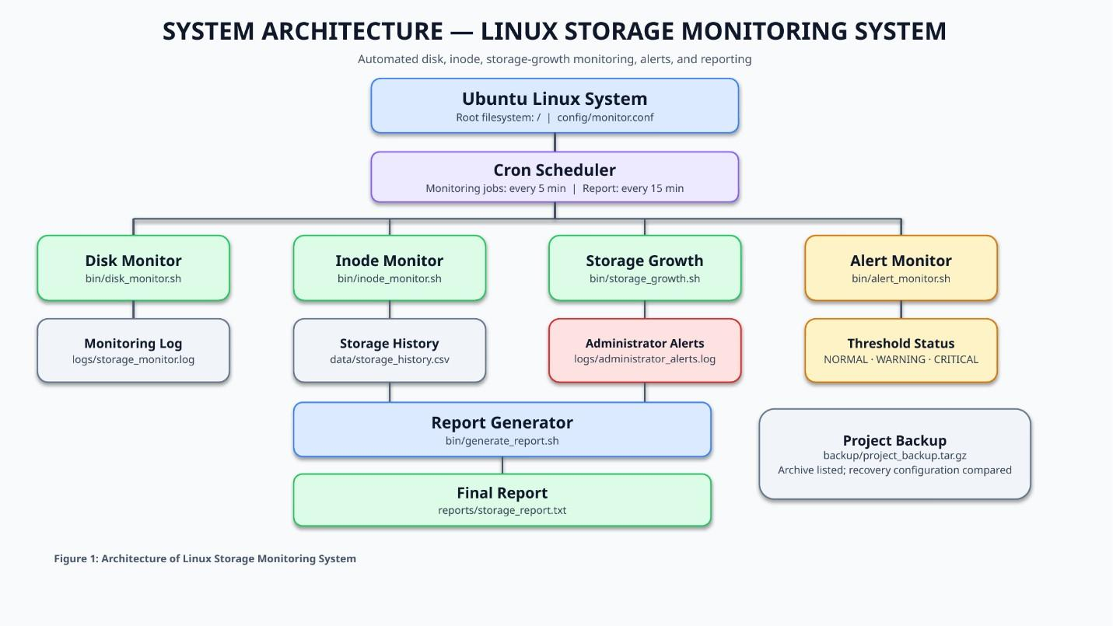

Linux System Administration E1ITA307
Linux System Administration
E1ITA307
Components and their roles
1. Client/User: The system administrator or user runs the scripts, checks storage reports, reviews
logs, and manages project files.
2. Linux Server: Ubuntu Linux provides the operating environment for the monitoring scripts,
system commands, scheduled tasks, and storage administration activities.
3. Storage: The root filesystem (/) is monitored for disk space and inode usage. Storage
measurements are recorded in a CSV file to help track changes over time.
4. Network: Network connectivity belongs to the general Linux environment. The implemented
storage monitoring functions primarily operate locally and do not require a network connection to
collect disk usage information.
5. Applications/Services: Bash scripts perform disk monitoring, inode monitoring, storage-
growth tracking, alert checking, and report generation. The Cron service schedules monitoring and
report-generation tasks.
6. Backup System: A compressed backup archive, backup/project_backup.tar.gz, stores project files.
The archive contents and selected recovered files were checked during testing.
7. Monitoring and Automation: The monitoring scripts use settings in config/monitor.conf.
Measurements are saved in data/storage_history.csv, while monitoring and alert messages are recorded
in the logs/ directory. Cron runs the scheduled tasks automatically, and the report generator creates
reports/storage_report.txt.
3.2 Linux Environment Setup
3.2.1 Linux Distribution and Version
The project was developed using Ubuntu Linux 26.04.1 LTS. The system information was checked
using the lsb_release -a command. The root filesystem is formatted with the ext4 filesystem and is
mounted at /. The storage monitoring system uses Linux utilities to check disk space and inode
utilization.

Linux System Administration E1ITA307
Linux System Administration
E1ITA307
The figure 3.2 records the Ubuntu version and filesystem details and helps verify the corresponding
implementation step.

Figure 3.2: Ubuntu version and filesystem details
3.2.2 Installation Process
The project directory was created in the user's home directory using the mkdir command. The main
directory, linux-storage-monitor, contains separate folders for monitoring scripts, configuration
files, logs, storage history, reports, tests, documentation, and backups. The tree utility was used to
display and verify the project structure.
BASH

Figure 3.3:Project directory structure and installation
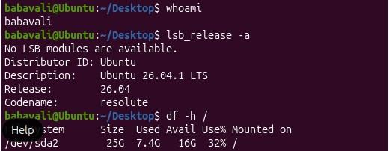
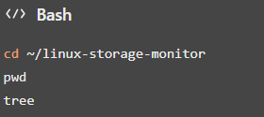
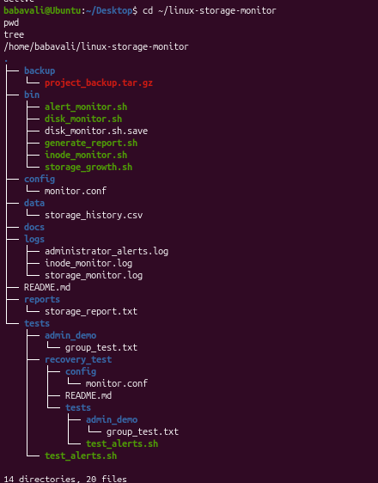

Linux System Administration E1ITA307
Linux System Administration
E1ITA307
The figure 3.3 image documents project directory structure and installation and supports the
explanation in this subsection.
3.2.3 Hostname Configuration
The hostname is used to identify the Linux system. The hostname and operating system details
were checked using Linux system commands. The terminal prompt identifies the system as Ubuntu
and displays the current account as rashmigowda. These details help identify the environment in which
the storage monitoring scripts are executed.

The figure 3.4 below illustrates project directory structure and installation as observed during
project setup and validation.

Figure 3.4: Project directory structure and installation
3.2.4 Network Configuration
The network configuration of the Linux environment was inspected using standard networking
commands. The commands display the available network interfaces, assigned IP addresses, and
routing information. The storage monitoring scripts operate locally and do not require network
connectivity to collect disk usage and inode information.
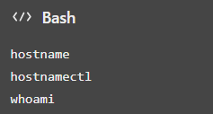
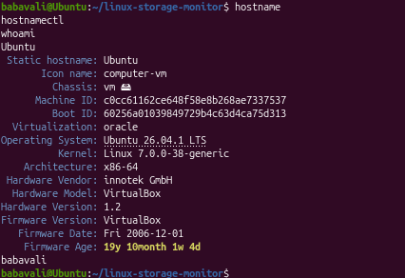

Linux System Administration E1ITA307
Linux System Administration
E1ITA307
The figure 3.5 records the project directory structure and installation and helps verify the
corresponding implementation step .

Figure 3.5: Project directory structure and installation
3.2.5 User Accounts
User and group management was demonstrated as part of Linux system administration. The project
was executed using the rashmigowda account. A test user named storagetest and a group named
storageproject were used to demonstrate group membership and access permissions. File
ownership and permissions were checked using a demonstration directory.
The figure 3.6 below illustrates project directory structure and installation as observed during
project setup and validation

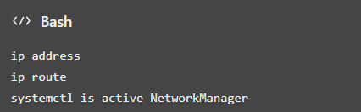
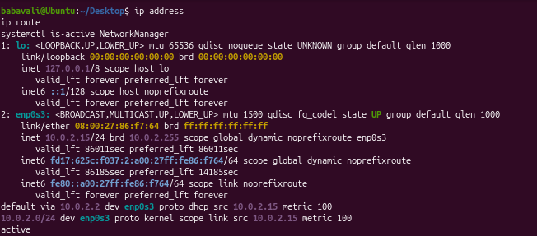
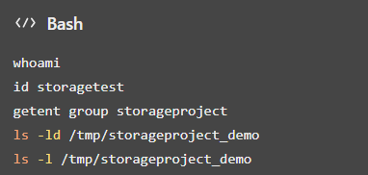

Linux System Administration E1ITA307
Linux System Administration
E1ITA307

Figure 3.6: Project directory structure and installation
3.2.6 Required Packages
The project uses Bash and standard Linux utilities for storage monitoring, file management, and
system administration. The tree utility is used to display the project directory structure. The tar and
gzip utilities are used to create and inspect the compressed backup archive. These utilities support
project organization, monitoring, and backup operations.

Figure 3.7: required packages
3.2.7 System Services
The Cron service was checked to verify that the Linux task scheduler was active. Cron was
configured to execute the disk monitoring, inode monitoring, storage growth, and alert monitoring
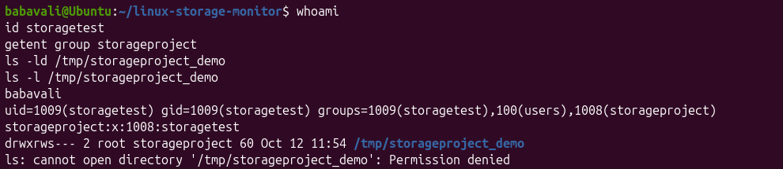
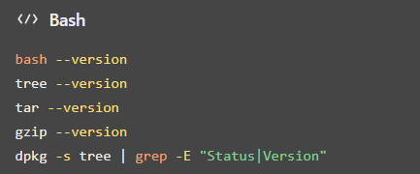
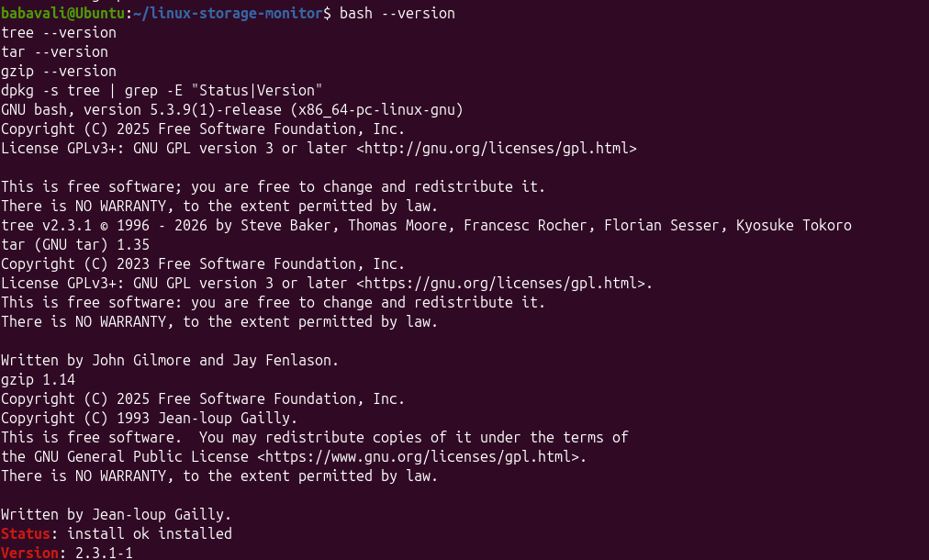

Linux System Administration E1ITA307
Linux System Administration
E1ITA307
scripts every five minutes. The report generation script was scheduled to run every fifteen
minutes. The configured tasks were verified using the crontab -l command.
The figure 3.8 records the project directory structure and installation and helps verify the
corresponding implementation step

Figure 3.8: Project directory structure and installation
3.3 User and Group Management
3.3.1 User Creation
A test user named storagetest was created in the Ubuntu Linux environment to
demonstrate user account management. The account was used to test group
membership and file access permissions. The id and getent passwd commands were
used to verify the user account information.
The figure 3.9 documents Ubuntu version and filesystem details and supports the explanation in
this subsection.
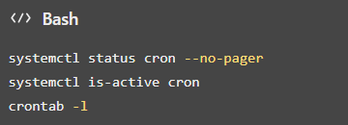
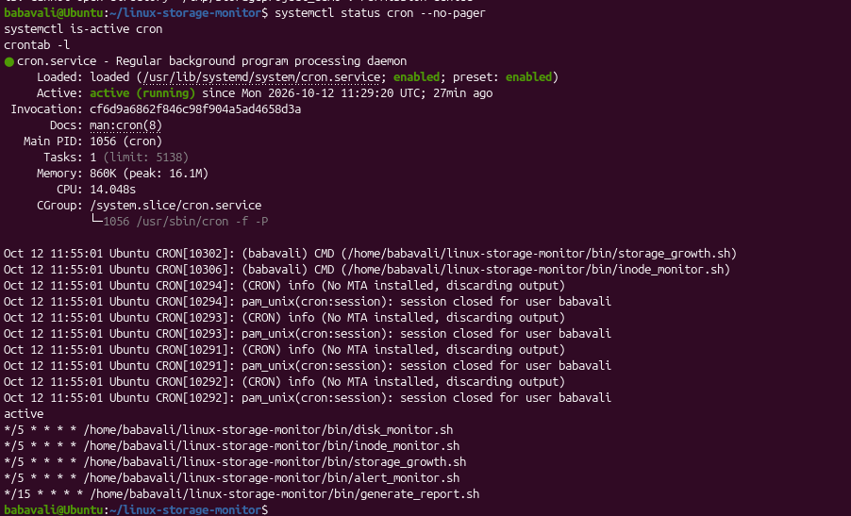

Linux System Administration E1ITA307
Linux System Administration
E1ITA307

Figure 3.9: Ubuntu version and filesystem details
3.3.2 Group Creation
A group named storageproject was created to demonstrate group management in Linux. Groups
help administrators manage permissions and provide access to files and directories for multiple
users. The getent group command was used to verify the group and its membership.
The figure 3.10 illustrates test user account configuration as observed during project setup and
validation.

Figure 3.10: Test user account configuration
3.3.3 User-Group Assignment
The existing user storagetest was assigned to the storageproject group. This assignment
demonstrates how Linux group membership can be used to manage access to project-related files
and directories. The id command was used to verify the user's group membership.
The figure 3.11 records the test user account configuration and helps verify the corresponding
implementation step.
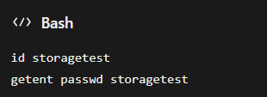
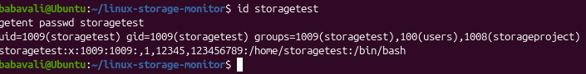
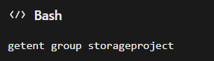

Linux System Administration E1ITA307
Linux System Administration
E1ITA307

Figure 3.11: Test user account configuration
3.3.4 Password Management
Password management was demonstrated during the creation and configuration of the test user
account. Linux provides administrative commands for setting and updating user passwords.
Passwords are managed securely by the operating system and are not displayed as plain text during
normal account operations.
The figure 3.12 documents test user account configuration and supports the explanation in this
subsection.

Figure 3.12:Test user account configuration
3.3.5 File Ownership
File ownership was configured to demonstrate Linux ownership management. The demonstration
directory and file were assigned to the root user and the storageproject group. The chown and ls -
l commands were used to configure and verify ownership.
The figure 3.13 documents test user account configuration and supports the explanation in this
subsection.
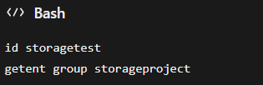
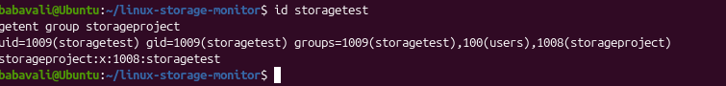
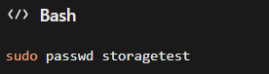
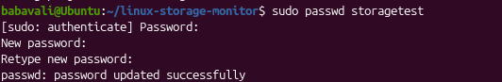

Linux System Administration E1ITA307
Linux System Administration
E1ITA307

Figure 3.13:Test user account configuration
3.3.6 File Permissions
Linux file permissions control the operations that users can perform on files and directories. The
demonstration directory was configured with permission 2770, which grants access to the owner
and group and enables the set-group-ID bit. The demonstration file was assigned permission 640,
which grants read and write access to the owner, read access to the group, and no access to other
users.
The figure 3.14 records the test user account configuration and helps verify the corresponding
implementation step.

Figure 3.14: Test user account configuration
3.3.7 Access Control
Access control was tested using the storagetest account. The test user was used to access a
demonstration file belonging to the storageproject group. The sudo -u command allows an
administrator to execute a command as another user. This test demonstrates how Linux
permissions determine whether a user can read a file.

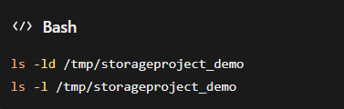
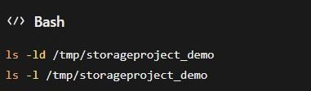
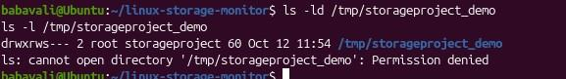
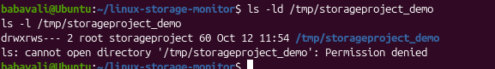

Linux System Administration E1ITA307
Linux System Administration
E1ITA307
The figure 3.15 documents test user account configuration and supports the explanation in this
subsection.

Figure 3.15: Test user account configuration
3.4. File and Directory Management
File and directory management is an important part of the Linux Storage Monitoring System. The
project uses a structured directory layout to store monitoring scripts, configuration files, log files,
storage history, reports, backups, and test files. This organization makes the project easier to
manage, maintain, and troubleshoot.
3.4.1 Directory Structure
The project directory linux-storage-monitor contains separate folders for scripts, configuration,
logs, data, reports, backups, tests, and documentation. This structure keeps the project files
organized and makes them easy to locate.
3.4.2 File Creation and Management
The project uses Bash scripts to monitor disk usage, inode usage, storage growth, and storage
alerts. Configuration settings are stored in monitor.conf. Monitoring information is recorded in
log files and storage_history.csv, while the generated storage summary is saved in
storage_report.txt.
3.4.3 File Permissions and Ownership
Linux file permissions are used to control access to files and directories. The project scripts have
permissions that allow them to be executed as required. The project also demonstrates ownership
and group permissions using the storageproject group and the storagetest user. These permissions
help control access to shared files.

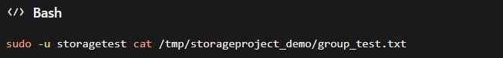

Linux System Administration E1ITA307
Linux System Administration
E1ITA307
3.4.4 Symbolic Links
A symbolic link was created to demonstrate how Linux can provide an alternative path to an
existing file. The project includes group_test_link.txt, which points to group_test.txt. Symbolic
links help users access files through different path names without creating another copy of the
original file.
3.4.5 Disk Usage Monitoring
Disk usage is monitored using Linux commands and the project’s monitoring scripts. The df
command displays filesystem space usage, while du displays the disk space used by files and
directories. The project also checks inode usage to identify possible inode exhaustion. Warning
and critical thresholds are defined in the configuration file to help identify storage usage that
requires attention.
3.4.6 File Searching and Log Filtering
Linux utilities such as find and grep are used to locate project files and search for specific
configuration settings or log entries. The tail command helps display recent log messages. These
utilities make it easier to review monitoring activity, investigate alerts, and troubleshoot
storagerelated issues.
Result: The project demonstrates organized file management, Linux permissions and ownership,
symbolic links, disk and inode usage monitoring, and basic file searching and log analysis.
3.5 Package and Process Management
Package and process management are important aspects of Linux system administration. Package
management is used to install, update, and remove software, while process management is used
to monitor running programs and manage system resources. In the Linux Storage Monitoring
System, these functions help maintain the required tools and monitor system activity.
3.5.1 Package Installation and Removal
The Advanced Package Tool (APT) is used to install and manage software packages in Ubuntu
Linux. The tree utility was installed to display the project directory structure. Installed packages
can be checked using package management commands.

Linux System Administration E1ITA307
Linux System Administration
E1ITA307
The figure 3.16 below illustrates Ubuntu version and filesystem details as observed during project
setup and validation.
Commands:

Figure 3.16:Ubuntu version and filesystem details

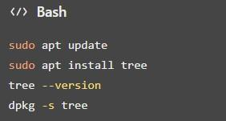
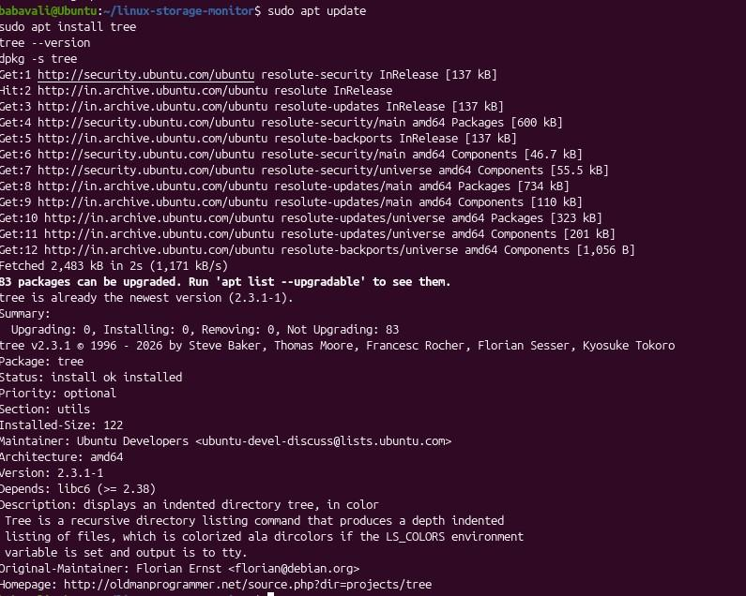

Linux System Administration E1ITA307
Linux System Administration
E1ITA307
3.5.2 Dependency Management
Dependency management ensures that the software and utilities required by the project are
available. The monitoring system uses Bash scripts and standard Linux commands to check
storage usage, process information, and system resources. APT helps install required packages
and manage their dependencies.
The figure 3.17 records the required Linux utilities and helps verify the corresponding
implementation step.

Figure 3.17:Required Linux utilities

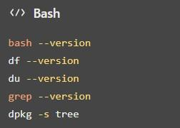
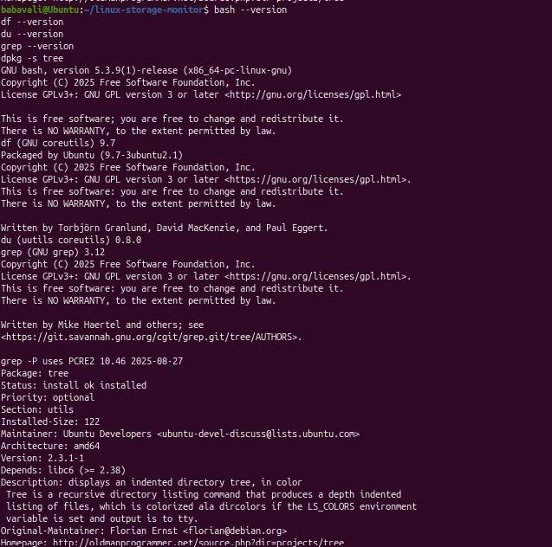

Linux System Administration E1ITA307
Linux System Administration
E1ITA307
3.5.3 Software Updates
Software updates help maintain system stability, improve security, and fix known issues. Ubuntu
provides APT commands to refresh package information and install available updates.
The figure 3.18 documents system memory and process status and supports the explanation in this
subsection.

Figure 3.18: System memory and process status

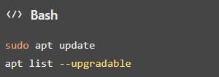
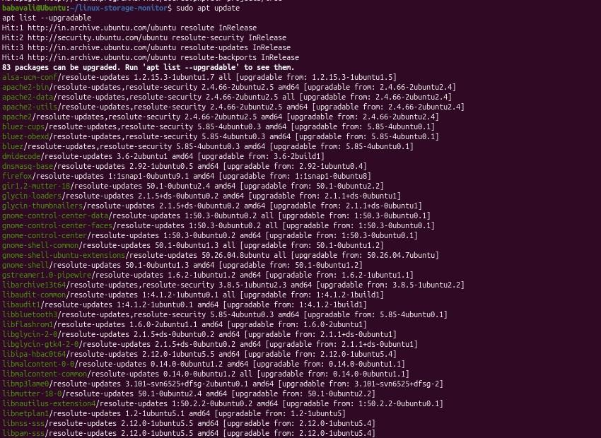

Linux System Administration E1ITA307
Linux System Administration
E1ITA307
3.5.4 Process Monitoring
Process monitoring helps identify programs currently running on the Linux system. Commands
such as ps, top, and free are used to observe processes, CPU activity, memory usage, and overall
system performance.
The figure 3.19 illustrates system memory and process status as observed during project setup and
validation.

Figure 3.19: System memory and process status
3.5.5 Process Termination
Linux provides the kill command to terminate a process when necessary. A process ID (PID)
identifies each running process. Before terminating a process, its PID should be checked carefully
to avoid stopping an important system service.
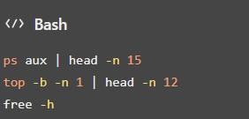
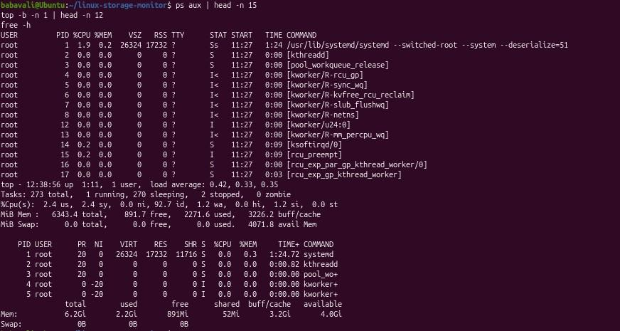

Linux System Administration E1ITA307
Linux System Administration
E1ITA307
The figure 3.20 records the Cron service and scheduled automation and helps verify the
corresponding implementation step.
Figure 3.20: Cron service and scheduled automation
3.5.6 Service Management
Linux services can be managed using systemctl. The Cron service is important to this project
because it runs scheduled monitoring tasks automatically. The service status can be checked to
verify that it is active.
The figure 3.21 documents Cron service and scheduled automation and supports the explanation
in this subsection.

Figure 3.21: Cron service and scheduled automation

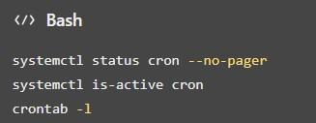
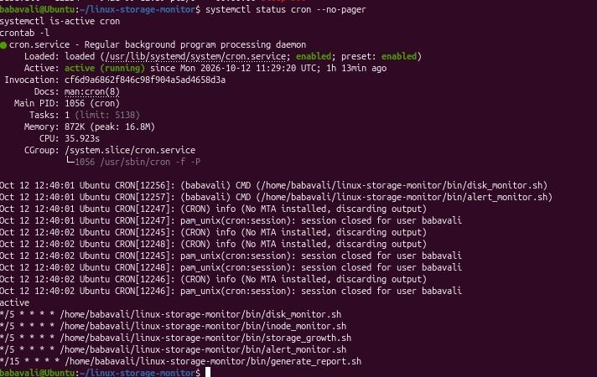
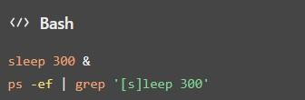

Linux System Administration E1ITA307
Linux System Administration
E1ITA307
3.5.7 Resource Monitoring
Resource monitoring helps observe disk space, inode availability, and memory usage. The project
uses Linux commands and monitoring scripts to identify storage usage and record monitoring
information. Warning and critical thresholds are defined in the configuration file.
The figure 3.22 illustrates Cron service and scheduled automation as observed during project setup
and validation.

Figure 3.22: Cron service and scheduled automation
3.6 Storage and File System Configuration
Storage and file system configuration are important parts of Linux system administration. They
help administrators understand disk partitions, file systems, mount points, and available storage
space. The Linux Storage Monitoring System uses Linux commands to monitor disk space and
inode usage and identify storage conditions that may require attention.
3.6.1 Disk and Partition Configuration
The df and lsblk commands are used to view filesystem usage and available block devices. The
project monitors the root filesystem (/) using the configured MONITOR_PATH=/ setting.
The figure 3.23 records the disk space monitoring and helps verify the corresponding
implementation step.

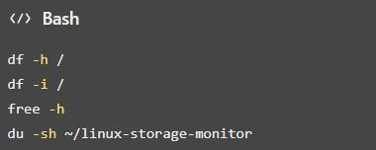
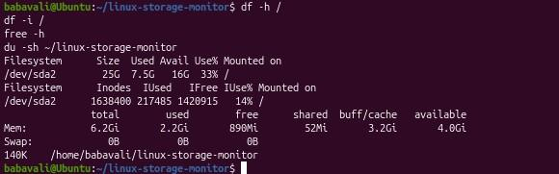

Linux System Administration E1ITA307
Linux System Administration
E1ITA307

Figure 3.23: Disk space monitoring
These commands display block devices, disk space usage, filesystem types, and the filesystem
mounted at the root directory
3.6.2 File System Creation
A file system organizes data on a storage device so that files and directories can be stored and
accessed. This project uses the existing Linux filesystem for monitoring. No new filesystem
creation is required for the monitoring scripts.
The figure 3.24 documents disk space monitoring and supports the explanation in this subsection.

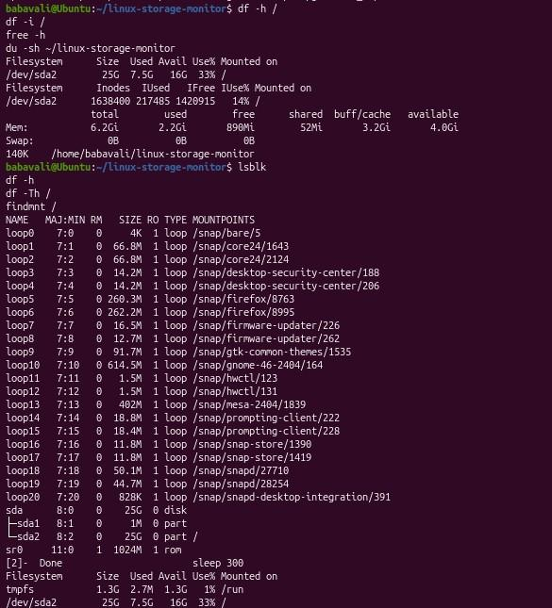
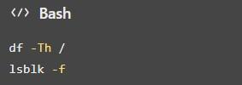

Linux System Administration E1ITA307
Linux System Administration
E1ITA307

Figure 3.24 : Disk space monitoring
3.6.3 Mounting and Unmounting
Mounting makes a filesystem accessible at a directory called a mount point. The findmnt
command displays mounted filesystems. This project monitors the root filesystem and does not
require a separate filesystem to be mounted or unmounted.
The figure 3.25 below illustrates disk space monitoring as observed during project setup and
validation.

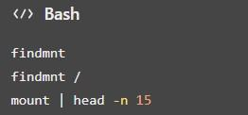
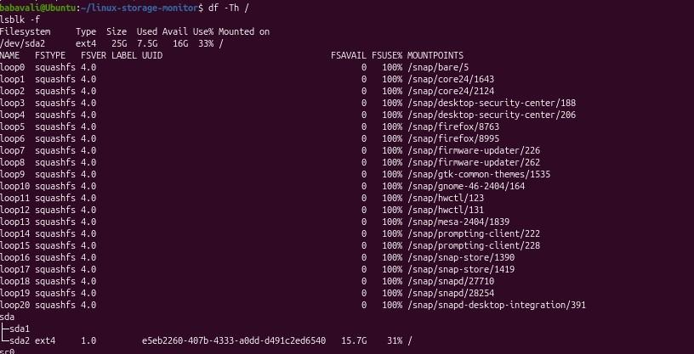

Linux System Administration E1ITA307
Linux System Administration
E1ITA307

Figure 3.25 : Disk space monitoring
3.6.4 Logical Volume Management (LVM)
Logical Volume Management (LVM) allows administrators to create and manage logical storage
volumes. LVM configuration is not part of the current project, so no logical volumes were created
or modified. The following commands can be used to check whether LVM devices are present.
The figure 3.26 records the project directory structure and installation and helps verify the
corresponding implementation step.

Figure 3.26: Project directory structure and installation

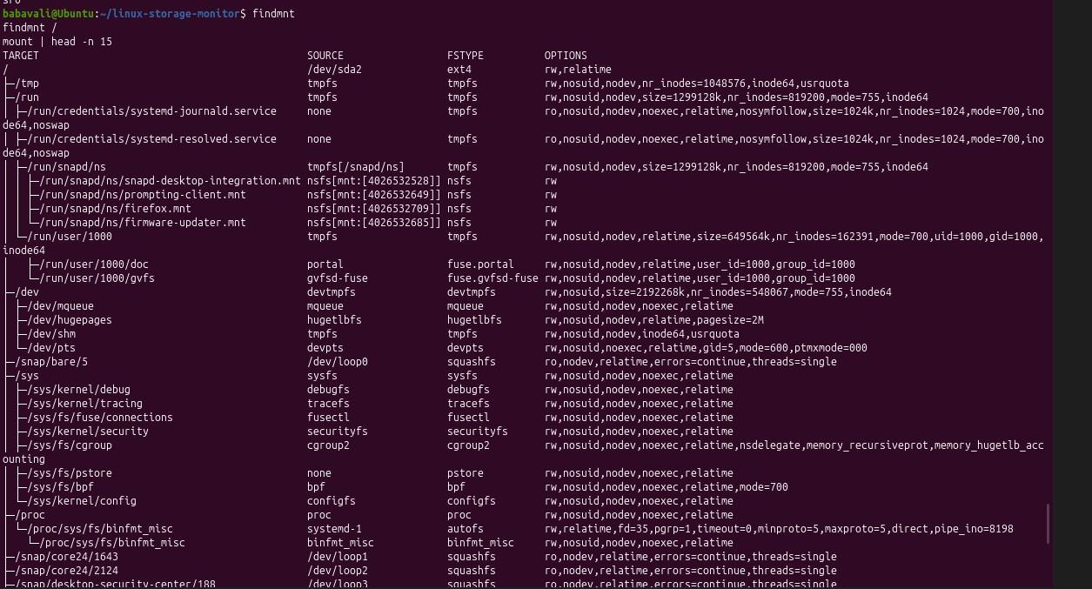
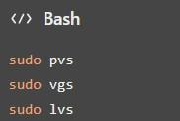
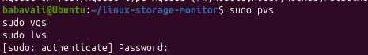

Linux System Administration E1ITA307
Linux System Administration
E1ITA307
3.6.5 Storage Allocation
Storage allocation refers to the disk space used by files, directories, and applications. The project
files are stored in the linux-storage-monitor directory under the user's home directory. The du
command is used to determine the storage space occupied by the project, while df shows overall
filesystem capacity and available space.
The figure 3.27 documents project directory structure and installation and supports the explanation
in this subsection.

Figure 3.27: Project directory structure and installation
These commands show the total project size, the sizes of its main subdirectories, and the available
storage on the root filesystem.
3.6.6 Disk Usage Monitoring
The monitoring system uses the df command and project scripts to check disk usage. It also
monitors inode usage, which indicates how many filesystem entries are in use. The warning and
critical thresholds are configured in config/monitor.conf.
The current configuration includes:

- MONITOR_PATH=/
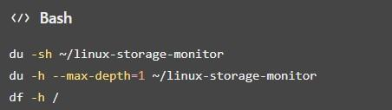
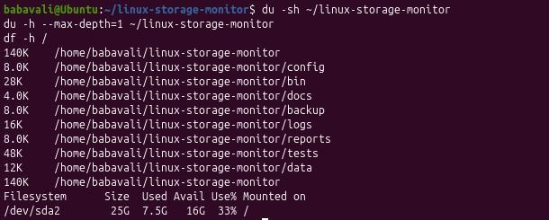

Linux System Administration E1ITA307
Linux System Administration
E1ITA307

- DISK_WARNING=80

- DISK_CRITICAL=90

- INODE_WARNING=80

- INODE_CRITICAL=90
These settings define the monitored path and the warning and critical usage thresholds as
percentages.
The figure 3.28 illustrates disk space monitoring as observed during project setup and validation.

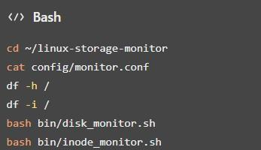
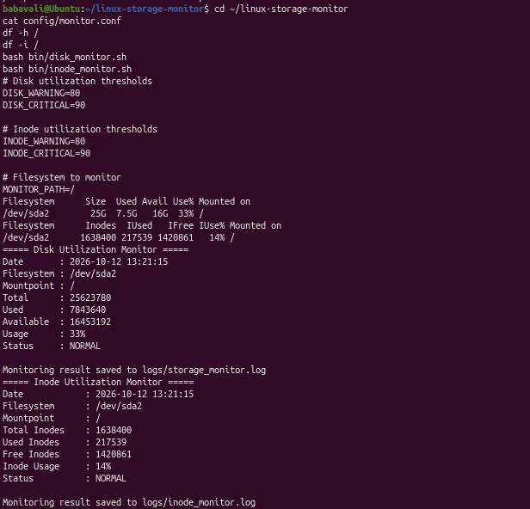

Linux System Administration E1ITA307
Linux System Administration
E1ITA307
Figure 3.28: Disk space monitoring
The configuration file can be checked to verify the thresholds. The disk and inode monitoring
scripts display the current storage conditions according to their implementation.
3.6.7 Storage Architecture and Configuration Details
The storage architecture of the project consists of the existing Linux filesystem, the project
directory, configuration files, monitoring scripts, log files, storage history, and generated reports.
The system monitors the existing root filesystem rather than creating a new partition or logical
volume. Monitoring scripts read storage information, compare usage against configured
thresholds, and store results in logs and history files. Reports and backup archives are maintained
within the project directory.
This figure 3.29 presents the project directory structure and installation, providing visual evidence
of the configuration or result described above.

Figure 3.29 : Project directory structure and installation
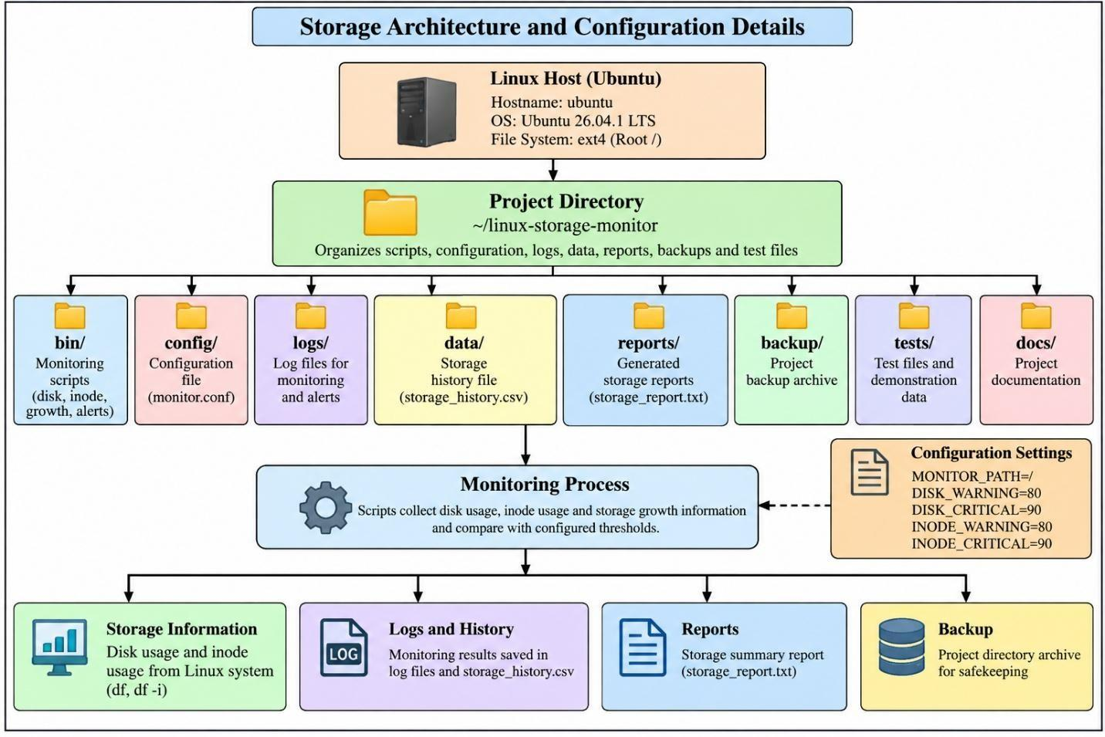

Linux System Administration E1ITA307
Linux System Administration
E1ITA307
3.7 Backup and Automation
Backup and automation are important features of the Linux Storage Monitoring System. Backup
helps protect project files from accidental loss, while automation allows monitoring scripts and
report generation tasks to run at scheduled intervals without requiring manual execution each time.
3.7.1 Backup Strategy
The project uses a compressed archive to create a backup of important project files. The backup is
stored as project_backup.tar.gz. The tar utility packages the selected files and directories, while
gzip compression reduces the archive size. This backup helps preserve project scripts,
configuration files, tests, and other important project data.
3.7.2 Backup Location
The backup archive is stored in the project's backup directory.
Backup path: ~/linux-storage-monitor/backup/project_backup.tar.gz
The archive can be checked using the following commands:

Figure 3.30: Project directory structure and installation
The first command displays the archive's size and details, while the second lists its contents without
extracting the files.
The figure 3.30 captures the relevant output for project directory structure and installation,
showing how this part of the Linux project was checked
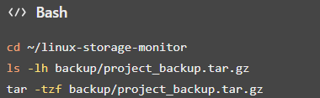
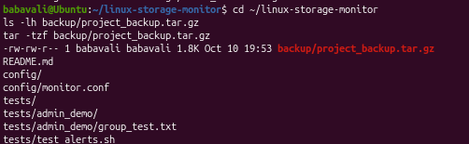

Linux System Administration E1ITA307
Linux System Administration
E1ITA307
3.7.3 Backup Frequency
The project contains a backup archive. A recurring backup schedule should not be assumed unless
a backup job has been configured. The monitoring scripts and report generation tasks are scheduled
separately using Cron.
The backup archive can be checked periodically to confirm that it exists and contains the expected
files.
3.7.4 Shell Script Automation
Bash shell scripts are used to automate the monitoring tasks. The project includes scripts for disk
usage monitoring, inode usage monitoring, storage growth tracking, alert monitoring, and report
generation.
The scripts are stored in the bin directory:

- disk_monitor.sh – monitors disk space usage.

- inode_monitor.sh – monitors inode utilization.

- storage_growth.sh – tracks storage growth.

- alert_monitor.sh – handles storage alert monitoring.

- generate_report.sh – generates the storage summary report.
These scripts reduce repetitive manual work by collecting storage information and recording
results automatically.
3.7.5 Cron Configuration
Cron is used to schedule the monitoring scripts and report generation. The Cron service runs
scheduled tasks at specified intervals.
The project's scheduled tasks include monitoring scripts running every five minutes and report
generation every fifteen minutes.
Commands to verify the service and scheduled jobs:

Linux System Administration E1ITA307
Linux System Administration
E1ITA307

Figure 3.31: Cron service and scheduled automation
The crontab -l command displays the current user's scheduled jobs. The Cron service status
confirms whether the scheduling service is active.
3.7.6 Log Generation
The monitoring system records information in log files so that monitoring activity and alerts can
be reviewed later. The project includes the following log files:

- logs/storage_monitor.log – stores storage monitoring information.

- logs/administrator_alerts.log – stores administrator alert information.

- data/storage_history.csv – stores storage history data.

- reports/storage_report.txt – contains the generated storage report.
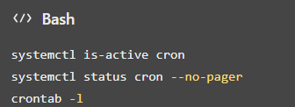
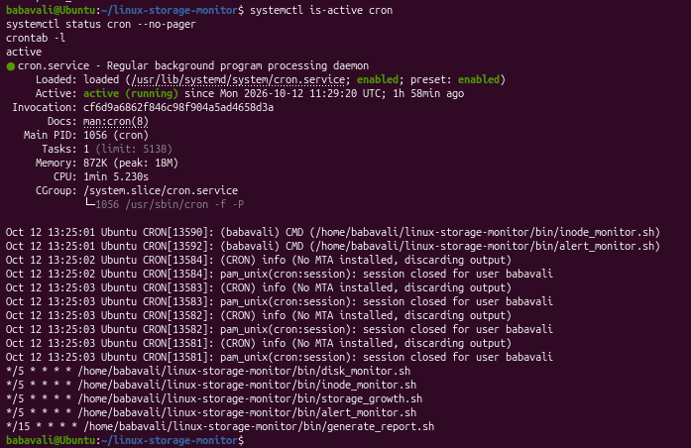

Linux System Administration E1ITA307
Linux System Administration
E1ITA307
Commands to inspect the logs and report:

Figure 3.32 : Storage threshold and alert checks
This figure 3.32 presents the storage threshold and alert checks, providing visual
evidence of the configuration or result described above.
These commands help verify monitoring activity, review alerts, and inspect the generated report.
3.7.7 Recovery Procedure
Recovery involves extracting selected files from the backup archive and checking that the
recovered files match the originals. The project backup can be inspected before extraction to
identify the required files.
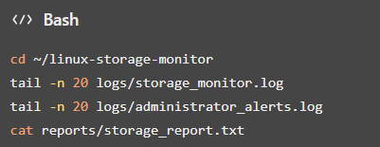
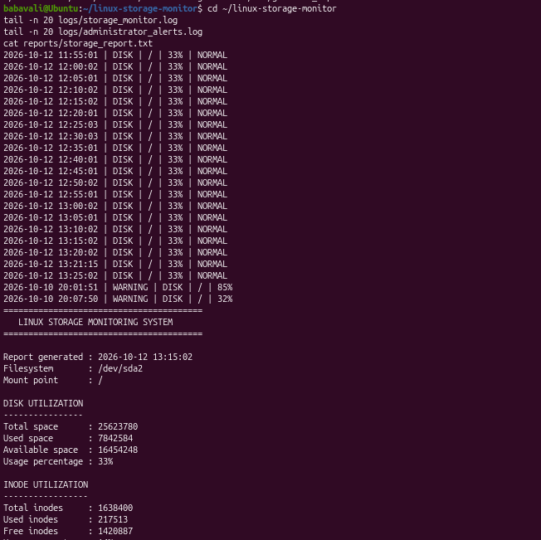

Linux System Administration E1ITA307
Linux System Administration
E1ITA307
To list the archive contents:

Figure 3.33 : Storage threshold and alert checks
To extract the archive into a separate recovery directory:

Figure 3.34: Storage threshold and alert checks
The figure 3.34 documents storage threshold and alert checks and supports
the explanation in this subsection.
After extraction, the recovered files can be inspected and compared with the original files. For
example, use diff to compare matching text files. An empty output indicates that the compared
files have no differences.
Recovery testing should be performed in a separate directory to avoid overwriting the original
project files.
3.7.8 Benefits of Automation
Automation reduces manual administrative effort by running storage checks and report generation
at scheduled intervals. It helps maintain regular monitoring, records storage information for later
review, and makes it easier to identify conditions that may require administrator attention.
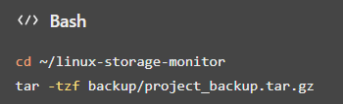
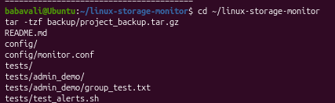
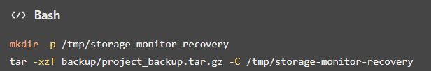

Linux System Administration E1ITA307
Linux System Administration
E1ITA307
Using Cron and Bash scripts improves consistency and reduces the need to execute each
monitoring command manually. The backup archive also provides a way to preserve and recover
selected project files when needed.
Result
The project demonstrates compressed backup storage, scheduled monitoring through Cron,
automatic report generation, log recording, and recovery testing of selected files. These features
support more consistent storage administration and reduce repetitive manual tasks.
3.8 Security and Access Control
Security and access control are important parts of the Linux Storage Monitoring System. They
help protect project files, control user access, and reduce the risk of unauthorized modifications.
The project demonstrates Linux user and group management, file permissions, ownership,
password management, and service status verification.
3.8.1 User Permissions
Linux user and group permissions help control access to files and directories. In this project, the
storagetest user and storageproject group are used to demonstrate access control. The user is added
to the project group so that group permissions can be tested.

Figure 3.35: Test user account configuration

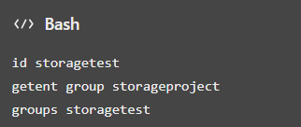
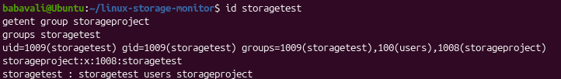

Linux System Administration E1ITA307
Linux System Administration
E1ITA307
3.8.2 File Permissions
Linux file permissions determine whether users can read, write, or execute files. The project
demonstrates directory and file permissions using a shared directory owned by root and the
storageproject group. The directory uses permission mode 2770, and the demonstration file uses
permission mode 640.
The figure 3.36 captures the relevant output for test user account configuration, showing how this
part of the Linux project was checked.
Commands:

Figure 3.36 : Test user account configuration
The directory's 2770 permission mode enables owner and group access and applies the set-group-
ID bit. The file's 640 permission mode gives the owner read and write access, the group read
access, and others no access.
3.8.3 Firewall Configuration
A firewall helps control incoming and outgoing network traffic. The Ubuntu firewall status was
checked using the UFW utility. The observed status was inactive, so an enabled firewall should
not be claimed as an implemented security measure.
Command:
Command:
sudo ufw status verbose

This command displays the firewall status and any configured rules. Enabling a firewall should be
done only after reviewing the system's network requirements.
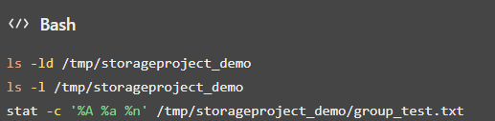
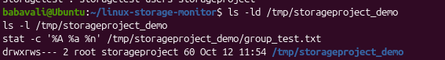

Linux System Administration E1ITA307
Linux System Administration
E1ITA307
3.8.4 SSH Configuration
Secure Shell (SSH) provides encrypted remote access to a Linux system. During the project
checks, the SSH service was not found. Therefore, SSH-based remote access configuration was
not implemented or verified as part of this project.
Command:

The command checks the SSH service status.
3.8.5 Service Access Control
Linux services can be inspected and managed using systemctl. The Cron service is used in this
project to schedule monitoring scripts and report generation. Checking its status helps verify that
the scheduling service is operating.
Commands:

Service status checks help administrators identify whether a required service is active and
investigate service-related issues.
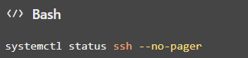
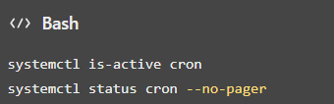

Linux System Administration E1ITA307
Linux System Administration
E1ITA307

Figure 3.37 : Test user account configuration
3.8.6 Password Policies
Linux user accounts can be protected using passwords. The project includes user and password
management demonstrations for the test account. Passwords should be kept confidential and
should follow the organization's password requirements.
Commands:

The first command allows an administrator to set or change the test user's password. The second
displays password status information.
3.8.7 Security Monitoring
Security-related checks include reviewing file permissions, checking user and group membership,
inspecting service status, and examining monitoring logs. These checks help identify access
configuration issues and provide information for troubleshooting.
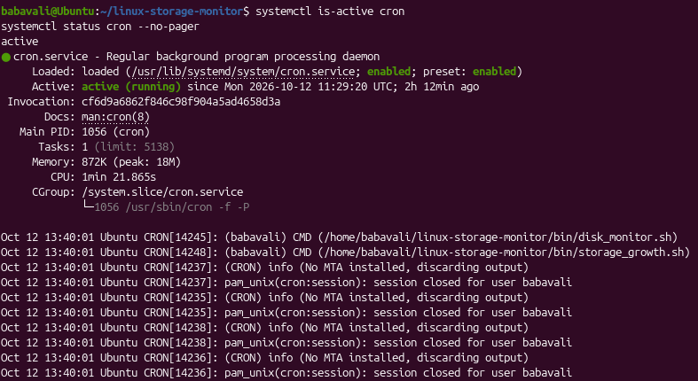
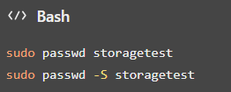

Linux System Administration E1ITA307
Linux System Administration
E1ITA307
Commands:

These commands display script permissions and recent monitoring and alert log entries:

Figure 3.38: Test user account configuration
3.8.8 Security Benefits
The implemented measures improve system security in the following ways:

- User and group management: helps organize access to shared project files.

- File permissions: limits reading, writing, and execution according to ownership and
permission settings.

- Password management: supports controlled access to user accounts.

- Service monitoring: helps administrators verify the status of scheduled services.

- Log inspection: supports troubleshooting and review of monitoring activity.

- Firewall and SSH checks: help identify the current state of network security components.
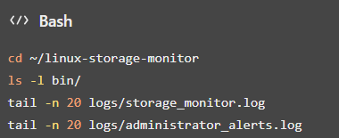
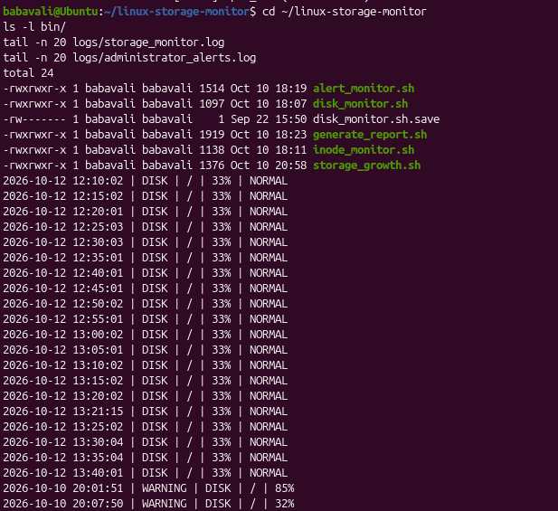

Linux System Administration E1ITA307
Linux System Administration
E1ITA307
4.TEST AND VALIDATION
4.1 Implementation Results
The Linux Storage Monitoring System was implemented using Bash shell scripts, Linux
administration commands, configuration files, Cron scheduling, log files, and backup utilities. The
system monitors disk space and inode usage, records storage information, generates reports, and
supports backup and recovery testing.
The implementation results demonstrate the use of Linux system administration concepts,
including file management, user and group permissions, package management, process
monitoring, service management, storage monitoring, and task automation.
4.1.1 Screenshots and Command Outputs
Screenshots of the terminal outputs provide evidence of the implementation. The project directory
structure, monitoring script outputs, configuration settings, log files, generated reports, and backup
archive can be included to demonstrate the operation of the system.

Figure 4.1 : Project directory structure and installation
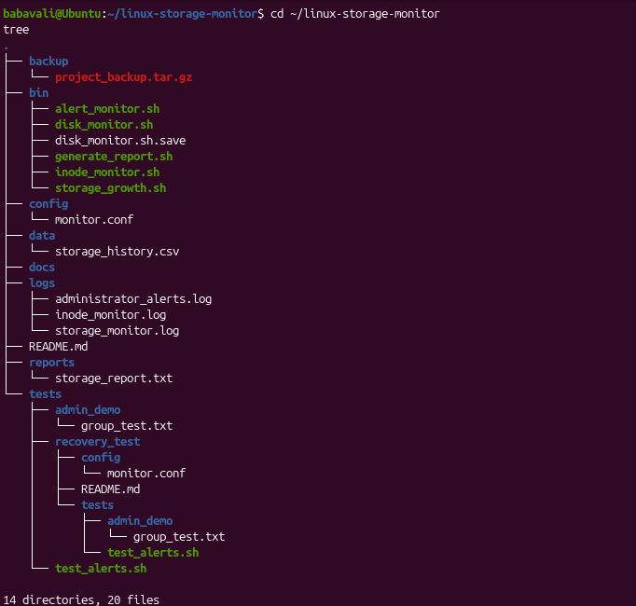

Linux System Administration E1ITA307
Linux System Administration
E1ITA307
4.1.2 Storage Monitoring Results
The system monitors disk space and inode usage to identify storage conditions that may require
attention.

Figure 4.2 : Project directory structure and installation
The observed disk usage was approximately 33%, while inode usage was approximately 14%.
Both values were below the configured warning threshold of 80% at the time of observation.
4.1.3 Configuration Results
The monitoring configuration defines the filesystem path and the warning and critical thresholds
used by the scripts.

Figure 4.3: Project directory structure and installation
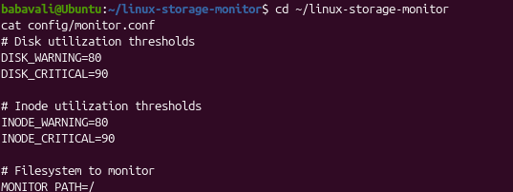
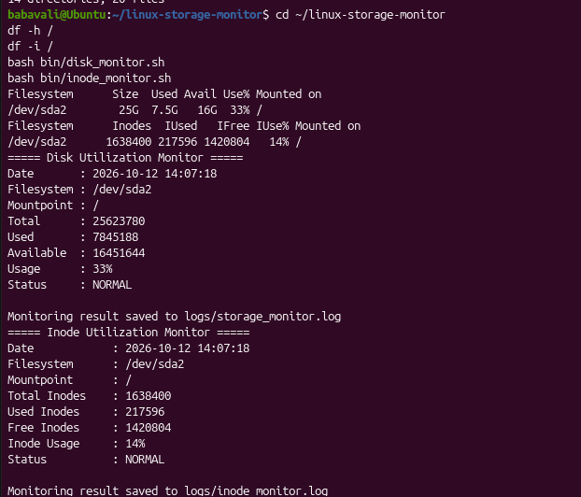

Linux System Administration E1ITA307
Linux System Administration
E1ITA307
The configuration includes MONITOR_PATH=/, disk warning and critical thresholds of 80% and
90%, and inode warning and critical thresholds of 80% and 90%.
4.1.4 System Status and Automation Results
Cron is used to execute the monitoring scripts and report generation tasks at scheduled intervals.

Figure 4.4 : Project directory structure and installation
The Cron service was verified as active. The configured schedule runs monitoring scripts every
five minutes and generates reports every fifteen minutes. The scheduled configuration reduces the
need for repeated manual execution.
4.1.5 Backup Results
A compressed backup archive is stored in the project's backup directory.
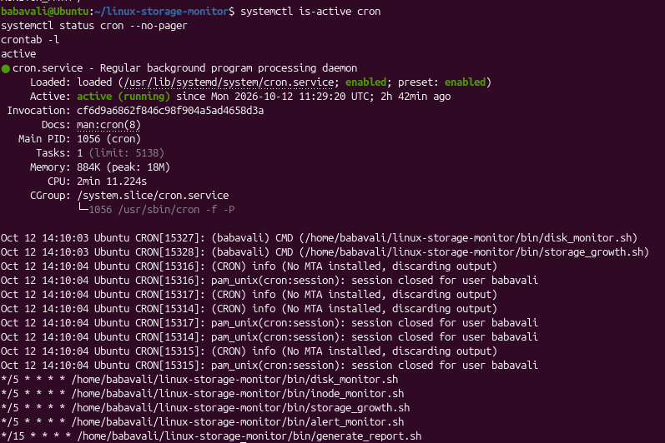

Linux System Administration E1ITA307
Linux System Administration
E1ITA307

Figure 4.5 : Project directory structure and installation
The backup archive was verified, and its contents were listed successfully. This confirms that the
archive exists and can be inspected.
4.1.6 Log and Report Results
The system stores monitoring activity, administrator alerts, storage history, and generated reports
in separate files.

Figure 4.6 : : Project directory structure and installation
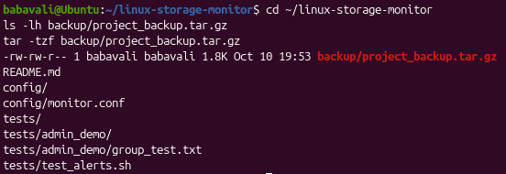
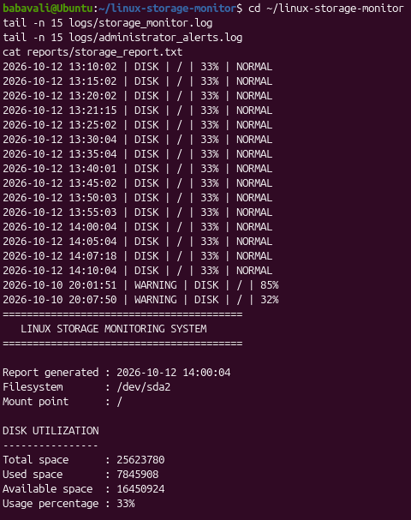

Linux System Administration E1ITA307
Linux System Administration
E1ITA307
The log files help review monitoring activity and alerts, while the report provides a summary of
storage monitoring results.
4.1.7 Security Configuration
The project demonstrated user and group management, file ownership, permission configuration,
and access testing. The test user successfully accessed the demonstration file through group
permissions. The UFW firewall was found to be inactive, and the SSH service was not found
during the checks.

Figure 4.7 : Project directory structure and installation

Overall, the implementation demonstrates a basic Linux storage monitoring solution that
combines storage checks, logging, report generation, scheduled execution, and backup
validation.

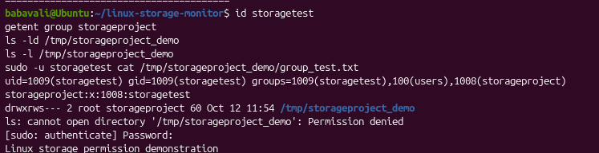

Linux System Administration E1ITA307
Linux System Administration
E1ITA307
4.2 Testing and Validation
Testing and validation were performed to verify the main functions of the Linux Storage
Monitoring System. The test cases cover user and group management, permissions, package
installation, service status, backup creation, recovery testing, automation, and access control.
Test Case
Expected Result
Actual Result
Status
User creation and
group verification
User and group exist, and
membership is configured
correctly.
storagetest and
storageproject were verified.
Pass
Permission
configuration
Correct access is granted
to authorized users.
The test user successfully
accessed the shared
demonstration file.
Pass
Package
installation
Required package is
installed successfully.
tree was installed and its
version was checked.
Pass
Service
configuration
Cron service runs
successfully.
Cron service status was
verified as active.
Pass
Backup execution
Backup archive exists and
contains project files.
Archive was present and its
contents were listed.
Pass
Data recovery
Selected files are
recovered and match
originals.
Selected recovered files
were compared with
originals using diff.
Pass
Automation
Scheduled tasks are
configured correctly.
Cron jobs were configured
for monitoring and report
generation.
Configuration
verified

Linux System Administration E1ITA307
Linux System Administration
E1ITA307
Storage monitoring
Disk and inode usage are
checked against
thresholds.
Usage was below the
warning thresholds during
observation.
Pass
Security test
Access follows the
configured file
permissions.
Group-based access to the
demonstration file was
successful.
Pass for
demonstrated
test
TABLE 1: TESTING AND VALIDATION

4.2.2 Recovery Testing
The backup recovery test checks whether selected files can be extracted into a separate directory
and compared with their original versions.
4.2.3 Package Verification
The package test verifies that the tree utility is installed and available.
4.2.4 Testing Summary
The tests demonstrate the main features of the Linux Storage Monitoring System, including storage
monitoring, configuration verification, user and group permissions, package management, Cron
scheduling, backup archive inspection, and selected-file recovery. These results show how Linux
administration tools and Bash scripts can support routine storage monitoring and reduce repetitive
manual work.

Linux System Administration E1ITA307
Linux System Administration
E1ITA307
5. Conclusion and Future Scope
5.1 Conclusion
The Linux Storage Monitoring System provided practical experience in Linux system
administration by implementing disk space monitoring, inode usage monitoring, storage growth
tracking, alert monitoring, and report generation. The project used Bash shell scripts, Linux
commands, configuration files, and Cron scheduling to automate routine storage monitoring tasks.
The project also demonstrated user and group management, file and directory permissions,
package and process management, storage usage analysis, backup creation, recovery testing, and
log management. The implementation was tested by checking monitoring outputs, verifying
scheduled tasks, inspecting the backup archive, and comparing selected recovered files with their
original versions.
The project achieved its main objective of demonstrating a basic Linux storage monitoring
solution. It helped develop practical knowledge of Linux administration, storage management,
automation, access control, and system maintenance.
5.2 Future Scope
The project can be enhanced in the following ways:

- Advanced monitoring and alerting: Introduce real-time monitoring and notifications when
disk or inode usage reaches warning or critical thresholds.

- Automated backup and recovery: Schedule regular backups and improve recovery
procedures to protect important project files.

- Centralized logging: Store monitoring logs in a centralized location to simplify analysis
and troubleshooting.

- Improved security: Strengthen file permissions, password policies, firewall configuration,
and access control.

- Graphical dashboard: Develop a dashboard to display disk usage, inode utilization, storage
growth, and alert history.

Linux System Administration E1ITA307
Linux System Administration
E1ITA307

- Containerization: Package the monitoring system using container technologies to improve
portability and deployment.

- Automated infrastructure management: Use configuration management tools to simplify
deployment and maintenance across multiple Linux systems.
References
1. Ubuntu Documentation, Ubuntu Server Documentation. Available at:
https://ubuntu.com/server/docs/.
Ubuntu
2. GNU Project, GNU Bash Reference Manual. Available at:
https://www.gnu.org/software/bash/manual/bash.html.
GNU
3. GNU Project, GNU Coreutils Manual. Available at:
https://www.gnu.org/software/coreutils/manual/coreutils.html.
GNU
4. Ubuntu Manpages, crontab — Maintains Crontab Files for Individual Users. Available at:
https://manpages.ubuntu.com/manpages/noble/man1/crontab.1.html.
maintains crontab files for individual users
5. GNU Project, GNU Tar Manual. Available at:
https://www.gnu.org/software/tar/manual/tar.html.
GNU
6. Linux Manual Pages Project, Linux Manual Pages (man pages). Available at:
https://www.kernel.org/doc/man-pages/.
7. Ubuntu Documentation, Managing Software. Available through the Ubuntu Server
Documentation

Linux System Administration E1ITA307
Linux System Administration
E1ITA307
Appendices
Appendix A: System Architecture

Figure A1 : System Architecture of Linux Storage Monitoring System

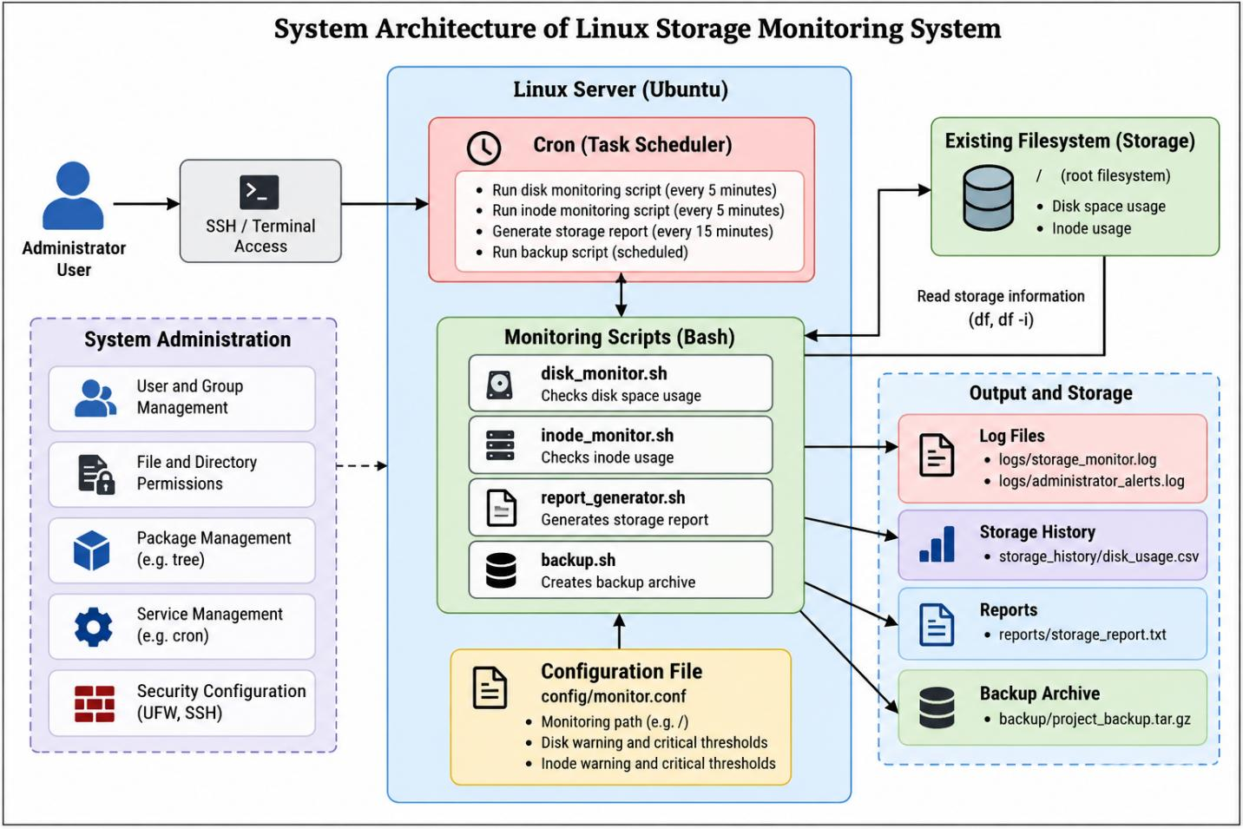

Linux System Administration E1ITA307
Linux System Administration
E1ITA307
Appendix B: Linux Commands and Configuration
This appendix presents important Linux commands, configuration files, and terminal outputs
used in the Linux Storage Monitoring System. The screenshots already included in this document
provide evidence of the commands and results.
B.1 System Information Commands
These commands display the current user, hostname, and Linux distribution details.
whoami
hostname
hostnamectl
lsb_release -a

Figure B1 : Ubuntu version and filesystem details
B.2 Project Directory Structure
The project directory organizes scripts, configuration, logs, data, reports, backups, tests, and
documentation.
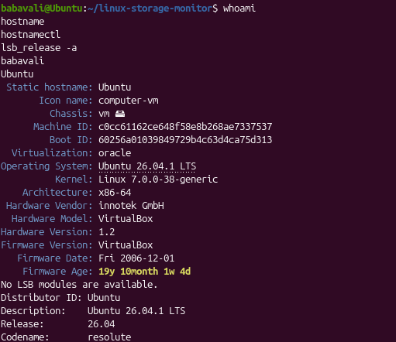

Linux System Administration E1ITA307
Linux System Administration
E1ITA307
Command:
cd ~/linux-storage-monitor

pwd
tree
find . -maxdepth 2 -type f

Figure B2 : Ubuntu version and filesystem details
B.3 Storage Monitoring Commands
These commands display filesystem capacity, inode utilization, filesystem type, and project
directory size.
df -h /
df -i /
df -Th /
du -sh ~/linux-storage-monitor
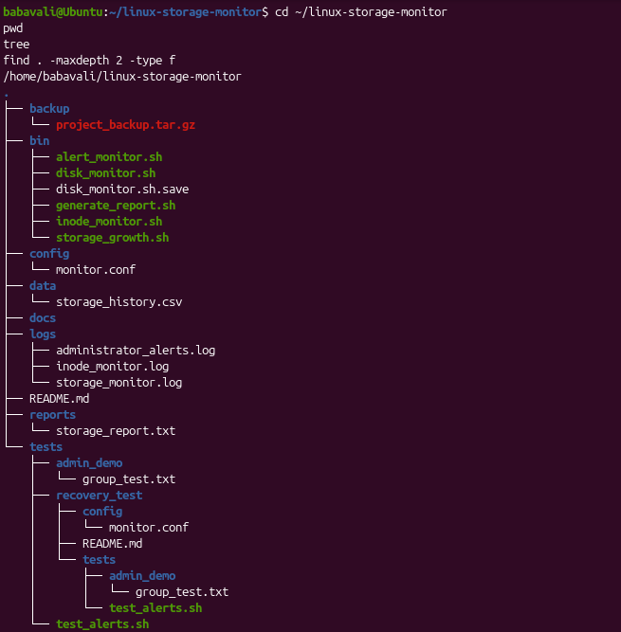

Linux System Administration E1ITA307
Linux System Administration
E1ITA307

Figure B3 : Project directory structure and installation

B.4 Monitoring Scripts
Bash scripts monitor disk usage, inode usage, storage growth, alerts, and report generation.
Command:
cd ~/linux-storage-monitor

bash bin/disk_monitor.sh
bash bin/inode_monitor.sh
bash bin/storage_growth.sh
bash bin/alert_monitor.sh
bash bin/generate_report.sh
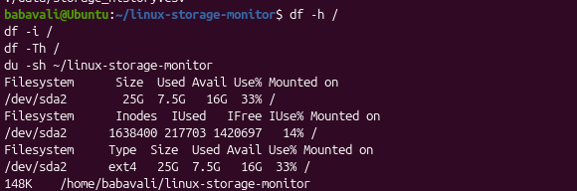

Linux System Administration E1ITA307
Linux System Administration
E1ITA307

Figure B4 : Project directory structure and
installation
B.5 Configuration File
The configuration file defines the monitored filesystem and warning and critical thresholds.
cat ~/linux-storage-monitor/config/monitor.conf

Figure B5 : Project directory structure and installation

B.6 User and Group Management
These commands verify the test user, project group, membership, and shared directory
permissions.
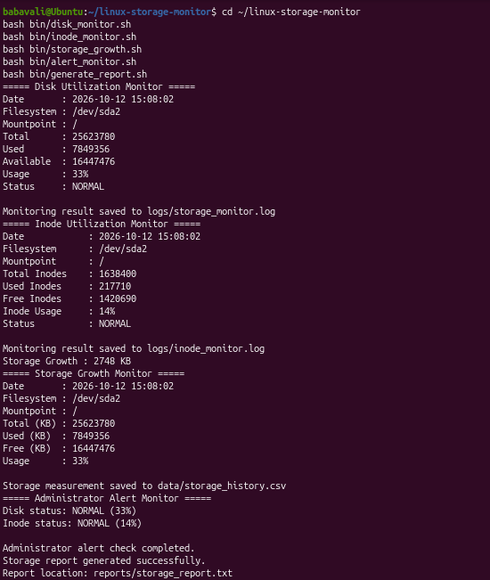
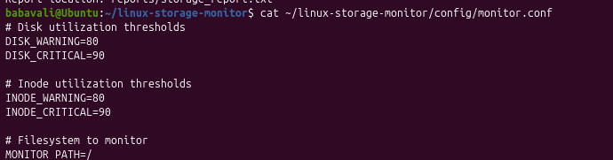

Linux System Administration E1ITA307
Linux System Administration
E1ITA307
id storagetest
getent group storageproject
groups storagetest
ls -ld /tmp/storageproject_demo
ls -l /tmp/storageproject_demo
.

Figure B6 : Project directory structure and installation

B.7 File Permissions and Access Testing
These commands inspect file permissions and test the test user's access to the demonstration file.

stat -c '%A %a %n' /tmp/storageproject_demo/group_test.txt
Command:
sudo -u storagetest cat /tmp/storageproject_demo/group_test.txt

Figure B7 : Project directory structure and installation
B.8 Package and Process Management
These commands verify the tree package and display running processes and memory usage.
tree --version
dpkg -s tree
ps aux | head -n 15
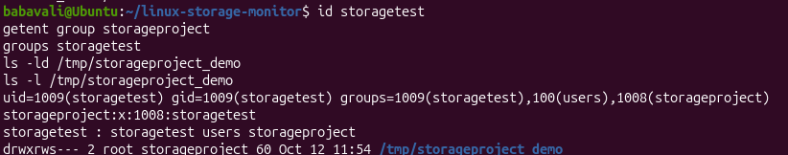
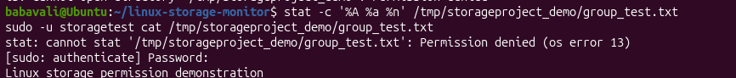

Linux System Administration E1ITA307
Linux System Administration
E1ITA307
free -h
top -b -n 1 | head -n 12

Figure B8 : Project directory structure and installation

B.9 Cron Service and Automation
Cron schedules the monitoring scripts and report generation.
Command:
systemctl is-active cron

Command:
systemctl status cron --no-pager

Command:
crontab -l

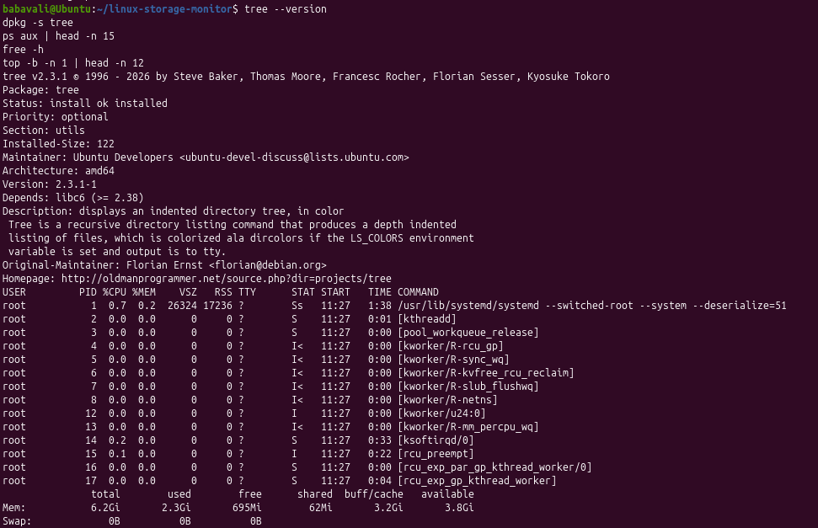

Linux System Administration E1ITA307
Linux System Administration
E1ITA307

Figure B9 : Project directory structure and
installation
B.10 Log and Report Management
These commands display recent monitoring logs, alert records, storage history, and the generated
report.
Command:
cd ~/linux-storage-monitor

tail -n 20 logs/storage_monitor.log
tail -n 20 logs/administrator_alerts.log
cat data/storage_history.csv
cat reports/storage_report.txt
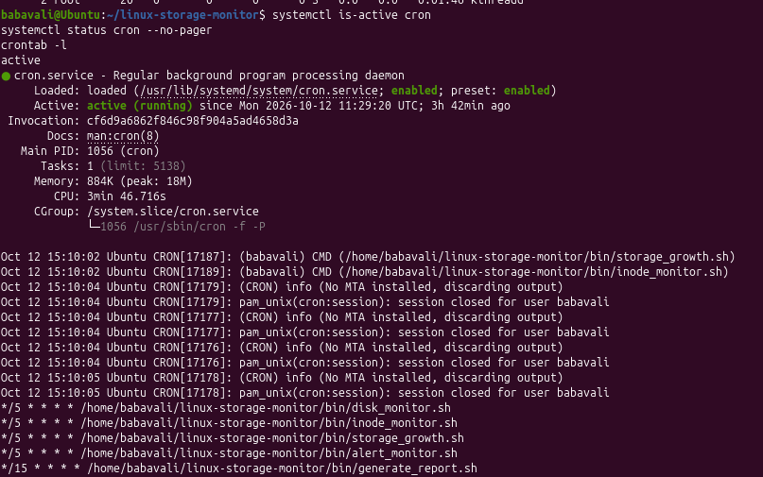

Linux System Administration E1ITA307
Linux System Administration
E1ITA307

Figure B10 : Project directory structure and installation

B.11 Backup and Recovery
The compressed archive is inspected and extracted into a separate directory for recovery testing.
Command:
cd ~/linux-storage-monitor

ls -lh backup/project_backup.tar.gz
tar -tzf backup/project_backup.tar.gz

Figure B11 : Project directory structure and installation

B.11.1 Recovery Commands
Extract the archive into a separate recovery directory without overwriting the original project.
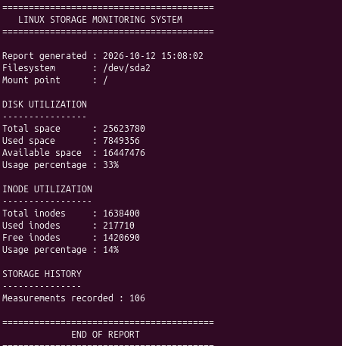
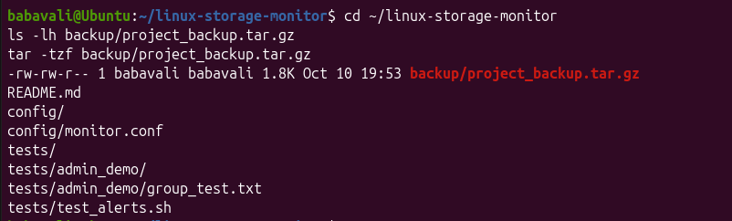

Linux System Administration E1ITA307
Linux System Administration
E1ITA307
mkdir -p /tmp/storage-monitor-recovery
tar -xzf ~/linux-storage-monitor/backup/project_backup.tar.gz -C /tmp/storage-monitor-
recovery
find /tmp/storage-monitor-recovery -type f

B.12 Important Project Files
File or Directory
Purpose
bin/disk_monitor.sh
Disk usage monitoring
bin/inode_monitor.sh
Inode usage monitoring
bin/storage_growth.sh
Storage growth tracking
bin/alert_monitor.sh
Alert monitoring
bin/generate_report.sh
Report generation
config/monitor.conf
Monitoring configuration and thresholds
logs/storage_monitor.log
Storage monitoring log
logs/administrator_alerts.log
Administrator alert log
data/storage_history.csv
Storage history records
reports/storage_report.txt
Generated storage report
backup/project_backup.tar.gz
Compressed project backup
TABLE1 : IMPORTANT PROJECT FILES

Linux System Administration E1ITA307
Linux System Administration
E1ITA307
APPENDIX C: SHELL SCRIPTS
The following Bash scripts demonstrate the main monitoring and reporting functions of the
Linux Storage Monitoring System.
C.1 Disk Monitoring Script — bin/disk_monitor.sh
Command:
#!/bin/bash

# Monitor disk space usage against configured thresholds.

BASE_DIR="$(cd "$(dirname "${BASH_SOURCE[0]}")/.." && pwd)"
CONFIG_FILE="$BASE_DIR/config/monitor.conf"
LOG_FILE="$BASE_DIR/logs/storage_monitor.log"

if [[ -f "$CONFIG_FILE" ]]; then
source "$CONFIG_FILE"
else
echo "Configuration file not found: $CONFIG_FILE" >&2
exit 1
fi

mkdir -p "$BASE_DIR/logs"
usage=$(df -P "$MONITOR_PATH" | awk 'NR==2 {gsub(/%/,"",$5); print $5}')
timestamp=$(date '+%Y-%m-%d %H:%M:%S')

if [[ -z "$usage" ]]; then
echo "$timestamp ERROR: Unable to read disk usage for $MONITOR_PATH" | tee -a "$LOG_FILE"
exit 1
elif (( usage >= DISK_CRITICAL )); then
echo "$timestamp CRITICAL: Disk usage is ${usage}% on $MONITOR_PATH" | tee -a "$LOG_FILE"
elif (( usage >= DISK_WARNING )); then
echo "$timestamp WARNING: Disk usage is ${usage}% on $MONITOR_PATH" | tee -a "$LOG_FILE"
else
echo "$timestamp OK: Disk usage is ${usage}% on $MONITOR_PATH" | tee -a "$LOG_FILE"
fi

C.2 Inode Monitoring Script — bin/inode_monitor.sh
Command:
#!/bin/bash

# Monitor inode usage against configured thresholds.

Linux System Administration E1ITA307
Linux System Administration
E1ITA307
BASE_DIR="$(cd "$(dirname "${BASH_SOURCE[0]}")/.." && pwd)"
CONFIG_FILE="$BASE_DIR/config/monitor.conf"
LOG_FILE="$BASE_DIR/logs/storage_monitor.log"

if [[ -f "$CONFIG_FILE" ]]; then
source "$CONFIG_FILE"
else
echo "Configuration file not found: $CONFIG_FILE" >&2
exit 1
fi

mkdir -p "$BASE_DIR/logs"
usage=$(df -Pi "$MONITOR_PATH" | awk 'NR==2 {gsub(/%/,"",$5); print $5}')
timestamp=$(date '+%Y-%m-%d %H:%M:%S')

if [[ -z "$usage" ]]; then
echo "$timestamp ERROR: Unable to read inode usage for $MONITOR_PATH" | tee -a "$LOG_FILE"
exit 1
elif (( usage >= INODE_CRITICAL )); then
echo "$timestamp CRITICAL: Inode usage is ${usage}% on $MONITOR_PATH" | tee -a "$LOG_FILE"
elif (( usage >= INODE_WARNING )); then
echo "$timestamp WARNING: Inode usage is ${usage}% on $MONITOR_PATH" | tee -a "$LOG_FILE"
else
echo "$timestamp OK: Inode usage is ${usage}% on $MONITOR_PATH" | tee -a "$LOG_FILE"
fi

C.3 Storage Growth Tracking — bin/storage_growth.sh
Command:
#!/bin/bash

# Append current storage usage to a CSV history file.

BASE_DIR="$(cd "$(dirname "${BASH_SOURCE[0]}")/.." && pwd)"
CONFIG_FILE="$BASE_DIR/config/monitor.conf"
HISTORY_FILE="$BASE_DIR/data/storage_history.csv"

if [[ -f "$CONFIG_FILE" ]]; then
source "$CONFIG_FILE"
else
echo "Configuration file not found: $CONFIG_FILE" >&2
exit 1
fi

Linux System Administration E1ITA307
Linux System Administration
E1ITA307

mkdir -p "$BASE_DIR/data"
if [[ ! -f "$HISTORY_FILE" ]]; then
echo "timestamp,mount_point,disk_usage_percent,inode_usage_percent" > "$HISTORY_FILE"
fi

disk_usage=$(df -P "$MONITOR_PATH" | awk 'NR==2 {gsub(/%/,"",$5); print $5}')
inode_usage=$(df -Pi "$MONITOR_PATH" | awk 'NR==2 {gsub(/%/,"",$5); print $5}')
timestamp=$(date '+%Y-%m-%d %H:%M:%S')

if [[ -z "$disk_usage" || -z "$inode_usage" ]]; then
echo "Unable to collect storage usage for $MONITOR_PATH" >&2
exit 1
fi

echo "\"$timestamp\",\"$MONITOR_PATH\",$disk_usage,$inode_usage" >> "$HISTORY_FILE"
echo "Storage history updated: $HISTORY_FILE"

C.4 Administrator Alert Script — bin/alert_monitor.sh
Command:
#!/bin/bash

# Record warning and critical storage conditions for administrator review.

BASE_DIR="$(cd "$(dirname "${BASH_SOURCE[0]}")/.." && pwd)"
CONFIG_FILE="$BASE_DIR/config/monitor.conf"
ALERT_FILE="$BASE_DIR/logs/administrator_alerts.log"

if [[ -f "$CONFIG_FILE" ]]; then
source "$CONFIG_FILE"
else
echo "Configuration file not found: $CONFIG_FILE" >&2
exit 1
fi

mkdir -p "$BASE_DIR/logs"
timestamp=$(date '+%Y-%m-%d %H:%M:%S')
disk_usage=$(df -P "$MONITOR_PATH" | awk 'NR==2 {gsub(/%/,"",$5); print $5}')
inode_usage=$(df -Pi "$MONITOR_PATH" | awk 'NR==2 {gsub(/%/,"",$5); print $5}')

if [[ -z "$disk_usage" || -z "$inode_usage" ]]; then
echo "$timestamp ERROR: Could not collect storage metrics." | tee -a "$ALERT_FILE"

Linux System Administration E1ITA307
Linux System Administration
E1ITA307
exit 1
fi

if (( disk_usage >= DISK_CRITICAL )); then
echo "$timestamp CRITICAL: Disk usage ${disk_usage}% on $MONITOR_PATH" | tee -a "$ALERT_FILE"
elif (( disk_usage >= DISK_WARNING )); then
echo "$timestamp WARNING: Disk usage ${disk_usage}% on $MONITOR_PATH" | tee -a "$ALERT_FILE"
fi

if (( inode_usage >= INODE_CRITICAL )); then
echo "$timestamp CRITICAL: Inode usage ${inode_usage}% on $MONITOR_PATH" | tee -a "$ALERT_FILE"
elif (( inode_usage >= INODE_WARNING )); then
echo "$timestamp WARNING: Inode usage ${inode_usage}% on $MONITOR_PATH" | tee -a "$ALERT_FILE"
fi

C.5 Report Generation — bin/generate_report.sh
Command:
#!/bin/bash

# Generate a plain-text storage monitoring report.

BASE_DIR="$(cd "$(dirname "${BASH_SOURCE[0]}")/.." && pwd)"
CONFIG_FILE="$BASE_DIR/config/monitor.conf"
REPORT_FILE="$BASE_DIR/reports/storage_report.txt"
LOG_FILE="$BASE_DIR/logs/storage_monitor.log"
ALERT_FILE="$BASE_DIR/logs/administrator_alerts.log"
HISTORY_FILE="$BASE_DIR/data/storage_history.csv"

if [[ -f "$CONFIG_FILE" ]]; then
source "$CONFIG_FILE"
else
echo "Configuration file not found: $CONFIG_FILE" >&2
exit 1
fi

mkdir -p "$BASE_DIR/reports"
{
echo "LINUX STORAGE MONITORING REPORT"
echo "Generated: $(date '+%Y-%m-%d %H:%M:%S')"
echo "Monitored path: $MONITOR_PATH"
echo
echo "DISK SPACE"

Linux System Administration E1ITA307
Linux System Administration
E1ITA307
df -h "$MONITOR_PATH"
echo
echo "INODE USAGE"
df -i "$MONITOR_PATH"
echo
echo "CONFIGURED THRESHOLDS"
echo "Disk warning: ${DISK_WARNING}%"
echo "Disk critical: ${DISK_CRITICAL}%"
echo "Inode warning: ${INODE_WARNING}%"
echo "Inode critical: ${INODE_CRITICAL}%"
echo
echo "RECENT MONITORING LOG ENTRIES"
if [[ -f "$LOG_FILE" ]]; then tail -n 10 "$LOG_FILE"; else echo "No monitoring log available."; fi
echo
echo "RECENT ADMINISTRATOR ALERTS"
if [[ -f "$ALERT_FILE" ]]; then tail -n 10 "$ALERT_FILE"; else echo "No alert log available."; fi
echo
echo "STORAGE HISTORY"
if [[ -f "$HISTORY_FILE" ]]; then tail -n 10 "$HISTORY_FILE"; else echo "No storage history available."; fi
} > "$REPORT_FILE"

echo "Report generated: $REPORT_FILE"

C.6 Monitoring Configuration — config/monitor.conf
MONITOR_PATH=/
DISK_WARNING=80
DISK_CRITICAL=90
INODE_WARNING=80
INODE_CRITICAL=90

Linux System Administration E1ITA307
Linux System Administration
E1ITA307
1. Project Overview
The Linux Storage Monitoring System is a small web application built on Ubuntu Linux. It
presents disk-space and inode information in a browser dashboard. The backend uses Python
Flask to read Linux command output and existing project log/report files, then returns the
information to the frontend through HTTP API endpoints.
Main technologies
- Frontend: HTML for page structure, CSS for appearance, and JavaScript for requesting and
displaying data.
- Backend: Python with the Flask web framework.
- Linux data sources: df -h / for disk usage and df -i / for inode usage.
- Existing project files: logs/storage_monitor.log and reports/storage_report.txt.
- Local development address: http://127.0.0.1:5000.
2. Frontend and Backend: What Each Part Does
Frontend
The frontend is the web page opened in Firefox. It is stored at backend/templates/index.html.
HTML defines the dashboard sections and buttons, CSS styles the cards and layout, and
JavaScript calls the backend APIs and puts the returned values on the page.
Backend
The backend is stored at backend/app.py. Flask serves the HTML page and defines API routes.
Python runs Linux commands to obtain current disk and inode values and reads the project's log
and report files.
How the parts communicate
Firefox dashboard (HTML/CSS/JavaScript)
| fetch('/api/storage') and fetch('/api/logs')
v
Python Flask backend (backend/app.py)
| runs df / df -i and reads project files

Linux System Administration E1ITA307
Linux System Administration
E1ITA307
v
Ubuntu Linux + logs/storage_monitor.log + reports/storage_report.txt
3. Project Setup
The project was opened in the terminal and the Python virtual environment was activated.
Command:
cd ~/linux-storage-monitor

source venv/bin/activate
The prompt displayed (venv), confirming that the virtual environment was active. Flask was
installed in that environment and its version was checked with:
python -m flask --version
The backend folder and HTML templates folder were created. The two main implementation
files are:
backend/app.py
backend/templates/index.html
A Python syntax check was also performed with python -m py_compile backend/app.py. When
this command completed without output, no syntax error was reported.
4. Backend Implementation
The backend file is backend/app.py. Its main responsibilities are:
- Create a Flask application.
- Run df -h / to get disk size, used space, available space, and usage percentage.
- Run df -i / to get total, used, and free inodes and inode usage percentage.
- Serve the dashboard at the root route (/).
- Return storage data as JSON at /api/storage.
- Return recent monitoring log lines as JSON at /api/logs.
- Return the saved storage report as JSON at /api/report.
Backend API routes
Route
Purpose
Result

Linux System Administration E1ITA307
Linux System Administration
E1ITA307
/
Loads the web dashboard
HTML page
/api/storage
Reads current disk and inode
data
JSON
/api/logs
Reads recent monitoring log
lines
JSON
/api/report
Reads
reports/storage_report.txt
JSON
5. Frontend Implementation
The frontend file is backend/templates/index.html. It includes:
- A page heading identifying the Linux Storage Monitoring System.
- Cards for disk usage, inode usage, and storage status.
- A Storage Information section with a Refresh Storage button.
- A Monitoring Logs section with a Refresh Logs button.
- JavaScript functions loadStorage() and loadLogs() to call the backend APIs.
- Automatic refresh of storage values every 30 seconds while the page is open.
6. Dashboard Result
The dashboard was opened in Firefox at http://127.0.0.1:5000. The screenshot below shows the
page rendering live storage values. At the time of the screenshot, disk usage was 34%, inode
usage was 14%, and the storage status was NORMAL. These values can change as the system
changes.

Linux System Administration E1ITA307
Linux System Administration
E1ITA307

Figure 1. Dashboard displaying disk usage, inode usage, and storage information.
7. Monitoring Logs Display
The Monitoring Logs section calls the /api/logs endpoint and displays recent entries from
logs/storage_monitor.log. The screenshot shows timestamps, the monitored filesystem, disk
usage percentages, and status values.
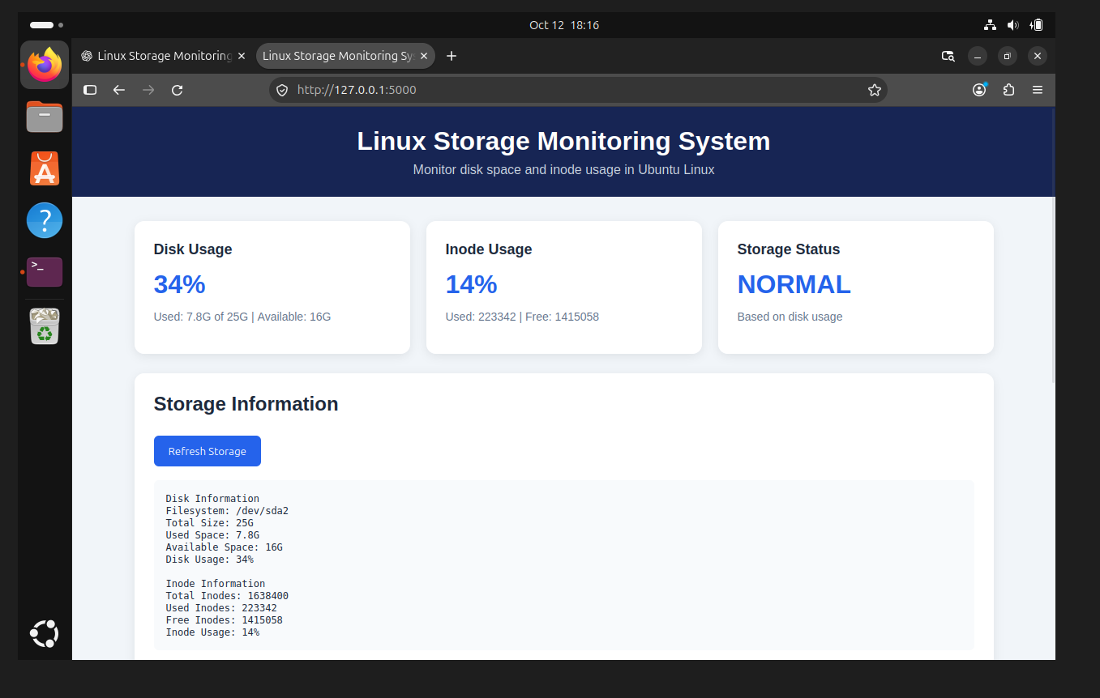

Linux System Administration E1ITA307
Linux System Administration
E1ITA307

Figure 2. Monitoring log entries displayed in the browser.
8. Testing the Backend APIs
The API endpoints were tested directly from a second terminal using curl. This verifies that Flask
returns data independently of the browser display.
Test A: Storage API
curl http://127.0.0.1:5000/api/storage
The response contained JSON fields for disk filesystem, size, used space, available space, usage
percentage, and inode totals and usage.
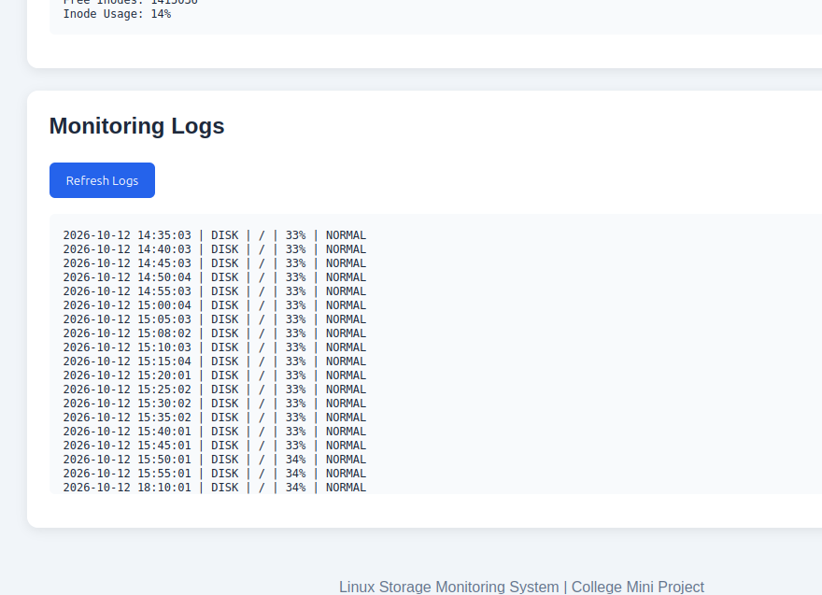

Linux System Administration E1ITA307
Linux System Administration
E1ITA307

Figure 3. Successful response from the /api/storage endpoint.
Test B: Logs API
curl http://127.0.0.1:5000/api/logs
The response contained a list of recent monitoring log lines in JSON format.

Figure 4. Successful response from the /api/logs endpoint.
Test C: Report API
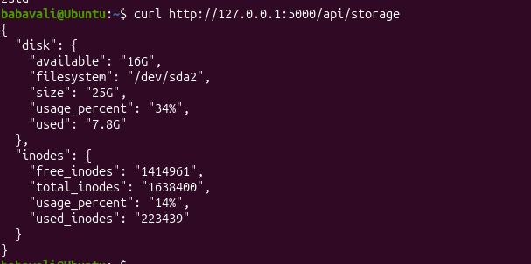
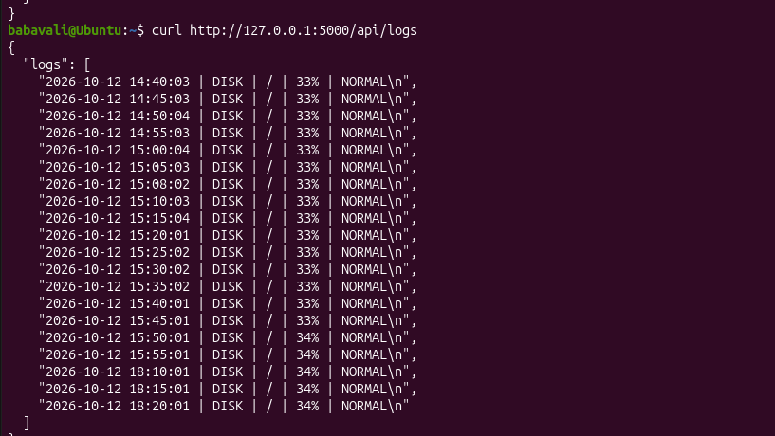

Linux System Administration E1ITA307
Linux System Administration
E1ITA307
curl http://127.0.0.1:5000/api/report
The response contained the contents of reports/storage_report.txt in a JSON field named report.
The report includes filesystem and mount point details, disk utilization, inode utilization, and the
number of recorded storage-history measurements.

Figure 5. Successful response from the /api/report endpoint.
9. Running the Application
To run the application in Ubuntu:
Command:
cd ~/linux-storage-monitor

source venv/bin/activate
python backend/app.py
Keep the terminal running the Flask server open. Then open Firefox and visit
http://127.0.0.1:5000. To test the APIs, open a second terminal and run one of the curl
commands in Section 8.
If Flask displays 'Address already in use' for port 5000, another process may already be running
the server. If the dashboard and API requests are already working, do not start a second copy
unnecessarily.
10. Current Results and Limitations
- The frontend dashboard loaded successfully in Firefox.
- Disk and inode data were displayed from the Ubuntu system.
- The monitoring log section displayed existing log records.
- The /api/storage and /api/logs endpoints were tested successfully with curl.
- The /api/report endpoint was added and tested successfully with curl.
- The report API returns the report text as JSON; a report button on the frontend has not yet
been connected.
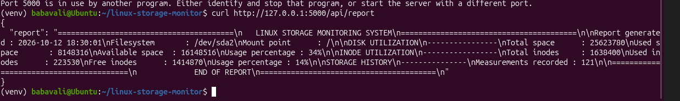

Linux System Administration E1ITA307
Linux System Administration
E1ITA307
- The project was run as a local development application. Flask's built-in development server
is suitable for this demonstration, not production deployment.
11. Simple Explanation for Project Demonstration
“Our project is a Linux Storage Monitoring System. The frontend is built using HTML, CSS, and
JavaScript. It shows disk usage, inode usage, storage status, and monitoring logs. The backend is
developed in Python using Flask. It runs Linux commands such as df -h and df -i to obtain
storage information. The frontend requests this information from Flask API endpoints, and the
backend returns the results in JSON format. We tested the storage and logs APIs using curl, and
also added and tested an API to retrieve our existing storage report.”
12. Important File Locations
linux-storage-monitor/
├── backend/
│ ├── app.py
│ └── templates/
│ └── index.html
├── logs/
│ └── storage_monitor.log
└── reports/
└── storage_report.txt

