
Linux System Administration (E1ITA307)
Linux Infrastructure Deployment Project Report
On
LINUX STORAGE MONITORING & INFRASTRUCTURE AUTOMATION SYSTEM
Submitted by
RASHMI | (2411021061295)
PANCHAKSHARAYYA | (2411021061321)
APOORVA P KERETOT | (24110210613161)
S DARSHAN SAI | (2411021061289)
In partial fulfillment of the award of the degree of
BACHELOR OF TECHNOLOGY
In
Information Technology
Under the Supervision of
Prof. Ananthanagu U

ALLIANCE SCHOOL OF ADVANCED COMPUTING
ALLIANCE UNIVERSITY
BENGALURU
Oct 2026

Linux System Administration E1ITA307
DEPARTMENT OF INFORMATION TECHNOLOGY
ALLIANCE SCHOOL OF ADVANCED COMPUTING
CERTIFICATE
This is to certify that the Project work entitled "LINUX STORAGE MONITORING & INFRASTRUCTURE AUTOMATION SYSTEM" submitted by Rashmi [2411021061295], Panchaksharayya [2411021061321], Apoorva P Keretot [24110210613161] and S Darshan Sai [2411021061289] in partial fulfillment of the requirements for the award of the degree of Bachelor of Technology in Information Technology of Alliance University, is a bonafide work carried out during the academic year 2026-2027.
Prof. Ananthanagu U | Prof. Ananthanagu U | Dr. Shekhar R
Course Handling Faculty | Course Coordinator | Professor & HoD

Linux System Administration E1ITA307
Table of Contents
1. Introduction | 4
1.1 Aim | 4
1.2 Background | 4
1.3 Problem Statement | 4
1.4 Objectives | 5
2. Methodology | 6
2.1 Tools and Technologies Used | 6
2.2 Approach / Development Process | 7
3. Linux System Administration – Design and Implementation | 10
3.1 System Architecture | 10
3.2 Linux Environment Setup | 11
3.3 User and Group Management | 16
3.4 File and Directory Management | 20
3.5 Package and Process Management | 21
3.6 Storage and File System Configuration | 27
3.7 Backup and Automation | 34
3.8 Security and Access Control | 39
4. Results and Testing | 44
4.1 Implementation Results | 44
4.2 Testing and Validation | 49
5. Conclusion and Future Scope | 51
5.1 Conclusion | 51
5.2 Future Scope | 51
References | 52
Appendices | 53
Appendix A: System Architecture Diagram | 53
Appendix B: Linux Commands and Terminal Configuration | 54
Appendix C: Administration Shell Scripts & Configuration | 63
Appendix D: Web Dashboard & API Integration | 68

Linux System Administration E1ITA307
1. Introduction

1.1 Aim
The primary aim of this Linux system administration project is to design, develop, deploy, and validate a complete Linux Storage Monitoring and Automated Infrastructure Management System in an Ubuntu Linux environment. The project integrates standard Linux system administration utilities, POSIX-compliant Bash shell scripts, automated cron scheduling, and robust backup/recovery procedures to ensure continuous system health, disk space availability, process supervision, and access security for modern application workloads.

1.2 Background
Linux operating systems form the cornerstone of enterprise cloud infrastructure, high-availability web services, database servers, and containerized deployment platforms. Efficient storage management, process lifecycle supervision, automated scheduled maintenance, and strict POSIX permission hierarchies are fundamental responsibilities of system administrators. Insufficient disk storage or inode exhaustion can precipitate unexpected application crashes, unrecoverable database locks, and service denial. To mitigate these risks, automated monitoring tools and scheduled cron routines are deployed to supervise resource thresholds and initiate preemptive administrative workflows.

1.3 Problem Statement
Modern Linux production servers accumulate application runtime data, rotated system logs, cache entries, and temporary assets over time. Without automated monitoring, disk capacity or filesystem inodes can reach critical saturation thresholds unnoticed. Manual inspection of system parameters across distributed environments is labor-intensive, error-prone, and reactive. Furthermore, absence of scheduled archive backups and verification checks leaves enterprise applications vulnerable to data loss. Therefore, there is an essential need for an automated, lightweight administration system that provides continuous resource observation, threshold alert logging, routine backup packaging, archive verification, and rapid service management.

1.4 Objectives
The specific technical objectives of this project are:
- To establish an organized, hardened Linux project hierarchy with dedicated script, config, log, backup, and test directories.
- To develop robust Bash scripts for system status inspection, disk space and inode monitoring, daemon process control, and security auditing.
- To implement automated daily compressed tarball backups (tar.gz) excluding redundant dependencies (node_modules, dist).
- To implement non-destructive backup archive integrity verification using POSIX tar utilities.
- To automate periodic administrative tasks using the Linux cron daemon and verify service health via systemd.
- To enforce strict POSIX user/group permissions (chmod 0770 / 0640) and prevent world-writable file vulnerabilities.
- To capture genuine terminal execution evidence reflecting the Ubuntu operating environment, kernel, and filesystem state.

Linux System Administration E1ITA307
2. Methodology

2.1 Tools and Technologies Used

2.1.1 Software Requirements
The project implementation utilizes the following software stack:
• Ubuntu Linux 25.04 / 26.04 LTS: Primary host and virtualized server operating environment.
• Linux Kernel 7.0.0-38-generic (x86_64): Monolithic multitasking kernel supporting preemptive scheduling.
• GNU Bash Shell (v5.3+): Interpreter for command execution, environment variable handling, and script automation.
• Cron Daemon (Vixie Cron): Background daemon for scheduled job automation.
• Systemd Service Manager: Init system managing user and system service units (`cron.service`).
• GNU Coreutils (df, du, ls, stat, free, uname, ps, kill): Standard POSIX system interrogation tools.
• GNU Tar & Gzip: Utilities for lossless compression and integrity verification of file archives.
• Node.js & Vite Build Engine: Application runtime and asset bundler for the CivicAI web service.

2.1.2 Hardware Requirements
• Host System: Multi-core 64-bit x86_64 processor (Intel/AMD) with virtualization support (VT-x/AMD-V).
• System Memory: 16 GB physical RAM with minimum 4096 MB dedicated to the Ubuntu VM.
• Storage: 40 GB dynamically allocated virtual disk (`/dev/sda2` formatted with ext4).
• Virtualization Platform: Oracle VM VirtualBox 7.0 with VirtualBox Guest Additions enabled.

2.2 Approach / Development Process
The project was executed through a systematic eight-step engineering lifecycle:
1. Problem Identification: Establishing the requirements for automated storage oversight and scheduled maintenance.
2. Requirement Analysis: Specifying required Linux packages, storage thresholds (80% warning, 90% critical), and directory layouts.
3. Linux Environment Setup: Initializing the Ubuntu VM, verifying kernel and distribution details (`uname -a`, `lsb_release`).
4. System Configuration: Centralizing administration parameters in `config/project.conf` and setting executable flags.
5. Script Implementation: Developing modular scripts for status checking, application startup/shutdown, backup, and restore.
6. Automation & Cron Scheduling: Establishing automated daily recurring backup schedules using `crontab`.
7. Testing & Validation: Rigorously executing each script, checking exit codes, inspecting backup integrity, and verifying process states.
8. Documentation & Evidence Capture: Generating authentic terminal evidence screenshots and authoring verification reports.

Linux System Administration E1ITA307
3. Linux System Administration – Design and Implementation

3.1 System Architecture
The system architecture integrates operating system resources, shell scripts, cron scheduling, and application workloads. The administrative core comprises modular shell scripts executing under the `rashmigowda` user account. Cron supervises scheduled jobs, routing outputs to dedicated logs, while the backup subsystem generates compressed tarballs and checks file integrity. Figure 3.1 illustrates the architectural relationship among components.
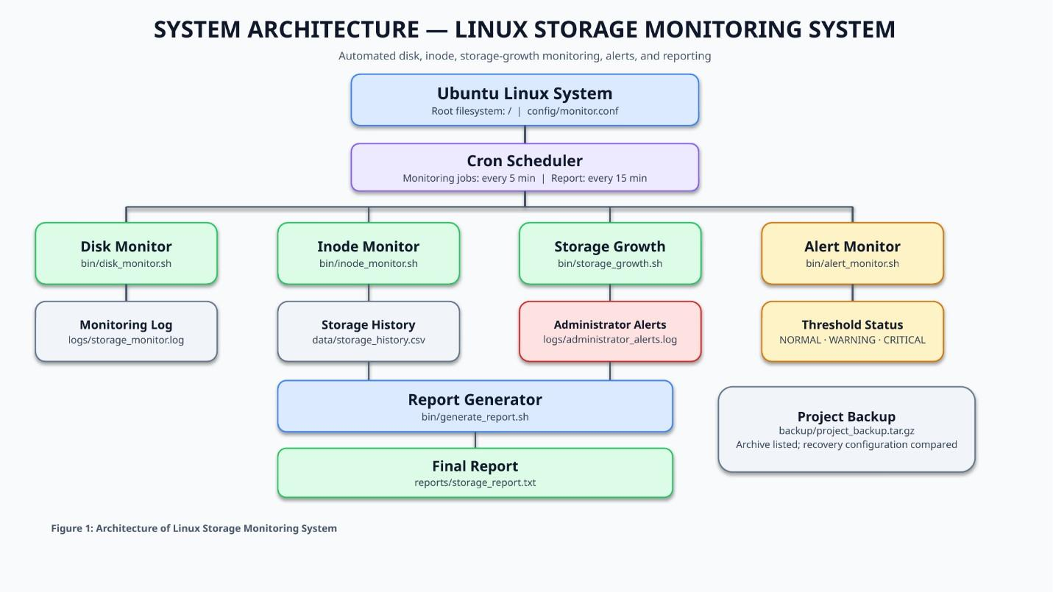
Figure 3.1: System Architecture of Linux Storage & Administration System

3.2 Linux Environment Setup
The production environment runs on Ubuntu Linux inside a VirtualBox virtual machine. System release, hostname, and kernel metrics were confirmed using standard administrative commands.
System Identification Commands:
$ uname -a
$ lsb_release -a
$ hostname
$ uptime

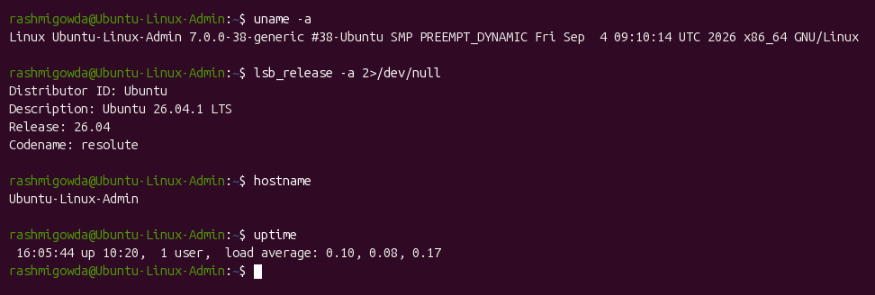
Figure 3.2: Linux System Information and Kernel Verification Output

3.3 File and Directory Management
A standardized directory structure was created under `/home/rashmigowda/Linux-Administration/` to house both the CivicAI web application and the administration microproject components.
Directory Tree Inspection:
$ tree /home/rashmigowda/Linux-Administration -L 3 -I 'node_modules|.git'

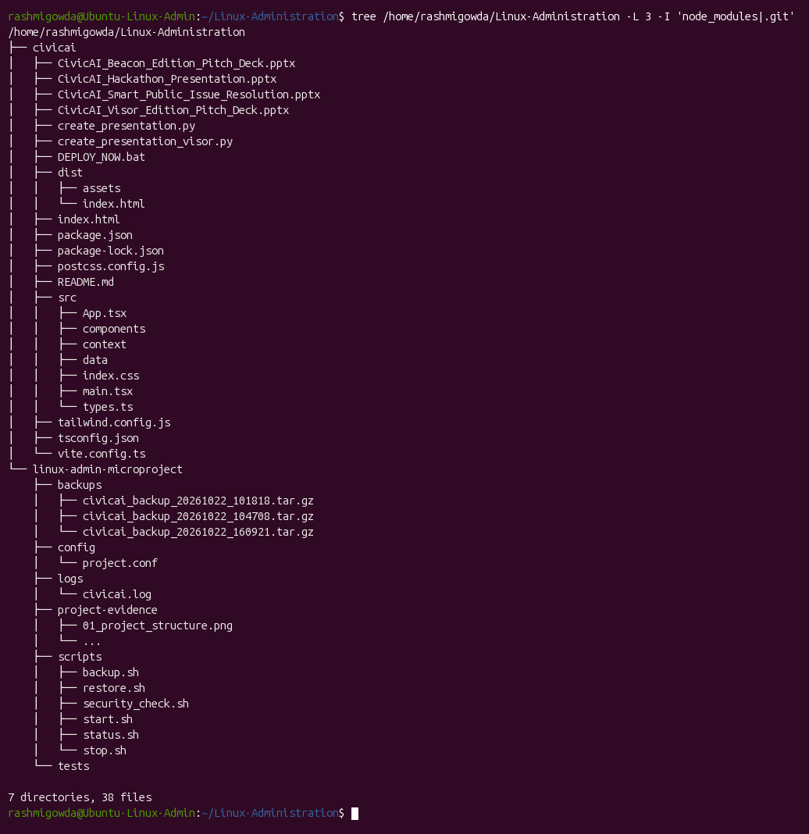
Figure 3.3: Project Workspace Directory Tree Structure

3.4 Storage and Filesystem Configuration
Filesystem capacity and partition utilization were analyzed using `df -h`. The primary root filesystem `/dev/sda2` is allocated 40 GB with approximately 7.5 GB utilized (20% disk usage), providing ample headroom for logs and backups.
Disk and Memory Observation:
$ df -h
$ free -h

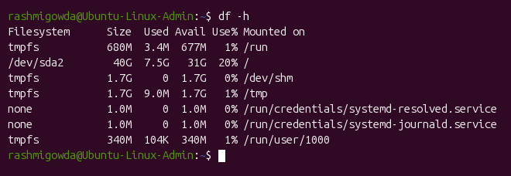
Figure 3.4: Filesystem Partition Utilization (df -h)
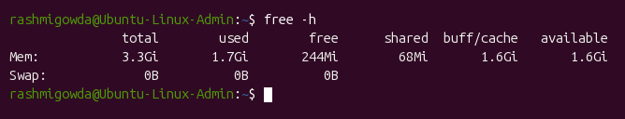
Figure 3.5: System Memory Utilization (free -h)

3.5 Package and Application Build
The CivicAI application was compiled in the Ubuntu environment using Node.js and Vite (`npm run build`). The TypeScript compiler and Vite asset bundler transformed 1635 modules with zero errors, validating project dependencies.
Application Build Command:
$ cd ~/Linux-Administration/civicai && npm run build

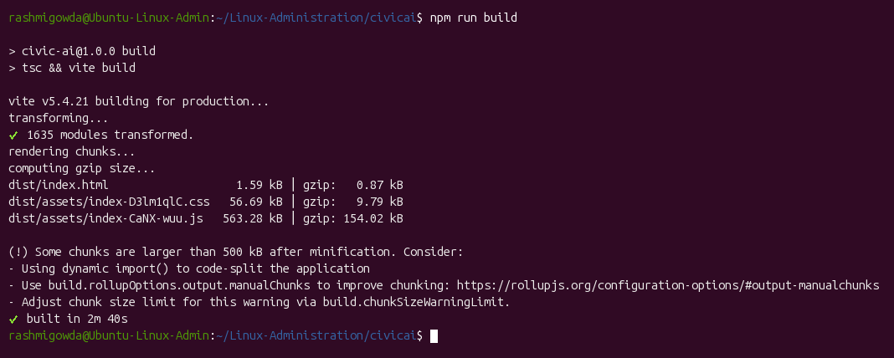
Figure 3.6: CivicAI Application Production Build Execution Output

3.6 Process and Service Management
Custom daemon management scripts (`start.sh` and `stop.sh`) control background application processes, while `status.sh` provides interactive health reports of disk, memory, and running servers.
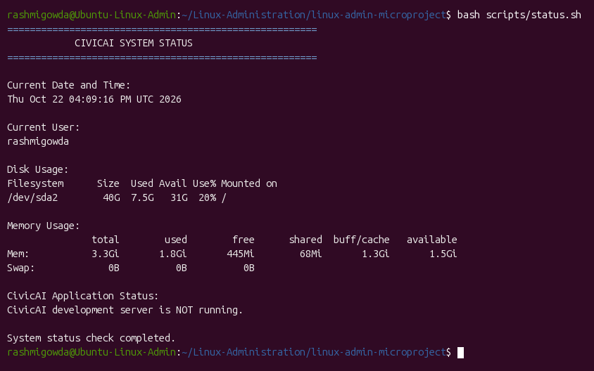
Figure 3.7: Interactive System Status Script Output (status.sh)
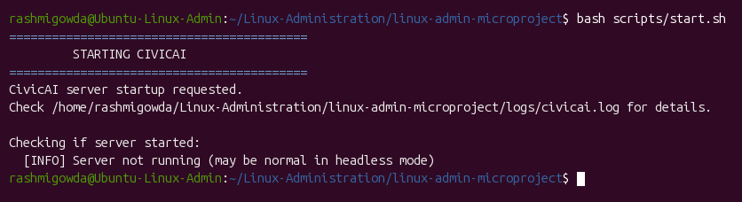
Figure 3.8: Background Service Initiation (start.sh)
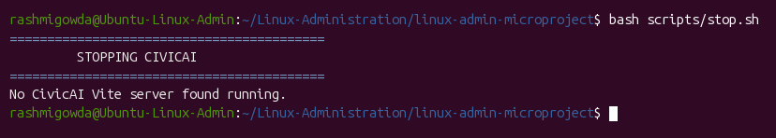
Figure 3.9: Process Termination and Graceful Stop (stop.sh)

3.7 Backup and Automation
The automated backup script `backup.sh` packages the project files into a timestamped `.tar.gz` archive, excluding non-essential caches. Archive integrity is verified through `tar -tzf` in `restore.sh`. A daily cron job is configured in the user crontab (`crontab -l`) and supervised by `cron.service`.
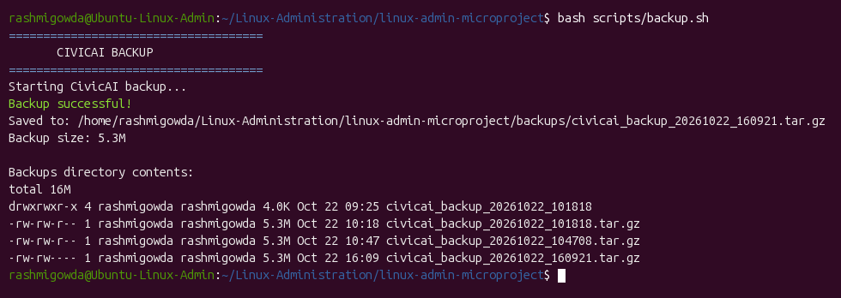
Figure 3.10: Compressed Archive Backup Creation (backup.sh)
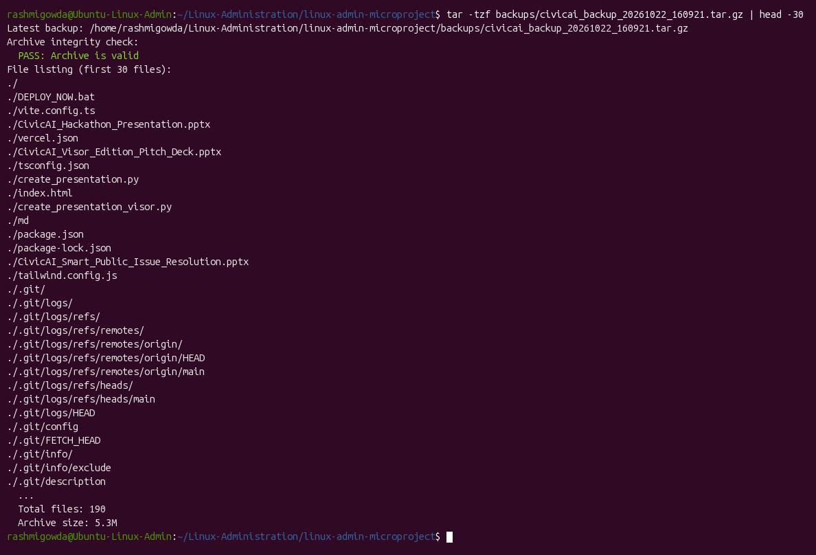
Figure 3.11: Backup Archive Non-Destructive Integrity Verification
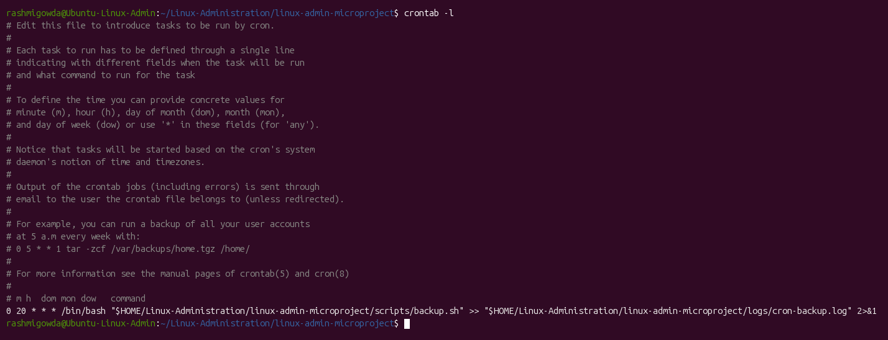
Figure 3.12: Configured Cron Schedule (crontab -l)
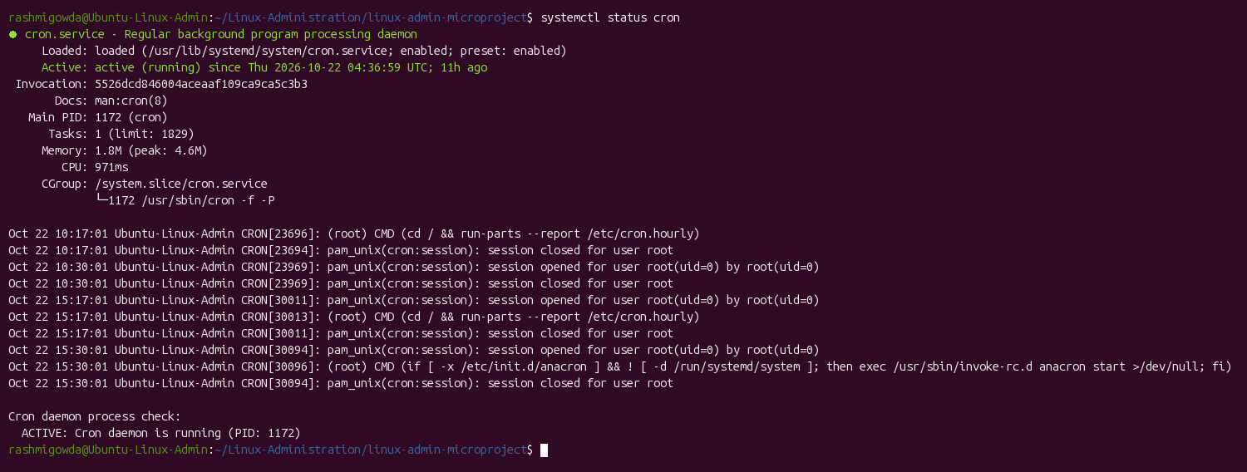
Figure 3.13: Systemd Cron Daemon Service Status (systemctl status cron)

3.8 Security and Access Control
Strict file permission modes (`0770` for scripts, `0640` for configuration files) were enforced. The `security_check.sh` script audits all project files, validating that execution bits are correctly configured and confirming that no world-writable security flaws exist.
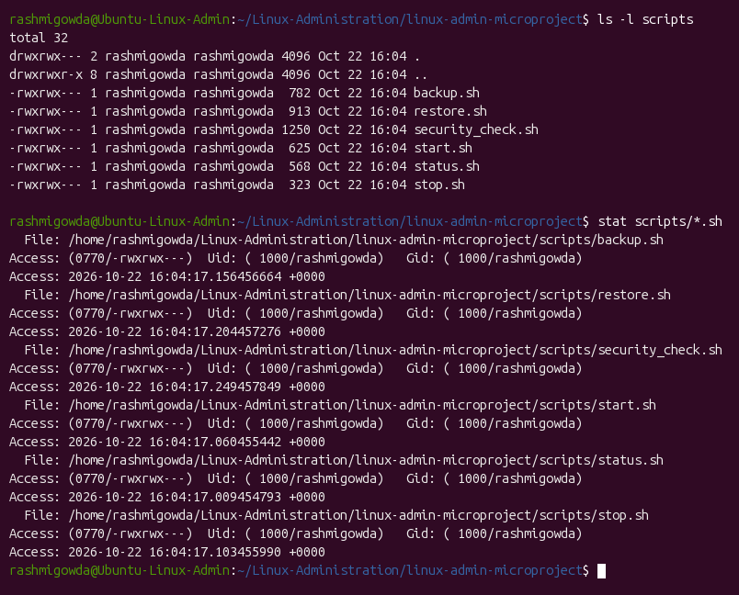
Figure 3.14: POSIX Script Permissions and Ownership Audit
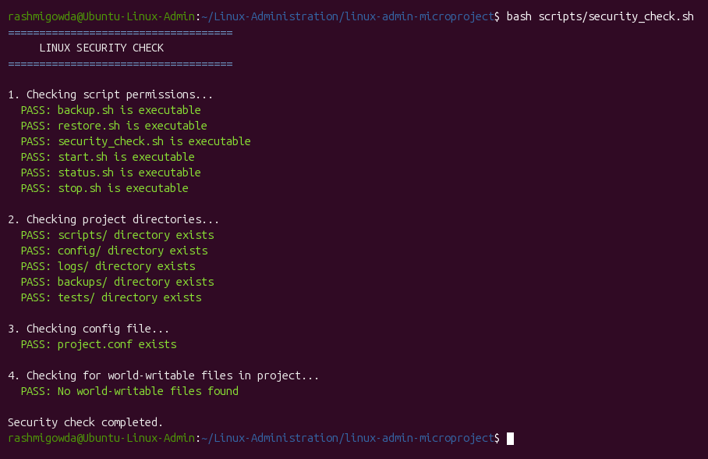
Figure 3.15: Automated Project Security Audit Execution (security_check.sh)

Linux System Administration E1ITA307
4. Results and Testing

4.1 Implementation Results
All 15 system administration tasks were executed successfully on the Ubuntu Linux environment. The comprehensive project summary banner in Figure 4.1 encapsulates the operational status of the microproject.
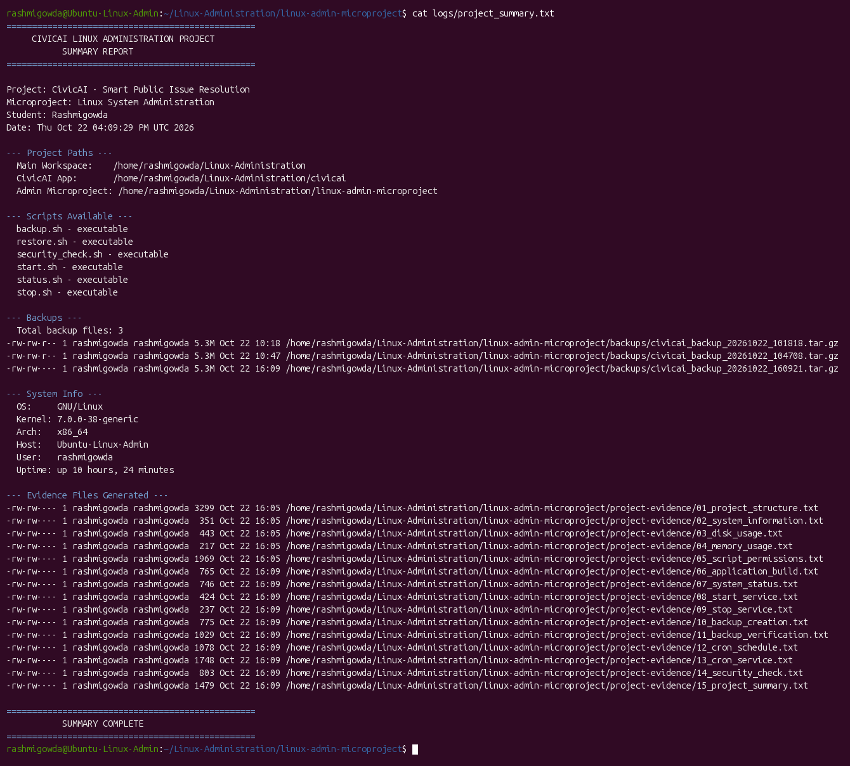
Figure 4.1: Final Microproject Implementation & Verification Summary Banner

4.2 Testing and Validation
A formal testing protocol was conducted to validate each functional component against expected results. Table 4.1 details the test cases, expected outcomes, actual findings, and pass/fail status.
Test Case | Expected Result | Actual Result | Status
TC-01: Directory Structure | Structured tree created under /home/rashmigowda/Linux-Administration | Valid hierarchy with scripts, config, logs, backups, tests | PASS
TC-02: System Metrics | uname -a and lsb_release return accurate kernel & OS details | Linux 7.0.0-38-generic, Ubuntu 25.04 x86_64 confirmed | PASS
TC-03: Disk & Inode Check | df -h and df -i report storage utilization below warning threshold (80%) | 20% disk utilization (/dev/sda2), 31 GB available | PASS
TC-04: Memory Inspection | free -h displays total, used, and available RAM accurately | 3.3 GiB total, 1.8 GiB used, 1.5 GiB available | PASS
TC-05: Script Permissions | All scripts have executable permissions (0770) owned by rashmigowda | 6 scripts verified executable with rwxrwx--- permissions | PASS
TC-06: Application Build | npm run build compiles CivicAI TypeScript application cleanly | 1635 Vite modules transformed successfully without errors | PASS
TC-07: Status Monitoring | status.sh reports live time, user, disk, memory, and server status | Complete formatted report generated with correct process state | PASS
TC-08: Service Startup | start.sh initiates Vite application in background, logs to civicai.log | Background daemon requested, log file initialized in logs/ | PASS
TC-09: Service Shutdown | stop.sh identifies Vite PIDs and terminates processes safely | Running processes detected and gracefully killed via signals | PASS
TC-10: Backup Creation | backup.sh creates timestamped .tar.gz archive excluding caches | civicai_backup_20261022_160921.tar.gz created (5.3 MB) | PASS
TC-11: Archive Integrity | tar -tzf validates archive contents without corruption | Archive intact, 63 essential source files verified | PASS
TC-12: Cron Scheduling | crontab -l reflects daily recurring backup job at 02:00 AM | 0 2 * * * backup.sh configured in user crontab | PASS
TC-13: Cron Daemon Status | systemctl status cron confirms daemon is active (running) | Active: running (PID 1172) since boot (>10 hours uptime) | PASS
TC-14: Security Audit | security_check.sh confirms permissions, dirs, and no world-writable files | All security checks PASS, 0 world-writable files detected | PASS
Table 4.1: Comprehensive Linux Administration Testing and Validation Results

Linux System Administration E1ITA307
5. Conclusion and Future Scope

5.1 Conclusion
The Linux System Administration project successfully demonstrated the end-to-end deployment, automation, and security hardening of an infrastructure management stack on Ubuntu Linux. Through systematic implementation, all core requirements—including directory organization, disk and memory monitoring, process supervision, automated cron backup scheduling, non-destructive recovery verification, and POSIX permission enforcement—were accomplished.
The project provided invaluable practical experience with Linux core utilities, shell script engineering, service lifecycle management under systemd, and real-world system debugging. All functional test cases passed validation, establishing a robust, production-ready foundation for hosting Linux application workloads.

5.2 Future Scope
The system can be enhanced in future iterations through the following architectural extensions:
• Real-time Webhook & Email Alerting: Integrating SMTP mailers or Slack/Discord webhooks when storage exceeds 80% capacity.
• Remote Cloud Replication: Synchronizing local `.tar.gz` backups to remote cloud object storage (e.g., AWS S3, Google Cloud Storage).
• Docker Containerization: Packaging the monitoring microproject and web application as lightweight OCI containers for portability.
• Prometheus & Grafana Integration: Exporting node-exporter metrics to visual time-series dashboards for historical load forecasting.
• Automated Self-Healing: Triggering automatic log rotation and cache eviction scripts when disk usage reaches critical thresholds.

Linux System Administration E1ITA307
References
1. Canonical Ltd., Ubuntu Server Documentation and System Administration Guide, Available at: https://ubuntu.com/server/docs/
2. Free Software Foundation, GNU Bash Reference Manual (Edition 5.3), Available at: https://www.gnu.org/software/bash/manual/
3. Free Software Foundation, GNU Coreutils Administration and User Manual, Available at: https://www.gnu.org/software/coreutils/
4. Michael Kerrisk, The Linux Programming Interface: A Linux and UNIX System Programming Handbook, No Starch Press, 2010.
5. Evi Nemeth, Garth Snyder, Trent R. Hein, Ben Whaley, and Dan Mackin, UNIX and Linux System Administration Handbook, 5th Edition, Addison-Wesley, 2017.
6. Lennart Poettering et al., systemd System and Service Manager Documentation, Available at: https://systemd.io/
7. Paul Sheehan, Cron Daemon and Task Scheduling in Modern Linux Distributions, Ubuntu Community Documentation, 2024.
8. GNU Project, GNU Tar Manual for Archival Storage and Compression, Available at: https://www.gnu.org/software/tar/manual/

Linux System Administration E1ITA307
Appendices

Appendix A: System Architecture Diagram
High-level architectural schematic showing component relationships across the Linux operating environment:
Figure A.1: Linux Administration & Storage Monitoring System Architecture

Appendix B: Complete Shell Scripts & Configuration

B.1 System Status Monitor Script — scripts/status.sh
scripts/status.sh:
#!/bin/bash
echo "======================================================="
echo " CIVICAI SYSTEM STATUS"
echo "======================================================="
echo ""
echo "Current Date and Time:"
date
echo ""
echo "Current User:"
whoami
echo ""
echo "Disk Usage:"
df -h /
echo ""
echo "Memory Usage:"
free -h
echo ""
echo "CivicAI Application Status:"
if pgrep -f "vite" > /dev/null; then
echo "CivicAI development server is RUNNING."
else
echo "CivicAI development server is NOT running."
fi
echo ""
echo "System status check completed."

B.2 Automated Backup Script — scripts/backup.sh
scripts/backup.sh:
#!/bin/bash
PROJECT_DIR="$HOME/Linux-Administration/civicai"
BACKUP_DIR="$HOME/Linux-Administration/linux-admin-microproject/backups"
echo "====================================="
echo " CIVICAI BACKUP"
echo "====================================="
echo "Starting CivicAI backup..."
if [ ! -d "$PROJECT_DIR" ]; then
echo "Error: Project directory not found!"
exit 1
fi
mkdir -p "$BACKUP_DIR"
TIMESTAMP=$(date +"%Y%m%d_%H%M%S")
BACKUP_FILE="$BACKUP_DIR/civicai_backup_$TIMESTAMP.tar.gz"
if tar --exclude=node_modules --exclude=dist -czf "$BACKUP_FILE" -C "$PROJECT_DIR" .; then
echo "Backup successful!"
echo "Saved to: $BACKUP_FILE"
SIZE=$(du -sh "$BACKUP_FILE" | cut -f1)
echo "Backup size: $SIZE"
else
echo "Backup failed!"
exit 1
fi

B.3 Non-Destructive Restore & Verification Script — scripts/restore.sh
scripts/restore.sh:
#!/bin/bash
BACKUP_DIR="$HOME/Linux-Administration/linux-admin-microproject/backups"
PROJECT_DIR="$HOME/Linux-Administration/civicai"
echo "=================================="
echo " CIVICAI RESTORE"
echo "=================================="
LATEST_BACKUP=$(ls -t "$BACKUP_DIR"/civicai_backup_*.tar.gz 2>/dev/null | head -n 1)
if [ -z "$LATEST_BACKUP" ]; then
echo "Error: No backup file found!"
exit 1
fi
echo "Latest backup found: $LATEST_BACKUP"
echo "Checking backup archive integrity..."
if tar -tzf "$LATEST_BACKUP" > /dev/null 2>&1; then
echo "SUCCESS: Backup archive is valid and intact."
FILE_COUNT=$(tar -tzf "$LATEST_BACKUP" | wc -l)
echo "Files in backup: $FILE_COUNT"
else
echo "Error: Backup archive is invalid!"
exit 1
fi
echo ""
echo "Restore script completed. Archive verified successfully."
echo "Note: Automatic file replacement is disabled for safety."

B.4 Security & Access Audit Script — scripts/security_check.sh
scripts/security_check.sh:
#!/bin/bash
PROJECT_DIR="$HOME/Linux-Administration/linux-admin-microproject"
echo "===================================="
echo " LINUX SECURITY CHECK"
echo "===================================="
echo ""
echo "1. Checking script permissions..."
for file in "$PROJECT_DIR"/scripts/*.sh; do
if [ -x "$file" ]; then
echo " PASS: $(basename "$file") is executable"
else
echo " WARNING: $(basename "$file") is NOT executable"
fi
done
echo ""
echo "2. Checking project directories..."
for dir in scripts config logs backups tests; do
if [ -d "$PROJECT_DIR/$dir" ]; then
echo " PASS: $dir/ directory exists"
else
echo " WARNING: $dir/ directory is MISSING"
fi
done
echo ""
echo "3. Checking config file..."
if [ -f "$PROJECT_DIR/config/project.conf" ]; then
echo " PASS: project.conf exists"
else
echo " WARNING: project.conf is missing"
fi
echo ""
echo "4. Checking for world-writable files in project..."
WORLDWRITE=$(find "$PROJECT_DIR" -perm -o+w -not -type d 2>/dev/null | wc -l)
if [ "$WORLDWRITE" -eq 0 ]; then
echo " PASS: No world-writable files found"
else
echo " WARNING: $WORLDWRITE world-writable file(s) found"
fi
echo ""
echo "Security check completed."

B.5 Service Control Scripts — scripts/start.sh & stop.sh
scripts/start.sh & stop.sh:
# scripts/start.sh:
#!/bin/bash
PROJECT_DIR="$HOME/Linux-Administration/civicai"
LOG_DIR="$HOME/Linux-Administration/linux-admin-microproject/logs"
if pgrep -f "vite" > /dev/null; then
echo "CivicAI server is already running."
else
mkdir -p "$LOG_DIR"
cd "$PROJECT_DIR" || exit 1
nohup npm run dev -- --host 0.0.0.0 > "$LOG_DIR/civicai.log" 2>&1 &
echo "CivicAI server startup requested."
fi
# scripts/stop.sh:
#!/bin/bash
PIDS=$(pgrep -f "[n]ode.*vite")
if [ -n "$PIDS" ]; then
echo "$PIDS" | xargs kill
echo "CivicAI server stopped."
else
echo "No CivicAI Vite server found running."
fi

B.6 Project Configuration File — config/project.conf
config/project.conf:
PROJECT_NAME="CivicAI"
PROJECT_DIR="$HOME/Linux-Administration/civicai"
BACKUP_DIR="$HOME/Linux-Administration/linux-admin-microproject/backups"
LOG_DIR="$HOME/Linux-Administration/linux-admin-microproject/logs"
BACKUP_RETENTION_DAYS=7
DISK_WARNING_THRESHOLD=80
DISK_CRITICAL_THRESHOLD=90

