DEVOPS MASTERY
Assignment 5 – DevOps Integration and Monitoring
End-to-End CI/CD, Deployment Strategies, Monitoring, Logging and Security
Student Name | Roll No. | Date | Assignment | Marks
Rashmika KV | 23BCS132 | 26/10/2026 | Assignment 5 | 6

ACTIVITY 1: ARCHITECTURE DIAGRAM AND WORKFLOW DESCRIPTION

1.1 System Architecture
The proposed DevOps integration architecture automates the application delivery process by connecting version control, continuous integration, containerization, deployment, monitoring, and logging tools. The workflow begins with a developer committing application changes to GitHub. Jenkins retrieves the source code, performs build and test operations, and builds a Docker image. The image is tagged and made available to the deployment environment.
The application is then deployed to Kubernetes, where Pods run the application and a Kubernetes Service provides access to it. Prometheus is used for monitoring, while Grafana provides a dashboard for visualizing collected metrics. Application logs support troubleshooting and failure detection. Terraform or Ansible can be integrated to manage infrastructure configuration.
Figure 1: Proposed DevOps Integration and Monitoring Architecture
Insert the architecture diagram exported from Mermaid Live Editor here.

1.2 Workflow Description
Step 1: Version Control
The developer commits application source-code changes and pushes them to the GitHub repository. GitHub provides centralized version control and maintains the project's change history.
Step 2: Continuous Integration
Jenkins retrieves the latest source code from GitHub. The pipeline executes the configured build and test stages to identify errors before the application proceeds to deployment.
Step 3: Containerization
After the build and test stages, Docker builds a container image using the application's source code and Dockerfile. The image is assigned a version tag to identify the build.
Step 4: Image Availability
The tagged Docker image is made available to the deployment environment. It may be stored in a container registry or transferred through another configured method.
Step 5: Kubernetes Deployment
Kubernetes deploys the container image using a Deployment resource. Kubernetes Pods run the application, and a Service provides a stable endpoint for accessing it.
Step 6: Monitoring and Visualization
Prometheus collects supported application or infrastructure metrics. Grafana connects to Prometheus and displays the collected metrics through dashboards, helping users understand application and system performance.
Step 7: Logging and Troubleshooting
Application logs provide information about application activity and errors. These logs help identify failures, investigate their causes, and determine corrective actions.
Step 8: Infrastructure Management and Feedback
Terraform or Ansible can be used to manage infrastructure configuration. When an issue is identified, the developer investigates the problem, modifies the application or configuration, and commits the correction to GitHub. This begins another development and delivery cycle.

1.3 Automation and Manual Activities
Activity | Execution Type | Description
Source-code version control | Automated by Git; commit and push initiated by the developer | Git tracks changes and GitHub stores the repository.
Source-code checkout | Automated when configured in Jenkins | Jenkins retrieves the source code.
Build and testing | Automated when configured in the pipeline | Jenkins executes the configured build and test commands.
Docker image creation | Automated when configured in the pipeline | Docker builds the container image.
Image tagging and transfer | Automated when configured | The image is tagged and made available for deployment.
Kubernetes deployment | Automated when configured; may also be initiated manually | The application is deployed using Kubernetes resources.
Monitoring and dashboard visualization | Automated after configuration | Prometheus collects supported metrics and Grafana visualizes them.
Log inspection and troubleshooting | Partially automated | Logs can be collected automatically, while investigation and corrective decisions may require human intervention.
Infrastructure configuration | Automated when Terraform or Ansible is configured | Infrastructure changes are defined and applied through configuration or automation.

1.4 Expected Outcome
The proposed architecture establishes a continuous delivery workflow that connects source-code management, build and testing, Docker containerization, Kubernetes deployment, monitoring, and logging. It aims to improve repeatability, reduce manual deployment effort, identify failures earlier, and support systematic troubleshooting.
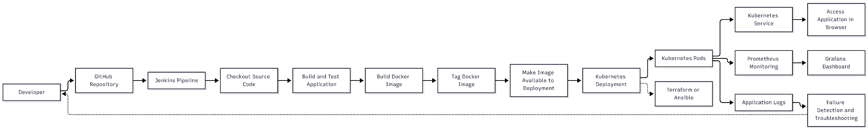
The diagram represents the proposed architecture. Each component must be configured and tested before its operation can be considered verified.

Activity 2 – Integrate CI with Docker

