2d Shooter

# Table of contents

* Game Description
* Controls description
* Interface sketch
* Screen Descriptions
* Enemies
* Scoring
* Sound Index
* Game Description
  + This is a 2d shoot’Em Up game, were the player destroys enemies, collect bonus and defeat a boss in order to gain more points
* Controls description
  + The player moves the ship using standard “wasd” controls, and shoots laser beams using space
* Interface Sketch

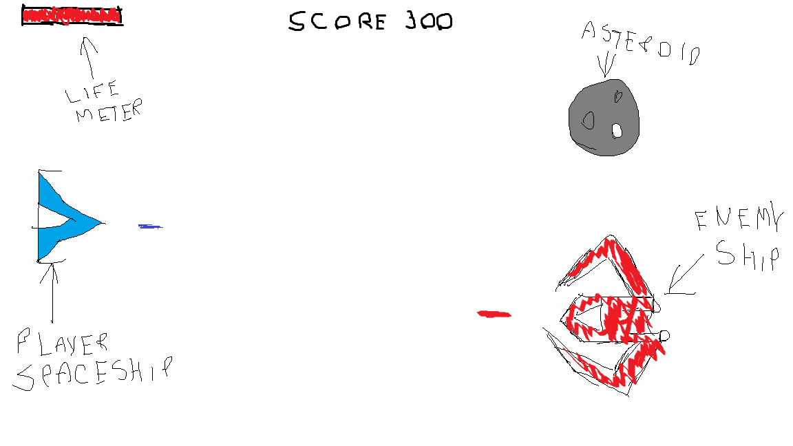

* Screen Descriptions

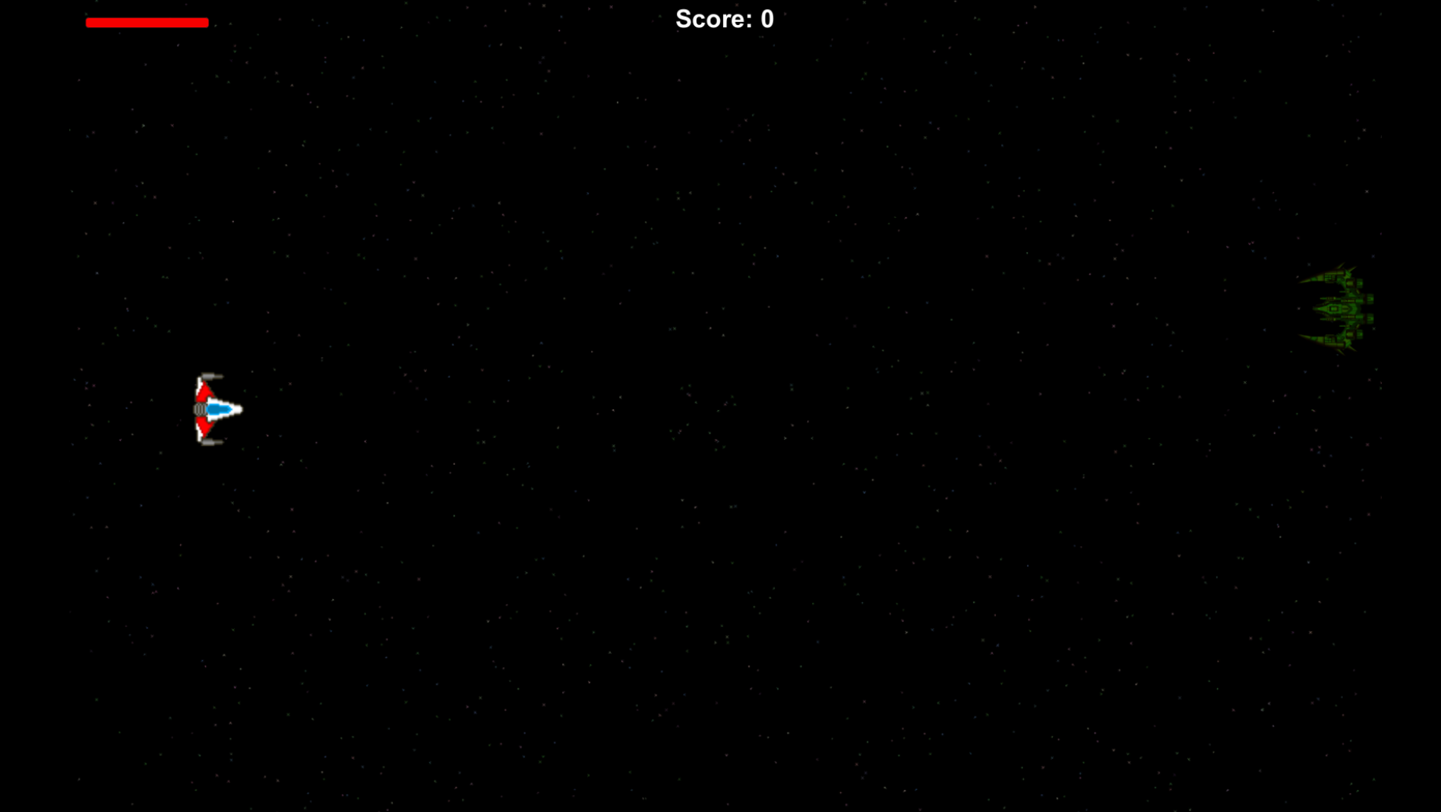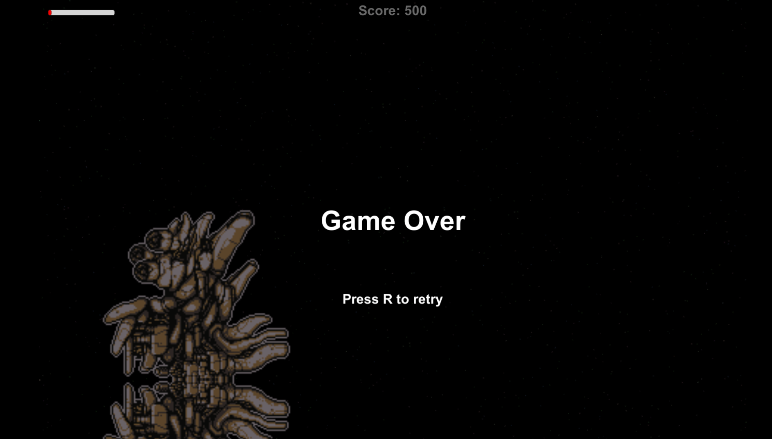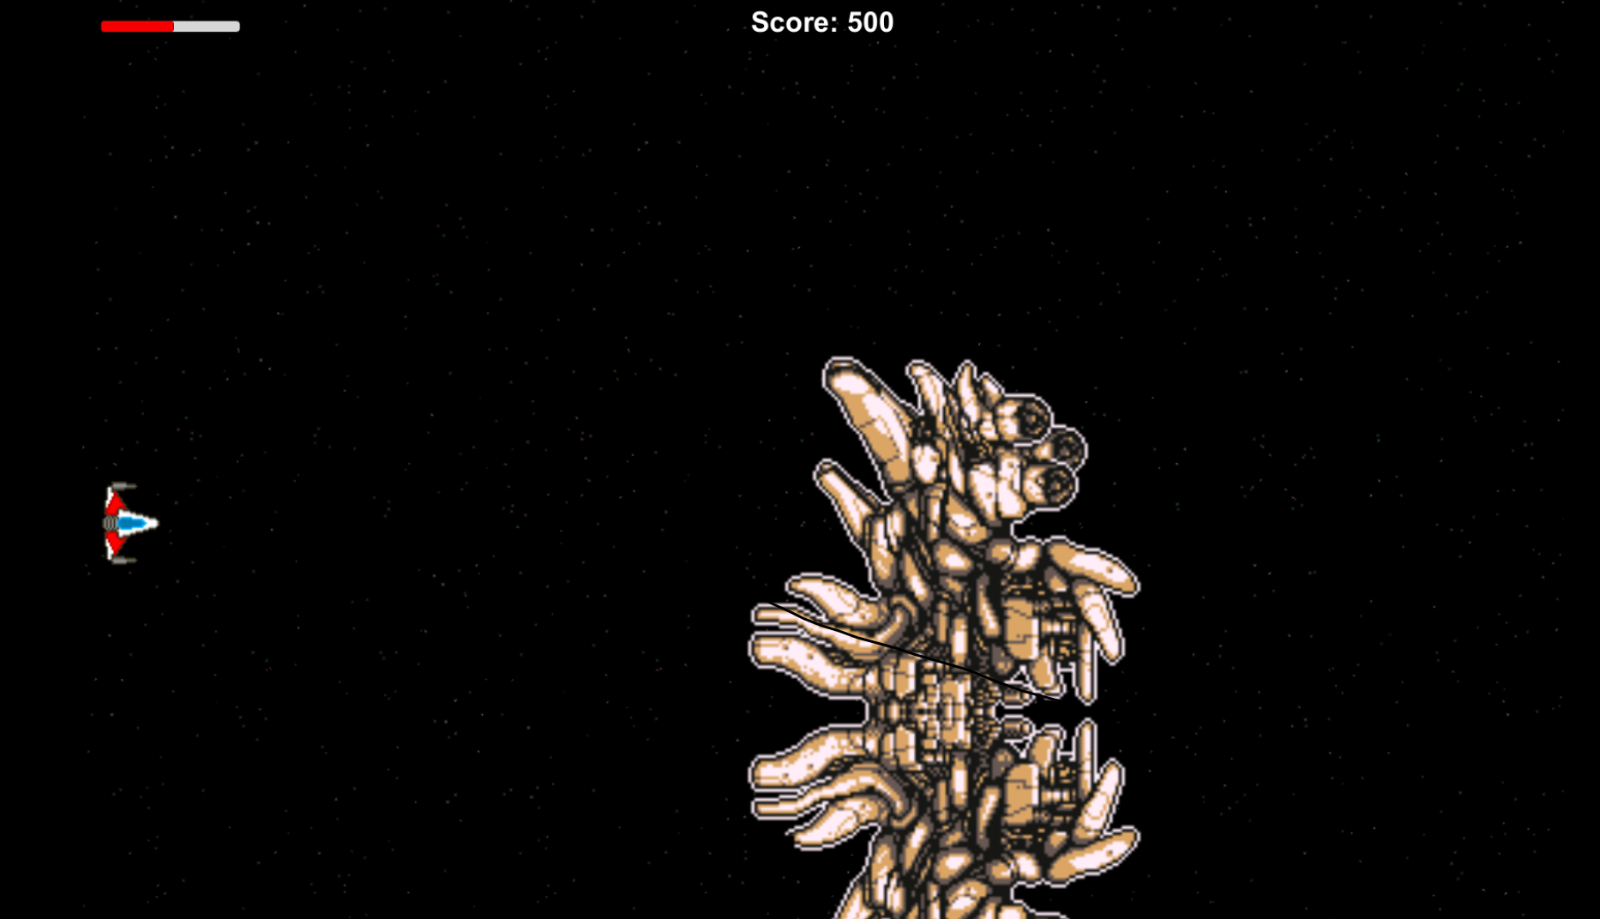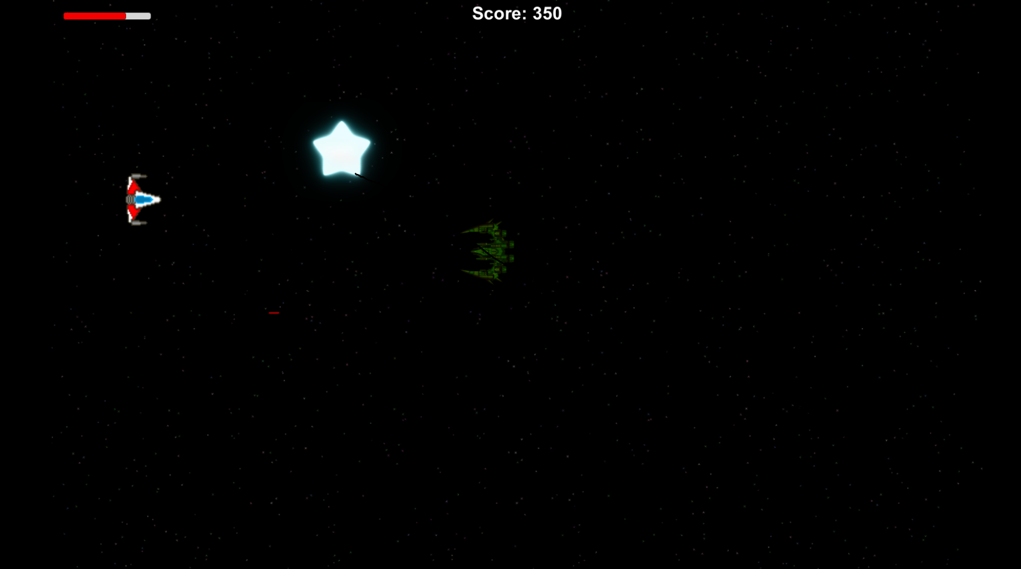

* Enemies
  + Asteroid: just goes in a straight line
  + Spaceship: moves in a wave way
  + Spaceship shooter: moves in a wave way and can shoot laser beams
  + Boss: it’s huge, moves in a wave way, shoots 3 laser beans, destroys the player in touch, and have a huge amount of life
* Scoring
  + Each enemy the player destroys give him a certain amount of points. Also, stars gives the player points.
* Sound index
  + boss_shot
  + boss_theme
  + collect
  + collect2
  + explosion
  + main_theme
  + shoot
* Art / Media index: