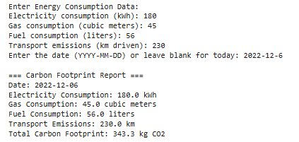

**Figure 1: Carbon Footprint Report 1**

(Source: Self-Created in Google Colab)

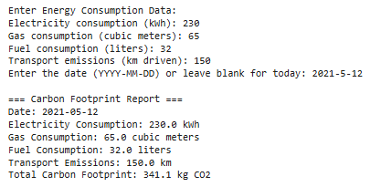

**Figure 2: Carbon Footprint Report 2**

(Source: Self-Created in Google Colab)

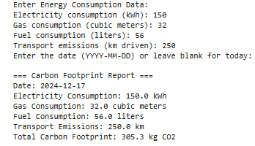

**Figure 3: Carbon Footprint Report 3**

(Source: Self-Created in Google Colab)

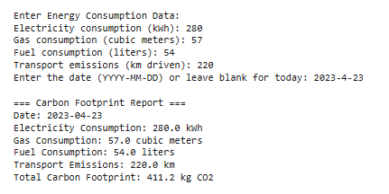

**Figure 4: Carbon Footprint Report 4**

(Source: Self-Created in Google Colab)

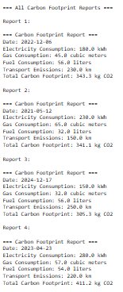

**Figure 5: All Carbon Footprint Reports**

(Source: Self-Created in Google Colab)

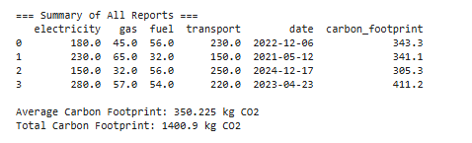

**Figure 6: Summary of All Reports**

(Source: Self-Created in Google Colab)