CS3283 - Embedded Systems Project

**Balasooriya K.B.R.D. – 210057R**

**rashmika.21@cse.mrt.ac.lk**

**Force-Feedback Glove for Virtual Interaction**

1. **Introduction**
   1. **Background**

Virtual reality and the metaverse are two rapidly growing technologies in the world. The main idea behind these technologies is to create a complete virtual world where users can interact with various elements. To achieve this, it's necessary to simulate all senses, including vision, sound, touch, taste, smell, and others, using electronics. Currently, vision and sound are achievable with existing hardware. However, a critical aspect that still needs to be addressed is the sense of touch.

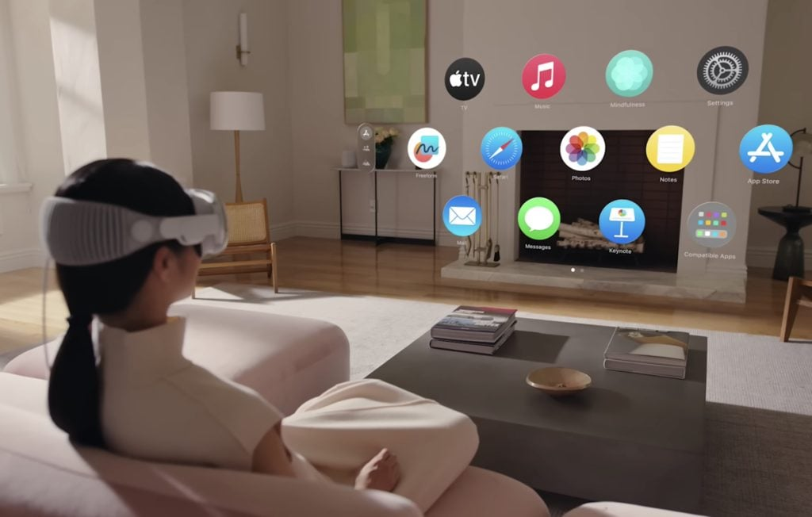

Image 1 – Apple vision pro VR-headset for simulated vison, and virtual surround sound [1]

* 1. **Problem Statement**

Despite several attempts to solve this problem, there is still no scalable, compact, and commercially reproducible product. Current implementations face numerous issues, such as size, battery life, comfort, and more.

* 1. **Objectives**

This project aims to address these challenges with new designs and techniques to develop an ultimate product that can be mass-produced for commercial applications.

* To design and develop a force-feedback glove that can provide tactile sensations to the user.
* To integrate the glove with an existing VR system to enhance user interaction.
* To test and evaluate the performance and user experience of the force-feedback glove.

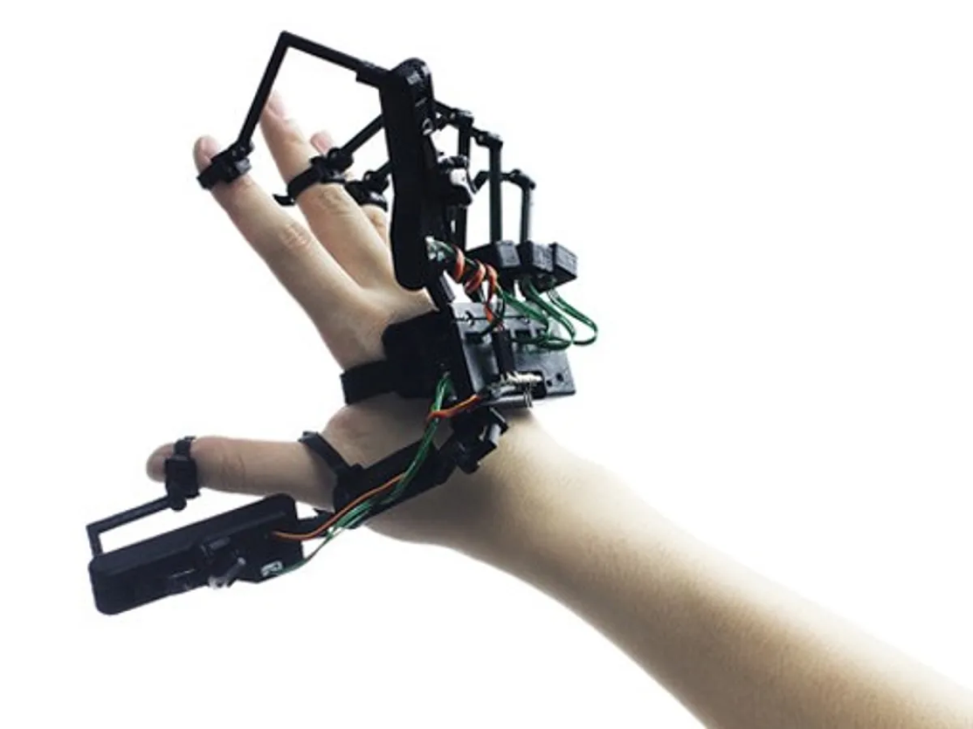

Image 2 – Force-Feedback system for fingers

1. **Literature Review**
   1. **Overview of Haptic Feedback Technology**

There are several haptic feedback methods implemented in the industry for touch and force simulation. Such as vibrating, motorized systems, electrostatic friction, and force feedback mechanisms. Each one has advantages and disadvantages for different applications.

* 1. **Existing Force-Feedback Devices**
* **Phantom® Omni™ Pen** [2]

This used motors to generate the haptic feedback to the user creating feel of surfaces and material qualities such as viscosity, roughness, and hardness of materials.

* **Haptic buttons on phones and trackpad on laptops.**

Some mobile phones use pressure sensitive buttons and vibrators to give the illusion of button presses.

1. **Project Design and Implementation**
   1. **System Architecture**

The force-feedback glove will consists of following components:

* **Microcontroller**: To process input signals and control the actuators.
* **Sensors**: To detect finger movements.
* **Actuators**: To provide force feedback to the fingers.
* **Communication Module**: For wireless communication with the VR running computer.
* **Battery**: For powering the device

1. **Conclusion**

This project aims to build a new force-feedback glove to solve the current limitations and improve the usability of a force-feedback glove in virtual reality applications.

# References:

|  |  |
| --- | --- |
| [1] | A. Inc., "www.apple.com," [Online]. Available: www.apple.com. |
| [2] | D. H. Lab, "www.delfthapticslab.nl," [Online]. Available: https://delfthapticslab.nl/device/phantom-omni/. |

https://www.researchgate.net/publication/323013854_Novel_digital_glove_design_for_virtual_reality_applications