Pocket Library Requirements

- Business Requirements
  - Easily to use
  - Save book records
- User Requirements
  - Register new books.
  - Check availability of books.
  - Borrow the books.
  - Notify the book after one week from borrowed.
- Software Requirements
  - Single user
- Functional
  - One user type: main single user account.
  - Register all book
  - Record of book borrow
  - Notify book borrowing: email/ notify the
  - Check book availability
- non-functional requirements
  - Reliability
  - Responsiveness: Provide quick responses to user actions.
  - Usability
  - Light weight app: Minimal storage consumption.
  - Storage not much from user
  - Online usage
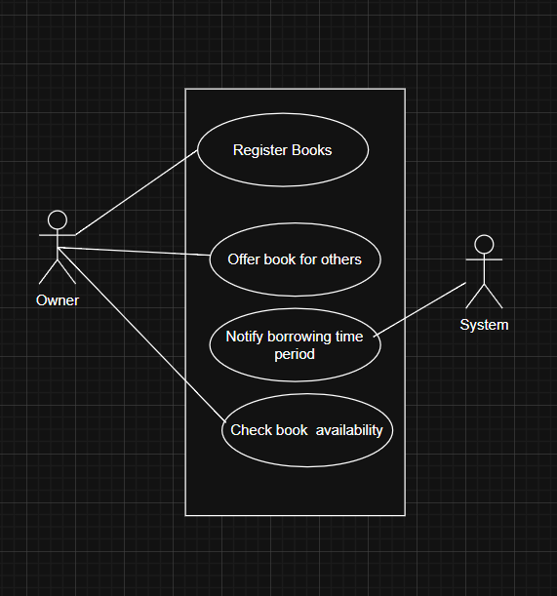
  - Efficiency: Should not consume much storage from the user device.
Use Case Diagram

Class Diagram

