**Assignment 1**

Aim: To study internal components of Central Processing Unit (C.P.U)

Theory:

1.**RAM**: RAM (Random Access Memory) is the hardware in a computing device where the operating system (OS), application programs and data in current use are kept so they can be quickly reached by the device's processor.

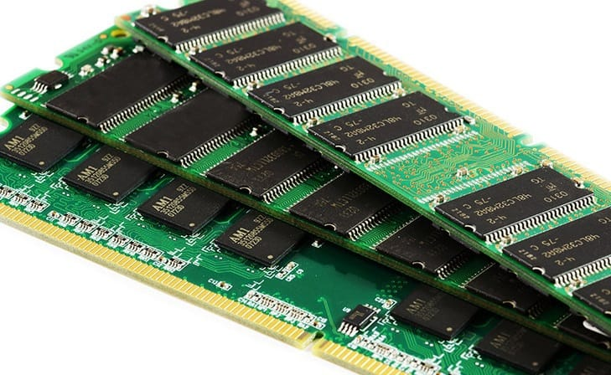

2.**CD-Drive**: A compact disc drive, or CD drive, is a device that lets you access a compact disc from a computer. Some CD drives are built into computers, but if your computer doesn't have one, you can usually attach an external one that connects to a USB port.

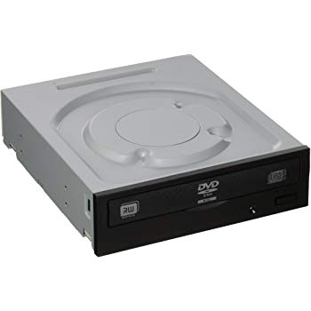

3.**ATX Cable**: An ATX style connector is a replacement for the older P8 and P9 AT style connector. It is one of the largest connectors inside a computer. It connects a power supply to an ATX style motherboard.

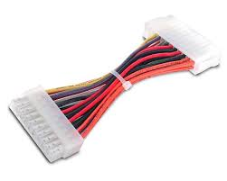

4.**CMOS**:CMOS (complementary metal-oxide-semiconductor) is the term usually used to describe the small amount of memory on a computer motherboard that stores the BIOS settings. Some of these BIOS settings include the system time and date as well as hardware settings.

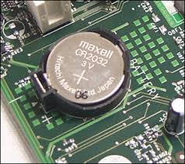

5.**North Bridge**: A northbridge or host bridge is one of the two chips in the core logic chipset architecture on a PC motherboard, the other being the southbridge.

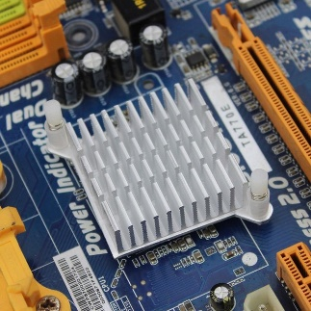

6.**South Bridge**:Southbridge is an Intel chipset that manages the basic forms of input/output ( I/O ) such as Universal Serial Bus ( USB ), serial , audio, Integrated Drive Electronics ( IDE ), and Industry Standard Architecture ( ISA ) I/O in a computer.

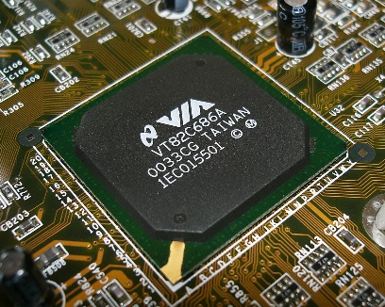

7.**SMPS**: An SMPS transfers power from a DC or AC source (often mains power) to DC loads, such as a personal computer, while converting voltage and current characteristics.

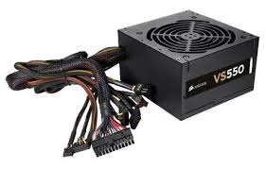

8.**Capacitor**: Big capacitors are used in computer power supplies. Tiny discrete ceramic and tantalum capacitors are built on the outside of the chip package or surround the chip on the motherboard. In signal processing, a capacitor and resistor smooth the spikes and sharp edges from a signal.

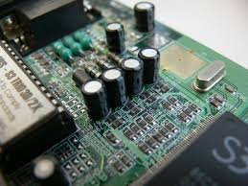

9.**Heat Sink**: A heat sink (also commonly spelled heatsink) is a passive heat exchanger that transfers the heat generated by an electronic or a mechanical device to a fluid medium, often air or a liquid coolant, where it is dissipated away from the device, thereby allowing regulation of the device's temperature at optimal levels.

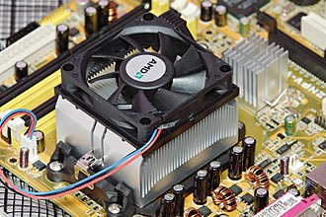

10. **Exhaust Fan**: Chassis or case fans, usually one exhaust fan to expel heated air from the rear and optionally an intake fan to draw cooler air in through the front, became common with the arrival of the Pentium 4 in late 2000.

