Unit-1: Introduction to machine learning

Subject Code:4350702

# 1.1.1 Overview of Human Learning and Machine Learning

## Overview of Human Learning:

* Human learning refers to the process by which individuals acquire knowledge, skills, behaviors, and attitudes through experiences, study, and observation. It is a fundamental aspect of human cognition and is influenced by various factors such as personal motivation, social interactions, cultural context, and prior knowledge- Human learning is a complex and dynamic process that occurs throughout a person's life and plays a crucial role in adapting to new situations, problem-solving, and decision-making.
* Key characteristics of human lemming include:

1. Cognitive Processes: Human learning involves various cognitive processes, including perception, attention, memory, and reasoning. These processes enable individuals to process information from the environment, encode it m memory, and retrieve it when needed.
2. Personalization: Human leaning is highly individualized, with each person having their own unique learning style and preferences. Some Individuals may excel in usual learning, while others may prefer auditory or kinesthetic learning methods.
3. Transfer of Knowledge: Humans can transfer knowledge and skills acquired in one context to solve problems in different situations. This ability to apply learning knowledge flexibly is known as transfer of learning.
4. Feedback and Reinforcement: Feedback is essential for human learning. Positive reinforcement for correct actions and constructive feedback for mistakes or errors help reinforce learning and guide future behaviors.
5. Long-Term Memory: Human learning involves the consolidation of information into long-term memory, allowing individuals to retain knowledge for extended periods and build upon it over time.

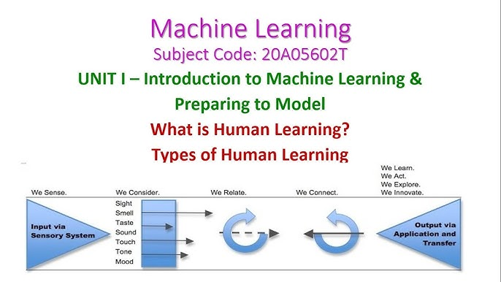

Overview of Machine Learning:

* Machine Learning (ML) is a subset of artificial Intelligence that focuses on the development of algorithms and models that enable computers and machines to learn from data without explicit programming. Instead of being explicitly programmed, ML systems learn patterns and representations from data and use them to make predictions, decisions, or identify patterns m new, unseen data.
* Key aspects of machine learning include:

1. Data-driven Approach: Machine learning algorithms rely on large datasets to discover patterns and relationships within the data. The more data the system receives, the better it can generalize and make accurate predictions on new data.
2. Types of Learning: There are different types of machine learning, including supervised learning, unsupervised learning, semi-supervised learning, and reinforcement learning. Each type addresses different learning tasks and scenarios.
3. Model Training: In machine learning, models are trained on historical data to learn from patterns and relationships. The framing process involves adjusting model parameters iteratively until the model achieves optimal performance.
4. Generalization: A key goal of machine learning is to create models that can generalize well to new, unseen data. The model should be able to make accurate predictions on data it has not encountered during training.
5. Diverse Applications: Machine learning has applications across various Industries, including natural language processing, computer vision, recommendation systems, fraud detection, healthcare, finance, and more.

In summary, both human learning and machine learning involve the acquisition of knowledge and skills, but they differ in their mechanisms and approaches. Human learning relies on cognitive processes and experiences, while machine learning leverages data-driven algorithms to enable computers to learn and make decisions autonomously.

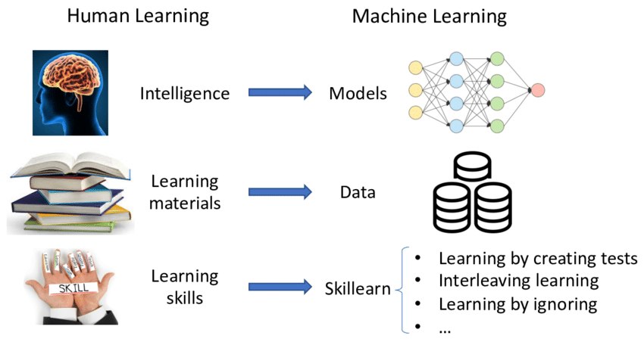

# 1.1.2 Types of Machine Learning

## 1. Supervised Machine Learning

* Supervised machine learning is a type of machine learning where the algorithm learns from labeled training data to make predictions or decisions on new, unseen data. In this approach, the dataset used for training the model consists of input-output pairs, where the input represents the features or attributes of the data, and the output is the corresponding label or target value that the model aims to predict. 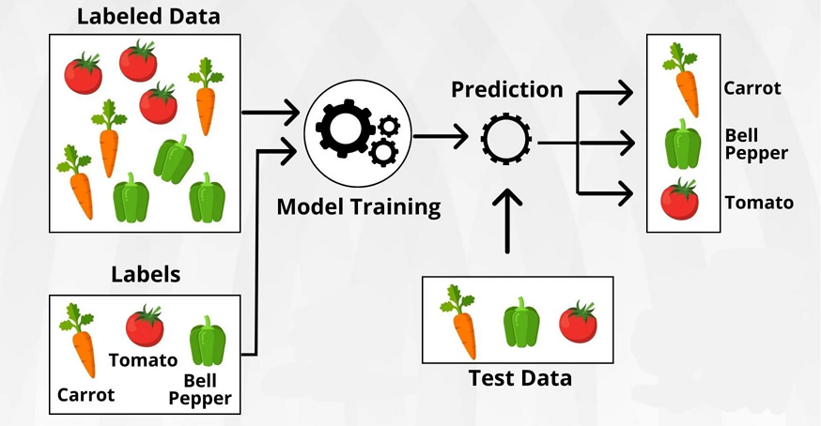
* The main characteristics of supervised machine learning are as follows:

1. Labeled Training Data: The foundation of supervised learning is the availability of a labeled dataset, where each example contains both input features and their corresponding correct output labels. These labels serve as a teacher or supe1Nisor that guides the learning process.
2. Training Phase: During the training phase, the algorithm takes the labeled data and learns the patterns, relationships, and mappings between the input features and the output labels, The goal is to find a model that can generalize well to unseen data and accurately predict the correct output labels
3. Supervised Learning Tasks:
4. Regression: In regression tasks, the output is a continuous numerical value. The algorithm learns to map input features to a continuous target variable. Examples include predicting housing prices, stock prices, or the temperature.
5. Classification: In classification tasks, the output is a discrete class label or category. The algorithm learns to classify input data into predefined classes. Examples include email spam detection, image recognition, sentiment analysis, or medical diagnosis.
6. Model Evaluation: After the training phase, the model's performance IS evaluated using a separate set of data called the validation or test set. This data was not used during training and helps assess how well the model generalizes to new, unseen examples. Common evaluation metrics depend on the specific task and may include accuracy, precision, recall, Fl score, mean squared (MSE), etc.
7. Model Prediction: Once the model is trained and evaluated, it can be used to make predictions on new data where the correct output is unknown. The model uses the learned patterns to predict the corresponding output label or value-

* Supervised machine learning algorithms encompass a wide range of techniques, including linear regression, logistic regression, support vector machines (SVM), decision trees, random f01ests, k-nearest neighbors (KININ), and neural networks. The choice of algorithm depends on the problem's complexity, the nature of the data, and the desired level of accuracy.

## 2. Unsupervised Machine Learning

* Unsupervised machine learning is a type of machine learning where the algorithm leans from unlabeled data, without explicit guidance or supervision in the form of labeled output. In this approach, the algorithm explores the patterns and structures inherent in the data without being told what to look for. Unsupervised learning is particularly useful when there is no labeled data available or when the patterns to be discovered are not known in advance. 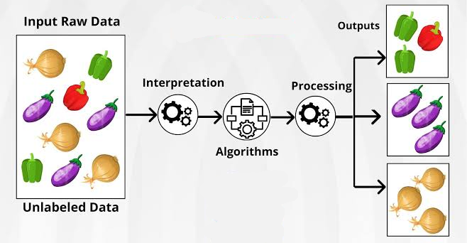
* The main characteristics of unsupervised machine learning are as follows:

1. Unlabeled Data: Unlike supervised learning, unsupervised learning algorithms work with data that has no predefined output labels. The algorithm's task is to find inherent structures, patterns, or relationships within the data.
2. Clustering: One of the primary tasks in unsupervised learning is clustering, where the algorithm groups similar data points together based on their similarities in the feature space. Clustering helps identify natural groupings or clusters within the data.
3. Dimensionality Reduction: Another common task is dimensionality reduction. which aims to reduce the number of features or variables in the data while preserving as much useful information as possible. Principal Component Analysis (PCA) and t-distributed Stochastic Neighbor Embedding (t-SNE) are examples of dimensionality reduction techniques.
4. Anomaly Detection: Unsupervised learning can also be used for anomaly detection, where the algorithm identifies data points that deviate significantly from the norm or the typical behavior of the data.

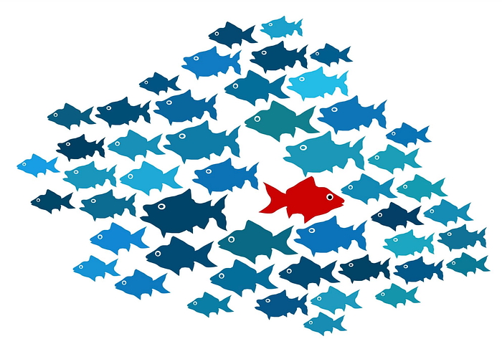

1. Model Evaluation: Evaluating unsupervised learning models can be more challenging compared to supervised learning since there are no explicit labels to compare against. Evaluation often relies on internal measures such as silhouette scores or external measures using domain knowledge.

* Common algorithms used in unsupervised learning include:

1. k-Means: A clustering algorithm that partitions data into K clusters, where each data point belongs to the cluster with the nearest mean.
2. Hierarchical Clustering: This algorithm builds a hierarchy of clusters by recursively merging or splitting them based on similarity.
3. Gaussian Mixture Models (GMM): A probabilistic model that represents data as a mixture of multiple Gaussian distributions, allowing for soft clustering.
4. Autoencoders: Neural networks used for dimensionality reduction and data reconstruction tasks.

* Unsupervised learning is valuable in various applications, including customer segmentation, anomaly detection, market basket analysis, and data compression. It can also be used m combination with supervised learning as part of a broader machine learning pipeline for feature extraction or data pre-processing. However, due to the lack of explicit labels, the interpretation and evaluation of unsupervised learning results may require domain knowledge and human Intuition.

## 3. Reinforcement Learning

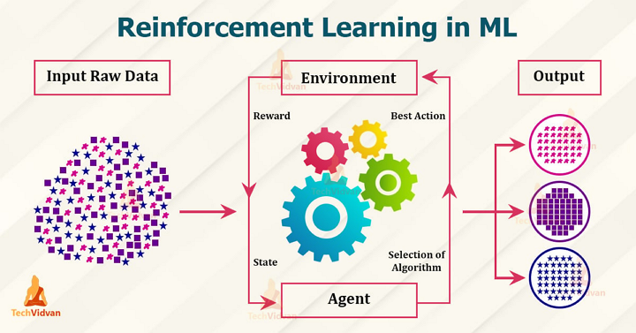

* Reinforcement Learning (RL) is a type of machine learning paradigm where an agent learns to make decisions by interacting with an environment. The agent learns to achieve a goal by receiving feedback in the form of rewards or penalties as it performs actions within the environment. The objective of the agent is to maximize the cumulative reward it receives over time.
* Key components of Reinforcement Learning:

1. Agent: The entity or system that learns and takes actions in the environment. The agent's goal is to learn the optimal policy, which is a strategy that determines the best action to take in a given state to maximize the expected cumulative reward.
2. Environment: The external system with which the agent interacts. The is dynamic and can change in response to the agent's actions. It provides the agent with feedback in the form of rewards or penalties after each action.
3. State: A state represents the current situation or configuration of the environment at a specific time. The agent uses state information to make decisions about which action to take.
4. Action: Actions are the decisions made by the agent to interact with the environment. The set of possible actions depends on the specific RL problem and the environment's characteristics.
5. Reward: The reward is a scalar value that represents the immediate feedback provided to the agent after each action. The agent's objective is to maximize the cumulative reward over time.
6. Policy: The policy is the strategy or mapping that the agent uses to determine which action to take in a given state. It defines the agent's behavior and is the primary focus of RL algorithms.

* Reinforcement Learning Algorithms:
* There are various RL algorithms, including model-free methods such as Q-Learning, SARSA and Deep Q Networks (DQNs), as well as model-based approaches like Policy Gradient methods and Actor-Critic methods. Each algorithm has its strengths and weaknesses, and the choice depends on the specific problem and environment.
* Reinforcement Learning has been successfully applied in areas like robotics, game playing, recommendation systems, autonomous vehicles, and optimizing control systems, among others. It is particularly well-stilted for problems where the agent must learn from trial and error to find an optimal strategy in complex and uncertain environments.

# 1.1.3 Applications of Machine Learning

* Machine Learning has a wide range of applications across various domains and industries. Some of the key applications of machine learning Include:

1. Natural Language Processing (NLP): Machine learning is used in NLP to build chatbots, virtual assistants, sentiment analysis tools, language translation services, and speech recognition systems.
2. Computer Vision: Machine learning is applied in computer vision tasks like object detection, image classification, facial recognition, autonomous vehicles, and medical Image analysis.
3. Recommender Systems: Machine learning algorithms power recommendation engines used in e-commerce platforms, streaming services, and social media platforms to personalize content and product recommendations for users.
4. Fraud Detection: Machine learning is used to detect fraudulent activities in finance, online transactions, and cybersecurity by identifying patterns and anomalies in data.
5. Healthcare: Machine learning is used in medical imaging, disease diagnosis, drug discovery, patient risk stratification, and personalized treatment recommendations.
6. Finance: In finance, machine learning is used for algorithmic trading, credit risk assessment, fraud detection, and customer churn prediction.
7. Internet of Things (IoT): Machine learning is applied in IoT devices and systems to enable smart homes, predictive maintenance, and energy efficiency.
8. Gaming: Machine leaning techniques are used in game development for creating non-player characters (NPCs) with adaptive and intelligent behaviors.
9. Social Media Analysis: Machine learning is used to analyze social media data for sentiment analysis, trend and identifying fake news.
10. Customer Service: Machine learning powers automated customer service systems, such as chatbots and virtual assistants, to provide quick and personalized support.
11. Personalization: Machine learning is used to personalize user experiences in marketing, content delivery, and product recommendations.
12. Climate Prediction: Machine learning algorithms me applied to analyze climate data for weather forecasting, climate modeling, and predicting natural disasters.
13. Sentiment Analysis: Machine learning is used to analyze text and determine the sentiment or emotions expressed by users in social media, product reviews, or customer feedback.
14. Speech Recognition: Machine learning algorithms are used to develop accurate and efficient speech recognition systems for voice assistants and transcription services.
15. Supply Chain Optimization: Machine learning helps optimize supply chain management by predicting demand, optimizing inventory, and Improving logistics.

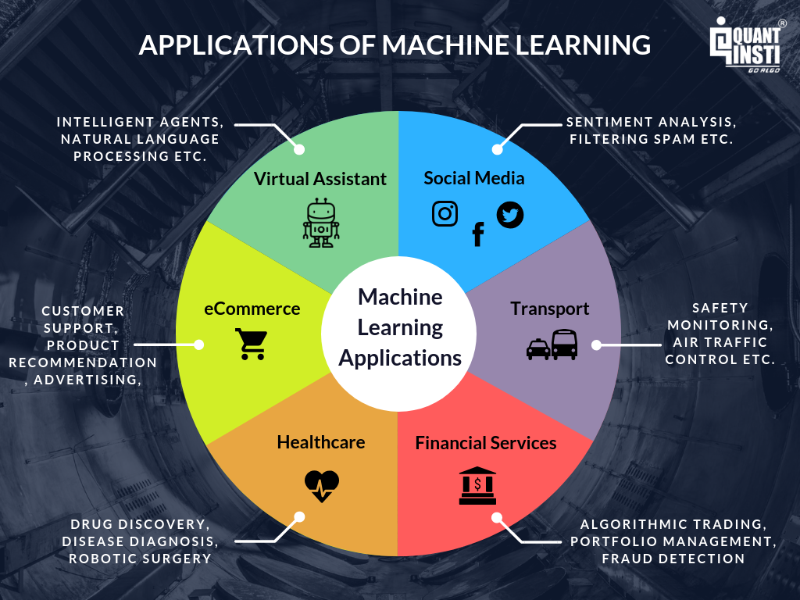

# 1.1.4 Tools and Technology for Machine Learning Top of Form

* There are various tools and technologies available for machine learning, ranging from programming languages and libraries to platforms and frameworks. Here are some of the popular ones:

1. Programming Languages:
2. Python: Python is widely used in the machine lemming community due to its simplicity, versatility, and rich ecosystem of libraries.
3. R: R is another popular language for statistical computing and data analysis, often used in academic and research environments.
4. Machine Learning Libraries and Frameworks:
5. TensorFlow: Developed by Google, TensorFlow is an open-source deep learning framework used for building and training neural networks.
6. PyTorch: Developed by Facebook's AI Research lab (FAIR), PyTorch is a popular deep learning framework known for Its dynamic computation graph and ease of use.
7. Scikit-learn: A versatile and easy-to-use library for traditional machine learning algorithms, such as regression, classification, clustering, and more.
8. Keras: A high-level neural network API, compatible with TensorFlow and other backends, simplifying the process of building and training neural networks
9. MXNet: A flexible deep learning framework that supports both imperative and symbolic programming, suitable for distributed computing.
10. Caffe: A deep learning framework known for its speed and efficiency, often used in computer vision tasks.
11. Data Manipulation and Analysis:
12. Pandas: A powerful Python library for data manipulation and analysis, offering data structures and functions for cleaning and preparing data.
13. NumPy: A fundamental library for numerical computing In Python, providing support for large, multi-dimensional arrays and mathematical functions.
14. Data Visualization:
15. Matplotlib: A popular Python library for creating static, interactive, and publication-quality visualizations.
16. Seaborn: Built on top of Matplotlib, Seaborn provides a higher-level interface for creating attractive statistical visualizations.
17. Plotly: A powerful library for interactive data visualizations, which can be used in Python, R, and JavaScript.
18. Cloud-based Machine Learning Platforms:
19. Google Cloud AI Platform: A cloud-based platform by Google that provides tools for building, deploying, and managing machine learning models.
20. Amazon SageMaker: A managed service by Amazon Web Services (AWS) for building, training, and deploying machine learning models at scale.
21. Microsoft Azure Machine Learning: A cloud-based platform by Microsoft that offers end-to-end machine learning capabilities.
22. AutoML (Automated Machine Learning) Platforms:
23. Google AutoML. A suite of tools by Google that automates the process of training and deploying machine learning models.
24. H20.ai: An open-source AutoML platform with features like automatic model selection, hyperparameter tuning, and model stacking.
25. Big Data and Distributed Computing:
26. Apache Spark: A powerful open-source data processing engine, often used for distributed machine learning tasks
27. Dask: A Python library that enables parallel computing and task scheduling for large-scale data processing and machine learning.