23SOECE11603                                    Enterprise Computing Through .NET Framework (CE525)

**Tutorial – 1**

**1. Write a program to print “Hello World”.**

using System;

using System.Collections.Generic;

using System.Linq;

using System.Text;

using System.Threading.Tasks;

namespace Q1

{

    internal class Program

    {

        static void Main(string[] args)

        {

            Console.WriteLine("Hello World!");

            Console.ReadLine();

        }

    }

}

**OUTPUT:**

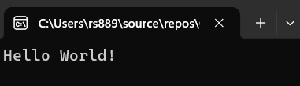

**2. Design your profile page as given below.**

using System;

using System.Collections.Generic;

using System.Linq;

using System.Text;

using System.Threading.Tasks;

namespace Q1

{

    internal class Program

    {

        static void Main(string[] args)

        {

            Console.WriteLine("Name:Rashmi Shah");

            Console.WriteLine("DOB:17/01/2005");

            Console.WriteLine("Adress:Tramba, RK University, Rajkot");

            Console.WriteLine("City:Rajkot");

            Console.WriteLine("Pin Code:360001");

            Console.WriteLine("state:Gujarat");

            Console.WriteLine("Country:India");

            Console.WriteLine("Email:rsah942@rku.ac.in");

            Console.ReadLine();

        }

    }

}

**OUTPUT:**

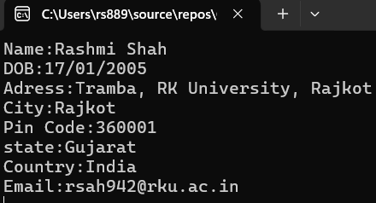

**3.Find out whether the given number is odd or even.**

using System;

using System.Collections.Generic;

using System.Linq;

using System.Text;

using System.Threading.Tasks;

namespace Program

{

    internal class even

    {

        static void Main(string[] args)

        {

            Console.Write("Enter a number: ");

            int num = Convert.ToInt32(Console.ReadLine());

            if (num % 2 == 0)

            {

                Console.WriteLine("Even");

            }

            else

            {

                Console.WriteLine("Odd");

            }

            Console.Read();

        }

    }

}

**OUTPUT:**

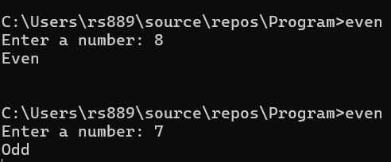

**4 : Rearrange the given code to correct the program. The resultant program will be to input a number and print whether the given number is odd or even.**

**namespace ConsoleApplication1**

**{**

**{**

**static void Main(string[] args)**

**{**

**int x;**

**Console.WriteLine("Enter Number : ");**

**x = Convert.ToInt32(str);**

**Console.WriteLine("Number is Even");**

**else**

**Console.Read();**

**string str = Console.ReadLine();**

**if (x % 2 == 0)**

**Console.WriteLine("Number is Odd");**

**}**

**}**

**}**

**class Program**

**using System;**

**Output:**

**Enter Number: 10**

**Number is Even**

**Corrected Code:**

using System;

using System.Collections.Generic;

using System.Diagnostics.Eventing.Reader;

using System.Linq;

using System.Text;

using System.Threading.Tasks;

namespace Program

{

    internal class Odd

    {

        static void Main(string[] args)

        {

            int x;

            Console.Write("Enter  Number: ");

            string str = Console.ReadLine();

            x = Convert.ToInt32(str);

            if (x % 2 == 0)

                Console.WriteLine("Number is Even ");

            else

                Console.WriteLine("Number is Odd ");

            Console.Read();

        }

    }

}

**Output:**

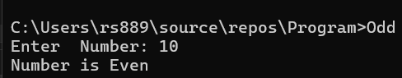

**5 : Write output of the program. Also write comment for each line for the following code.**

**using System;**

**namespace ConsoleApplication1**

**{**

**class Program**

**{**

**static void Main(string[] args)**

**{**

**int n,fact=1;**

**Console.WriteLine("Enter Number : ");**

**string str = Console.ReadLine();**

**n = Convert.ToInt32(str);**

**for (int i = 1; i <= n; i++)**

**{**

**fact = fact * i;**

**}**

**Console.WriteLine("Factorial : {0}",fact);**

**Console.Read();**

**}**

**}**

**}**

using System;

using System.Collections.Generic;

using System.Linq;

using System.Text;

using System.Threading.Tasks;

namespace ConsoleApplication1

{

    internal class Program

    {

        static void Main(string[] args)

        {

            int n, fact = 1; // Declare two variables: 'n' for input number and 'fact' initialized to 1

            Console.Write("Enter Number : "); // Prompt user to enter a number

            string str = Console.ReadLine(); // Read input as string and store in 'str'

            n = Convert.ToInt32(str); // Convert the string to integer and store in 'n'

            for (int i = 1; i <= n; i++) // Loop from 1 to n

            {

                fact = fact * i; // Multiply fact by i in each iteration (factorial logic)

            }

            Console.Write("Factorial : {0}", fact); // Print the calculated factorial

            Console.Read(); // Wait for user input before closing console

        }

    }

}

**Output:** 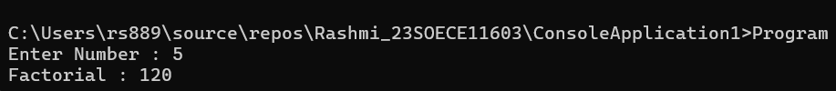

**6 : Write missing statement to get the desired output.**

**using System;**

**namespace ConsoleApplication1**

**{**

**class Program**

**{**

**static void Main(string[] args)**

**{**

**int a,b,c,result;**

**Console.Write("Enter Number   1: ");**

**//Missing statement**

**a = Convert.ToInt32(str);**

**Console.Write("Enter Number  2 : ");**

**//Missing statement**

**b = Convert.ToInt32(str);**

**Console.Write("Enter Number   3 : ");**

**str = Console.ReadLine();**

**//Missing statement**

**result = Sum(a, b, c);**

**//Missing statement**

**Console.Read();**

**}**

**static int Sum(int x, int y, int z)**

**{**

**int res;**

**res = x+y+z;**

**return res;**

**}**

**}**

**}**

**Output:**

**Enter Number 1 : 10**

**Enter Number 2 : 20**

**Enter Number 3 : 30**

**Sum : 60**

using System;

using System.Collections.Generic;

using System.Linq;

using System.Text;

using System.Threading.Tasks;

namespace ConsoleApplication1

{

    internal class Program

    {

        static void Main(string[] args)

        {

            int a, b, c, result;

            string str;

            Console.Write("Enter Number 1: ");

            str = Console.ReadLine();

            a = Convert.ToInt32(str);

            Console.Write("Enter Number 2: ");

            str = Console.ReadLine();

            b = Convert.ToInt32(str);

            Console.Write("Enter Number 3: ");

            str = Console.ReadLine();

            c = Convert.ToInt32(str);

            result = Sum(a, b, c);

            Console.WriteLine("Sum : {0} ", result);

            Console.ReadLine();

        }

        static int Sum(int x, int y, int z)

        {

            int res;

            res = x + y + z;

            return res;

        }

    }

}

**Output:**

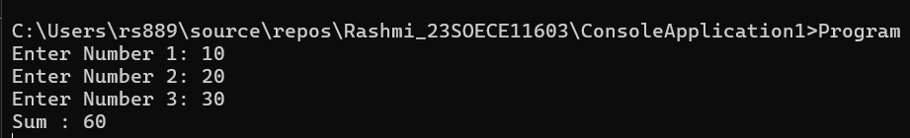

**7 : Predict and write the output of the given code.**

**using System;  
namespace While_Loop  
{  
  class Program  
   {  
     static void Main(string[] args)  
      {  
        int num1,res, i;  
   
        Console.WriteLine("Enter a number");  
        num1 = Convert.ToInt32(Console.ReadLine());  
        i = 1; //Initialization**

**//Check whether condition matches or not  
        while (i <= 10)  
         {  
           res = num1 * i;  
           Console.WriteLine("{0} x {1} = {2}", num1, i, res);  
            i++; //Increment by one  
         }  
        Console.ReadLine();             
      }  
   }  
}**

**Output:**

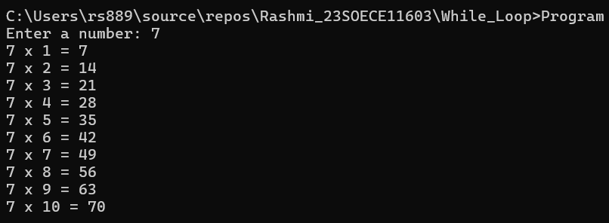

**8 Write a program to convert given name in upper characters.  
INPUT : John F Kennedy  
OUTPUT: JOHN F KENNEDY**

using System;

using System.Collections.Generic;

using System.Linq;

using System.Text;

using System.Threading.Tasks;

namespace Upper

{

    internal class Program

    {

        static void Main(string[] args)

        {

            Console.Write("Enter Name: ");

            string name = Console.ReadLine();

            Console.WriteLine(name.ToUpper());

        }

    }

}

**Output:**

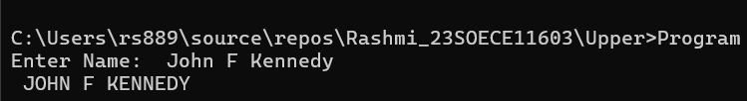

**9 Write a Program to convert given name in toggle case.  
INPUT : JoHn F kEnNedy  
OUTPUT: jOhN f KeNneDY**

using System;

using System.Collections.Generic;

using System.Linq;

using System.Text;

using System.Threading.Tasks;

namespace Upper

{

    internal class Program

    {

        static void Main(string[] args)

        {

            Console.Write("Enter Name: ");

            string name = Console.ReadLine();

            string toggle = "";

            foreach (char ch in name)

            {

                if (char.IsUpper(ch))

                    toggle += char.ToLower(ch);

                else

                    toggle += char.ToUpper(ch);

            }

            Console.WriteLine(toggle);

        }

    }

}

**Output:**

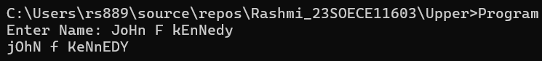

**10 Write a Program which accepts mobile no as a string from the user and converts the last 5 digits into X.  
INPUT : 1234567890  
OUTPUT: 12345XXXXX**

using System;

using System.Collections.Generic;

using System.Linq;

using System.Text;

using System.Threading.Tasks;

namespace Upper

{

    internal class Program

    {

        static void Main(string[] args)

        {

            Console.Write("Enter Mobile Number:");

            string mobile = Console.ReadLine();

            string result = mobile.Substring(0, 5) + "XXXXX";

            Console.WriteLine(result);

        }

    }

}

**OUTPUT:**

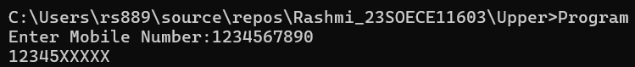

**11  Write a Program which accepts name and gender from the user. Here, gender may have only 1 character, M or F.  
Based on the gender prefix the name Mr. & Ms.  
NAME : Hillary Clinton  
GENDER : F**

using System;

using System.Collections.Generic;

using System.Linq;

using System.Text;

using System.Threading.Tasks;

namespace Upper

{

    internal class Program

    {

        static void Main(string[] args)

        {

            Console.Write("Enter Name: ");

            string name = Console.ReadLine();

            Console.Write("Enter Gender (M/F): ");

            char gender = Convert.ToChar(Console.ReadLine().ToUpper());

            if (gender == 'M')

                Console.WriteLine("Mr. " + name);

            else if (gender == 'F')

                Console.WriteLine("Ms. " + name);

            else

                Console.WriteLine("Invalid gender");

        }

    }

}

**OUTPUT:**

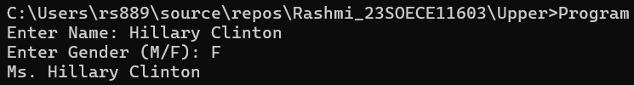

**12 Write a Program which accepts name from the user and prints the same  
INPUT : Winston Churchill  
OUTPUT: Winston Churchill**

using System;

using System.Collections.Generic;

using System.Linq;

using System.Text;

using System.Threading.Tasks;

namespace Upper

{

    internal class Program

    {

        static void Main(string[] args)

        {

            Console.Write("Enter Name:");

            string name = Console.ReadLine();

            Console.WriteLine(name);

        }

    }

}

**OUTPUT:**

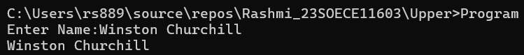

**13 Write a Program to prints the following series  
0 1 1 2 3 5 8 13 21 34 55**

using System;

using System.Collections.Generic;

using System.Linq;

using System.Text;

using System.Threading.Tasks;

namespace Upper

{

    internal class Program

    {

        static void Main(string[] args)

        {

            int a = 0, b = 1, c, n = 11;

            Console.Write("{0} {1} ", a, b);

            for (int i = 2; i < n; i++)

            {

                c = a + b;

                Console.Write("{0} ", c);

                a = b;

                b = c;

            }

            }

    }

}

**OUTPUT:**



**14 Write a Program which accepts no from the user and print the same in words.  
INPUT : 98732  
OUTPUT: Nine Eight Seven Three Two**

using System;

using System.Collections.Generic;

using System.Linq;

using System.Text;

using System.Threading.Tasks;

namespace Upper

{

    internal class Program

    {

        static void Main(string[] args)

        {

            string[] words = { "Zero", "One", "Two", "Three", "Four", "Five", "Six", "Seven", "Eight", "Nine" };

            Console.Write("Enter Number: ");

            string number = Console.ReadLine();

            foreach (char digit in number)

            {

                Console.Write(words[digit - '0'] + " ");

            }

            }

    }

}

**OUTPUT:**

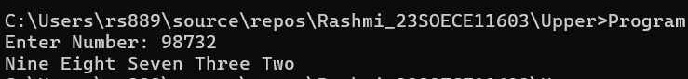

**15  Write a Program to check whether the given no is Armstrong no or not.**

using System;

using System.Collections.Generic;

using System.Linq;

using System.Text;

using System.Threading.Tasks;

namespace Upper

{

    internal class Program

    {

        static void Main(string[] args)

        {

            Console.Write("Enter number: ");

            int num = Convert.ToInt32(Console.ReadLine());

            int temp = num, sum = 0;

            while (temp > 0)

            {

                int digit = temp % 10;

                sum += digit * digit * digit;

                temp /= 10;

            }

            if (sum == num)

                Console.WriteLine("Armstrong Number");

            else

                Console.WriteLine("Not an Armstrong Number");

        }

    }

}

**OUTPUT:**

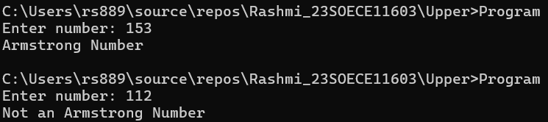

**16  Write a program to display a pattern like a right angle triangle using an asterisk**

**The pattern like :**

**\***

**\*\***

**\*\*\***

**\*\*\*\***

using System;

using System.Collections.Generic;

using System.Linq;

using System.Text;

using System.Threading.Tasks;

namespace Upper

{

    internal class Program

    {

        static void Main(string[] args)

        {

            for (int i = 1; i <= 4; i++)

            {

                for (int j = 1; j <= i; j++)

                    Console.Write("*");

                Console.WriteLine();

            }

        }

    }

}

**OUTPUT:**

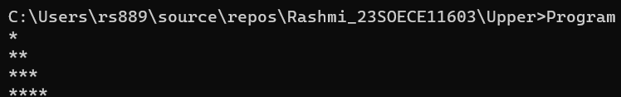

**17. Write a Program to generate following output.**

**1**

**1 2**

**1 2 3**

**1 2 3 4**

using System;

using System.Collections.Generic;

using System.Linq;

using System.Text;

using System.Threading.Tasks;

namespace Upper

{

    internal class Program

    {

        static void Main(string[] args)

        {

            for (int i = 1; i <= 4; i++)

            {

                for (int j = 1; j <= i; j++)

                    Console.Write(j + " ");

                Console.WriteLine();

            }

        }

    }

}

**OUTPUT:**

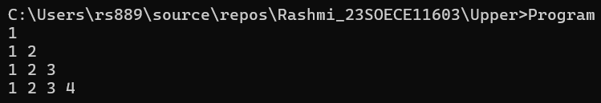

**18 Write a program to make such a pattern like a right angle triangle with the number increased by 1.**

**The pattern like :**

**1**

**2 3**

**4 5 6**

**7 8 9 10**

using System;

using System.Collections.Generic;

using System.Linq;

using System.Text;

using System.Threading.Tasks;

namespace Upper

{

    internal class Program

    {

        static void Main(string[] args)

        {

            int count = 1;

            for (int i = 1; i <= 4; i++)

            {

                for (int j = 1; j <= i; j++)

                    Console.Write(count++ + " ");

                    Console.WriteLine();

            }

        }

    }

}

**OUTPUT:**

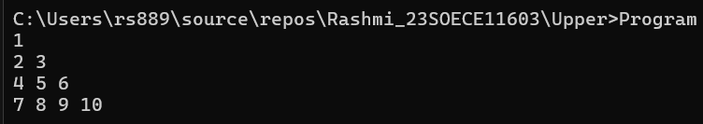

**19. Write a program to make such a pattern as a pyramid with an asterisk.**

**\***

**\* \***

**\* * \***

**\* * * \***

using System;

using System.Collections.Generic;

using System.Linq;

using System.Text;

using System.Threading.Tasks;

namespace Upper

{

    internal class Program

    {

        static void Main(string[] args)

        {

            int rows = 4;

            for (int i = 1; i <= rows; i++)

            {

                for (int j = i; j < rows; j++)

                    Console.Write(" ");

                for (int k = 1; k <= i; k++)

                    Console.Write("* ");

                Console.WriteLine();

            }

        }

    }

}

**OUTPUT:**

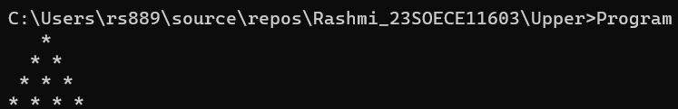

**20. Write a program to make a pyramid pattern with numbers increased by 1.**

**1**

**2 3**

**4 5 6**

**7 8 9 10**

using System;

using System.Collections.Generic;

using System.Linq;

using System.Text;

using System.Threading.Tasks;

namespace Upper

{

    internal class Program

    {

        static void Main(string[] args)

        {

            int num = 1;

            for (int i = 1; i <= 4; i++)

            {

                for (int j = i; j < 4; j++)

                    Console.Write(" ");

                for (int k = 1; k <= i; k++)

                    Console.Write(num++ + " ");

                Console.WriteLine();

            }

        }

    }

}

**OUTPUT:** 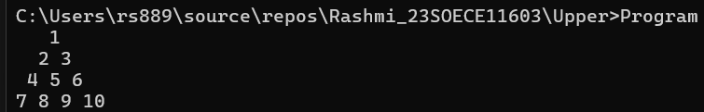

**21. Write a program to find the sum of the series 5 +55 + 555 + 5555 + .. n terms.   
Test Data :  
Input the number of terms : 4**

**Input number : 5  
*Expected Output* :  
5 + 55 + 555 + 5555  
The Sum is : 6170**

using System;

using System.Collections.Generic;

using System.Linq;

using System.Text;

using System.Threading.Tasks;

namespace Upper

{

    internal class Program

    {

        static void Main(string[] args)

        {

            Console.Write("Enter number of terms: ");

            int n = Convert.ToInt32(Console.ReadLine());

            Console.Write("Enter base number: ");

            int num = Convert.ToInt32(Console.ReadLine());

            int term = 0, sum = 0;

            for (int i = 1; i <= n; i++)

            {

                term = term * 10 + num;

                Console.Write(term);

                if (i < n) Console.Write(" + ");

                sum += term;

            }

            Console.WriteLine("\nThe Sum is : {0}", sum);

        }

    }

}

**OUTPUT:**

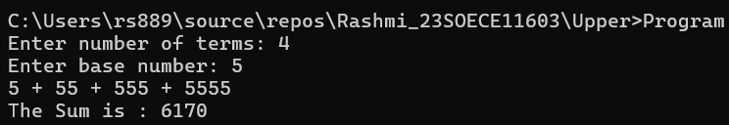

**22. Write a program to display a pattern like a diamond.**

**\***

**\*\*\***

**\*\*\*\*\***

**\*\*\*\*\*\*\***

**\*\*\*\*\*\*\*\*\***

**\*\*\*\*\*\*\***

**\*\*\*\*\***

**\*\*\***

**\***

using System;

using System.Collections.Generic;

using System.Linq;

using System.Text;

using System.Threading.Tasks;

namespace Upper

{

    internal class Program

    {

        static void Main(string[] args)

        {

            int n = 5;

            for (int i = 1; i <= n; i++)

            {

                for (int j = i; j < n; j++)

                    Console.Write(" ");

                for (int k = 1; k <= (2 * i - 1); k++)

                    Console.Write("*");

                Console.WriteLine();

            }

            for (int i = n - 1; i >= 1; i--)

            {

                for (int j = n; j > i; j--)

                    Console.Write(" ");

                for (int k = 1; k <= (2 * i - 1); k++)

                    Console.Write("*");

                Console.WriteLine();

            }

        }

    }

}

**OUTPUT:**

