**Automatic recommendation of motivation for depressed users on Social Media**

**ABSTRACT**

Depression is a mental health condition marked by an overwhelming feeling of sadness, isolation and despair that affects how a person thinks, feels and performs. Symptoms associated with depression can be observed on Twitter, Facebook, and other social media platforms. Automated methods are increasingly able to detect depression and other mental illnesses although, there are research gaps in providing automated motivational services.   
  
In this work, we explore the possibilities to recommend motivation according to the solution of a depressional post on social media. We leverage on different word-embedding techniques to generate word vectors and understand the context of depression to recommend a contextual motivation.

**KEYWORDS**

Wordembedding,Cosine-Similarity,N-gram,Word2Vec model,Fasttext, Glove,TFIDF , Countvecterizer

**INTRODUCTION**

Two types of information that are especially helpful for recommendation operations are what kind of depression it is and what will be the motivation for a particular depressive sentence. Twitter is used to collect all the dataset including depression tweets and motivation tweets . Specifically, two types of tweets are useful: (i) depression-tweets, which inform about the type of depression (study related, or job related or anything else) and (ii) Motivation-tweets, which inform how the depression can be overcomed.

|  |  |
| --- | --- |
| Depression_Tweet | Motivation_tweet |
| 1.Eating fast food and junk food is linked to higher risk of obesity,depression,digestive problems,heart diseas. | 1.Apparently research says that the best way to avoid seasonal depression is to avoid sweets. |
| 2.Hey depression i think you need some rest everyday you are working hard to destroy my life | 2.Depression is the silent killer and it comes in all shapes and sizes so we all need to work together and work hard. |

For the recommendation operation, the first challenge is to extract and differenciate depression-tweets and motivation-tweets from among the thousands of tweets posted , most of which contain conversational content. This problem of identifying depression-tweets and motivation-tweets was addressed in our prior works. We assume that a set of depression-tweets and a set of motivation-tweets have already been identified from a given (large) set of tweets After that data preparation and data cleaning operations like- stopwords removal , stemming, lemmatization , pos tagging are done before going to the main methodologies of automatic depression-motivation matching.

We experiment with several methodologies for building the recommendation system which will automatically match depression-tweets and motivation-tweets, ranging from countvec, noun overlap to pretrained models like glove, fasttext , word2vec.

**METHODOLOGIES FOR MATCHING DEPRESSION TWEETS AND MOTIVATION TWEETS**

For a particular depression-tweet, a list of motivation-tweets, ranked in decreasing order of how closely they match the depression-tweet are identified. We use several techniques for matching as given below:

**1. TF-IDF Vectorizer:**

TF-IDF stands for “Term Frequency — Inverse Data Frequency”.

Term Frequency (tf):It is the frequency of the word in each document in the corpus. It is the ratio of number of times the word appears in a document compared to the total number of words in that document. It increases as the number of occurrences of that word within the document increases. Each document has its own tf.

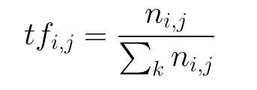

Inverse Data Frequency (idf): It is used to calculate the weight of rare words across all documents in the corpus. The words that occur rarely in the corpus have a high IDF score. It is given by the equation below.

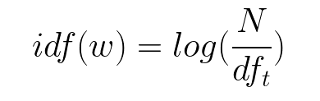

TF-IDF score (w) can be find by combining these two for a word in a document in the corpus. It is the product of tf and idf:

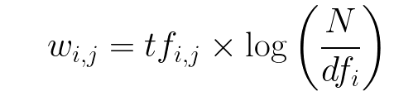

By using TFIDF Vectorizer text is transformed to feature vectors that can be used as input to estimator. We will import TfidfVectorizer from sklearn.feature_extraction.text .Next we will initialise the vectorizer and then call fit and transform over it to calculate the TF-IDF score for the depression tweet set and the motivation tweet set particularly.The output obtained is in the form of a skewed matrix.Cosine Similarity of these 2 matrix will be calculated and for a given depression tweet, motivation-tweets ranked in the decreasing order will be displayed.

**2.CountVectorizer:**

It is the most straightforward one, it counts the number of times a token appears in the document and uses this value as its weight..We will initialise the countvectorizer and then call fit and transform over it to calculate the countvectorizer score for the depression tweet set and the motivation tweet set particularly. Skewed matrix is obtained as output.Cosine Similarity of these 2 matrix will be calculated and for a given depression tweet, motivation-tweets ranked in the decreasing order will be displayed.

**3.Common Noun Overlap:**

We use a part-of-speech tagger on depression-tweets and motivation-tweets to identify the different types of nouns,as nouns are likely to indicate the specific reason of depression . To check the match of an motivation-tweet with a depression-tweet, we check if the fraction of the nouns in the depression-tweet that are also contained in the motivation-tweet. For a given depression-tweet, motivation-tweets are ranked in the decreasing order of the fraction of common nouns.

***4. Local word embeddings [Word2Vec]:***

Predictive models learn their vectors in order to improve their predictive ability of a loss such as the loss of predicting the vector for a target word from the vectors of the surrounding context words. Word2Vec is a predictive embedding model. There are two main Word2Vec architectures that are used to produce a distributed representation of words:

***i.CBOW****:*The CBOW model trains each word against its context

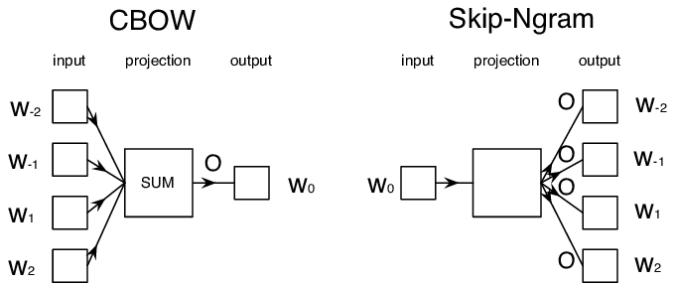

**ii.Skip-Gram:**Skip-gram trains each the context against the word

Here we train Word2vec on the set of motivation-tweets Skip-Gram architecture is used here . We construct a tweet-vector for each tweet, by averaging the Word2vec term-vectors of the terms contained in the tweet. The match between an motivation-tweet and a depression tweet is calculated from the cosine similarity of their tweet-vectors. For a given depression-tweet, motivation-tweets are ranked in the decreasing order of this cosine similarity value.

**5. Pre-trained word embeddings:**

A limitation of the previous method is that a large set of tweets about the current event is needed to learn the local word embeddings.

***i.Word2Vec :***It is one of the most extensively used methodologies due to its training speed and performance. Word2vec is a predictive model, which means that instead of utilizing word counts, it is trained to predict a target word from the context of its neighboring words. Here one hot encodding is used first for encodind each word, then feeds it into a hidden layer using a matrix of weights; the output of this process is the target word. The word embedding vectors are actually the weights of this fitted model. Word2Vec is not a truly unsupervised learning technique (since there is some sort of error backpropagation taking place through correct and incorrect predictions), they are a self-supervised technique, a specific instance of supervised learning where the targets are generated from the input data. To illustrate, here’s a simple visual:

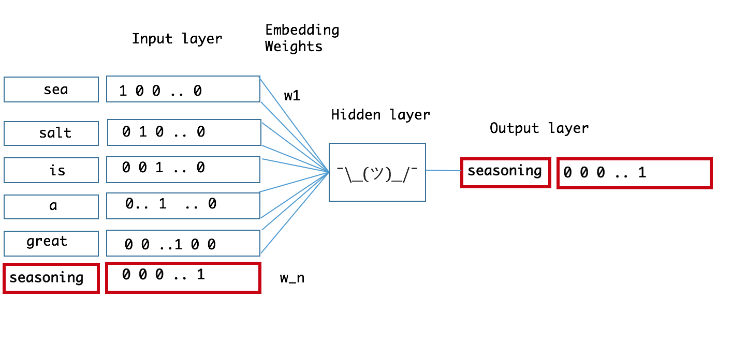

*The pre-trained Google word2vec model was trained on Google news data (about 100 billion words); it contains 3 million words and phrases and was fit using 300-dimensional word vectors.*

**ii.FastText:**FastText is a library developed by Facebook for text classification, but it can also be used to learn word embeddings.fastText is an extension of the word2vec model.Instead of learning vectors for words directly, here each word is represented as an n-gram of characters.So,for example,if we take the word, “mango” with n=3, the fastText representation of this word is <ma,man,ang,ngo,go>,where the angular brackets indicate the beginning and end of the word.

**iii.Glove_Twitter:** GloVe represents global vectors for word representation. It is an unsupervised learning algorithm developed by Stanford for generating word embeddings by aggregating global word-word co-occurrence matrix from a corpus.Glove_Twitter model is pre-trained on two billion tweets from the Twitter 1% random sample.

For all the pre-trained embeddings, we follow a matching methodology after building the model use use n_similarity() method, to compute the cosine similarity between the tweet-vectors of depression-tweets and motivation-tweets.

**EXPERIMENTS AND RESULTS**

**Datasets:** Dataset that is used here is collected from Twitter .We then used three human annotators for identifing depression-tweets and motivation-tweets. Among all the tweets 189 motivation tweets and 470 depression tweets are found.

**Evaluation measures:**For a given depression-tweet, each methodology produces top 5 ranked list of motivation-tweets, evaluated as follows:

|  |  |  |
| --- | --- | --- |
| Methods | Precision@5 | MRR |
| 1.TFIDF | 0.439 | 0.8 |
| 2.CountVectorizer | 0.32 | 0.66 |
| 3.NounOverlap | 0.44 | 0.6 |
| 4.Word2Vec | 0.48 | 0.9 |
| 5.Word2Vec Pretrained model | 0.52 | 0.666 |
| 6.FastText | 0.56 | 0.8 |
| 7.Glove | 0.59 | 0.766 |
| 8.Glove Twitter | 0.68 | 0.9 |

(i) Precision of matching: Each methodology retrieve 5 top-matching motivation-tweets for each depression tweet. Then the human annotators check each depression-motivation pair, and judge whether the match is correct or not. There was very high agreement between all the annotators; majority voting was considered in the few cases where there was no unanimous agreement. The precision of a matching methodology is the fraction of pairs that are matched correctly by the methodology. In Information Retrieval terminology, we are computing [Precision@5](mailto:Precision@5).

Precision@k = (# of recommended items @k that are relevant) / (# of recommended items @k)

(ii) Recall of matching: The recall of a methodology is the fraction of all depression-tweets for which the methodology is able to identify at least one correct matching (based on the judgement of the annotators).

Recall@k = (# of recommended items @k that are relevant) / (total # of relevant items)

(iii)MRR:The **mean reciprocal rank** is a [statistic](https://en.wikipedia.org/wiki/Statistic) measure for evaluating any process that produces a list of possible responses to a sample of queries, ordered by probability of correctness.

**Evaluation results:**Table 2 compares the performance of the various methodologies for the two datasets. We see that the methodology based on pretrained models perform reasonably well. Among all pretrained models glove_twitter model performs the best.

**CONCLUSION**

With the escalating frequency of social anxiety disorder and other mental health issues, novel techniques for assessing psychological state have become increasingly important.We introduced the problem of matching depression-motivation tweet by building a automatic motivation recommendation system to the depressed user on social media. We plan to study more realistic versions of the automatic matching problem in future.

**REFERENCE:**

1."Automatic Matching of Resource Needs and Availabilities in Microblogs for Post-Disaster Relief", Companion of the The Web Conference 2018 on The Web Conference 2018 - WWW '18, 2018

2.Yu Huang, Haoyi Xiong, Kevin Leach, Yuyan Zhang, Philip Chow, Karl Fua, Bethany A.

Teachman, Laura E. Barnes. "Assessing social anxiety using gps trajectories and point-of-

interest data", Proceedings of the 2016 ACM International Joint Conference on Pervasive and

Ubiquitous Computing - UbiComp '16, 2016

3.[www.freecodecamp.org](http://www.freecodecamp.org/)

4.[www.datascience.com](http://www.datascience.com/)

5.medium.com

