Name: Rashmita Gade Batch: ANP-C7781 Student ID: AF0403156

**1. Perform the following tasks:**

a. Create Student table with following attributes (STUDENT_ID, FIRST_NAME, LAST_NAME, PHONE_NUMBER, MARKS, COURSE_ID).

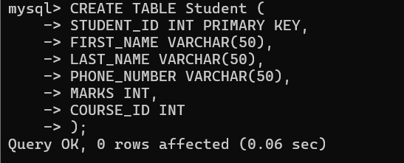

b. Create Course table with following attributes (COURSE_ID, COURSE_NAME).

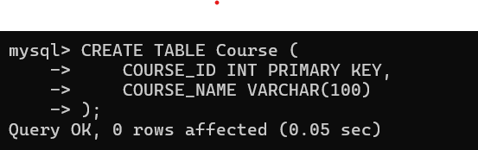

c. Write a SQL statement to insert 8 records with your own value into the tables.

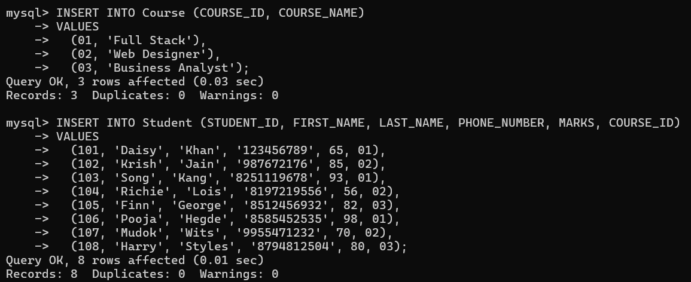

d. Write a query to get the number of students with the same course.

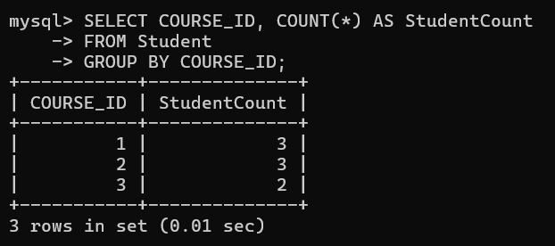

f. Write a query to get the student name, course name and marks of the students.

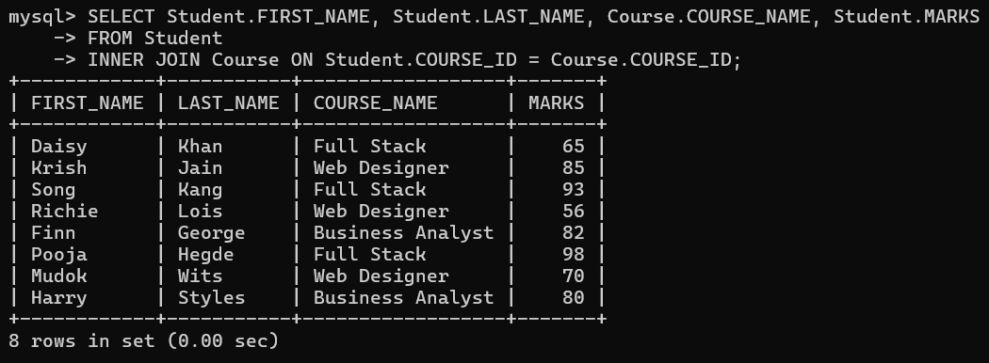

g. Write a query to get the Average marks of students course wise.

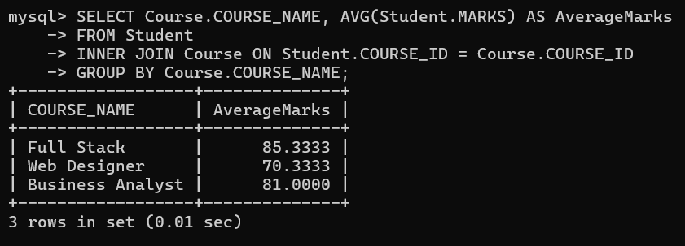

**2.  Create database for hospital management system & Perform the following tasks:**

a. Create HEALTH CARE WORKERS table with following attributes (EMPLOYEE_ID, FIRST_NAME, LAST_NAME, EMAIL, PHONE_NUMBER, HIRE_DATE, SALARY, DESIGNATION).

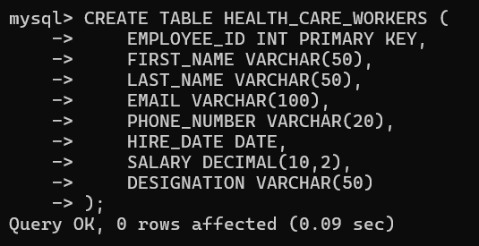

b. Create PATIENT table with following attributes (PATIENT_ID, NAME, PHONE_NUMBER).

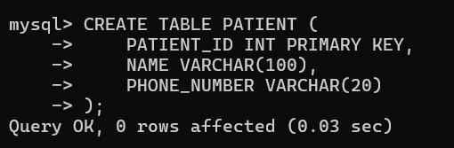

c. Write a SQL statement to insert 10 records with your own value into the tables.

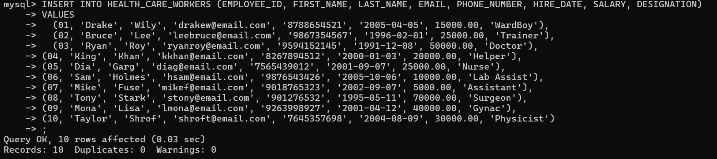

d. Write a query to get the names first_name, last_name, Designation, salary.

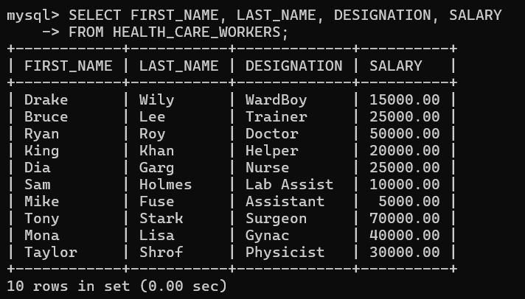

e. Write a query to get the number of employees with the same Designation

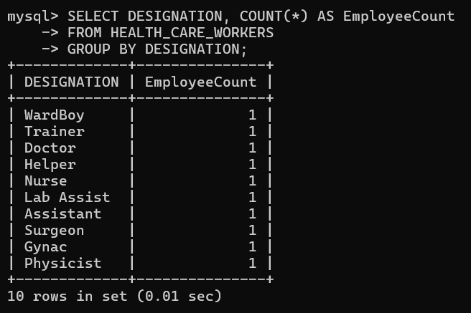

f. Write a query to get employee name who are getting salary more than 25000.

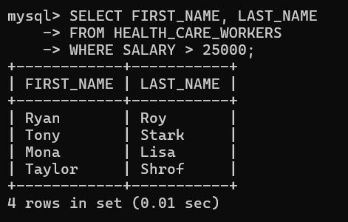

g. Fetch HEALTH CARE WORKERS name using their employee id.

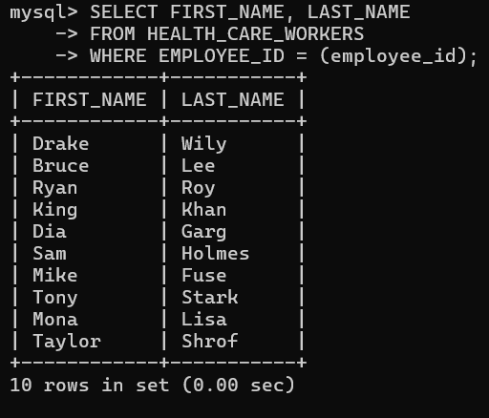

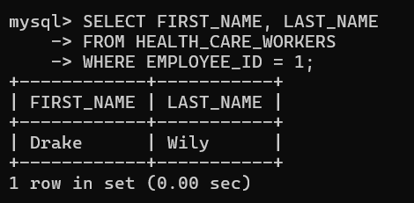

**3.Consider two tables, customers and orders, with the following structures:**

Customers Table: customer_id (Primary Key) first_name Last_name

Orders Table: order_id (Primary Key) customer_id (Foreign Key) order_date Total_amount

Write an SQL query to retrieve the first and last names of customers along with the order date and total amount of their orders.

Use an INNER JOIN to connect the two tables.

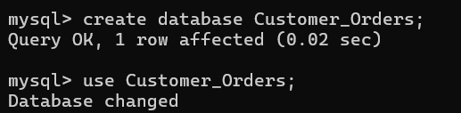

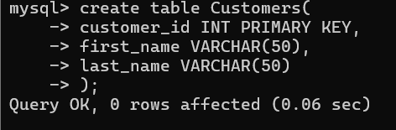

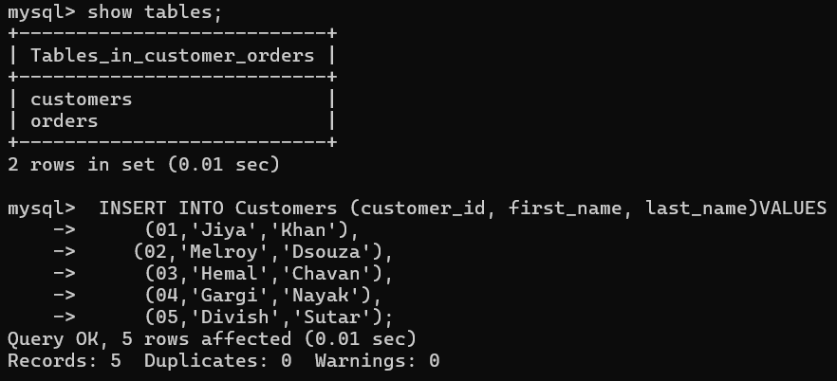

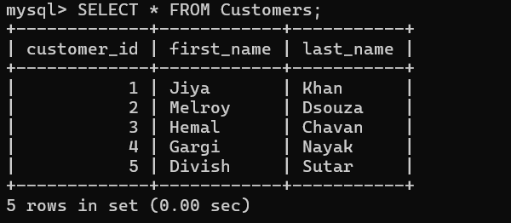

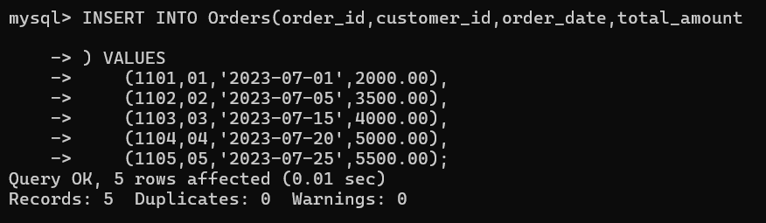

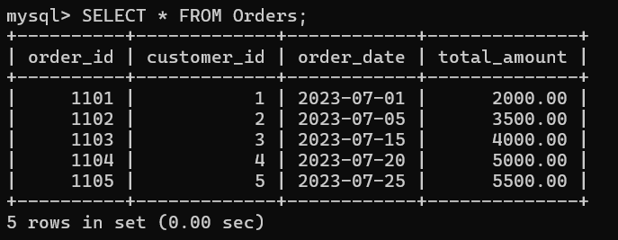

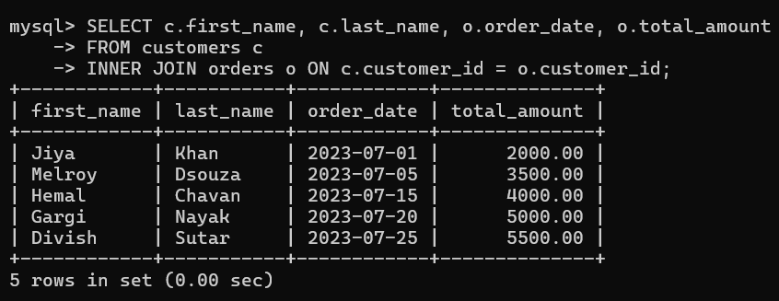

**4.Consider two tables, departments and employees, with the following structures:**

Departments Table: department_id (Primary Key) department_name

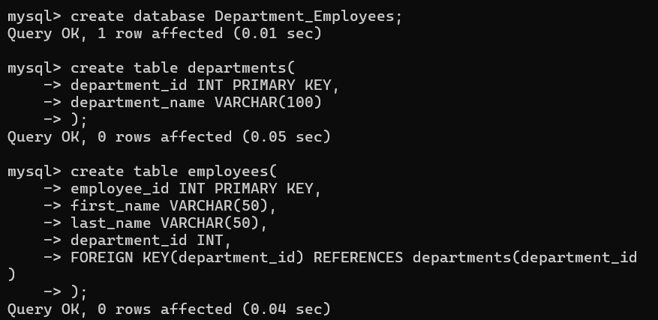

Employees Table: employee_id (Primary Key) first_name last_name department_id (Foreign Key)

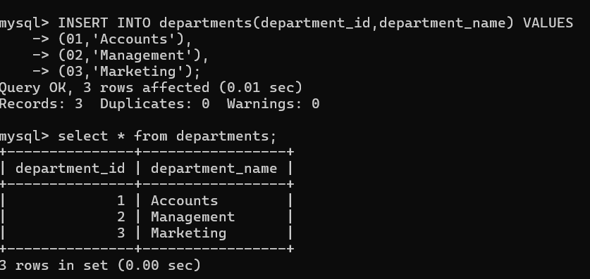

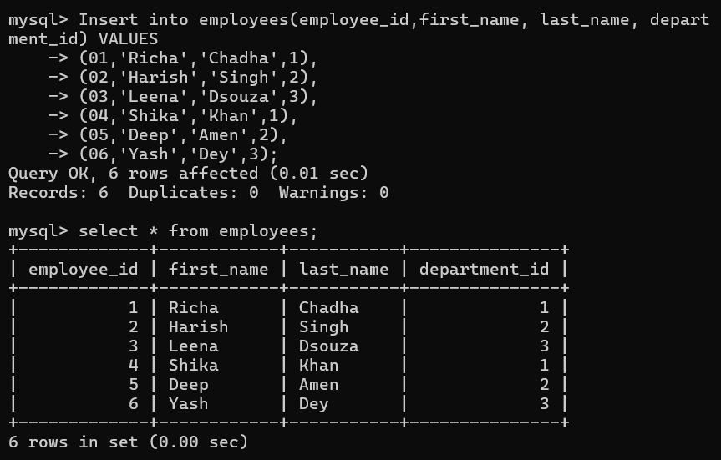

Write an SQL query to retrieve a list of all departments and the names of employees who belong to each department. Use a LEFT JOIN to include departments that have no employees.

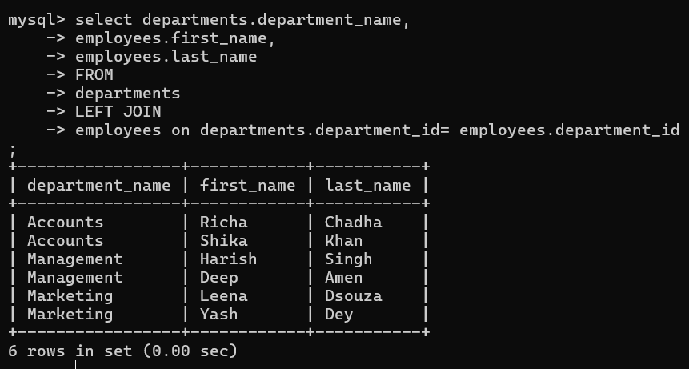

**5. Write a program to show JDBC connection with MYSQL and perform the following operations:**

Create table Customer with following fields:

Custno, Custname, Custaddress,Phoneno, City, Pincode, Country

Insert 5 records in Customer table.

1. Insert values
2. Delete values
3. update city name .
4. Show table in the console

**Jdbclab.java**

package Drama;

import java.sql.*;

public class jdbclab {

public static void main(String[] args) {

Connection con = null;

Statement st = null;

try {

Class.*forName*("com.mysql.cj.jdbc.Driver");

con = DriverManager.*getConnection*("jdbc:mysql://localhost:3306/rasdb", "root", "WJ28@krhps");

st = con.createStatement();

// Creating table

String createTableSQL = "CREATE TABLE IF NOT EXISTS Customers (" +

"Custno INT PRIMARY KEY, " +

"Custname VARCHAR(100), " +

"Custaddress VARCHAR(255), " +

"Phoneno VARCHAR(20), " +

"City VARCHAR(50), " +

"Pincode VARCHAR(10), " +

"Country VARCHAR(50)" +

")";

st.executeUpdate(createTableSQL);

System.*out*.println("Customer table created successfully");

// Inserting records

String insertSQL = "INSERT INTO Customers (Custno, Custname, Custaddress, Phoneno, City, Pincode, Country) VALUES " +

"(1, 'Henry', '65 Sunshine Home', '9876564140', 'Vegas', '20001', 'USA'), " +

"(2, 'Lucky', '202 JApt', '8251562789', 'Amsterdam', '40404', 'USA'), " +

"(3, 'Kenny', '401 SA Society', '9987543567', 'Yemen', '50909', 'SA'), " +

"(4, 'Dimmy', '105 Evergreen Park', '9123457687', 'Finland', '10206', 'UK'), " +

"(5, 'Merry', '3003 Aries Apt', '8799217650', 'Serbia', '70105', 'Asia')";

st.executeUpdate(insertSQL);

System.*out*.println("5 records inserted into Customer table");

} catch (Exception e) {

e.printStackTrace();

} finally {

try {

if (st != null) st.close();

if (con != null) con.close();

} catch (SQLException se) {

se.printStackTrace();

}

}

}

}

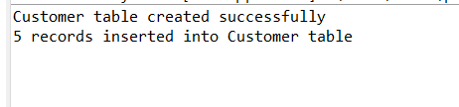

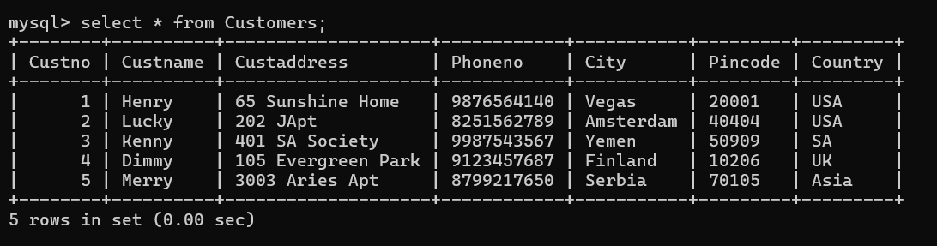

**deletejdbcLab.java**

**package** Drama;

**import** java.sql.Connection;

**import** java.sql.DriverManager;

**import** java.sql.PreparedStatement;

**public** **class** deletejdbcLab {

**public** **static** **void** main(String[] args) **throws** Exception {

String custname1 = "Lucky";

Class.*forName*("com.mysql.cj.jdbc.Driver");

Connection con = DriverManager.*getConnection*("jdbc:mysql://localhost:3306/rasdb","root","WJ28@krhps");

PreparedStatement ps = con.prepareStatement("delete from Customers where Custname =?");

ps.setString(1, custname1);

**int** count = ps.executeUpdate();

**if**(count > 0)

{

System.***out***.println("Customer details Deleted");

}

**else**

{

System.***out***.println("Failed to delete details");

}

}

}

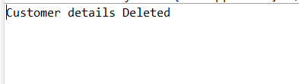

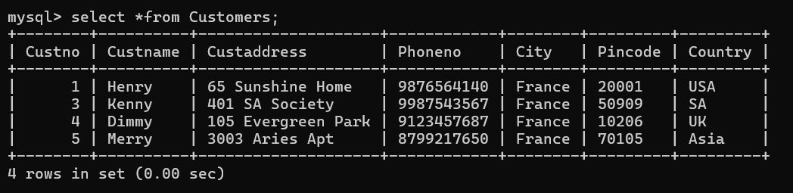

**updatejdbcLab.java**

**package** Drama;

**import** java.sql.*;

**public** **class** updatejdbcLab {

**public** **static** **void** main(String[] args) {

**try** {

String city1 = "France";

Class.*forName*("com.mysql.cj.jdbc.Driver");

Connection con = DriverManager.*getConnection*("jdbc:mysql://localhost:3306/rasdb","root","WJ28@krhps");

PreparedStatement ps = con.prepareStatement("update Customers set City =?");

ps.setString(1, city1);

**int** count = ps.executeUpdate();

**if**(count > 0)

{

System.***out***.println("cities updated to France");

}

**else**

{

System.***out***.println("Failed to update details");

}

}**catch** (Exception e) {

System.***out***.println(e);

}

}

}

