

Ms OFFICE

[Document subtitle]



[Date]

[Company name]

[Company address]

Contents

**1.** **Resume** 2

2. **Letter Format** 3

**3.** **Photo Editing** 4

1. 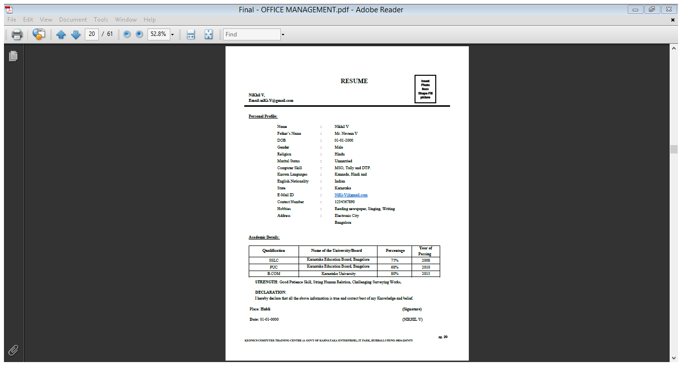**Resume**
2. 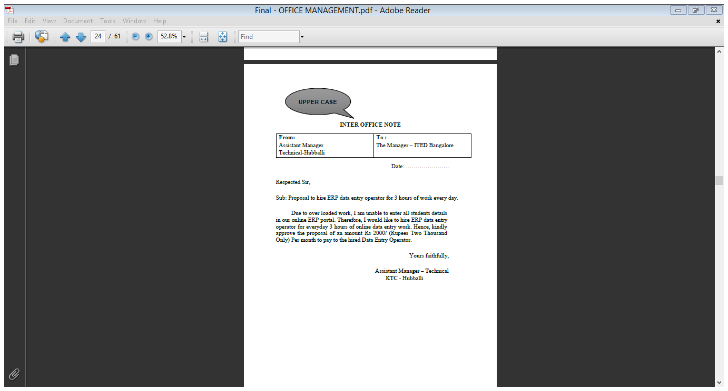**Letter Format**



1. **Photo Editing**

