**KEONICS**

Never Stop Learning

KEONICS COMPUTER TRAINING

CENTRE

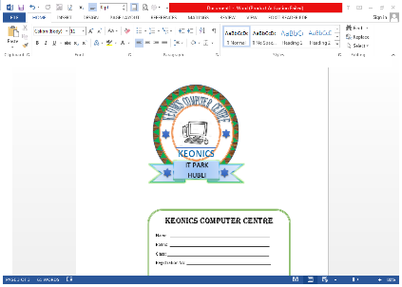

Address: IT Park. OPP.Glass House.

Hosur-Hubli.

Website: www.keonics.com

🕿: 0836-2357675