**C++ OOPS LAB (week 5a)**

**Karnati Rashvitha Ayyappa**

**AP20110010706**

**CSE-B**

**1)** Write a program using functions, to check if two strings are anagram of each other.

**CODE:**

#include <iostream>

#include <bits/stdc++.h>

#include <string.h>

using namespace std;

int anagram (string s1, string s2)

{

if(s1==s2)

{

return 1;

}

else

{

return 0;

}

}

int main ()

{

string s1 = "“, s2 = "";

cout<<"Enter 2 Strings(in same case):"<<endl;

getline(cin, s1);

getline(cin, s2);

transform (s1. begin (), s1.end (), s1. begin (),:: tolower);

transform (s2. begin (), s2.end(), s2.begin(), ::tolower);

sort(s1. begin(), s1.end());

sort(s2.begin(),s2.end());

if(anagram(s1,s2))

cout<<"Yes, the 2 strings are anagram of each other"<<endl;

else

cout<<"No, the 2 strings are not anagram of each other"<<endl;

}

**OUTPUT**

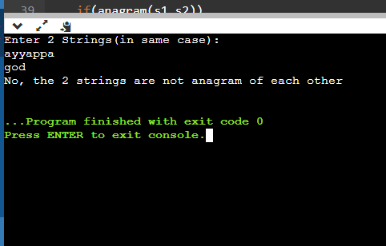

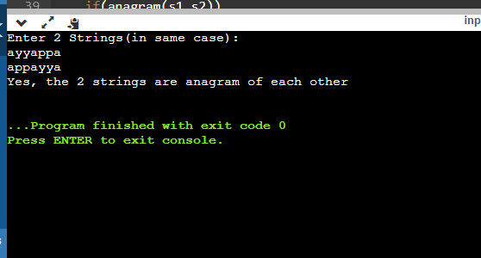

**2) Write a C++ program using functions that determines the winning team of the tournament and print its respective team ID.**

**CODE:**

#include <iostream>

using namespace std;

int main ()

{

int teams,i,j,best=0;

cout<<"Number of teams participating in the tournament: ";

cin>>teams;

int match[teams][5];

int t1=0,t2=0;

cout<<"\nIndividual team statistic/performance:"<<endl;

for(i=0;i<teams;i++)

{

cout<<"\nTeam "<<i+1<<": ";

for(j=0;j<5;j++)

cin>>match[i][j];

}

for(i=1;i<teams;i++)

{

for(j=0;j<5;j++)

{

if(match[best][j]>=match[i][j])

t1 += 1;

else

t2 += 1;

}

if(t2>t1)

best = i;

t1 = 0;

t2 = 0;

}

cout<<"\nThe winner is Team "<<best+1;

}

**OUTPUT**

