# Step 1 – Window Displays

Start the application by running “**Main.java**” file. This is where the main function is located.

The following window appears:

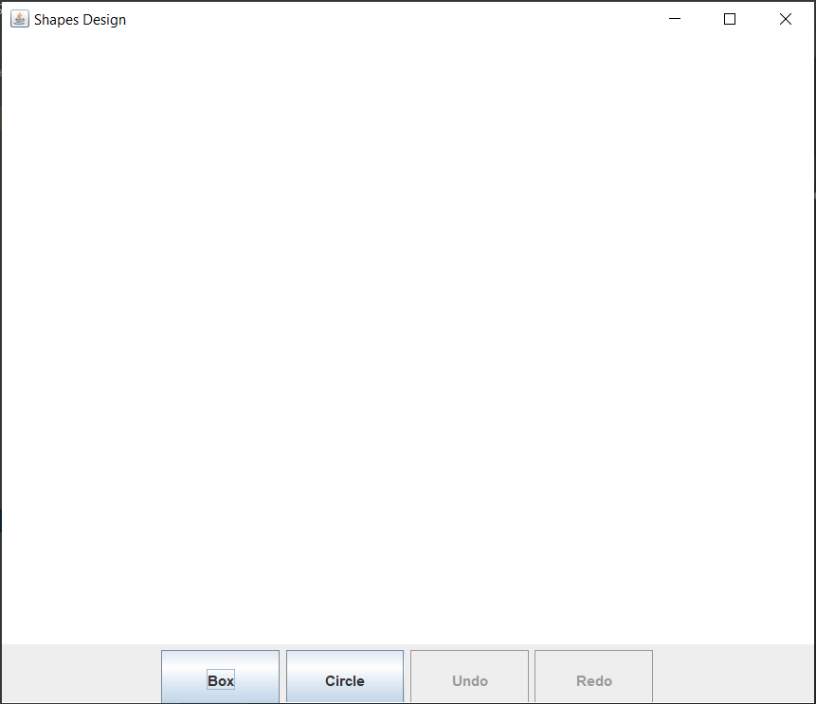

# Step 2

1. Click on any of shapes buttons – Box, Circle.

2. Click on the canvas area. (Here we have clicked on Box Button and then clicked on canvas)

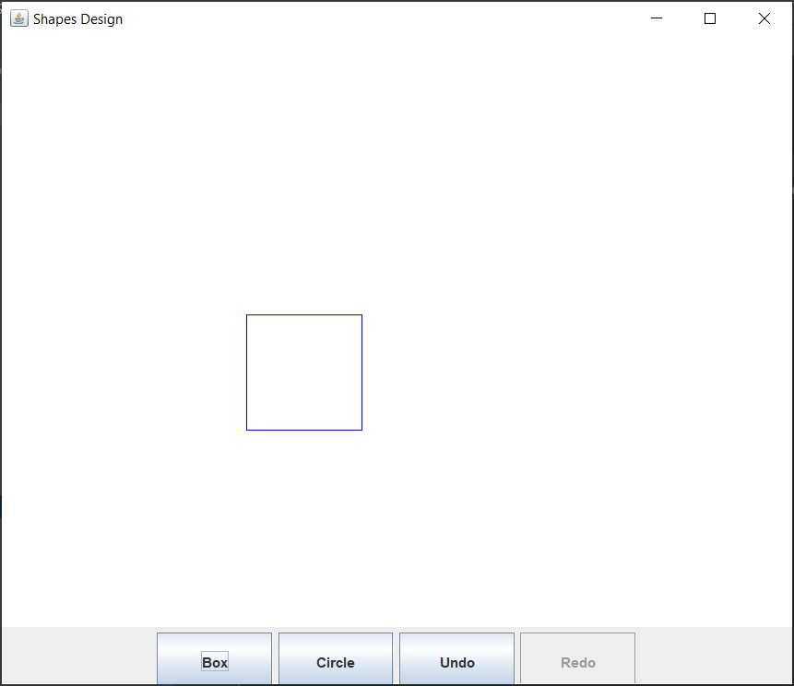

# Step 3

1. Click on Circle Button.

2. Click on the canvas area.

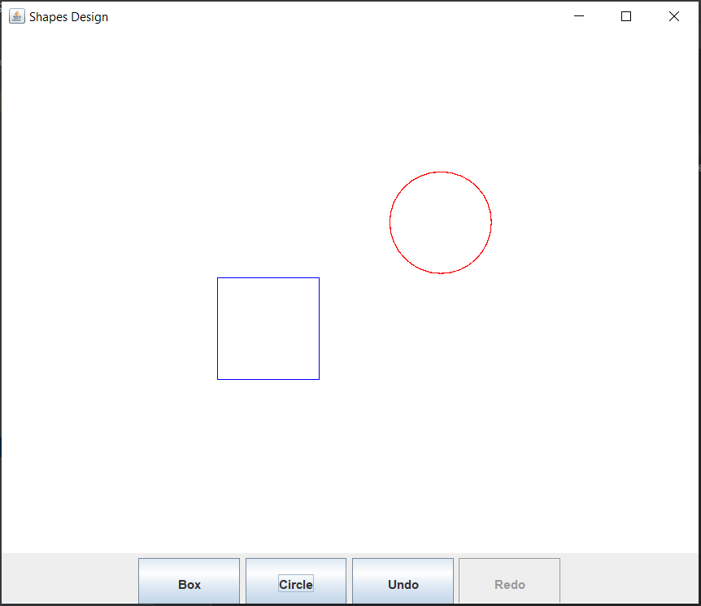

# Step 4 - Undo

1. Now Click o Undo Button and the last generated shape will be undone and sent to stack.

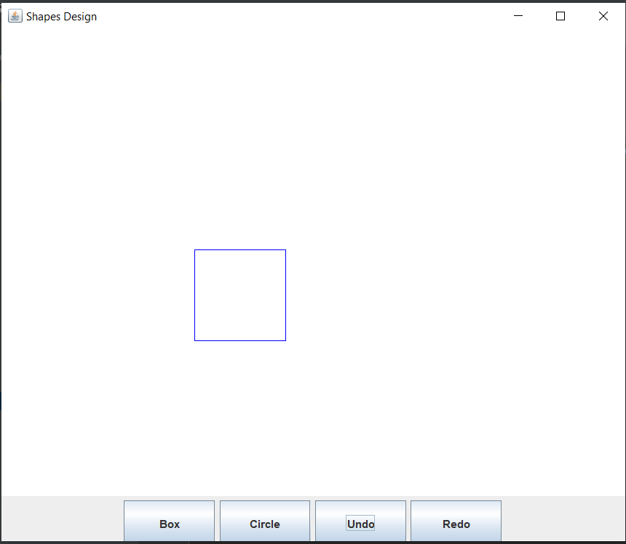

1. When we further Undo it, it will remove the remaining shape.

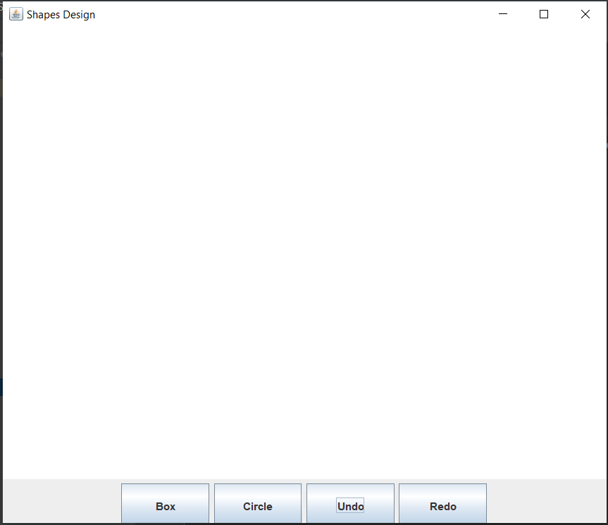

# Step 4 – Redo

1. Now Click o Redo Button and the last undone shape will be redone.

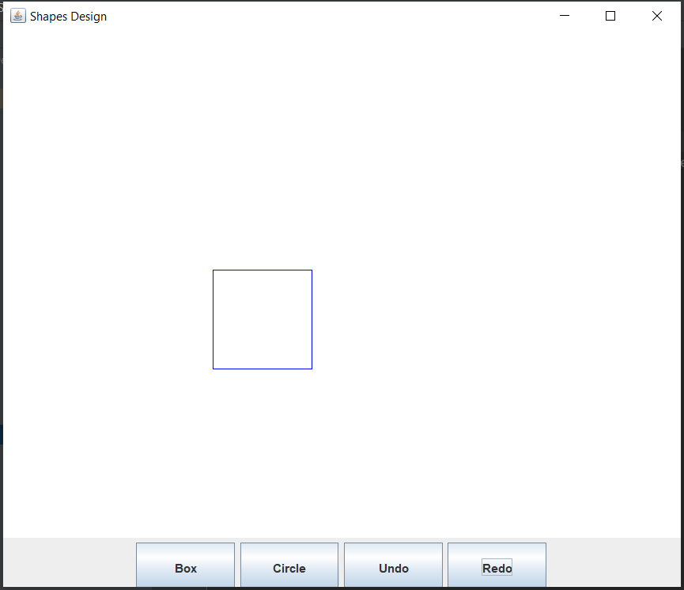

1. If we Redo it again, then the next shape will appear on canvas

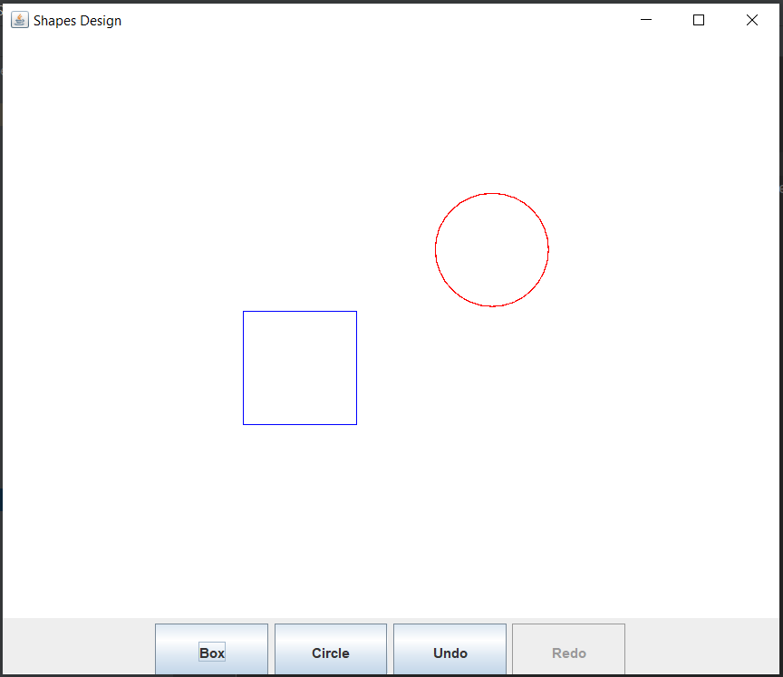

In this way we can do Redo and Undo Shapes as per the sequence it was added in the stack.

Patterns Implemented:

1. Controller
2. Expert
3. Composite
4. Iterator
5. Command
6. State