**Problem Statement**

Have a look at the nltk Bayes Classifier that does the prediction of male/female names based on the last letter in the name. Think of a new feature that you could extract from the data-set; define a method for it (modifying gender features). Discuss the results of this change, what new outputs occur in the classification and what things remain the same?

**Problem**

Problem posed is predicting gender of a person correctly when her/his name is supplied. List of names of male [2943 samples] and female [5001 samples] are parsed and set of (name, gender_label) tuples is made. Before applying classifier, this list of tuples is shuffled and divided into 2 groups : training and testing. 1st 500 tuples of shuffled list are held up for testing and rest of 7444 samples are used for training classifier.

**Approach**

Training the classifier on list of entire corpora of names would make it a mare memorizer. But names have patterns. E.g. Phonetic endings of male names are most often (Julius - ə). Whereas, for female names, vowel endings are seen frequently (Julia - ɑː). Hence, naively, name ending in ‘a’ such as ‘Ophelia’ is more likely to be of same class as Julia. Such patterns or **features** are captured using naïve bayes classifier of python’s nltk package.

**Naive Bays classifier**

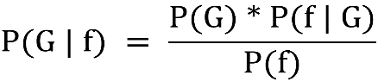Bays theorem is basis of probability based supervised classification. In case of given data, It works on thought that if probabilities of class labels[G - gender], feature sets for names[ f1,2,..n : {‘last_letter’, ‘is_last_letter_vowel’, …}] and conditional probability of feature set given class label is known – then we can predict a class label given feature set of new data. This aposteriori value [refer formula] is calculated for each class and class label that maximizes P(G | n) is assigned to the data.

*Naive Bays classifier* mitigates a potential challenge with Bays classifier that is– predicating conditional probability of all feature vector tuples given a label. Instead, Naïve Bayes Classifier considers all features conditionally independent. Which means –

* Suppose for a set of names [offilia, Julia, Aradhana], we find 2 features – [‘last_letter’, ‘is_last_letter_a_vowel’]
* 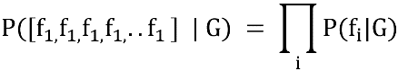We know that both these features must have correlation since ‘aeiou’ are captured as vowels as well as last letters.
* But for simplicity of calculations, Naïve Bayes classifiers ignore it and treat features separately[refer figure]
* In case of nltk package, denominator P(f) is not explicitly calculated. But instead – numerator is simply normalized. Hence, apriori for each class “label” given set of labels “l” and functions “f1..fn” is given by

$$P(label | feature) = \frac{P(label) * P(f1 | label)* .... P(fn | label)}{sum(l) * [P(l) * P(f1| l)....*P(fn | l)] }$$

**Present Implementation**

Current implementation derives a single feature ‘last_letter’ from data. Hence, last letters of all names in training data are used as input features and mapped against class labels to train a naïve bayes classifier.

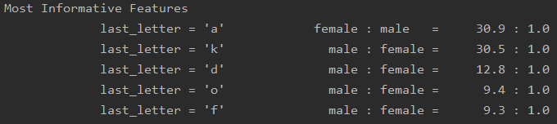**Observations**

* 26 distinct cases [Counter({'last_letter': 26})] are found for feature ‘last_letter’. [Roman letters a-z]
* Most informative last letters [which lead to a classification boundary] are [a, k, d, o, f]. As assumed, names ending with ‘a’ have high chance of classification as female name.
* 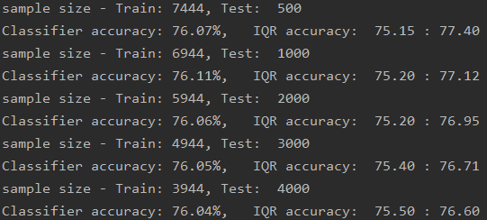Accuracy varies each time program runs, hence I averaged accuracies over 100 iterations and calculated mean accuracy . This single feature approach gives **prediction accuracy of ~75-76% with default split ratio = 0.93** (test – 500): (train- 7444)
* **When I varied split ratio; No significant change in mean accuracy was observed.**

**Additional Features**

I have added 2 new features to the feature selection function. Motive behind each feature is mentioned separately:

* Last_2_letters: Target male names like Nath**an** – Eth**an** – Ry**an**; Just**in** - Mart**in** etc.
* Last_3_letter: Target common female names like Ju**lia** – Ophe**lia,** Christ**ina** - Mart**ina** etc.

**Observations**

* Last_2_letters improves mean accuracy of classifier to ~78 % with default split ratio

My interpretation behind probable cause for increase in accuracy is : inherent bias associated last letter a, e and y with female names is not sufficient to classify male names like sacha, Hamja, Joe. ‘last_2_letters’ provides more level of details associated with combination of last to letters.

* Last_3_letters decreases mean accuracy of classifier back to ~75% with default split ratio

Decrease in accuracy probable result of underfitting. ’last_3_letters’ would have 263 possible combinations. Such large training corpus is not available. We can observe Most Informative Features :

last_3_letters = 'nne' female : male = 34.8 : 1.0 ……… eg [Adrianne]

last_3_letters = 'ana' female : male = 25.7 : 1.0 ……… eg [Melina]

last_3_letters = 'tta' female : male = 25.3 : 1.0 ……… eg [Margretta]

**Importance of Features**

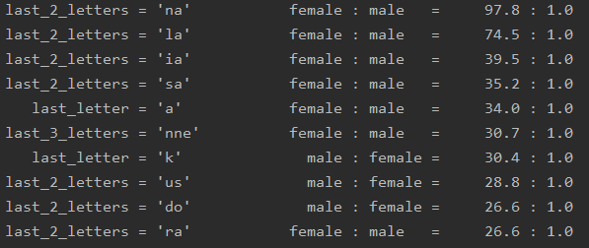To check effect of multiple features together to find optimal feature sets effecting classification. As new features are introduced, naturally vector combinations for those features are created by ML algorithm during fitting on training data. As last-letter had 26 possible vectors [a-z], similarly ’last_2_letters’ would have 262 additional possible combinations. But in naïve bayes, all features are considered conditionally independent; so finding effect of each feature on output is important for dimensionality reduction by omission during retraining. Classifier module of nltk package provides method show_most_informative_features(n). It returns top n important feature vectors which influence classifier. Top 10 features observed are shown in adjoined figure.

Training multiple features endorsed accuracy to ~79% default split ratio. But cost of training [time] was much larger than individual features. When I analyzed frequencies in top 100 important features, I noticed that feature ‘last_2_letters’ and ‘last_3_letters’ played major role in classifying gender.

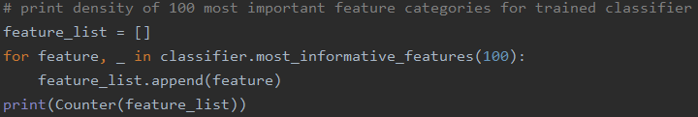

This solution can be improved bypreprocessing input set. Joint names are not currently handled e.g. Hans-Peter, Jean-Paul, John-Patrick, Ann-Marie, Jo-Ann etc.