Literature Review and Research Methods:
Reading Prescription Label

Project Topic:
The development of an OCR - LLM - TTS based label reading system for medicine prescriptions as my project topic, driven by a synthesis of insights from an extensive literature review and my personal fascination with working on Large Language Model (LLM) use cases in the medical field.

Passion for Healthcare Technology:
My personal interest in healthcare technology, particularly in improving patient safety and enhancing the efficiency of healthcare processes, motivated me to explore innovative solutions in this domain.
Recognizing the real-world impact of misinterpreted prescriptions and the potential consequences for patient health, I found a meaningful connection between my interest in technology and the societal need for more effective label reading methods.

Literature Reviews:
OCR Abstract and Citation:

In Medium articles focused on HyperScience.^{[1]} , it is clearly implied that "an OCR engine alone is not sufficient”. Organizations want accurate data extraction and insights, but they need to be able to process all sorts of documents, including complex ones with high variability and handwriting. That’s why at HyperScience we have developed our own text recognition engine called Optical Intelligent Character Recognition (OICR), an ML-based OCR that takes context into account and can understand human intent (e.g. to ignore cross-outs or read messy handwriting). This approach offers the highest levels of accuracy in the industry for both printed and handwritten text.

An Android application named MediPic,^{[3]} designed to address the challenges posed by misinterpreting drug names in medical prescriptions. Here's a revised version that aims to enhance clarity and conciseness.
The accurate interpretation of drug names in medical prescriptions is crucial for patient safety. Illegible handwriting and difficulties in recognizing medicine names by pharmacists contribute to potential health risks. This study presents MediPic, an Android application that tackles these challenges by implementing optical character recognition (OCR). MediPic utilizes the Tesseract library for OCR to extract readable text from partially scanned handwritten medicine names. The application further employs Repres to match partial strings with correct drug names, significantly reducing instances of misinterpretation. By implementing MediPic, pharmacists can minimize uncertainties in dispensing medication, ensuring patient safety. Additionally, the application provides valuable information to patients about their prescribed medicines.

IEEE research paper suggested for TTS (Text to Speech):
In a research article of “Image Text to speech”^{[2]} it is implicit that the primary challenge in communication lies in language bias between communicators. This device caters to individuals unfamiliar with English, providing translations into their native languages. The innovation in this research lies in the speech output available in 53 different languages, translating from English. The prototype, based on Raspberry Pi and a camera module, extracts text from images and converts it to translated speech in the user's preferred language using Tesseract OCR, Google Speech API, and Microsoft Translator. Beneficial for travelers and the visually impaired, this device enables users to hear English text in their chosen language, enhancing accessibility and communication.

Literature review with gaps to overcome:

Challenges Addressed by OCR-LLM-TTS Integration:
The literature review underscored the prevalent challenges in medicine label reading, motivating a solution that integrates Optical Character Recognition (OCR), Large Language Models (LLM), and Text-to-Speech (TTS) technologies.

Text line segmentation mentioned is a critical phase in off-line optical character recognition (OCR) systems particularly dealing with notepad format for prescription, as inaccuracies in segmentation can lead to OCR failures. Handwritten document segmentation poses challenges due to the diverse nature of handwriting. This paper^{[6]} addresses the lack of a universally accepted text segmentation algorithm evaluation method by proposing a basic test framework. The framework includes experiments related to text line segmentation, skew rate, and reference text line evaluation, providing a versatile and efficient evaluation method for text analysis algorithms.

Enhancing Medical Text with language Understanding:
Existing research highlighted the potential of LLMs in addressing linguistic nuances in medical text, making them an ideal component for enhancing the understanding of prescription details.

Tesseract is a character recognition engine that can read scanned text and convert it into digital text. It is open-source software that is released under the Apache License 2.0. Tesseract is available for various operating systems, including Windows, Linux, and Mac OS X. Hence, Tesseract is a popular tool to recognize text in images, such as scanned documents and digital photos. Tesseract is accurate and efficient, and it can handle a variety of languages. Read more^{[7]}.

OCR and TTS in Healthcare Technology:
Studies suggested a growing interest in applying OCR and TTS technologies to healthcare contexts, indicating their effectiveness in mitigating challenges related to illegible handwriting and improving accessibility to medical information.

Methodology:

Perspective while implementing OCR:
While the existing literature predominantly focuses on Optical Character Recognition (OCR) implementations for extracting prescription text, my approach aims to extend this research by comprehensively evaluating and comparing multiple OCR technologies. This includes Tesseract, Amazon Textract, and easyOCR, as well as integrating Large Language Models (LLM) GPT-3, BERT, etc. into the analysis. The objective is to determine the accuracy and performance of these technologies. Additionally, my project involves the implementation of a Text-to-Speech (TTS) system with gTTS, pyttsx3 or Raspberry Pi. enhancing patient understanding by converting the extracted text, including insights from LLM, into spoken words. This multi-faceted approach seeks to provide a more nuanced exploration of OCR and LLM technologies, ultimately improving the overall accessibility and comprehension of medical prescriptions for patients.
My project aims to address the challenges posed by varying formats in medical prescriptions, such as tabular formats commonly found in eye checkup prescriptions and more detailed medicinal prescriptions containing information about medicines and dosage details. The objective is to enhance the efficiency of the model in interpreting and processing diverse prescription formats, ultimately making it more accessible and user-friendly for patients.

Overview Flowchart:

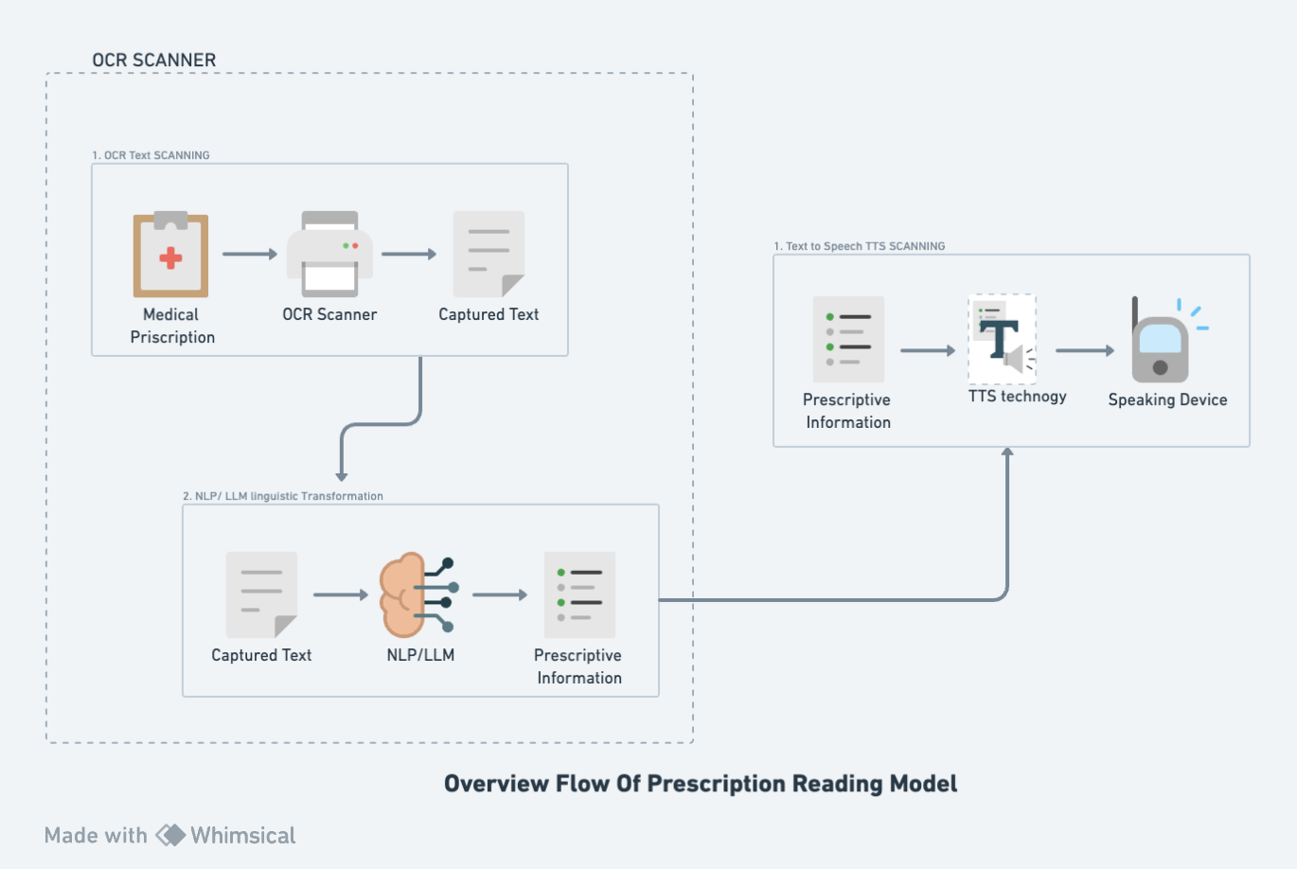

This comprehensive process ensures accurate text extraction, linguistic understanding, and effective conversion of medical prescription information into spoken words, catering to improved accessibility and comprehension for users. The integration of OCR, LLM/NLP, and TTS technologies in the flowchart contributes to a holistic solution for addressing challenges in prescription label reading.

References:

Study links:

1. Hyperscience knowledge-base optical-character-recognition
2. Document sec III: IEEE search paper: "Image Text To Speech Conversion In The Desired Language By Translating With Raspberry Pi", 2016R IEEE International Conference on Computational Intelligence and Computing Research (ICCIC)
3. Researchgate.net Prescriptio publications
4. OCR by Breta: github link
5. Wikipedia
6. PubMed OCR handwritten-text
7. https://viso.ai/computer-vision/optical-character-recognition-ocr/

Websites OCR technique used in:
https://www.zennioptical.com/b/prescription-scanner

Extraction of prescription text from: Medical Prescription Format Templates

